OS test 1 – study guide

https://www.cs.uic.edu/~jbell/CourseNotes/OperatingSystems/

Chapter 1\*\*\*\*\*\*\*\*\*\*\*\*\*\*\*\*\*\*\*\*\*\*\*\*\*\*\*\*\*\*\*\*\*\*\*\*\*\*\*\*\*\*\*\*\*\*\*\*\*\*\*\*\*\*\*\*\*\*\*\*

**Introduction**

**References:**

1. Abraham Silberschatz, Greg Gagne, and Peter Baer Galvin, "Operating System Concepts, **Ninth** Edition ", Chapter 1

Just as in [***The Blind Men and the Elephant***](https://www.cs.uic.edu/~jbell/CourseNotes/OperatingSystems/blindMen.html), this chapter looks at Operating Systems from a number of different viewpoints. No one view really shows the complete picture, but by looking from a number of different views, we can get a pretty good overall picture of what operating systems are all about.

**1.1 What Operating Systems Do - For Users, For Applications, etc.**

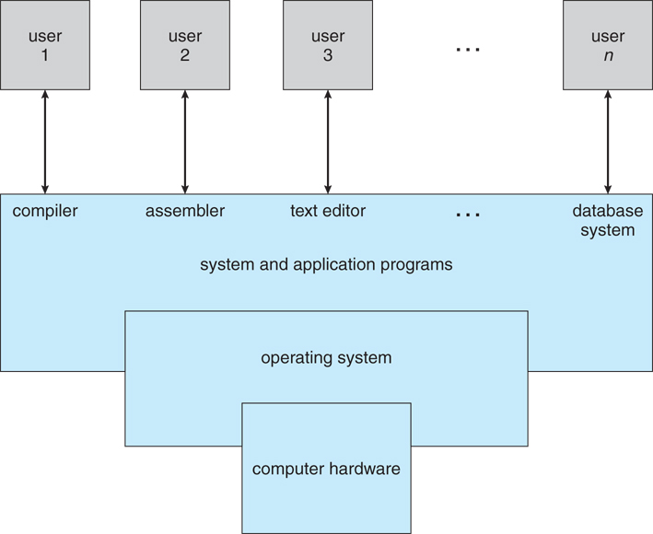  
**Figure 1.1 - Abstract view of the components of a computer system**

* Computer = HW + OS + Apps + Users
* OS serves as interface between HW and ( Apps & Users )
* OS provides services for Apps & Users
* OS manages resources ( Government model, it doesn't produce anything. )
* Debates about what is included in the OS - Just the kernel, or everything the vendor ships?  
  ( Consider the distinction between system applications and 3rd party or user apps. )

**1.2 Computer-System Organization - What are all the parts, and how do they fit together?**

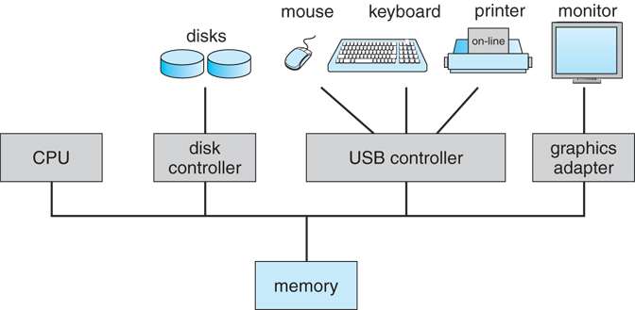  
**Figure 1.2 - A modern computer system**

**1.2.1 Computer-System Operation**

* Bootstrap program
* Shared memory between CPU and I/O cards
* Time slicing for multi-process operation
* Interrupt handling - clock, HW, SW
* Implementation of system calls

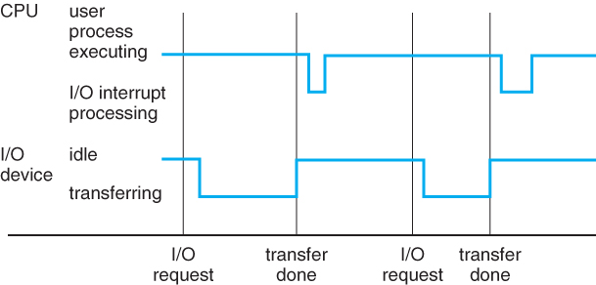  
**Figure 1.3 - Interrupt timeline for a single process doing output**

**1.2.2 Storage Structure**

* Main memory ( RAM )
  + Programs must be loaded into RAM to run.
  + Instructions and data fetched from RAM into registers.
  + RAM is volatile
  + "Medium" size and speed
* Other electronic ( volatile ) memory is faster, smaller, and more expensive per bit:
  + Registers
  + CPU Cache
* Non-volatile memory ( "permanent" storage ) is slower, larger, and less expensive per bit:
  + Electronic disks
  + Magnetic disks
  + Optical disks
  + Magnetic Tapes

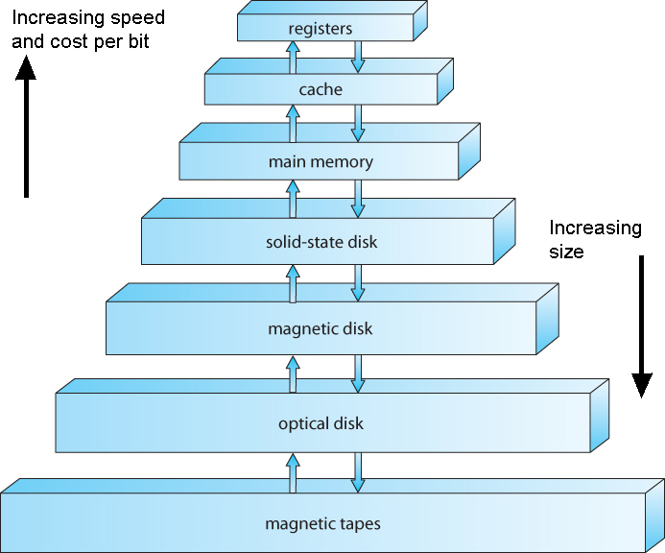  
**Figure 1.4 - Storage-device hierarchy**

**1.2.3 I/O Structure**

* Typical operation involves I/O requests, direct memory access ( DMA ), and interrupt handling.

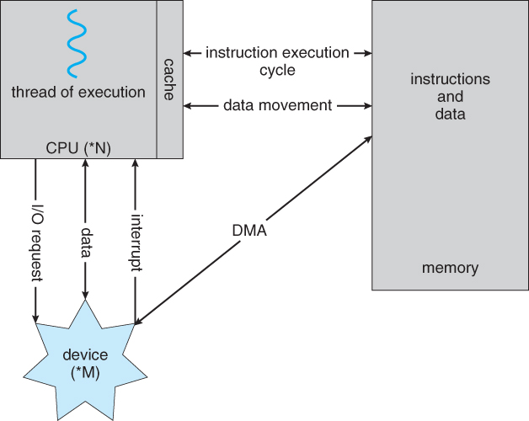  
**Figure 1.5 - How a modern computer system works**

**1.3 Computer-System Architecture - Different Operating Systems for Different Kinds of Computer Environments**

**1.3.1 Single-Processor Systems**

* One main CPU which manages the computer and runs user apps.
* Other specialized processors ( disk controllers, GPUs, etc. ) do not run user apps.

**1.3.2 Multiprocessor Systems**

1. Increased throughput - Faster execution, but not 100% linear speedup.
2. Economy of scale - Peripherals, disks, memory, shared among processors.
3. Increased reliability
   * Failure of a CPU slows system, doesn't crash it.
   * Redundant processing provides system of checks and balances. ( e.g. NASA )

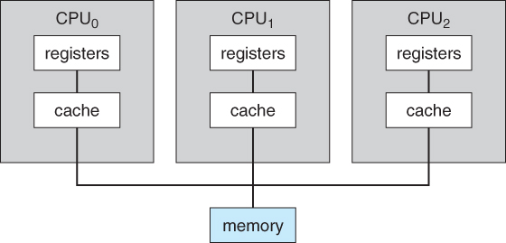  
**Figure 1.6 - Symmetric multiprocessing architecture**

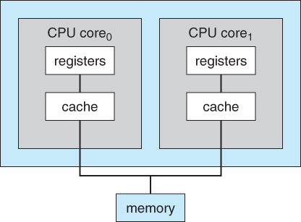  
**Figure 1.7 - A dual-core design with two cores placed on the same chip**

**1.3.3 Clustered Systems**

* Independent systems, with shared common storage and connected by a high-speed LAN, working together.
* Special considerations for access to shared storage are required, ( Distributed lock management ), as are collaboration protocols.

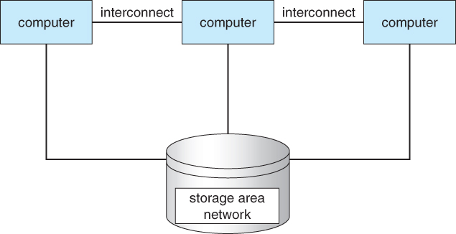  
**Figure 1.8 - General structure of a clustered system**

**1.4 Operating-System Structure**

A time-sharing ( multi-user multi-tasking ) OS requires:

* Memory management
* Process management
* Job scheduling
* Resource allocation strategies
* Swap space / virtual memory in physical memory
* Interrupt handling
* File system management
* Protection and security
* Inter-process communications

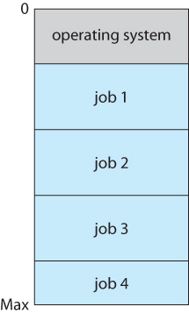  
**Figure 1.9 - Memory layout for a multiprogramming system**

**1.5 Operating-System Operations**

Interrupt-driven nature of modern OSes requires that erroneous processes not be able to disturb anything else.

**1.5.1 Dual-Mode and Multimode Operation**

* User mode when executing harmless code in user applications
* Kernel mode ( a.k.a. system mode, supervisor mode, privileged mode ) when executing potentially dangerous code in the system kernel.
* Certain machine instructions ( privileged instructions ) can only be executed in kernel mode.
* Kernel mode can only be entered by making system calls. User code cannot flip the mode switch.
* Modern computers support dual-mode operation in hardware, and therefore most modern OSes support dual-mode operation.

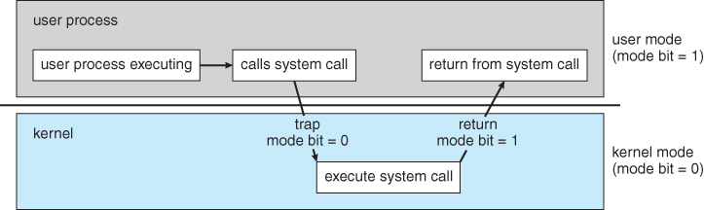  
**Figure 1.10 - Transition from user to kernel mode**

* The concept of modes can be extended beyond two, requiring more than a single mode bit
* CPUs that support virtualization use one of these extra bits to indicate when the virtual machine manager, VMM, is in control of the system. The VMM has more privileges than ordinary user programs, but not so many as the full kernel.
* System calls are typically implemented in the form of software interrupts, which causes the hardware's interrupt handler to transfer control over to an appropriate interrupt handler, which is part of the operating system, switching the mode bit to kernel mode in the process. The interrupt handler checks exactly which interrupt was generated, checks additional parameters ( generally passed through registers ) if appropriate, and then calls the appropriate kernel service routine to handle the service requested by the system call.
* User programs' attempts to execute illegal instructions ( privileged or non-existent instructions ), or to access forbidden memory areas, also generate software interrupts, which are trapped by the interrupt handler and control is transferred to the OS, which issues an appropriate error message, possibly dumps data to a log ( core ) file for later analysis, and then terminates the offending program.

**1.5.2 Timer**

* Before the kernel begins executing user code, a timer is set to generate an interrupt.
* The timer interrupt handler reverts control back to the kernel.
* This assures that no user process can take over the system.
* Timer control is a privileged instruction, ( requiring kernel mode. )

**1.6 Process Management**

An OS is responsible for the following tasks with regards to process management:

* Creating and deleting both user and system processes
* Ensuring that each process receives its necessary resources, without interfering with other processes.
* Suspending and resuming processes
* Process synchronization and communication
* Deadlock handling

**1.7 Memory Management**

An OS is responsible for the following tasks with regards to memory management:

* Keeping track of which blocks of memory are currently in use, and by which processes.
* Determining which blocks of code and data to move into and out of memory, and when.
* Allocating and deallocating memory as needed. ( E.g. new, malloc )

**1.8 Storage Management**

**1.8.1 File-System Management**

An OS is responsible for the following tasks with regards to filesystem management:

* Creating and deleting files and directories
* Supporting primitives for manipulating files and directories. ( open, flush, etc. )
* Mapping files onto secondary storage.
* Backing up files onto stable permanent storage media.

**1.8.2 Mass-Storage Management**

An OS is responsible for the following tasks with regards to mass-storage management:

* Free disk space management
* Storage allocation
* Disk scheduling

Note the trade-offs regarding size, speed, longevity, security, and re-writability between different mass storage devices, including floppy disks, hard disks, tape drives, CDs, DVDs, etc.

**1.8.3 Caching**

* There are many cases in which a smaller higher-speed storage space serves as a cache, or temporary storage, for some of the most frequently needed portions of larger slower storage areas.
* The hierarchy of memory storage ranges from CPU registers to hard drives and external storage. ( See table below. )
* The OS is responsible for determining what information to store in what level of cache, and when to transfer data from one level to another.
* The proper choice of cache management can have a profound impact on system performance.
* Data read in from disk follows a migration path from the hard drive to main memory, then to the CPU cache, and finally to the registers before it can be used, while data being written follows the reverse path. Each step ( other than the registers ) will typically fetch more data than is immediately needed, and cache the excess in order to satisfy future requests faster. For writing, small amounts of data are frequently buffered until there is enough to fill an entire "block" on the next output device in the chain.
* The issues get more complicated when multiple processes ( or worse multiple computers ) access common data, as it is important to ensure that every access reaches the most up-to-date copy of the cached data ( amongst several copies in different cache levels. )

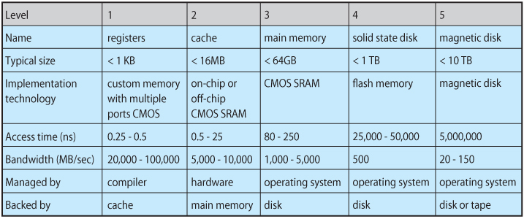  
**Figure 1.11 - Performance of various levels of storage**

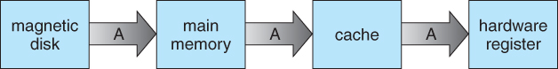  
**Figure 1.12 - Migration of integer A from disk to register**

**1.8.4 I/O Systems**

The I/O subsystem consists of several components:

* A memory-management component that includes buffering, caching, and spooling.
* A general device-driver interface.
* Drivers for specific hardware devices.
* ( UNIX implements multiple device interfaces for many types of devices, one for accessing the device character by character and one for accessing the device block by block. These can be seen by doing a long listing of /dev, and looking for a "c" or "b" in the first position. You will also note that the "size" field contains two numbers, known as the major and minor device numbers, instead of the normal one. The major number signifies which device driver handles I/O for this device, and the minor number is a parameter passed to the driver to let it know which specific device is being accessed. Where a device can be accessed as either a block or character device, the minor numbers for the two options usually differ by a single bit. )

**1.9 Protection and Security**

* ***Protection*** involves ensuring that no process access or interfere with resources to which they are not entitled, either by design or by accident. ( E.g. "protection faults" when pointer variables are misused. )
* ***Security*** involves protecting the system from deliberate attacks, either from legitimate users of the system attempting to gain unauthorized access and privileges, or external attackers attempting to access or damage the system.

**1.10 Kernel Data Structures**

**1.10.1 Lists, Stacks, and Queues**

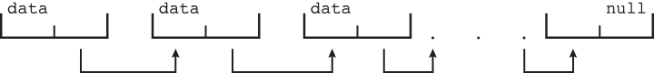  
**Figure 1.13 - Singly linked list**

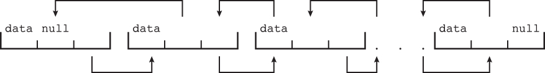  
**Figure 1.14 - Doubly linked list**

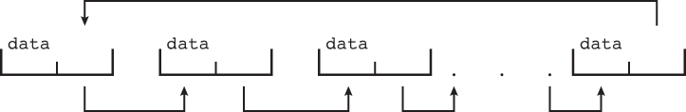  
**Figure 1.15 - Circularly linked list**

**1.10.2 Trees**

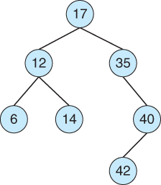  
**Figure 1.16 - Binary search trees**

**1.10.3 Hash Functions and Maps**

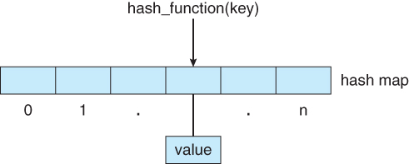  
**Figure 1.17 - Hash map**

**1.10.4 Bitmaps**

* A string of 1s and 0s used to keep track of the boolean state of a collection of objects, such as the free state of blocks on a disk or pages in memory..

**1.11 Computing Environments**

**1.11.1 Traditional Computing**

**1.11.2 Mobile Computing**

* Computing on small handheld devices such as smart phones or tablets. ( As opposed to laptops, which still fall under traditional computing. )
* May take advantage of additional built-in sensors, such as GPS, tilt, compass, and inertial movement.
* Typically connect to the Internet using wireless networking ( IEEE 802.11 ) or cellular telephone technology.
* Limited in storage capacity, memory capacity, and computing power relative to a PC.
* Generally uses slower processors, that consume less battery power and produce less heat.
* The two dominant OSes today are Google Android and Apple iOS.

**1.11.3 Distributed Systems**

* Distributed Systems consist of multiple, possibly heterogeneous, computers connected together via a network and cooperating in some way, form, or fashion.
* Networks may range from small tight LANs to broad reaching WANs.
  + WAN = Wide Area Network, such as an international corporation
  + MAN =Metropolitan Area Network, covering a region the size of a city for example.
  + LAN =Local Area Network, typical of a home, business, single-site corporation, or university campus.
  + PAN = Personal Area Network, such as the bluetooth connection between your PC, phone, headset, car, etc.
* Network access speeds, throughputs, reliabilities, are all important issues.
* OS view of the network may range from just a special form of file access to complex well-coordinated network operating systems.
* Shared resources may include files, CPU cycles, RAM, printers, and other resources.

**1.11.4 Client-Server Computing**

* A defined server provides services ( HW or SW ) to other systems which serve as clients. ( Technically clients and servers are processes, not HW, and may co-exist on the same physical computer. )
* A process may act as both client and server of either the same or different resources.
* Served resources may include disk space, CPU cycles, time of day, IP name information, graphical displays ( X Servers ), or other resources.

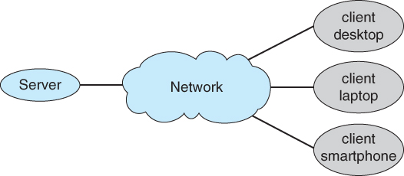  
**Figure 1.18 - General structure of a client-server system**

**1.11.5 Peer-to-Peer Computing**

* Any computer or process on the network may provide services to any other which requests it. There is no clear "leader" or overall organization.
* May employ a central "directory" server for looking up the location of resources, or may use peer-to-peer searching to find resources.
* E.g. Skype uses a central server to locate a desired peer, and then further communication is peer to peer.

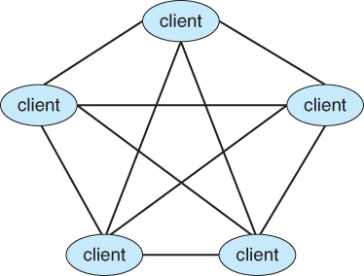  
**Figure 1.19 - Peer-to-peer system with no centralized service**

**1.11.6 Virtualization**

* Allows one or more "guest" operating systems to run on virtual machines hosted by a single physical machine and the virtual machine manager.
* Useful for cross-platform development and support.
* For example, a student could run UNIX on a virtual machine, hosted by a virtual machine manager on a Windows based personal computer. The student would have full root access to the virtual machine, and if it crashed, the underlying Windows machine should be unaffected.
* System calls have to be caught by the VMM and translated into ( different ) system calls made to the real underlying OS.
* Virtualization can slow down program that have to run through the VMM, but can also speed up some things if virtual hardware can be accessed through a cache instead of a physical device.
* Depending on the implementation, programs can also run simultaneously on the native OS, bypassing the virtual machines.

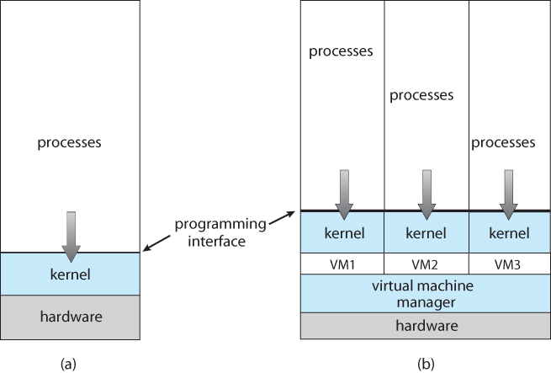  
**Figure 1.20 - VMWare**

* To run Linux on a Windows system using VMware, follow these steps:
  1. Download the free "VMware Player" tool from <http://www.vmware.com/download/player> and install it on your system
  2. Choose a Linux version from among hundreds of virtual machine images at <http://www.vmware.com/appliances>
  3. Boot the virtual machine within VMware Player.

**1.11.7 Cloud Computing**

* Delivers computing, storage, and applications as a service over a network.
* Types of cloud computing:
  + Public cloud - Available to anyone willing to pay for the service.
  + Private cloud - Run by a company for internal use only.
  + Hybrid cloud - A cloud with both public and private components.
  + Software as a Service - SaaS - Applications such as word processors available via the Internet
  + Platform as a Service - PaaS - A software stack available for application use, such as a database server
  + Infrastructure as a Service - IaaS - Servers or storage available on the Internet, such as backup servers, photo storage, or file storage.
  + Service providers may provide more than one type of service
* Clouds may contain thousands of physical computers, millions of virtual ones, and petabytes of total storage.
* Web hosting services may offer ( one or more ) virtual machine(s) to each of their clients.

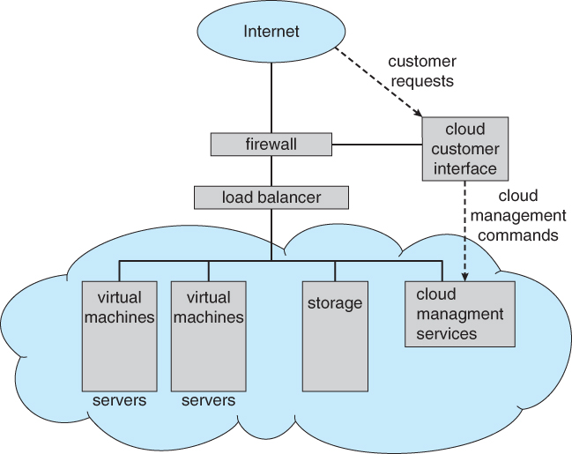  
**Figure 1.21 - Cloud computing**

**1.11.8 Real-Time Embedded Systems**

* Embedded into devices such as automobiles, climate control systems, process control, and even toasters and refrigerators.
* May involve specialized chips, or generic CPUs applied to a particular task. ( Consider the current price of 80286 or even 8086 or 8088 chips, which are still plenty powerful enough for simple electronic devices such as kids toys. )
* Process control devices require real-time ( interrupt driven ) OSes. Response time can be critical for many such devices.

**1.12 Open-Source Operating Systems**

* ( For more information on the Flourish conference held at UIC on the subject of Free Libre and Open Source Software , visit [http://www.flourishconf.com](http://www.flourishconf.com/) )
* Open-Source software is published ( sometimes sold ) with the source code, so that anyone can see and optionally modify the code.
* Open-source SW is often developed and maintained by a small army of loosely connected often unpaid programmers, each working towards the common good.
* Critics argue that open-source SW can be buggy, but proponents counter that bugs are found and fixed quickly, since there are so many pairs of eyes inspecting all the code.
* Open-source operating systems are a good resource for studying OS development, since students can examine the source code and even change it and re-compile the changes.

**1.12.1 History**

* At one time ( 1950s ) a lot of code was open-source.
* Later, companies tried to protect the privacy of their code, particularly sensitive issues such as copyright protection algorithms.
* In 1983 Richard Stallman started the GNU project to produce an open-source UNIX.
* He later published the GNU Manifesto, arguing that ALL software should be open-source, and founded the [Free Software Foundation](http://www.fsf.org/) to promote open-source development.
* FSF and GNU use the [GNU General Public License](http://www.gnu.org/copyleft/gpl.html) which essentially states that all users of the software have full rights to copy and change the SW however they wish, so long as anything they distribute further contain the same license agreement. ( Copylefting )

**1.12.2 Linux**

* Developed by Linus Torvalds in Finland in 1991 as the first full operating system developed by GNU.
* Many different distributions of Linux have evolved from Linus's original, including RedHat, SUSE, Fedora, Debian, Slackware, and Ubuntu, each geared toward a different group of end-users and operating environments.
* To run Linux on a Windows system using VMware, follow these steps:
  1. Download the free "VMware Player" tool from <http://www.vmware.com/download/player> and install it on your system
  2. Choose a Linux version from among hundreds of virtual machine images at <http://www.vmware.com/appliances>
  3. Boot the virtual machine within VMware Player.

**1.12.3 BSD UNIX**

* UNIX was originally developed at ATT Bell labs, and the source code made available to computer science students at many universities, including the University of California at Berkeley, UCB.
* UCB students developed UNIX further, and released their product as BSD UNIX in both binary and source-code format.
* BSD UNIX is not open-source, however, because a license is still needed from ATT.
* In spite of various lawsuits, there are now several versions of BSD UNIX, including Free BSD, NetBSD, OpenBSD, and DragonflyBSD
* The source code is located in /usr/src.
* The core of the Mac operating system is Darwin, derived from BSD UNIX, and is available at <http://developer.apple.com/opensource/index.html>

**1.13.4 Solaris**

* Solaris is the UNIX operating system for computers from Sun Microsystems.
* Solaris was originally based on BSD UNIX, and has since migrated to ATT SystemV as its basis.
* Parts of Solaris are now open-source, and some are not because they are still covered by ATT copyrights.
* It is possible to change the open-source components of Solaris, re-compile them, and then link them in with binary libraries of the copyrighted portions of Solaris.
* Open Solaris is available from <http://www.opensolaris.org/os/>
* Solaris also allows viewing of the source code online, without having to download and unpack the entire package.

**1.13.5 Utility**

* The free software movement is gaining rapidly in popularity, leading to thousands of ongoing projects involving untold numbers of programmers.
* Sites such as <http://freshmeat.net/> and <http://distrowatch.com/> provide portals to many of these projects.

**1.14 Summary**

Chapter 2\*\*\*\*\*\*\*\*\*\*\*\*\*\*\*\*\*\*\*\*\*\*\*\*\*\*\*\*\*\*\*\*\*\*\*\*\*\*\*\*\*\*\*\*\*\*\*\*\*\*\*\*\*\*\*\*\*\*\*\*

# Operating-System Structures

### References:

1. Abraham Silberschatz, Greg Gagne, and Peter Baer Galvin, "Operating System Concepts, Ninth Edition ", Chapter 2

This chapter deals with how operating systems are structured and organized. Different design issues and choices are examined and compared, and the basic structure of several popular OSes are presented.

### 2.1 Operating-System Services

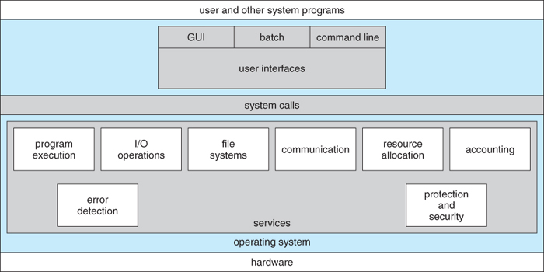  
**Figure 2.1 - A view of operating system services**

OSes provide environments in which programs run, and services for the users of the system, including:

* **User Interfaces** - Means by which users can issue commands to the system. Depending on the system these may be a command-line interface ( e.g. sh, csh, ksh, tcsh, etc. ), a GUI interface ( e.g. Windows, X-Windows, KDE, Gnome, etc. ), or a batch command systems. The latter are generally older systems using punch cards of job-control language, JCL, but may still be used today for specialty systems designed for a single purpose.
* **Program Execution** - The OS must be able to load a program into RAM, run the program, and terminate the program, either normally or abnormally.
* **I/O Operations** - The OS is responsible for transferring data to and from I/O devices, including keyboards, terminals, printers, and storage devices.
* **File-System Manipulation** - In addition to raw data storage, the OS is also responsible for maintaining directory and subdirectory structures, mapping file names to specific blocks of data storage, and providing tools for navigating and utilizing the file system.
* **Communications** - Inter-process communications, IPC, either between processes running on the same processor, or between processes running on separate processors or separate machines. May be implemented as either shared memory or message passing, ( or some systems may offer both. )
* **Error Detection** - Both hardware and software errors must be detected and handled appropriately, with a minimum of harmful repercussions. Some systems may include complex error avoidance or recovery systems, including backups, RAID drives, and other redundant systems. Debugging and diagnostic tools aid users and administrators in tracing down the cause of problems.

Other systems aid in the efficient operation of the OS itself:

* **Resource Allocation** - E.g. CPU cycles, main memory, storage space, and peripheral devices. Some resources are managed with generic systems and others with very carefully designed and specially tuned systems, customized for a particular resource and operating environment.
* **Accounting** - Keeping track of system activity and resource usage, either for billing purposes or for statistical record keeping that can be used to optimize future performance.
* **Protection and Security** - Preventing harm to the system and to resources, either through wayward internal processes or malicious outsiders. Authentication, ownership, and restricted access are obvious parts of this system. Highly secure systems may log all process activity down to excruciating detail, and security regulation dictate the storage of those records on permanent non-erasable medium for extended times in secure ( off-site ) facilities.

### 2.2 User Operating-System Interface

#### 2.2.1 Command Interpreter

* Gets and processes the next user request, and launches the requested programs.
* In some systems the CI may be incorporated directly into the kernel.
* More commonly the CI is a separate program that launches once the user logs in or otherwise accesses the system.
* UNIX, for example, provides the user with a choice of different shells, which may either be configured to launch automatically at login, or which may be changed on the fly. ( Each of these shells uses a different configuration file of initial settings and commands that are executed upon startup. )
* Different shells provide different functionality, in terms of certain commands that are implemented directly by the shell without launching any external programs. Most provide at least a rudimentary command interpretation structure for use in shell script programming ( loops, decision constructs, variables, etc. )
* An interesting distinction is the processing of wild card file naming and I/O re-direction. On UNIX systems those details are handled by the shell, and the program which is launched sees only a list of filenames generated by the shell from the wild cards. On a DOS system, the wild cards are passed along to the programs, which can interpret the wild cards as the program sees fit.

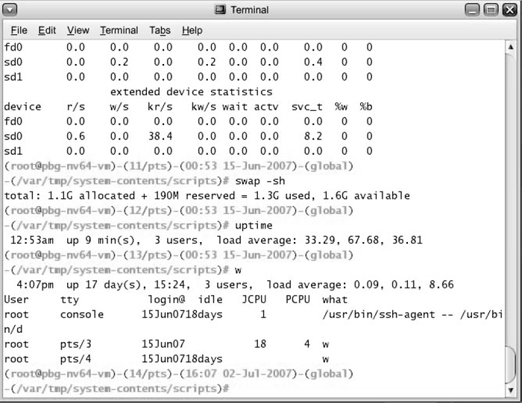  
**Figure 2.2 - The Bourne shell command interpreter in Solaris 10**

#### 2.2.2 Graphical User Interface, GUI

* Generally implemented as a desktop metaphor, with file folders, trash cans, and resource icons.
* Icons represent some item on the system, and respond accordingly when the icon is activated.
* First developed in the early 1970's at Xerox PARC research facility.
* In some systems the GUI is just a front end for activating a traditional command line interpreter running in the background. In others the GUI is a true graphical shell in its own right.
* Mac has traditionally provided ONLY the GUI interface. With the advent of OSX ( based partially on UNIX ), a command line interface has also become available.
* Because mice and keyboards are impractical for small mobile devices, these normally use a touch-screen interface today, that responds to various patterns of swipes or "gestures". When these first came out they often had a physical keyboard and/or a trackball of some kind built in, but today a virtual keyboard is more commonly implemented on the touch screen.

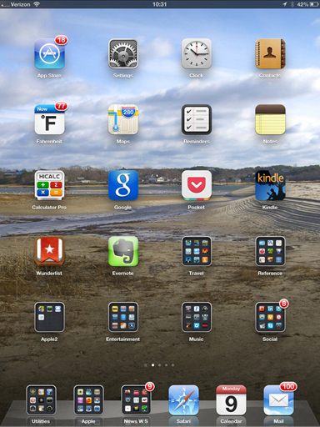  
**Figure 2.3 - The iPad touchscreen**

#### 2.2.3 Choice of interface

* Most modern systems allow individual users to select their desired interface, and to customize its operation, as well as the ability to switch between different interfaces as needed. System administrators generally determine which interface a user starts with when they first log in.
* GUI interfaces usually provide an option for a terminal emulator window for entering command-line commands.
* Command-line commands can also be entered into **shell scripts**, which can then be run like any other programs.

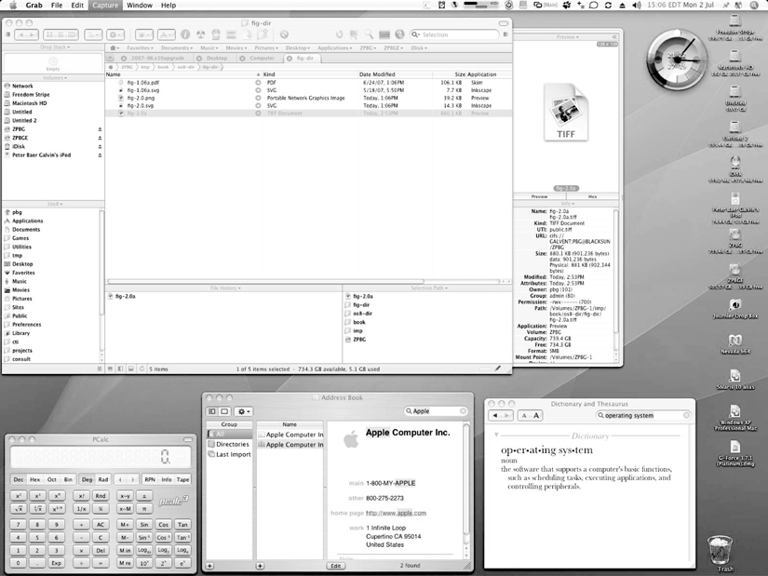  
**Figure 2.4 - The Mac OS X GUI**

### 2.3 System Calls

* System calls provide a means for user or application programs to call upon the services of the operating system.
* Generally written in C or C++, although some are written in assembly for optimal performance.
* Figure 2.4 illustrates the sequence of system calls required to copy a file:

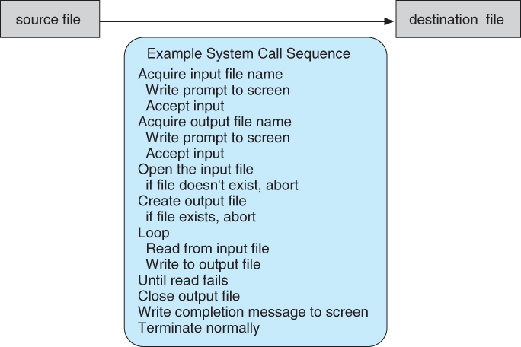  
**Figure 2.5 - Example of how system calls are used.**

* You can use "strace" to see more examples of the large number of system calls invoked by a single simple command. Read the man page for strace, and try some simple examples. ( strace mkdir temp, strace cd temp, strace date > t.t, strace cp t.t t.2, etc. )
* Most programmers do not use the low-level system calls directly, but instead use an "Application Programming Interface", API. The following sidebar shows the read( ) call available in the API on UNIX based systems::

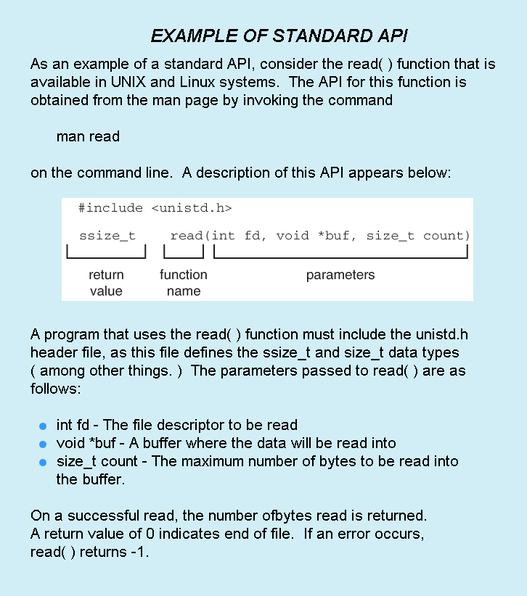

The use of APIs instead of direct system calls provides for greater program portability between different systems. The API then makes the appropriate system calls through the **system call interface**, using a table lookup to access specific numbered system calls, as shown in Figure 2.6:

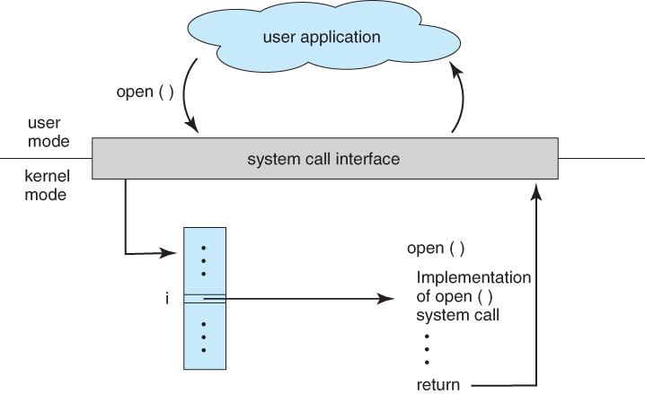  
**Figure 2.6 - The handling of a user application invoking the open( ) system call**

* Parameters are generally passed to system calls via registers, or less commonly, by values pushed onto the stack. Large blocks of data are generally accessed indirectly, through a memory address passed in a register or on the stack, as shown in Figure 2.7:

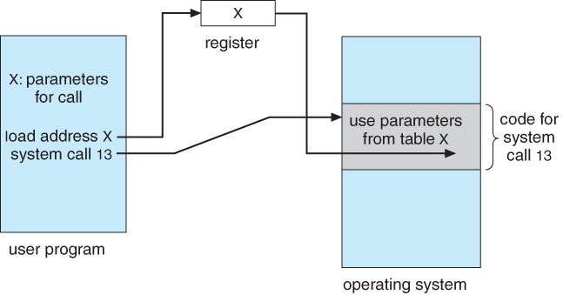  
**Figure 2.7 - Passing of parameters as a table**

### 2.4 Types of System Calls

Six major categories, as outlined in Figure 2.8 and the following six subsections:

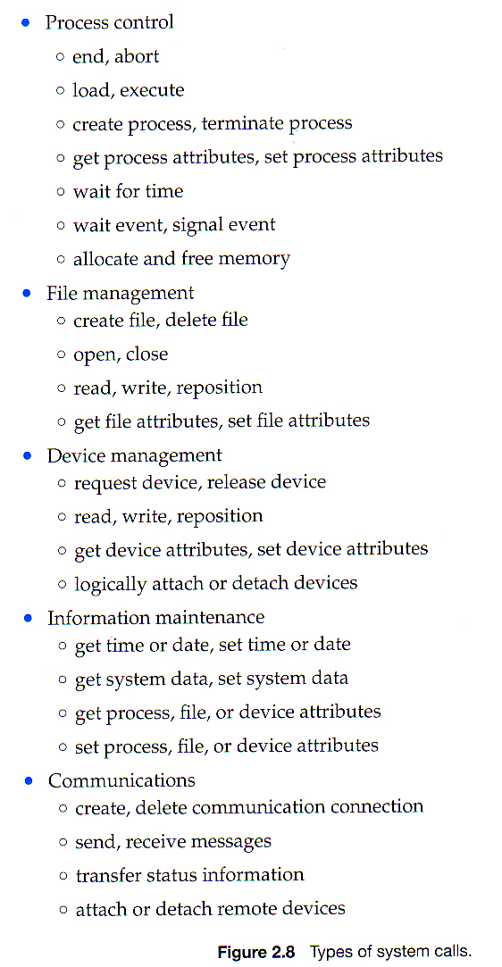  
**( Sixth type, protection, not shown here but described below. )**

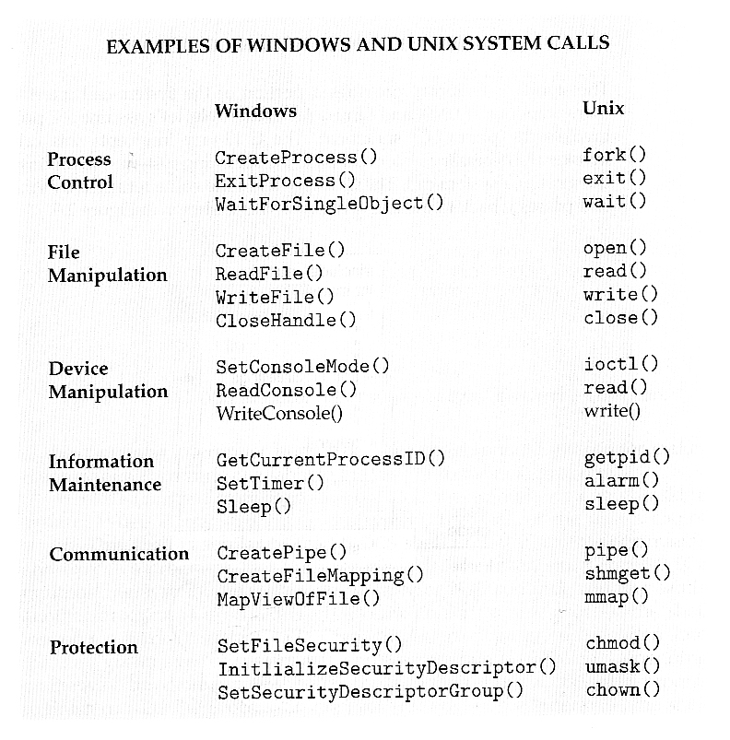

* Standard library calls may also generate system calls, as shown here:

### https://www.cs.uic.edu/~jbell/CourseNotes/OperatingSystems/images/Chapter2/2_sidebar_C_Library.jpg

#### 2.4.1 Process Control

* Process control system calls include end, abort, load, execute, create process, terminate process, get/set process attributes, wait for time or event, signal event, and allocate and free memory.
* Processes must be created, launched, monitored, paused, resumed,and eventually stopped.
* When one process pauses or stops, then another must be launched or resumed
* When processes stop abnormally it may be necessary to provide core dumps and/or other diagnostic or recovery tools.
* Compare DOS ( a single-tasking system ) with UNIX ( a multi-tasking system ).
  + When a process is launched in DOS, the command interpreter first unloads as much of itself as it can to free up memory, then loads the process and transfers control to it. The interpreter does not resume until the process has completed, as shown in Figure 2.9:

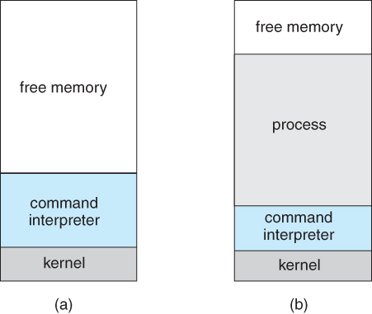  
**Figure 2.9 - MS-DOS execution. (a) At system startup. (b) Running a program.**

* + Because UNIX is a multi-tasking system, the command interpreter remains completely resident when executing a process, as shown in Figure 2.11 below.
    - The user can switch back to the command interpreter at any time, and can place the running process in the background even if it was not originally launched as a background process.
    - In order to do this, the command interpreter first executes a "fork" system call, which creates a second process which is an exact duplicate ( clone ) of the original command interpreter. The original process is known as the parent, and the cloned process is known as the child, with its own unique process ID and parent ID.
    - The child process then executes an "exec" system call, which replaces its code with that of the desired process.
    - The parent ( command interpreter ) normally waits for the child to complete before issuing a new command prompt, but in some cases it can also issue a new prompt right away, without waiting for the child process to complete. ( The child is then said to be running "in the background", or "as a background process". )

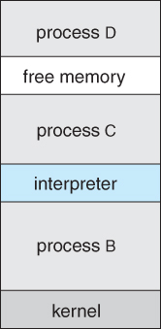  
**Figure 2.10 - FreeBSD running multiple programs**

#### 2.4.2 File Management

* File management system calls include create file, delete file, open, close, read, write, reposition, get file attributes, and set file attributes.
* These operations may also be supported for directories as well as ordinary files.
* ( The actual directory structure may be implemented using ordinary files on the file system, or through other means. Further details will be covered in chapters 11 and 12. )

#### 2.4.3 Device Management

* Device management system calls include request device, release device, read, write, reposition, get/set device attributes, and logically attach or detach devices.
* Devices may be physical ( e.g. disk drives ), or virtual / abstract ( e.g. files, partitions, and RAM disks ).
* Some systems represent devices as special files in the file system, so that accessing the "file" calls upon the appropriate device drivers in the OS. See for example the /dev directory on any UNIX system.

#### 2.4.4 Information Maintenance

* Information maintenance system calls include calls to get/set the time, date, system data, and process, file, or device attributes.
* Systems may also provide the ability to dump memory at any time, single step programs pausing execution after each instruction, and tracing the operation of programs, all of which can help to debug programs.

#### 2.4.5 Communication

* Communication system calls create/delete communication connection, send/receive messages, transfer status information, and attach/detach remote devices.
* The **message passing** model must support calls to:
  + Identify a remote process and/or host with which to communicate.
  + Establish a connection between the two processes.
  + Open and close the connection as needed.
  + Transmit messages along the connection.
  + Wait for incoming messages, in either a blocking or non-blocking state.
  + Delete the connection when no longer needed.
* The **shared memory** model must support calls to:
  + Create and access memory that is shared amongst processes ( and threads. )
  + Provide locking mechanisms restricting simultaneous access.
  + Free up shared memory and/or dynamically allocate it as needed.
* Message passing is simpler and easier, ( particularly for inter-computer communications ), and is generally appropriate for small amounts of data.
* Shared memory is faster, and is generally the better approach where large amounts of data are to be shared, ( particularly when most processes are reading the data rather than writing it, or at least when only one or a small number of processes need to change any given data item. )

#### 2.4.6 Protection

* Protection provides mechanisms for controlling which users / processes have access to which system resources.
* System calls allow the access mechanisms to be adjusted as needed, and for non-priveleged users to be granted elevated access permissions under carefully controlled temporary circumstances.
* Once only of concern on multi-user systems, protection is now important on all systems, in the age of ubiquitous network connectivity.

### 2.5 System Programs

* System programs provide OS functionality through separate applications, which are not part of the kernel or command interpreters. They are also known as system utilities or system applications.
* Most systems also ship with useful applications such as calculators and simple editors, ( e.g. Notepad ). Some debate arises as to the border between system and non-system applications.
* System programs may be divided into these categories:
  + **File management** - programs to create, delete, copy, rename, print, list, and generally manipulate files and directories.
  + **Status information** - Utilities to check on the date, time, number of users, processes running, data logging, etc. System **registries** are used to store and recall configuration information for particular applications.
  + **File modification** - e.g. text editors and other tools which can change file contents.
  + **Programming-language support** - E.g. Compilers, linkers, debuggers, profilers, assemblers, library archive management, interpreters for common languages, and support for make.
  + **Program loading and execution** - loaders, dynamic loaders, overlay loaders, etc., as well as interactive debuggers.
  + **Communications** - Programs for providing connectivity between processes and users, including mail, web browsers, remote logins, file transfers, and remote command execution.
  + **Background services**- System daemons are commonly started when the system is booted, and run for as long as the system is running, handling necessary services. Examples include network daemons, print servers, process schedulers, and system error monitoring services.
* Most operating systems today also come complete with a set of **application programs** to provide additional services, such as copying files or checking the time and date.
* Most users' views of the system is determined by their command interpreter and the application programs. Most never make system calls, even through the API, ( with the exception of simple ( file ) I/O in user-written programs. )

### 2.6 Operating-System Design and Implementation

#### 2.6.1 Design Goals

* **Requirements** define properties which the finished system must have, and are a necessary first step in designing any large complex system.
  + **User requirements** are features that users care about and understand, and are written in commonly understood vernacular. They generally do not include any implementation details, and are written similar to the product description one might find on a sales brochure or the outside of a shrink-wrapped box.
  + **System requirements** are written for the developers, and include more details about implementation specifics, performance requirements, compatibility constraints, standards compliance, etc. These requirements serve as a "contract" between the customer and the developers, ( and between developers and subcontractors ), and can get quite detailed.
* Requirements for operating systems can vary greatly depending on the planned scope and usage of the system. ( Single user / multi-user, specialized system / general purpose, high/low security, performance needs, operating environment, etc. )

#### 2.6.2 Mechanisms and Policies

* Policies determine what is to be done. Mechanisms determine how it is to be implemented.
* If properly separated and implemented, policy changes can be easily adjusted without re-writing the code, just by adjusting parameters or possibly loading new data / configuration files. For example the relative priority of background versus foreground tasks.

#### 2.6.3 Implementation

* Traditionally OSes were written in assembly language. This provided direct control over hardware-related issues, but inextricably tied a particular OS to a particular HW platform.
* Recent advances in compiler efficiencies mean that most modern OSes are written in C, or more recently, C++. Critical sections of code are still written in assembly language, ( or written in C, compiled to assembly, and then fine-tuned and optimized by hand from there. )
* Operating systems may be developed using **emulators** of the target hardware, particularly if the real hardware is unavailable ( e.g. not built yet ), or not a suitable platform for development, ( e.g. smart phones, game consoles, or other similar devices. )

### 2.7 Operating-System Structure

For efficient performance and implementation an OS should be partitioned into separate subsystems, each with carefully defined tasks, inputs, outputs, and performance characteristics. These subsystems can then be arranged in various architectural configurations:

#### 2.7.1 Simple Structure

When DOS was originally written its developers had no idea how big and important it would eventually become. It was written by a few programmers in a relatively short amount of time, without the benefit of modern software engineering techniques, and then gradually grew over time to exceed its original expectations. It does not break the system into subsystems, and has no distinction between user and kernel modes, allowing all programs direct access to the underlying hardware. ( Note that user versus kernel mode was not supported by the 8088 chip set anyway, so that really wasn't an option back then. )

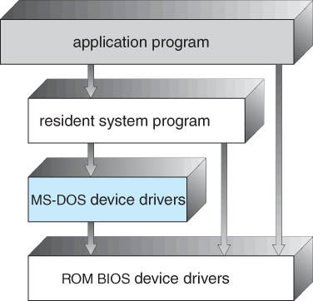  
**Figure 2.11 - MS-DOS layer structure**

The original UNIX OS used a simple layered approach, but almost all the OS was in one big layer, not really breaking the OS down into layered subsystems:

#### https://www.cs.uic.edu/~jbell/CourseNotes/OperatingSystems/images/Chapter2/2_12_UNIX_Structure.jpg **Figure 2.12** - Traditional UNIX system structure

#### 2.7.2 Layered Approach

* Another approach is to break the OS into a number of smaller layers, each of which rests on the layer below it, and relies solely on the services provided by the next lower layer.
* This approach allows each layer to be developed and debugged independently, with the assumption that all lower layers have already been debugged and are trusted to deliver proper services.
* The problem is deciding what order in which to place the layers, as no layer can call upon the services of any higher layer, and so many chicken-and-egg situations may arise.
* Layered approaches can also be less efficient, as a request for service from a higher layer has to filter through all lower layers before it reaches the HW, possibly with significant processing at each step.

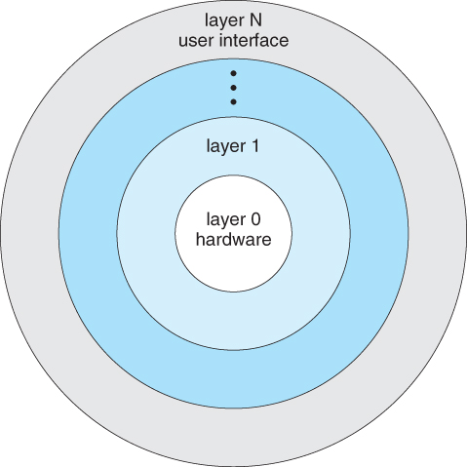  
**Figure 2.13 - A layered operating system**

#### 2.7.3 Microkernels

* The basic idea behind micro kernels is to remove all non-essential services from the kernel, and implement them as system applications instead, thereby making the kernel as small and efficient as possible.
* Most microkernels provide basic process and memory management, and message passing between other services, and not much more.
* Security and protection can be enhanced, as most services are performed in user mode, not kernel mode.
* System expansion can also be easier, because it only involves adding more system applications, not rebuilding a new kernel.
* Mach was the first and most widely known microkernel, and now forms a major component of Mac OSX.
* Windows NT was originally microkernel, but suffered from performance problems relative to Windows 95. NT 4.0 improved performance by moving more services into the kernel, and now XP is back to being more monolithic.
* Another microkernel example is QNX, a real-time OS for embedded systems.

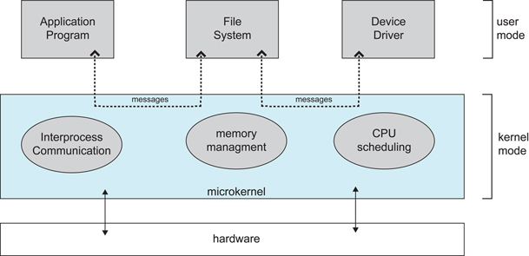  
**Figure 2.14 - Architecture of a typical microkernel**

#### 2.7.4 Modules

* Modern OS development is object-oriented, with a relatively small core kernel and a set of ***modules*** which can be linked in dynamically. See for example the Solaris structure, as shown in Figure 2.13 below.
* Modules are similar to layers in that each subsystem has clearly defined tasks and interfaces, but any module is free to contact any other module, eliminating the problems of going through multiple intermediary layers, as well as the chicken-and-egg problems.
* The kernel is relatively small in this architecture, similar to microkernels, but the kernel does not have to implement message passing since modules are free to contact each other directly.

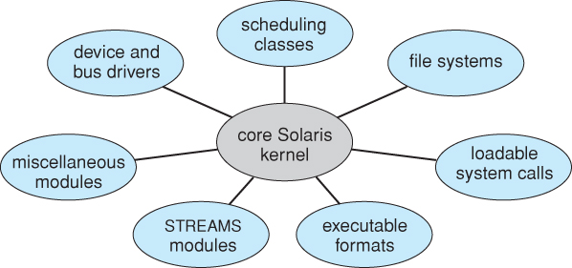  
**Figure 2.15 - Solaris loadable modules**

#### 2.7.5 Hybrid Systems

* Most OSes today do not strictly adhere to one architecture, but are hybrids of several.

#### 2.7.5.1 Mac OS X

* The Max OSX architecture relies on the Mach microkernel for basic system management services, and the BSD kernel for additional services. Application services and dynamically loadable modules ( kernel extensions ) provide the rest of the OS functionality:

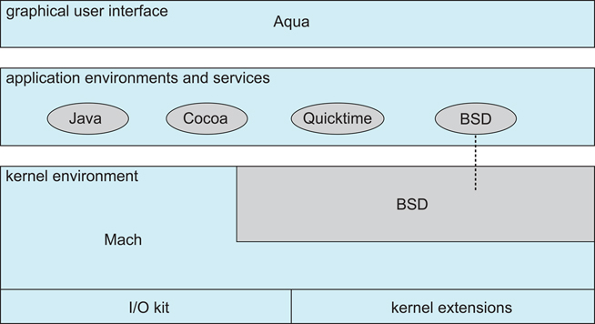  
**Figure 2.16 - The Mac OS X structure**

#### 2.7.5.2 iOS

* The **iOS** operating system was developed by Apple for iPhones and iPads. It runs with less memory and computing power needs than Max OS X, and supports touchscreen interface and graphics for small screens:

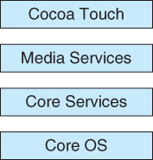  
**Figure 2.17 - Architecture of Apple's iOS.**

#### 2.7.5.3 Android

* The Android OS was developed for Android smartphones and tablets by the Open Handset Alliance, primarily Google.
* Android is an open-source OS, as opposed to iOS, which has lead to its popularity.
* Android includes versions of Linux and a Java virtual machine both optimized for small platforms.
* Android apps are developed using a special Java-for-Android development environment.

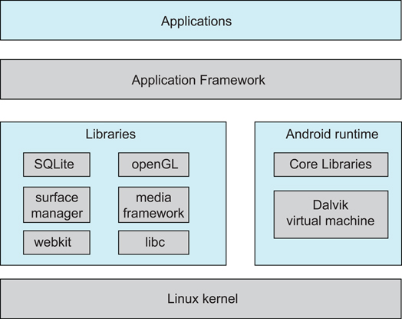  
**Figure 2.18 - Architecture of Google's Android**

### 2.8 Operating-System Debugging

|  |
| --- |
| Kernighan's Law  "Debugging is twice as hard as writing the code in the first place. Therefore, if you write the code as cleverly as possible, you are, by definition, not smart enough to debug it." |

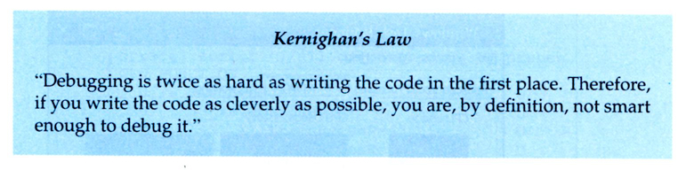

* Debugging here includes both error discovery and elimination and performance tuning.

#### 2.8.1 Failure Analysis

* Debuggers allow processes to be executed stepwise, and provide for the examination of variables and expressions as the execution progresses.
* Profilers can document program execution, to produce statistics on how much time was spent on different sections or even lines of code.
* If an ordinary process crashes, a memory dump of the state of that process's memory at the time of the crash can be saved to a disk file for later analysis.
  + The program must be specially compiled to include debugging information, which may slow down its performance.
* These approaches don't really work well for OS code, for several reasons:
  + The performance hit caused by adding the debugging ( tracing ) code would be unacceptable. ( Particularly if one tried to "single-step" the OS while people were trying to use it to get work done! )
  + Many parts of the OS run in kernel mode, and make direct access to the hardware.
  + If an error occurred during one of the kernel's file-access or direct disk-access routines, for example, then it would not be practical to try to write a crash dump into an ordinary file on the filesystem.
    - Instead the kernel crash dump might be saved to a special unallocated portion of the disk reserved for that purpose.

#### 2.8.2 Performance Tuning

* Performance tuning ( debottlenecking ) requires monitoring system performance.
* One approach is for the system to record important events into log files, which can then be analyzed by other tools. These traces can also be used to evaluate how a proposed new system would perform under the same workload.
* Another approach is to provide utilities that will report system status upon demand, such as the unix "top" command. ( w, uptime, ps, etc. )
* System utilities may provide monitoring support.

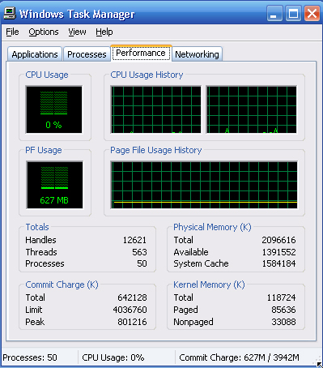  
**Figure 2.19 - The Windows task manager.**

#### 2.8.3 DTrace

* DTrace is a special facility for tracing a running OS, developed for Solaris 10.
* DTrace adds "probes" directly into the OS code, which can be queried by "probe consumers".
* Probes are removed when not in use, so the DTrace facility has zero impact on the system when not being used, and a proportional impact in use.
* Consider, for example, the trace of an ioctl system call as shown in Figure 2.22 below.

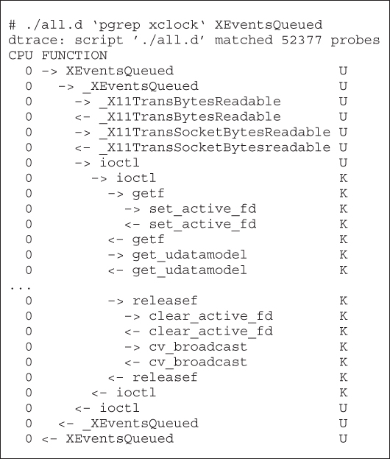  
**Figure 2.20 - Solaris 10 dtrace follows a system call within the kernel**

* Probe code is restricted to be "safe", ( e.g. no loops allowed ), and to use a minimum of system resources.
* When a probe fires, ***enabling control blocks, ECBs,***are performed, each having the structure of an if-then block
* When a consumer terminates, the ECBs associated with that consumer are removed. When no more ECBs remain interested in a particular probe, then that probe is also removed.
* For example, the following D code monitors the CPU time of each process running with user ID of 101. The output is shown in Figure 2.23 below.

sched:::on-cpu  
uid == 101  
{  
     self->ts = timestamp;

}

sched:::off-cpu  
self->ts   
{  
     @time[execname] = sum( timestamp - self->ts );  
     self->ts = 0;

}

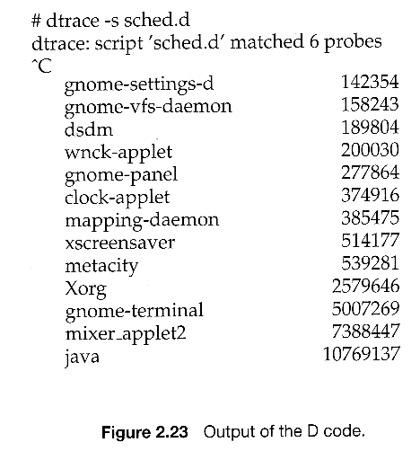  
**Figure 2.21**

* Use of DTrace is restricted, due to the direct access to ( and ability to change ) critical kernel data structures.
* Because DTrace is open-source, it is being adopted by several UNIX distributions. Others are busy producing similar utilities.

### 2.9 Operating-System Generation

* OSes may be designed and built for a specific HW configuration at a specific site, but more commonly they are designed with a number of variable parameters and components, which are then configured for a particular operating environment.
* Systems sometimes need to be re-configured after the initial installation, to add additional resources, capabilities, or to tune performance, logging, or security.
* Information that is needed to configure an OS include:
  + What CPU(s) are installed on the system, and what optional characteristics does each have?
  + How much RAM is installed? ( This may be determined automatically, either at install or boot time. )
  + What devices are present? The OS needs to determine which device drivers to include, as well as some device-specific characteristics and parameters.
  + What OS options are desired, and what values to set for particular OS parameters. The latter may include the size of the open file table, the number of buffers to use, process scheduling ( priority ) parameters, disk scheduling algorithms, number of slots in the process table, etc.
* At one extreme the OS source code can be edited, re-compiled, and linked into a new kernel.
* More commonly configuration tables determine which modules to link into the new kernel, and what values to set for some key important parameters. This approach may require the configuration of complicated makefiles, which can be done either automatically or through interactive configuration programs; Then make is used to actually generate the new kernel specified by the new parameters.
* At the other extreme a system configuration may be entirely defined by table data, in which case the "rebuilding" of the system merely requires editing data tables.
* Once a system has been regenerated, it is usually required to reboot the system to activate the new kernel. Because there are possibilities for errors, most systems provide some mechanism for booting to older or alternate kernels.

### 2.10 System Boot

The general approach when most computers boot up goes something like this:

* When the system powers up, an interrupt is generated which loads a memory address into the program counter, and the system begins executing instructions found at that address. This address points to the "bootstrap" program located in ROM chips ( or EPROM chips ) on the motherboard.
* The ROM bootstrap program first runs hardware checks, determining what physical resources are present and doing power-on self tests ( POST ) of all HW for which this is applicable. Some devices, such as controller cards may have their own on-board diagnostics, which are called by the ROM bootstrap program.
* The user generally has the option of pressing a special key during the POST process, which will launch the ROM BIOS configuration utility if pressed. This utility allows the user to specify and configure certain hardware parameters as where to look for an OS and whether or not to restrict access to the utility with a password.
  + Some hardware may also provide access to additional configuration setup programs, such as for a RAID disk controller or some special graphics or networking cards.
* Assuming the utility has not been invoked, the bootstrap program then looks for a non-volatile storage device containing an OS. Depending on configuration, it may look for a floppy drive, CD ROM drive, or primary or secondary hard drives, in the order specified by the HW configuration utility.
* Assuming it goes to a hard drive, it will find the first sector on the hard drive and load up the fdisk table, which contains information about how the physical hard drive is divided up into logical partitions, where each partition starts and ends, and which partition is the "active" partition used for booting the system.
* There is also a very small amount of system code in the portion of the first disk block not occupied by the fdisk table. This bootstrap code is the first step that is not built into the hardware, i.e. the first part which might be in any way OS-specific. Generally this code knows just enough to access the hard drive, and to load and execute a ( slightly ) larger boot program.
* For a single-boot system, the boot program loaded off of the hard disk will then proceed to locate the kernel on the hard drive, load the kernel into memory, and then transfer control over to the kernel. There may be some opportunity to specify a particular kernel to be loaded at this stage, which may be useful if a new kernel has just been generated and doesn't work, or if the system has multiple kernels available with different configurations for different purposes. ( Some systems may boot different configurations automatically, depending on what hardware has been found in earlier steps. )
* For dual-boot or multiple-boot systems, the boot program will give the user an opportunity to specify a particular OS to load, with a default choice if the user does not pick a particular OS within a given time frame. The boot program then finds the boot loader for the chosen single-boot OS, and runs that program as described in the previous bullet point.
* Once the kernel is running, it may give the user the opportunity to enter into single-user mode, also known as maintenance mode. This mode launches very few if any system services, and does not enable any logins other than the primary log in on the console. This mode is used primarily for system maintenance and diagnostics.
* When the system enters full multi-user multi-tasking mode, it examines configuration files to determine which system services are to be started, and launches each of them in turn. It then spawns login programs ( gettys ) on each of the login devices which have been configured to enable user logins.
  + ( The getty program initializes terminal I/O, issues the login prompt, accepts login names and passwords, and authenticates the user. If the user's password is authenticated, then the getty looks in system files to determine what shell is assigned to the user, and then "execs" ( becomes ) the user's shell. The shell program will look in system and user configuration files to initialize itself, and then issue prompts for user commands. Whenever the shell dies, either through logout or other means, then the system will issue a new getty for that terminal device. )

### 2.11 Summary

### Old 2.8 Virtual Machines ( Moved elsewhere in the 9th edition. )

* The concept of a virtual machine is to provide an interface that looks like independent hardware, to multiple different OSes running simultaneously on the same physical hardware. Each OS believes that it has access to and control over its own CPU, RAM, I/O devices, hard drives, etc.
* One obvious use for this system is for the development and testing of software that must run on multiple platforms and/or OSes.
* One obvious difficulty involves the sharing of hard drives, which are generally partitioned into separate smaller virtual disks for each operating OS.

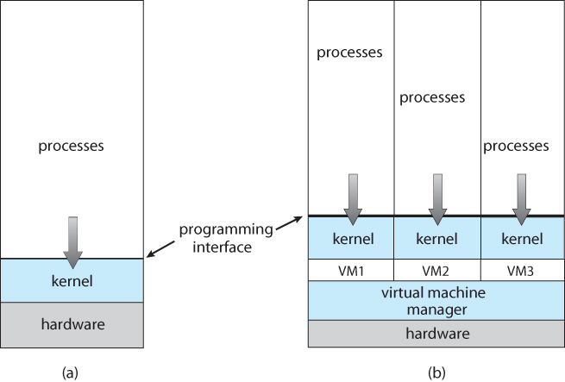  
**Figure 16.1 - System models. (a) Nonvirtual machine. (b)Virtual machine.**

#### 2.8.1 History

* Virtual machines first appeared as the VM Operating System for IBM mainframes in 1972.

#### 2.8.2 Benefits

* Each OS runs independently of all the others, offering protection and security benefits.
* ( Sharing of physical resources is not commonly implemented, but may be done as if the virtual machines were networked together. )
* Virtual machines are a very useful tool for OS development, as they allow a user full access to and control over a virtual machine, without affecting other users operating the real machine.
* As mentioned before, this approach can also be useful for product development and testing of SW that must run on multiple OSes / HW platforms.

#### 2.8.3 Simulation

* An alternative to creating an entire virtual machine is to simply run an ***emulator***, which allows a program written for one OS to run on a different OS.
* For example, a UNIX machine may run a DOS emulator in order to run DOS programs, or vice-versa.
* Emulators tend to run considerably slower than the native OS, and are also generally less than perfect.

#### 2.8.4 Para-virtualization

* Para-virtualization is another variation on the theme, in which an environment is provided for the guest program that is ***similar to***its native OS, without trying to completely mimic it.
* Guest programs must also be modified to run on the para-virtual OS.
* Solaris 10 uses a ***zone*** system, in which the low-level hardware is not virtualized, but the OS and its devices ( device drivers ) are.
  + Within a zone, processes have the view of an isolated system, in which only the processes and resources within that zone are seen to exist.
  + Figure 2.18 shows a Solaris system with the normal "global" operating space as well as two additional zones running on a small virtualization layer.

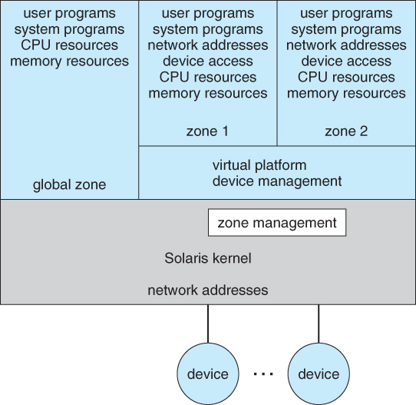  
**Figure 16.7 - Solaris 10 with two zones.**

#### 2.8.5 Implementation

* Implementation may be challenging, partially due to the consequences of user versus kernel mode.
  + Each of the simultaneously running kernels needs to operate in kernel mode at some point, but the virtual machine actually runs in user mode.
  + So the kernel mode has to be simulated for each of the loaded OSes, and kernel system calls passed through the virtual machine into a true kernel mode for eventual HW access.
* The virtual machines may run slower, due to the increased levels of code between applications and the HW, or they may run faster, due to the benefits of caching. ( And virtual devices may also be faster than real devices, such as RAM disks which are faster than physical disks. )

#### 2.8.6 Examples

##### 2.8.6.1 VMware

* Abstracts the 80x86 hardware platform, allowing simultaneous operation of multiple Windows and Linux OSes, as shown by example in Figure 2.19:

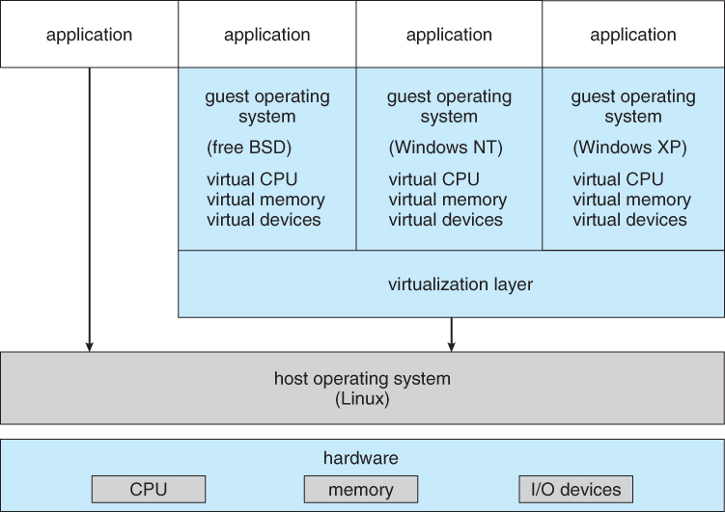  
**Figure 16.9 - VMWare Workstation architecture**

##### 2.8.6.2 The Java Virtual Machine

* Java was designed from the beginning to be platform independent, by running Java only on a Java Virtual Machine, JVM, of which different implementations have been developed for numerous different underlying HW platforms.
* Java source code is compiled into Java byte code in .class files. Java byte code is binary instructions that will run on the JVM.
* The JVM implements memory management and garbage collection.
* Java byte code may be interpreted as it runs, or compiled to native system binary code using just-in-time ( JIT ) compilation. Under this scheme, the first time that a piece of Java byte code is encountered, it is compiled to the appropriate native machine binary code by the Java interpreter. This native binary code is then cached, so that the next time that piece of code is encountered it can be used directly.
* Some hardware chips have been developed to run Java byte code directly, which is an interesting application of a real machine being developed to emulate the services of a virtual one!

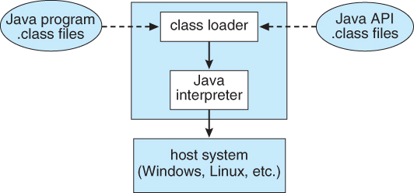  
**Figure 16.10 - The Java virtual machine**

* The .NET framework also relies on the concept of compiling code for an intermediary virtual machine, ( Common Language Runtime, CLR ), and then using JIT compilation and caching to run the programs on specific hardware, as shown in Figure 2.21:

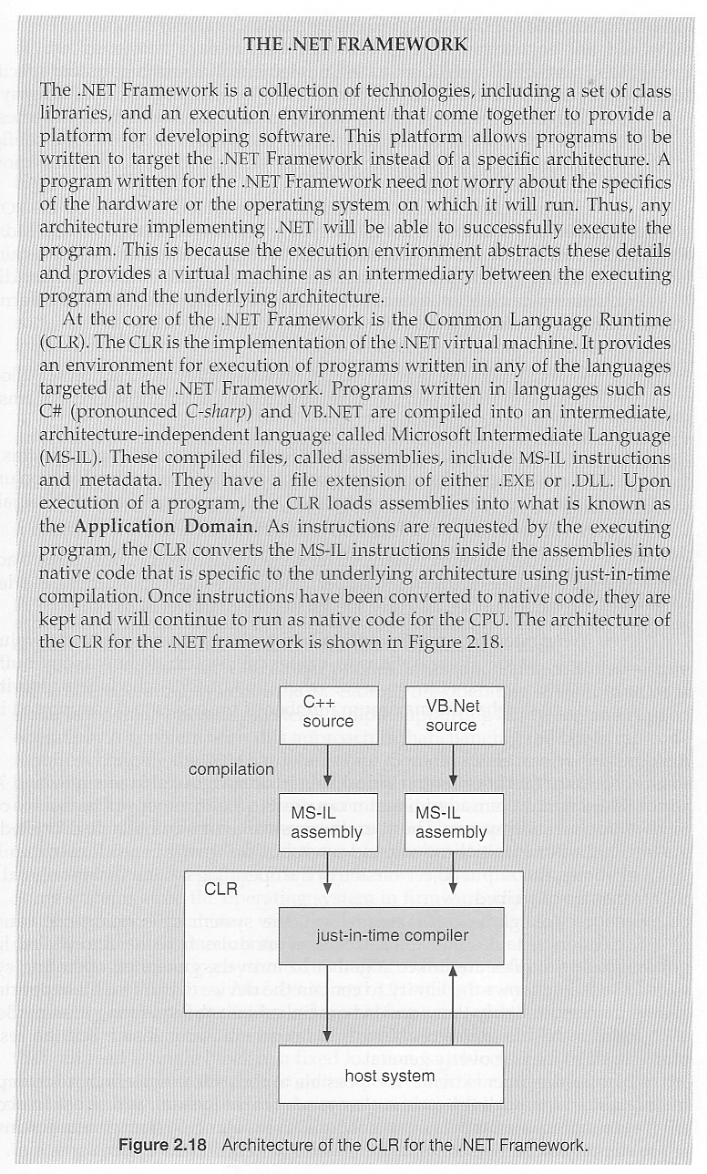  
**Figure 2.21**

Chapter 3\*\*\*\*\*\*\*\*\*\*\*\*\*\*\*\*\*\*\*\*\*\*\*\*\*\*\*\*\*\*\*\*\*\*\*\*\*\*\*\*\*\*\*\*\*\*\*\*\*\*\*\*\*\*\*\*\*\*\*\*

# Processes

### References:

1. Abraham Silberschatz, Greg Gagne, and Peter Baer Galvin, "Operating System Concepts, Ninth Edition ", Chapter 3

### 3.1 Process Concept

* A process is an instance of a program in execution.
* Batch systems work in terms of "jobs". Many modern process concepts are still expressed in terms of jobs, ( e.g. job scheduling ), and the two terms are often used interchangeably.

#### 3.1.1 The Process

* Process memory is divided into four sections as shown in Figure 3.1 below:
  + The text section comprises the compiled program code, read in from non-volatile storage when the program is launched.
  + The data section stores global and static variables, allocated and initialized prior to executing main.
  + The heap is used for dynamic memory allocation, and is managed via calls to new, delete, malloc, free, etc.
  + The stack is used for local variables. Space on the stack is reserved for local variables when they are declared ( at function entrance or elsewhere, depending on the language ), and the space is freed up when the variables go out of scope. Note that the stack is also used for function return values, and the exact mechanisms of stack management may be language specific.
  + Note that the stack and the heap start at opposite ends of the process's free space and grow towards each other. If they should ever meet, then either a stack overflow error will occur, or else a call to new or malloc will fail due to insufficient memory available.
* When processes are swapped out of memory and later restored, additional information must also be stored and restored. Key among them are the program counter and the value of all program registers.

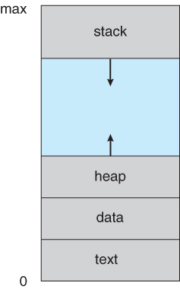  
**Figure 3.1 - A process in memory**

#### 3.1.2 Process State

* Processes may be in one of 5 states, as shown in Figure 3.2 below.
  + **New** - The process is in the stage of being created.
  + **Ready**- The process has all the resources available that it needs to run, but the CPU is not currently working on this process's instructions.
  + **Running**- The CPU is working on this process's instructions.
  + **Waiting** - The process cannot run at the moment, because it is waiting for some resource to become available or for some event to occur. For example the process may be waiting for keyboard input, disk access request, inter-process messages, a timer to go off, or a child process to finish.
  + **Terminated -**The process has completed.
* The load average reported by the "w" command indicate the average number of processes in the "Ready" state over the last 1, 5, and 15 minutes, i.e. processes who have everything they need to run but cannot because the CPU is busy doing something else.
* Some systems may have other states besides the ones listed here.

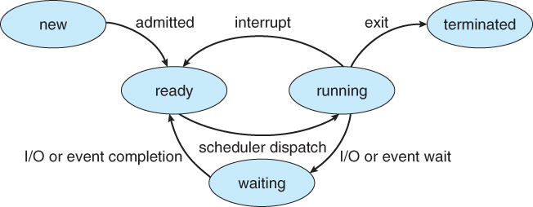  
**Figure 3.2 - Diagram of process state**

#### 3.1.3 Process Control Block

For each process there is a Process Control Block, PCB, which stores the following ( types of ) process-specific information, as illustrated in Figure 3.1. ( Specific details may vary from system to system. )

* **Process State** - Running, waiting, etc., as discussed above.
* **Process ID**, and parent process ID.
* **CPU registers and Program Counter** - These need to be saved and restored when swapping processes in and out of the CPU.
* **CPU-Scheduling information** - Such as priority information and pointers to scheduling queues.
* **Memory-Management information** - E.g. page tables or segment tables.
* **Accounting information** - user and kernel CPU time consumed, account numbers, limits, etc.
* **I/O Status information** - Devices allocated, open file tables, etc.

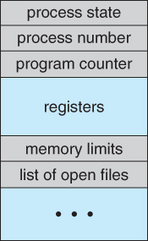  
**Figure 3.3 - Process control block ( PCB )**

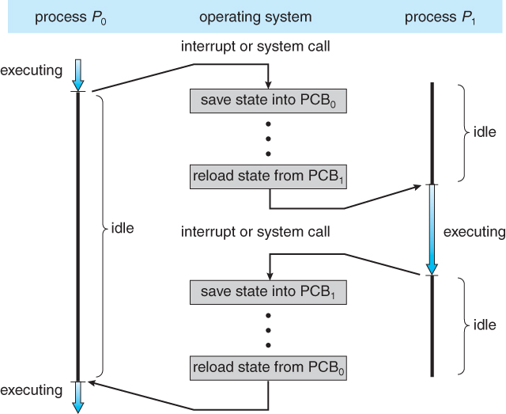  
**Figure 3.4 - Diagram showing CPU switch from process to process**

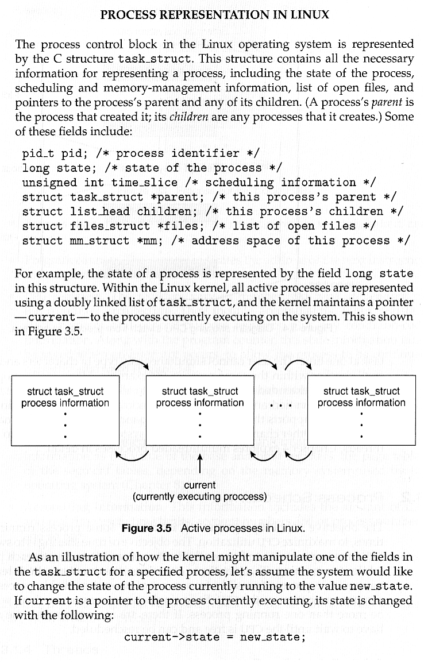  
**Unnumbered side bar**

### Digging Deeper: [The Linux task\_struct definition in sched.h](http://lxr.linux.no/#linux+v3.11/include/linux/sched.h#L1027) ( See also the top of that file. )

#### 3.1.4 Threads

* Modern systems allow a single process to have multiple threads of execution, which execute concurrently. Threads are covered extensively in the next chapter.

### 3.2 Process Scheduling

* The two main objectives of the process scheduling system are to keep the CPU busy at all times and to deliver "acceptable" response times for all programs, particularly for interactive ones.
* The process scheduler must meet these objectives by implementing suitable policies for swapping processes in and out of the CPU.
* ( Note that these objectives can be conflicting. In particular, every time the system steps in to swap processes it takes up time on the CPU to do so, which is thereby "lost" from doing any useful productive work. )

#### 3.2.1 Scheduling Queues

* All processes are stored in the **job queue.**
* Processes in the Ready state are placed in the **ready queue.**
* Processes waiting for a device to become available or to deliver data are placed in **device queues**. There is generally a separate device queue for each device.
* Other queues may also be created and used as needed.

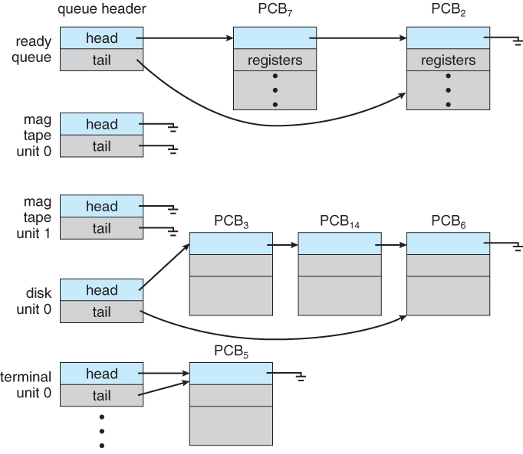   
**Figure 3.5 - The ready queue and various I/O device queues**

#### 3.2.2 Schedulers

* A **long-term scheduler** is typical of a batch system or a very heavily loaded system. It runs infrequently, ( such as when one process ends selecting one more to be loaded in from disk in its place ), and can afford to take the time to implement intelligent and advanced scheduling algorithms.
* The **short-term scheduler**, or CPU Scheduler, runs very frequently, on the order of 100 milliseconds, and must very quickly swap one process out of the CPU and swap in another one.
* Some systems also employ a**medium-term scheduler**. When system loads get high, this scheduler will swap one or more processes out of the ready queue system for a few seconds, in order to allow smaller faster jobs to finish up quickly and clear the system. See the differences in Figures 3.7 and 3.8 below.
* An efficient scheduling system will select a good **process mix** of **CPU-bound** processes and **I/O bound** processes.

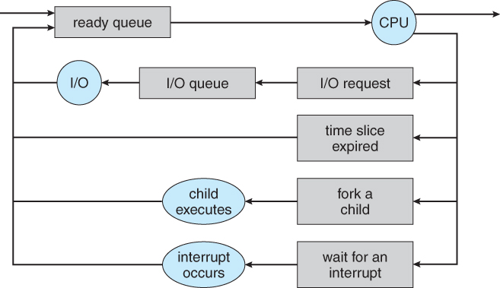  
**Figure 3.6 - Queueing-diagram representation of process scheduling**

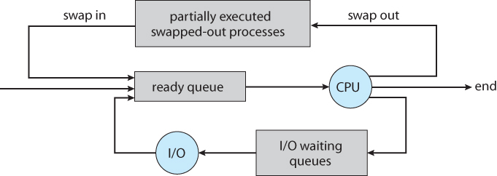   
**Figure 3.7 - Addition of a medium-term scheduling to the queueing diagram**

#### 3.2.3 Context Switch

* Whenever an interrupt arrives, the CPU must do a **state-save** of the currently running process, then switch into kernel mode to handle the interrupt, and then do a **state-restore** of the interrupted process.
* Similarly, a **context switch** occurs when the time slice for one process has expired and a new process is to be loaded from the ready queue. This will be instigated by a timer interrupt, which will then cause the current process's state to be saved and the new process's state to be restored.
* Saving and restoring states involves saving and restoring all of the registers and program counter(s), as well as the process control blocks described above.
* Context switching happens VERY VERY frequently, and the overhead of doing the switching is just lost CPU time, so context switches ( state saves & restores ) need to be as fast as possible. Some hardware has special provisions for speeding this up, such as a single machine instruction for saving or restoring all registers at once.
* Some Sun hardware actually has multiple sets of registers, so the context switching can be speeded up by merely switching which set of registers are currently in use. Obviously there is a limit as to how many processes can be switched between in this manner, making it attractive to implement the medium-term scheduler to swap some processes out as shown in Figure 3.8 above.

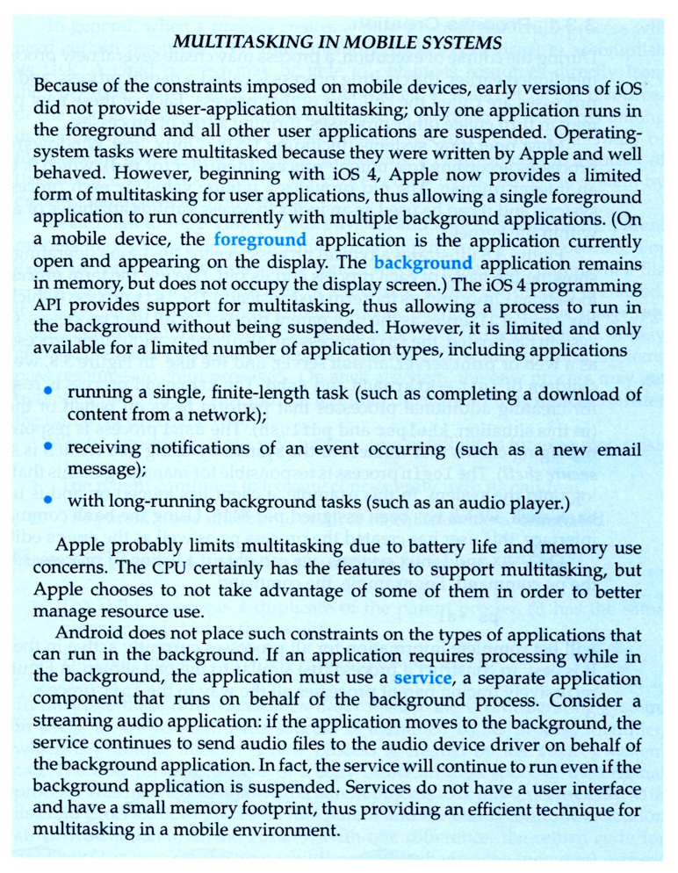

### 3.3 Operations on Processes

#### 3.3.1 Process Creation

* Processes may create other processes through appropriate system calls, such as **fork** or **spawn**. The process which does the creating is termed the **parent** of the other process, which is termed its **child**.
* Each process is given an integer identifier, termed its**process identifier**, or PID. The parent PID ( PPID ) is also stored for each process.
* On typical UNIX systems the process scheduler is termed **sched**, and is given PID 0. The first thing it does at system startup time is to launch **init**, which gives that process PID 1. Init then launches all system daemons and user logins, and becomes the ultimate parent of all other processes. Figure 3.9 shows a typical process tree for a Linux system, and other systems will have similar though not identical trees:

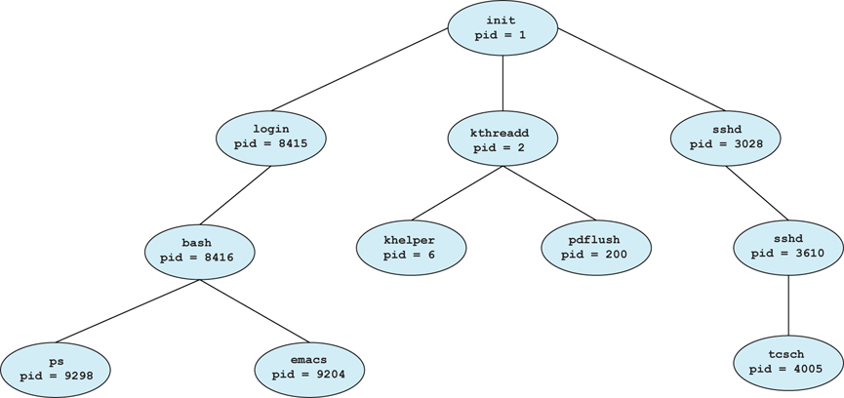  
**Figure 3.8 - A tree of processes on a typical Linux system**

* Depending on system implementation, a child process may receive some amount of shared resources with its parent. Child processes may or may not be limited to a subset of the resources originally allocated to the parent, preventing runaway children from consuming all of a certain system resource.
* There are two options for the parent process after creating the child:
  1. Wait for the child process to terminate before proceeding. The parent makes a wait( ) system call, for either a specific child or for any child, which causes the parent process to block until the wait( ) returns. UNIX shells normally wait for their children to complete before issuing a new prompt.
  2. Run concurrently with the child, continuing to process without waiting. This is the operation seen when a UNIX shell runs a process as a background task. It is also possible for the parent to run for a while, and then wait for the child later, which might occur in a sort of a parallel processing operation. ( E.g. the parent may fork off a number of children without waiting for any of them, then do a little work of its own, and then wait for the children. )
* Two possibilities for the address space of the child relative to the parent:
  1. The child may be an exact duplicate of the parent, sharing the same program and data segments in memory. Each will have their own PCB, including program counter, registers, and PID. This is the behavior of the **fork** system call in UNIX.
  2. The child process may have a new program loaded into its address space, with all new code and data segments. This is the behavior of the **spawn** system calls in Windows. UNIX systems implement this as a second step, using the **exec** system call.
* Figures 3.10 and 3.11 below shows the fork and exec process on a UNIX system. Note that the **fork** system call returns the PID of the processes child to each process - It returns a zero to the child process and a non-zero child PID to the parent, so the return value indicates which process is which. Process IDs can be looked up any time for the current process or its direct parent using the getpid( ) and getppid( ) system calls respectively.

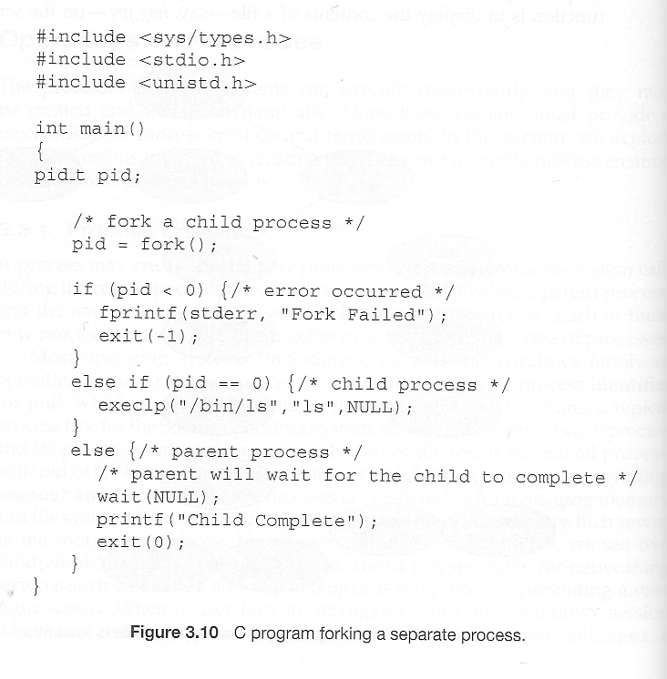  
**Figure 3.9 Creating a separate process using the UNIX fork( ) system call.**

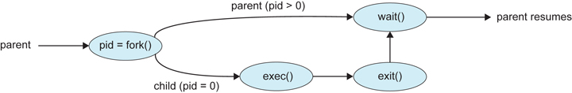  
**Figure 3.10 - Process creation using the fork( ) system call**

* Related man pages:
  1. [fork( 2 )](http://linuxmanpages.com/man2/fork.2.php)
  2. [exec( 3 )](http://linuxmanpages.com/man3/exec.3.php)
  3. [wait( 2 )](http://linuxmanpages.com/man2/wait.2.php)

* Figure 3.12 shows the more complicated process for Windows, which must provide all of the parameter information for the new process as part of the forking process.

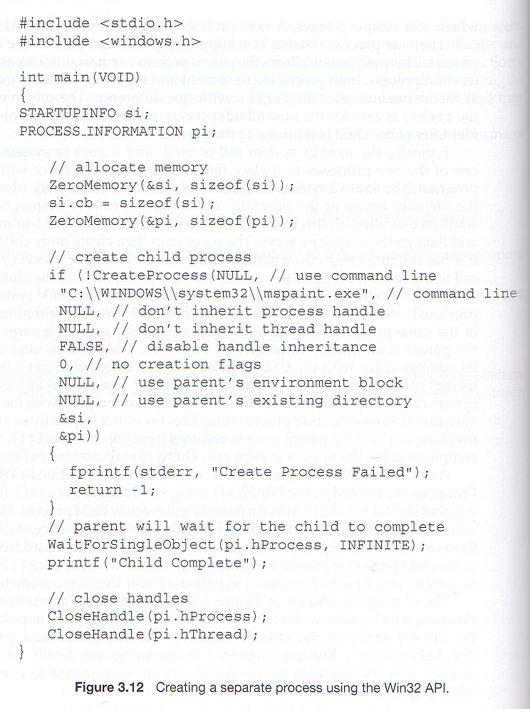   
**Figure 3.11**

#### 3.3.2 Process Termination

* Processes may request their own termination by making the **exit( )**system call, typically returning an int. This int is passed along to the parent if it is doing a **wait( )**, and is typically zero on successful completion and some non-zero code in the event of problems.
  + child code:
  + int exitCode;

exit( exitCode ); // return exitCode; has the same effect when executed from main( )

* + parent code:
  + pid\_t pid;
  + int status
  + pid = wait( &status );
  + // pid indicates which child exited. exitCode in low-order bits of status

// macros can test the high-order bits of status for why it stopped

* Processes may also be terminated by the system for a variety of reasons, including:
  + The inability of the system to deliver necessary system resources.
  + In response to a KILL command, or other un handled process interrupt.
  + A parent may kill its children if the task assigned to them is no longer needed.
  + If the parent exits, the system may or may not allow the child to continue without a parent. ( On UNIX systems, orphaned processes are generally inherited by init, which then proceeds to kill them. The UNIX ***nohup*** command allows a child to continue executing after its parent has exited. )
* When a process terminates, all of its system resources are freed up, open files flushed and closed, etc. The process termination status and execution times are returned to the parent if the parent is waiting for the child to terminate, or eventually returned to init if the process becomes an orphan. ( Processes which are trying to terminate but which cannot because their parent is not waiting for them are termed **zombies**. These are eventually inherited by init as orphans and killed off. Note that modern UNIX shells do not produce as many orphans and zombies as older systems used to. )

### 3.4 Interprocess Communication

* **Independent Processes** operating concurrently on a systems are those that can neither affect other processes or be affected by other processes.
* **Cooperating Processes** are those that can affect or be affected by other processes. There are several reasons why cooperating processes are allowed:
  + Information Sharing - There may be several processes which need access to the same file for example. ( e.g. pipelines. )
  + Computation speedup - Often a solution to a problem can be solved faster if the problem can be broken down into sub-tasks to be solved simultaneously ( particularly when multiple processors are involved. )
  + Modularity - The most efficient architecture may be to break a system down into cooperating modules. ( E.g. databases with a client-server architecture. )
  + Convenience - Even a single user may be multi-tasking, such as editing, compiling, printing, and running the same code in different windows.

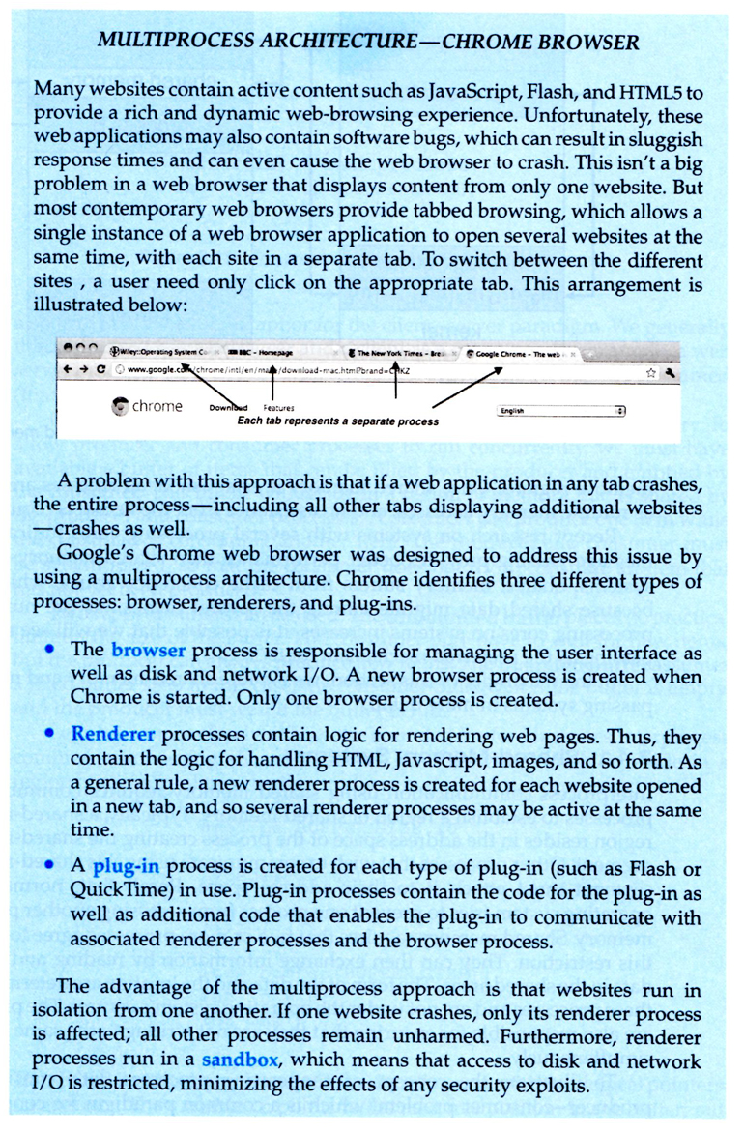

* Cooperating processes require some type of inter-process communication, which is most commonly one of two types: Shared Memory systems or Message Passing systems. Figure 3.13 illustrates the difference between the two systems:

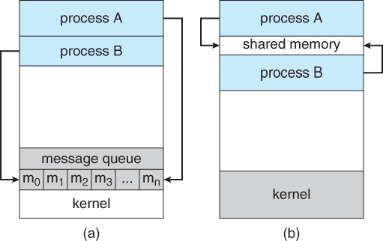  
**Figure 3.12 - Communications models: (a) Message passing. (b) Shared memory.**

* Shared Memory is faster once it is set up, because no system calls are required and access occurs at normal memory speeds. However it is more complicated to set up, and doesn't work as well across multiple computers. Shared memory is generally preferable when large amounts of information must be shared quickly on the same computer.
* Message Passing requires system calls for every message transfer, and is therefore slower, but it is simpler to set up and works well across multiple computers. Message passing is generally preferable when the amount and/or frequency of data transfers is small, or when multiple computers are involved.

#### 3.4.1 Shared-Memory Systems

* In general the memory to be shared in a shared-memory system is initially within the address space of a particular process, which needs to make system calls in order to make that memory publicly available to one or more other processes.
* Other processes which wish to use the shared memory must then make their own system calls to attach the shared memory area onto their address space.
* Generally a few messages must be passed back and forth between the cooperating processes first in order to set up and coordinate the shared memory access.

#### Producer-Consumer Example Using Shared Memory

* This is a classic example, in which one process is producing data and another process is consuming the data. ( In this example in the order in which it is produced, although that could vary. )
* The data is passed via an intermediary buffer, which may be either unbounded or bounded. With a bounded buffer the producer may have to wait until there is space available in the buffer, but with an unbounded buffer the producer will never need to wait. The consumer may need to wait in either case until there is data available.
* This example uses shared memory and a circular queue. Note in the code below that only the producer changes "in", and only the consumer changes "out", and that they can never be accessing the same array location at the same time.
* First the following data is set up in the shared memory area:

#define BUFFER\_SIZE 10

typedef struct {  
     . . .  
} item;

item buffer[ BUFFER\_SIZE ];  
int in = 0;  
int out = 0;

* Then the producer process. Note that the buffer is full when "in" is one less than "out" in a circular sense:

// Code from Figure 3.13

item nextProduced;

while( true ) {

/\* Produce an item and store it in nextProduced \*/  
nextProduced = makeNewItem( . . . );   
  
/\* Wait for space to become available \*/   
while( ( ( in + 1 ) % BUFFER\_SIZE ) == out )  
      ; /\* Do nothing \*/  
  
/\* And then store the item and repeat the loop. \*/   
buffer[ in ] = nextProduced;  
in = ( in + 1 ) % BUFFER\_SIZE;

}

* Then the consumer process. Note that the buffer is empty when "in" is equal to "out":

// Code from Figure 3.14

item nextConsumed;

while( true ) {

/\* Wait for an item to become available \*/   
while( in == out )  
      ; /\* Do nothing \*/

/\* Get the next available item \*/   
nextConsumed = buffer[ out ];  
out = ( out + 1 ) % BUFFER\_SIZE;  
  
/\* Consume the item in nextConsumed  
     ( Do something with it ) \*/

}

#### 3.4.2 Message-Passing Systems

* Message passing systems must support at a minimum system calls for "send message" and "receive message".
* A communication link must be established between the cooperating processes before messages can be sent.
* There are three key issues to be resolved in message passing systems as further explored in the next three subsections:
  + Direct or indirect communication ( naming )
  + Synchronous or asynchronous communication
  + Automatic or explicit buffering.

##### 3.4.2.1 Naming

* With **direct communication** the sender must know the name of the receiver to which it wishes to send a message.
  + There is a one-to-one link between every sender-receiver pair.
  + For **symmetric**communication, the receiver must also know the specific name of the sender from which it wishes to receive messages.   
    For **asymmetric** communications, this is not necessary.
* **Indirect communication** uses shared mailboxes, or ports.
  + Multiple processes can share the same mailbox or boxes.
  + Only one process can read any given message in a mailbox. Initially the process that creates the mailbox is the owner, and is the only one allowed to read mail in the mailbox, although this privilege may be transferred.
    - ( Of course the process that reads the message can immediately turn around and place an identical message back in the box for someone else to read, but that may put it at the back end of a queue of messages. )
  + The OS must provide system calls to create and delete mailboxes, and to send and receive messages to/from mailboxes.

##### 3.4.2.2 Synchronization

* Either the sending or receiving of messages ( or neither or both ) may be either **blocking** or **non-blocking**.

##### 3.4.2.3 Buffering

* Messages are passed via queues, which may have one of three capacity configurations:
  1. **Zero capacity** - Messages cannot be stored in the queue, so senders must block until receivers accept the messages.
  2. **Bounded capacity**- There is a certain pre-determined finite capacity in the queue. Senders must block if the queue is full, until space becomes available in the queue, but may be either blocking or non-blocking otherwise.
  3. **Unbounded capacity** - The queue has a theoretical infinite capacity, so senders are never forced to block.

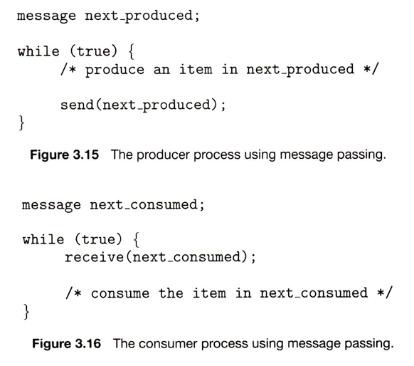

### 3.5 Examples of IPC Systems

#### 3.5.1 An Example: POSIX Shared Memory ( Eighth Edition Version )

1. The first step in using shared memory is for one of the processes involved to allocate some shared memory, using shmget:

int segment\_id = shmget( IPC\_PRIVATE, size, S\_IRUSR | S\_IWUSR );

* + The first parameter specifies the key ( identifier ) of the segment. IPC\_PRIVATE creates a new shared memory segment.
  + The second parameter indicates how big the shared memory segment is to be, in bytes.
  + The third parameter is a set of bitwise ORed flags. In this case the segment is being created for reading and writing.
  + The return value of shmget is an integer identifier

1. Any process which wishes to use the shared memory must attach the shared memory to their address space, using shmat:

char \* shared\_memory = ( char \* ) shmat( segment\_id, NULL, 0 );

* + The first parameter specifies the key ( identifier ) of the segment that the process wishes to attach to its address space
  + The second parameter indicates where the process wishes to have the segment attached. NULL indicates that the system should decide.
  + The third parameter is a flag for read-only operation. Zero indicates read-write; One indicates readonly.
  + The return value of shmat is a void \*, which the process can use ( type cast ) as appropriate. In this example it is being used as a character pointer.

1. Then processes may access the memory using the pointer returned by shmat, for example using sprintf:

sprintf( shared\_memory, "Writing to shared memory\n" );

1. When a process no longer needs a piece of shared memory, it can be detached using shmdt:

shmdt( shared\_memory );

1. And finally the process that originally allocated the shared memory can remove it from the system suing shmctl.

shmctl( segment\_id, IPC\_RMID );

1. Figure 3.16 from the eighth edition illustrates a complete program implementing shared memory on a POSIX system:

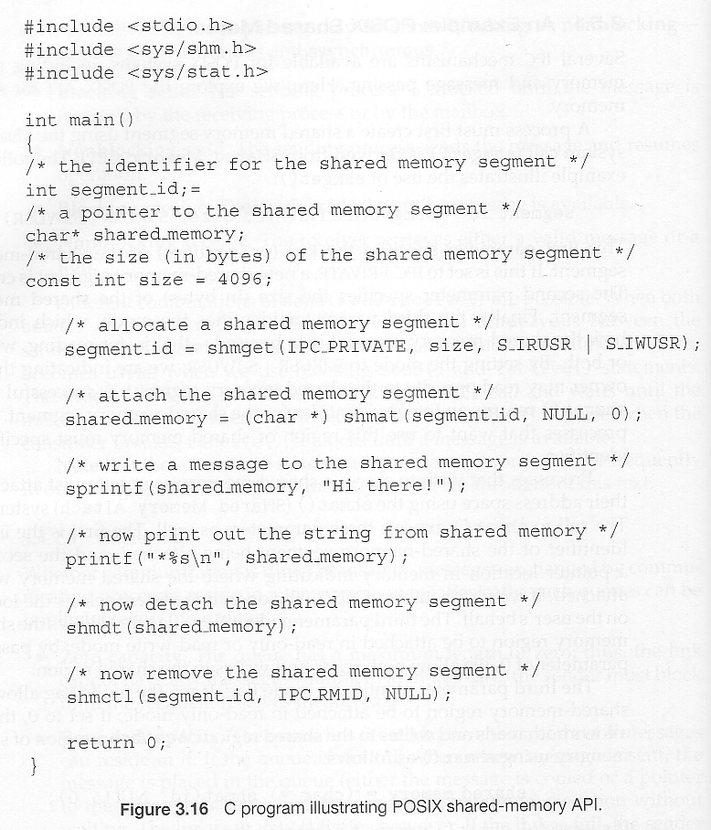

#### 3.5.1 An Example: POSIX Shared Memory ( Ninth Edition Version )

1. The ninth edition shows an alternate approach to shared memory in POSIX systems. Under this approach, the first step in using shared memory is to create a shared-memory object using shm\_open( ),in a fashion similar to other file opening commands. The name provided will be the name of the memory-mapped file.

shm\_fd = shm\_open( name,O\_CREAT | O\_RDRW,0666 );

1. The next step is to set the size of the file using ftruncate:

ftruncate( shm\_fd, 4096 );

1. Finally the mmap system call maps the file to a memory address in the user program space.and makes it shared. In this example the process that created the shared memory will be writing to it:

ptr = mmap( 0, SIZE,PROT\_WRITE, MAP\_SHARED, shm\_fd, 0 );

1. The "borrower" of the shared memory, ( not the one who created it ), calls shm\_open( ) and mmap( ) with different arguments, skips the ftruncate( ) step and unlinks ( removes ) the file name when it is done with it. Note that the "borrower" must use the same file name as the "lender" who created it. ( This information could have been passed using messages. )

shm\_unlink( name );

1. Note that writing to and reading from the shared memory is done with pointers and memory addresses ( sprintf ) in both the 9th and 8th edition versions, even though the 9th edition is illustrating memory mapping of a file.
2. Figures 3.17 and 3.18 from the ninth edition illustrate a complete program implementing shared memory on a POSIX system:

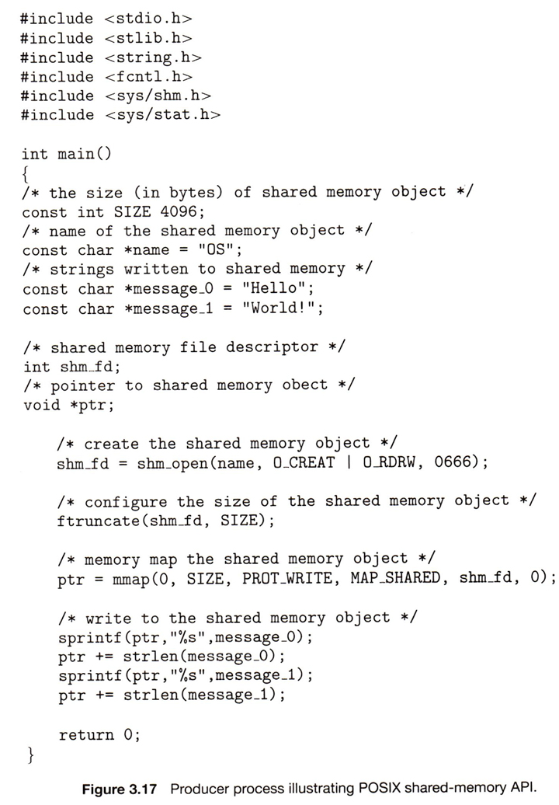

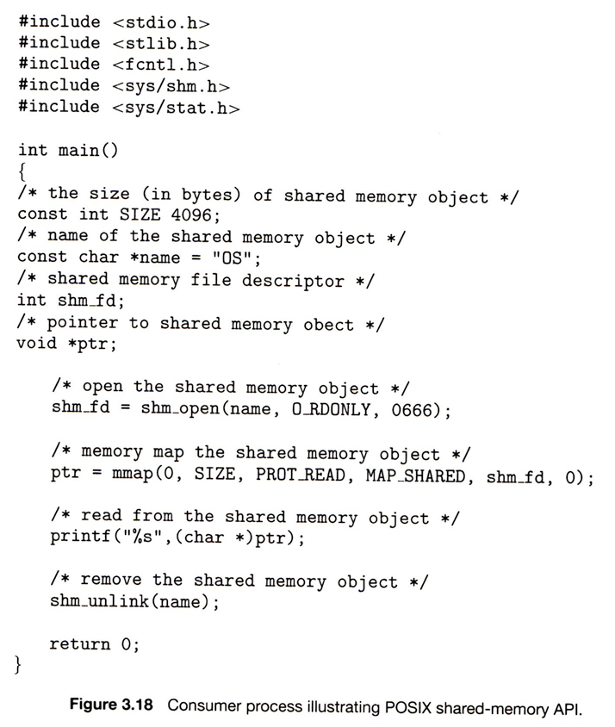

#### 3.5.2 An Example: Mach

* Recall that the Mach kernel is a micro kernel, which performs few services besides delivering messages between other tasks ( both system tasks and user tasks. )
* Most communication in Mach, including all system calls and inter-process communication is done via messages sent to mailboxes, also known as ports.
* Whenever a task ( process ) is created, it automatically gets two special mailboxes: a Kernel mailbox, and a Notify mailbox.
  + The kernel communicates with the task using the Kernel mailbox.
  + The kernel sends notification of events to the Notify mailbox.
* Three system calls are used for message transfer:
  + msg\_send( ) sends a message to a mailbox
  + msg\_receive( ) receives a message.
  + msg\_rpc( ) sends a message and waits for exactly one message in response from the sender.
* Port\_allocate( ) creates a new mailbox and the associated queue for holding messages ( size 8 by default. )
* Only one task at a time can own or receive messages from any given mailbox, but these are transferable.
* Messages from the same sender to the same receiver are guaranteed to arrive in FIFO order, but no guarantees are made regarding messages from multiple senders.
* Messages consist of a fixed-length header followed by variable length data.
  + The header contains the mailbox number ( address ) of the receiver and the sender.
  + The data section consists of a list of typed data items, each containing a type, size, and value.
* If the receiver's mailbox is full, the sender has four choices:
  + Wait indefinitely until there is room in the mailbox.
  + Wait at most N milliseconds.
  + Do not wait at all.
  + Temporarily cache the message with the kernel, for delivery when the mailbox becomes available.
    - Only one such message can be pending at any given time from any given sender to any given receiver.
    - Normally only used by certain system tasks, such as the print spooler, which must notify the "client" of the completion of their job, but cannot wait around for the mailbox to become available.
* Receive calls must specify the mailbox or mailbox set from which they wish to receive messages.
* Port\_status( ) reports the number of messages waiting in any given mailbox.
* If there are no messages available in a mailbox ( set ), the receiver can either block for N milliseconds, or not block at all.
* In order to avoid delays caused by copying messages ( multiple times ), Mach re-maps the memory space for the message from the sender's address space to the receiver's address space ( using virtual memory techniques to be covered later ), and does not actually move the message anywhere at all. ( When the sending and receiving task are both on the same computer. )

#### 3.5.3 An Example: Windows XP

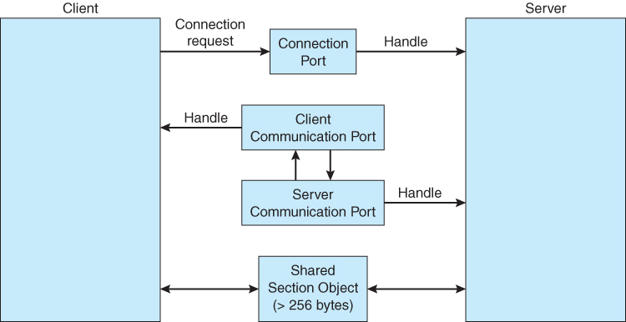  
**Figure 3.19 - Advanced local procedure calls in Windows**

### 3.6 Communication in Client-Server Systems

#### 3.6.1 Sockets

* A **socket** is an endpoint for communication.
* Two processes communicating over a network often use a pair of connected sockets as a communication channel. Software that is designed for client-server operation may also use sockets for communication between two processes running on the same computer - For example the UI for a database program may communicate with the back-end database manager using sockets. ( If the program were developed this way from the beginning, it makes it very easy to port it from a single-computer system to a networked application. )
* A socket is identified by an IP address concatenated with a port number, e.g. 200.100.50.5:80.

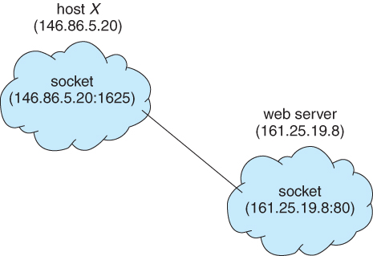  
**Figure 3.20 - Communication using sockets**

* Port numbers below 1024 are considered to be well-known, and are generally reserved for common Internet services. For example, telnet servers listen to port 23, ftp servers to port 21, and web servers to port 80.
* General purpose user sockets are assigned unused ports over 1024 by the operating system in response to system calls such as socket( ) or soctkepair( ).
* Communication channels via sockets may be of one of two major forms:
  + **Connection-oriented ( TCP, Transmission Control Protocol )** connections emulate a telephone connection. All packets sent down the connection are guaranteed to arrive in good condition at the other end, and to be delivered to the receiving process in the order in which they were sent. The TCP layer of the network protocol takes steps to verify all packets sent, re-send packets if necessary, and arrange the received packets in the proper order before delivering them to the receiving process. There is a certain amount of overhead involved in this procedure, and if one packet is missing or delayed, then any packets which follow will have to wait until the errant packet is delivered before they can continue their journey.
  + **Connectionless ( UDP, User Datagram Protocol )**emulate individual telegrams. There is no guarantee that any particular packet will get through undamaged ( or at all ), and no guarantee that the packets will get delivered in any particular order. There may even be duplicate packets delivered, depending on how the intermediary connections are configured. UDP transmissions are much faster than TCP, but applications must implement their own error checking and recovery procedures.
* Sockets are considered a low-level communications channel, and processes may often choose to use something at a higher level, such as those covered in the next two sections.
* Figure 3.19 and 3.20 illustrate a client-server system for determining the current date using sockets in Java.

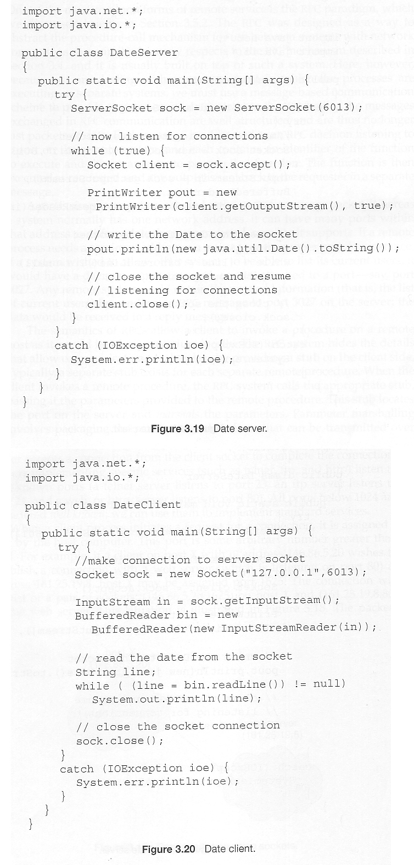  
**Figure 3.21 and Figure 3.22**

#### 3.6.2 Remote Procedure Calls, RPC

* The general concept of RPC is to make procedure calls similarly to calling on ordinary local procedures, except the procedure being called lies on a remote machine.
* Implementation involves ***stubs*** on either end of the connection.
  + The local process calls on the stub, much as it would call upon a local procedure.
  + The RPC system packages up ( marshals ) the parameters to the procedure call, and transmits them to the remote system.
  + On the remote side, the RPC daemon accepts the parameters and calls upon the appropriate remote procedure to perform the requested work.
  + Any results to be returned are then packaged up and sent back by the RPC system to the local system, which then unpackages them and returns the results to the local calling procedure.
* One potential difficulty is the formatting of data on local versus remote systems. ( e.g. big-endian versus little-endian. ) The resolution of this problem generally involves an agreed-upon intermediary format, such as XDR ( external data representation. )
* Another issue is identifying which procedure on the remote system a particular RPC is destined for.
  + Remote procedures are identified by ports, though not the same ports as the socket ports described earlier.
  + One solution is for the calling procedure to know the port number they wish to communicate with on the remote system. This is problematic, as the port number would be compiled into the code, and it makes it break down if the remote system changes their port numbers.
  + More commonly a matchmaker process is employed, which acts like a telephone directory service. The local process must first contact the matchmaker on the remote system ( at a well-known port number ), which looks up the desired port number and returns it. The local process can then use that information to contact the desired remote procedure. This operation involves an extra step, but is much more flexible. An example of the matchmaker process is illustrated in Figure 3.21 below.
* One common example of a system based on RPC calls is a networked file system. Messages are passed to read, write, delete, rename, or check status, as might be made for ordinary local disk access requests.

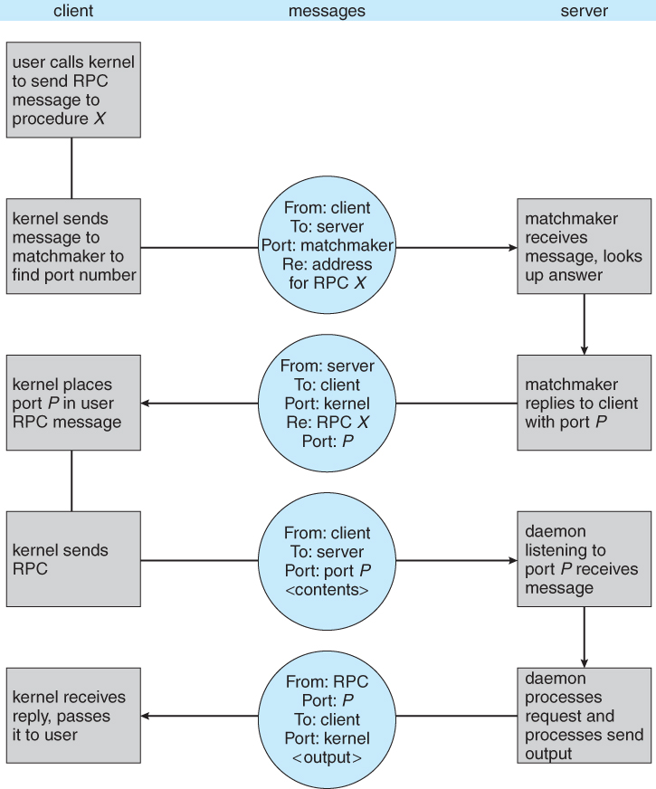   
**Figure 3.23 - Execution of a remote procedure call ( RPC ).**

#### 3.6.3 Pipes

* ***Pipes*** are one of the earliest and simplest channels of communications between ( UNIX ) processes.
* There are four key considerations in implementing pipes:
  1. Unidirectional or Bidirectional communication?
  2. Is bidirectional communication half-duplex or full-duplex?
  3. Must a relationship such as parent-child exist between the processes?
  4. Can pipes communicate over a network, or only on the same machine?
* The following sections examine these issues on UNIX and Windows

##### 3.6.3.1 Ordinary Pipes

* Ordinary pipes are uni-directional, with a reading end and a writing end. ( If bidirectional communications are needed, then a second pipe is required. )
* In UNIX ordinary pipes are created with the system call "int pipe( int fd [ ] )".
  + The return value is 0 on success, -1 if an error occurs.
  + The int array must be allocated before the call, and the values are filled in by the pipe system call:
    - fd[ 0 ] is filled in with a file descriptor for the reading end of the pipe
    - fd[ 1 ] is filled in with a file descriptor for the writing end of the pipe
  + UNIX pipes are accessible as files, using standard read( ) and write( ) system calls.
  + Ordinary pipes are only accessible within the process that created them.
    - Typically a parent creates the pipe before forking off a child.
    - When the child inherits open files from its parent, including the pipe file(s), a channel of communication is established.
    - Each process ( parent and child ) should first close the ends of the pipe that they are not using. For example, if the parent is writing to the pipe and the child is reading, then the parent should close the reading end of its pipe after the fork and the child should close the writing end.
* Figure 3.22 shows an ordinary pipe in UNIX, and Figure 3.23 shows code in which it is used.

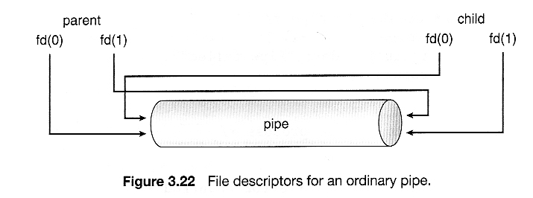  
**Figure 3.24**

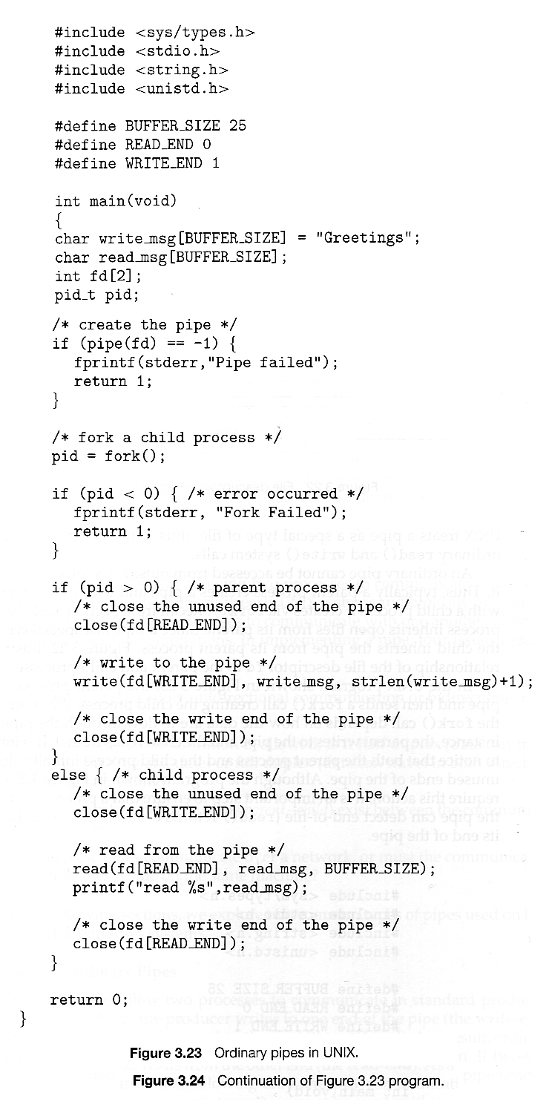  
**Figure 3.25 and Figure 3.26**

* Ordinary pipes in Windows are very similar
  + Windows terms them ***anonymous*** pipes
  + They are still limited to parent-child relationships.
  + They are read from and written to as files.
  + They are created with CreatePipe( ) function, which takes additional arguments.
  + In Windows it is necessary to specify what resources a child inherits, such as pipes.

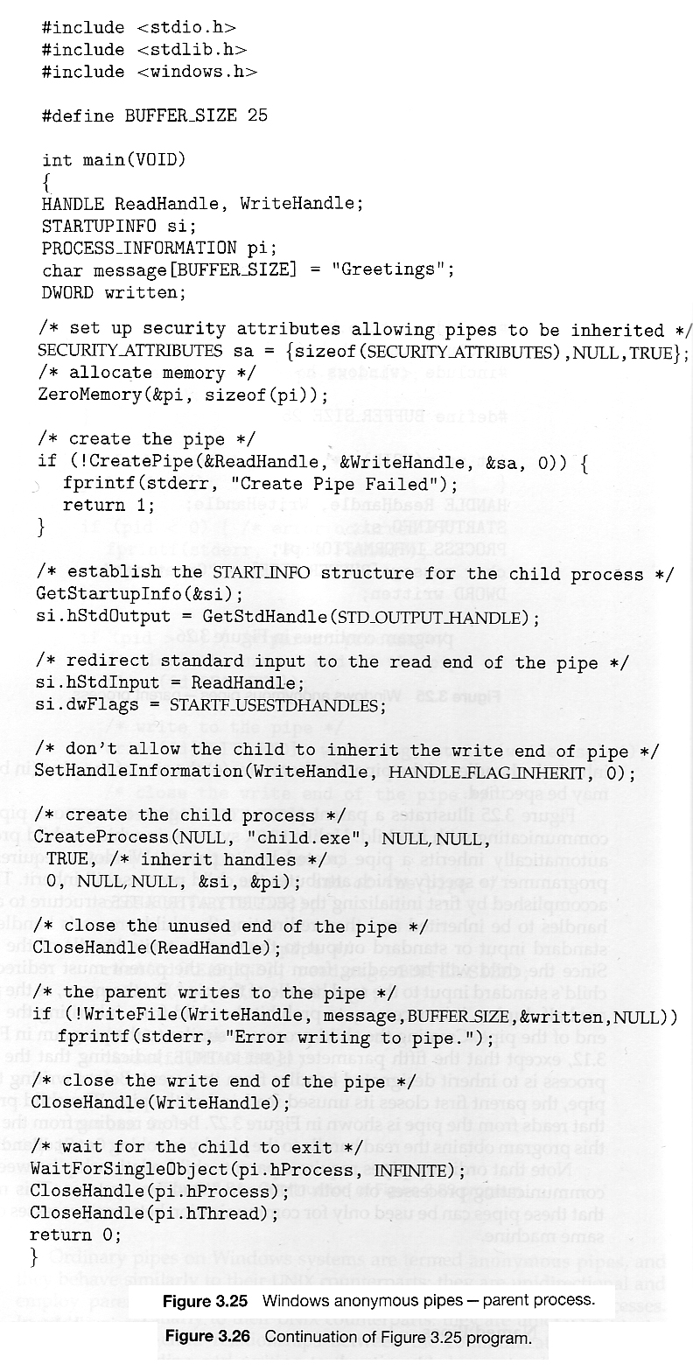  
**Figure 3.27 and Figure 3.28**

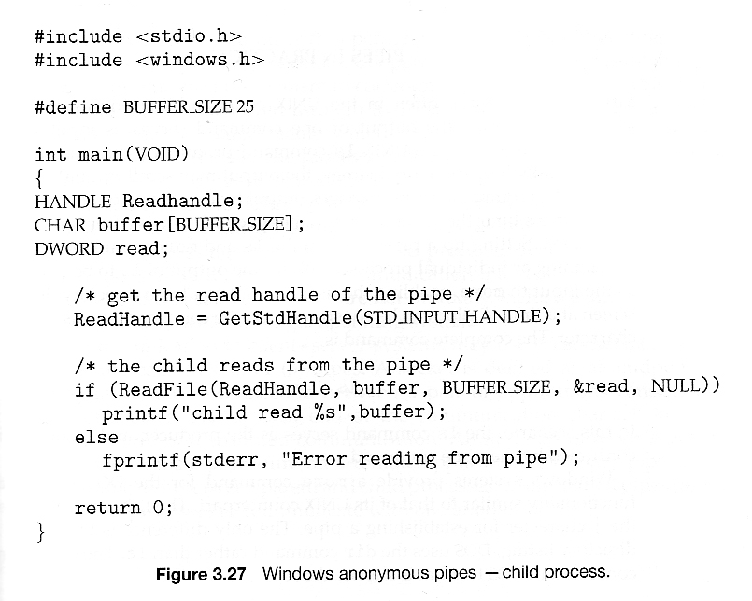  
**Figure 3.29**

##### 3.6.3.2 Named Pipes

* Named pipes support bidirectional communication, communication between non parent-child related processes, and persistence after the process which created them exits. Multiple processes can also share a named pipe, typically one reader and multiple writers.
* In UNIX, named pipes are termed fifos, and appear as ordinary files in the file system.
  + ( Recognizable by a "p" as the first character of a long listing, e.g. /dev/initctl )
  + Created with mkfifo( ) and manipulated with read( ), write( ), open( ), close( ), etc.
  + UNIX named pipes are bidirectional, but half-duplex, so two pipes are still typically used for bidirectional communications.
  + UNIX named pipes still require that all processes be running on the same machine. Otherwise sockets are used.
* Windows named pipes provide richer communications.
* Full-duplex is supported.
* Processes may reside on the same or different machines
* Created and manipulated using CreateNamedPipe( ), ConnectNamedPipe( ), ReadFile( ),and WriteFile( ).

#### Race Conditions ( Not from the book )

Any time there are two or more processes or threads operating concurrently, there is potential for a particularly difficult class of problems known as ***race conditions.*** The identifying characteristic of race conditions is that the performance varies depending on which process or thread executes their instructions before the other one, and this becomes a problem when the program runs correctly in some instances and incorrectly in others. Race conditions are notoriously difficult to debug, because they are unpredictable, unrepeatable, and may not exhibit themselves for years.

Here is an example involving a server and a client communicating via sockets:

1. First the server writes a greeting message to the client via the socket:

const int BUFFLENGTH = 100;

char buffer[ BUFFLENGTH ];

sprintf( buffer, "Hello Client %d!", i );

write( clientSockets[ i ], buffer, strlen( buffer ) + 1 );

2. The client then reads the greeting into its own buffer. The client does not know for sure how long the message is, so it allocates a buffer bigger than it needs to be. The following will read all available characters in the socket, up to a maximum of BUFFLENGTH characters:

const int BUFFLENGTH = 100;

char buffer[ BUFFLENGTH ];

read( mysocket, buffer, BUFFLENGTH );

cout << "Client received: " << buffer << "\n";

3. Now the server prepares a packet of work and writes that to the socket:

write( clientSockets[ i ], & wPacket, sizeof( wPacket ) );

4. And finally the client reads in the work packet and processes it:

read( mysocket, & wPacket, sizeof( wPacket ) );

**The Problem:**The problem arises if the server executes step 3 before the client has had a chance to execute step 2, which can easily happen depending on process scheduling. In this case, when the client finally gets around to executing step 2, it will read in not only the original greeting, but also the first part of the work packet. And just to make things harder to figure out, the cout << statement in step 2 will only print out the greeting message, since there is a null byte at the end of the greeting. This actually isn't even a problem at this point, but then later when the client executes step 4, it does not accurately read in the work packet because part of it has already been read into the buffer in step 2.

**Solution I:**The easiest solution is to have the server write the entire buffer in step 1, rather than just the part filled with the greeting, as:

write( clientSockets[ i ], buffer, BUFFLENGTH );

Unfortunately this solution has two problems: (1) It wastes bandwidth and time by writing more than is needed, and more importantly, (2) It leaves the code open to future problems if the BUFFLENGTH is not the same in the client and in the server.

**Solution II:**A better approach for handling variable-length strings is to first write the length of the string, followed by the string itself as a separate write. Under this solution the server code changes to:

sprintf( buffer, "Hello Client %d!", i );

int length = strlen( buffer ) + 1;

write( clientSockets[ i ], &length, sizeof( int ) );

write( clientSockets[ i ], buffer, length );

and the client code changes to:

int length;

if( read( mysocket, &length, sizeof( int ) ) != sizeof( int ) ) {

perror( "client read error: " );

exit( -1 );

}

if( length < 1 || length > BUFFLENGTH ) {

cerr << "Client read invalid length = " << length << endl;

exit( -1 );

}

if( read( mysocket, buffer, length ) != length ) {

perror( "client read error: " );

exit( -1 );

}

cout << "Client received: " << buffer << "\n";

Note that the above solution also checks the return value from the read system call, to verify that the number of characters read is equal to the number expected. ( Some of those checks were actually in the original code, but were omitted from the notes for clarity. The real code also uses select( ) before reading, to verify that there are characters present to read and to delay if not. )

Note also that this problem could not be ( easily ) solved using the synchronization tools covered in chapter 6, because the problem is not really one of two processes accessing the same data at the same time.

### 3.7 Summary

#### OLD 3.6.3 Remote Method Invocation, RMI ( Optional, Removed from 8th edition )

* RMI is the Java implementation of RPC for contacting processes operating on a different Java Virtual Machine, JVM, which may or may not be running on a different physical machine.
* There are two key differences between RPC and RMI, both based on the object-oriented nature of Java:
  + RPC accesses remote procedures or functions, in a procedural-programming paradigm. RMI accesses methods within remote Objects.
  + The data passed by RPC as function parameters are ordinary data only, i.e. ints, floats, doubles, etc. RMI also supports the passing of Objects.
* RMI is implemented using stubs ( on the client side ) and skeletons ( on the servers side ), whose responsibility is to package ( marshall ) and unpack the parameters and return values being passed back and forth, as illustrated in Figures 3.22 and 3.23:
* See the [Java online documentation](http://java.sun.com/j2se/1.5.0/docs/tooldocs/index.html#rmi) for more details on RMI, including issues with value vs. reference parameter passing, and the requirements that certain passed data items be Serializable.

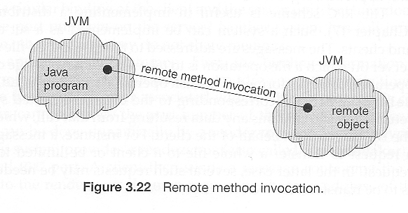  
Figure omitted in 8th edition

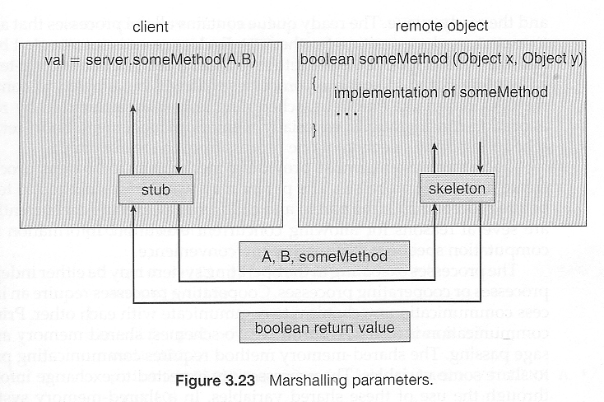  
Figure omitted in 8th edition

#### 

Chapter 4\*\*\*\*\*\*\*\*\*\*\*\*\*\*\*\*\*\*\*\*\*\*\*\*\*\*\*\*\*\*\*\*\*\*\*\*\*\*\*\*\*\*\*\*\*\*\*\*\*\*\*\*\*\*\*\*\*\*\*\*

**Threads**

**References:**

1. Abraham Silberschatz, Greg Gagne, and Peter Baer Galvin, "Operating System Concepts, Ninth Edition ", Chapter 4

**4.1 Overview**

* A ***thread*** is a basic unit of CPU utilization, consisting of a program counter, a stack, and a set of registers, ( and a thread ID. )
* Traditional ( heavyweight ) processes have a single thread of control - There is one program counter, and one sequence of instructions that can be carried out at any given time.
* As shown in Figure 4.1, multi-threaded applications have multiple threads within a single process, each having their own program counter, stack and set of registers, but sharing common code, data, and certain structures such as open files.

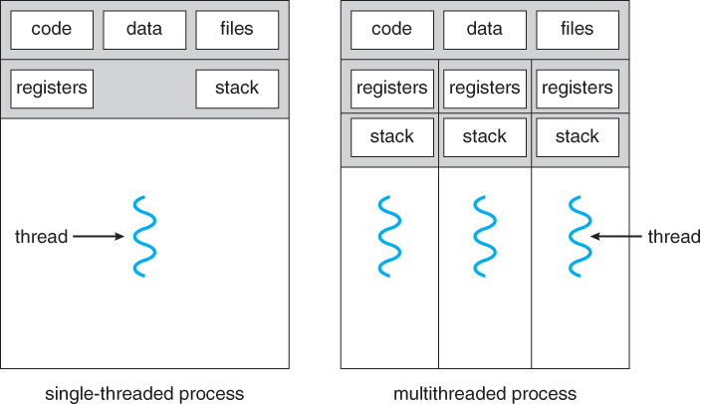  
**Figure 4.1 - Single-threaded and multithreaded processes**

**4.1.1 Motivation**

* Threads are very useful in modern programming whenever a process has multiple tasks to perform independently of the others.
* This is particularly true when one of the tasks may block, and it is desired to allow the other tasks to proceed without blocking.
* For example in a word processor, a background thread may check spelling and grammar while a foreground thread processes user input ( keystrokes ), while yet a third thread loads images from the hard drive, and a fourth does periodic automatic backups of the file being edited.
* Another example is a web server - Multiple threads allow for multiple requests to be satisfied simultaneously, without having to service requests sequentially or to fork off separate processes for every incoming request. ( The latter is how this sort of thing was done before the concept of threads was developed. A daemon would listen at a port, fork off a child for every incoming request to be processed, and then go back to listening to the port. )

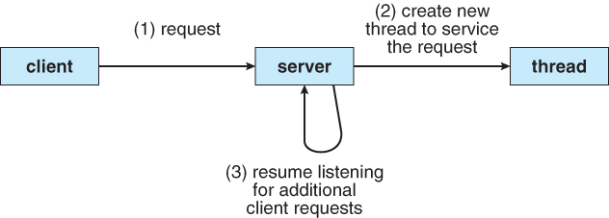  
**Figure 4.2 - Multithreaded server architecture**

**4.1.2 Benefits**

* There are four major categories of benefits to multi-threading:
  1. Responsiveness - One thread may provide rapid response while other threads are blocked or slowed down doing intensive calculations.
  2. Resource sharing - By default threads share common code, data, and other resources, which allows multiple tasks to be performed simultaneously in a single address space.
  3. Economy - Creating and managing threads ( and context switches between them ) is much faster than performing the same tasks for processes.
  4. Scalability, i.e. Utilization of multiprocessor architectures - A single threaded process can only run on one CPU, no matter how many may be available, whereas the execution of a multi-threaded application may be split amongst available processors. ( Note that single threaded processes can still benefit from multi-processor architectures when there are multiple processes contending for the CPU, i.e. when the load average is above some certain threshold. )

**4.2 Multicore Programming**

* A recent trend in computer architecture is to produce chips with multiple ***cores***, or CPUs on a single chip.
* A multi-threaded application running on a traditional single-core chip would have to interleave the threads, as shown in Figure 4.3. On a multi-core chip, however, the threads could be spread across the available cores, allowing true parallel processing, as shown in Figure 4.4.

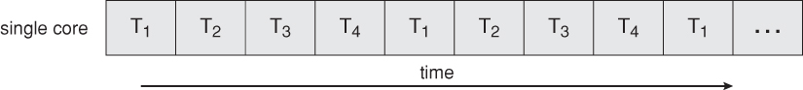  
**Figure 4.3 - Concurrent execution on a single-core system.**

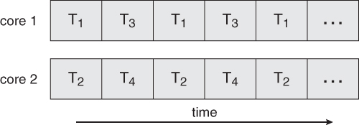  
**Figure 4.4 - Parallel execution on a multicore system**

* For operating systems, multi-core chips require new scheduling algorithms to make better use of the multiple cores available.
* As multi-threading becomes more pervasive and more important ( thousands instead of tens of threads ), CPUs have been developed to support more simultaneous threads per core in hardware.

**4.2.1 Programming Challenges ( New section, same content ? )**

* For application programmers, there are five areas where multi-core chips present new challenges:
  1. **Identifying tasks** - Examining applications to find activities that can be performed concurrently.
  2. **Balance** - Finding tasks to run concurrently that provide equal value. I.e. don't waste a thread on trivial tasks.
  3. **Data splitting** - To prevent the threads from interfering with one another.
  4. **Data dependency** - If one task is dependent upon the results of another, then the tasks need to be synchronized to assure access in the proper order.
  5. **Testing and debugging** - Inherently more difficult in parallel processing situations, as the race conditions become much more complex and difficult to identify.

**4.2.2 Types of Parallelism ( new )**

In theory there are two different ways to parallelize the workload:

1. **Data parallelism** divides the data up amongst multiple cores ( threads ), and performs the same task on each subset of the data. For example dividing a large image up into pieces and performing the same digital image processing on each piece on different cores.
2. **Task parallelism** divides the different tasks to be performed among the different cores and performs them simultaneously.

In practice no program is ever divided up solely by one or the other of these, but instead by some sort of hybrid combination.

**4.3 Multithreading Models**

* There are two types of threads to be managed in a modern system: User threads and kernel threads.
* User threads are supported above the kernel, without kernel support. These are the threads that application programmers would put into their programs.
* Kernel threads are supported within the kernel of the OS itself. All modern OSes support kernel level threads, allowing the kernel to perform multiple simultaneous tasks and/or to service multiple kernel system calls simultaneously.
* In a specific implementation, the user threads must be mapped to kernel threads, using one of the following strategies.

**4.3.1 Many-To-One Model**

* In the many-to-one model, many user-level threads are all mapped onto a single kernel thread.
* Thread management is handled by the thread library in user space, which is very efficient.
* However, if a blocking system call is made, then the entire process blocks, even if the other user threads would otherwise be able to continue.
* Because a single kernel thread can operate only on a single CPU, the many-to-one model does not allow individual processes to be split across multiple CPUs.
* Green threads for Solaris and GNU Portable Threads implement the many-to-one model in the past, but few systems continue to do so today.

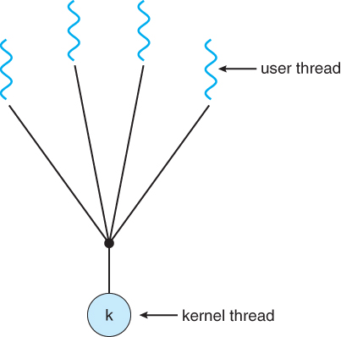  
**Figure 4.5 - Many-to-one model**

**4.3.2 One-To-One Model**

* The one-to-one model creates a separate kernel thread to handle each user thread.
* One-to-one model overcomes the problems listed above involving blocking system calls and the splitting of processes across multiple CPUs.
* However the overhead of managing the one-to-one model is more significant, involving more overhead and slowing down the system.
* Most implementations of this model place a limit on how many threads can be created.
* Linux and Windows from 95 to XP implement the one-to-one model for threads.

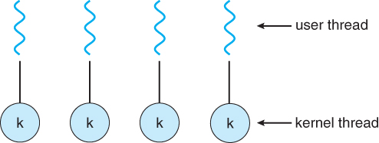  
**Figure 4.6 - One-to-one model**

**4.3.3 Many-To-Many Model**

* The many-to-many model multiplexes any number of user threads onto an equal or smaller number of kernel threads, combining the best features of the one-to-one and many-to-one models.
* Users have no restrictions on the number of threads created.
* Blocking kernel system calls do not block the entire process.
* Processes can be split across multiple processors.
* Individual processes may be allocated variable numbers of kernel threads, depending on the number of CPUs present and other factors.

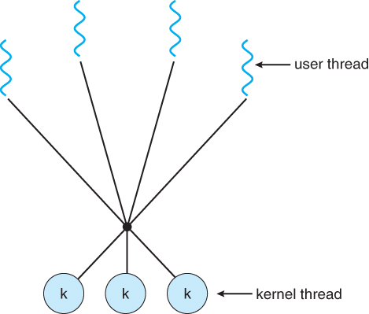  
**Figure 4.7 - Many-to-many model**

* One popular variation of the many-to-many model is the two-tier model, which allows either many-to-many or one-to-one operation.
* IRIX, HP-UX, and Tru64 UNIX use the two-tier model, as did Solaris prior to Solaris 9.

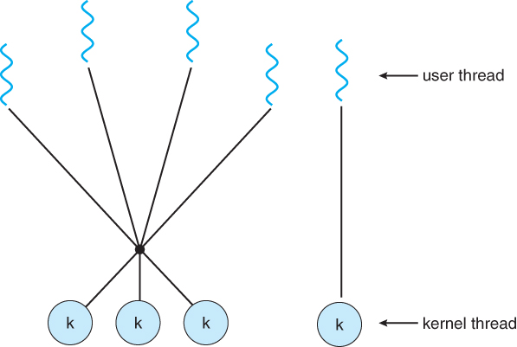  
**Figure 4.8 - Two-level model**

**4.4 Thread Libraries**

* Thread libraries provide programmers with an API for creating and managing threads.
* Thread libraries may be implemented either in user space or in kernel space. The former involves API functions implemented solely within user space, with no kernel support. The latter involves system calls, and requires a kernel with thread library support.
* There are three main thread libraries in use today:
  1. POSIX Pthreads - may be provided as either a user or kernel library, as an extension to the POSIX standard.
  2. Win32 threads - provided as a kernel-level library on Windows systems.
  3. Java threads - Since Java generally runs on a Java Virtual Machine, the implementation of threads is based upon whatever OS and hardware the JVM is running on, i.e. either Pthreads or Win32 threads depending on the system.
* The following sections will demonstrate the use of threads in all three systems for calculating the sum of integers from 0 to N in a separate thread, and storing the result in a variable "sum".

**4.4.1 Pthreads**

* The POSIX standard ( IEEE 1003.1c ) defines the *specification* for pThreads, not the *implementation*.
* pThreads are available on Solaris, Linux, Mac OSX, Tru64, and via public domain shareware for Windows.
* Global variables are shared amongst all threads.
* One thread can wait for the others to rejoin before continuing.
* pThreads begin execution in a specified function, in this example the runner( ) function:

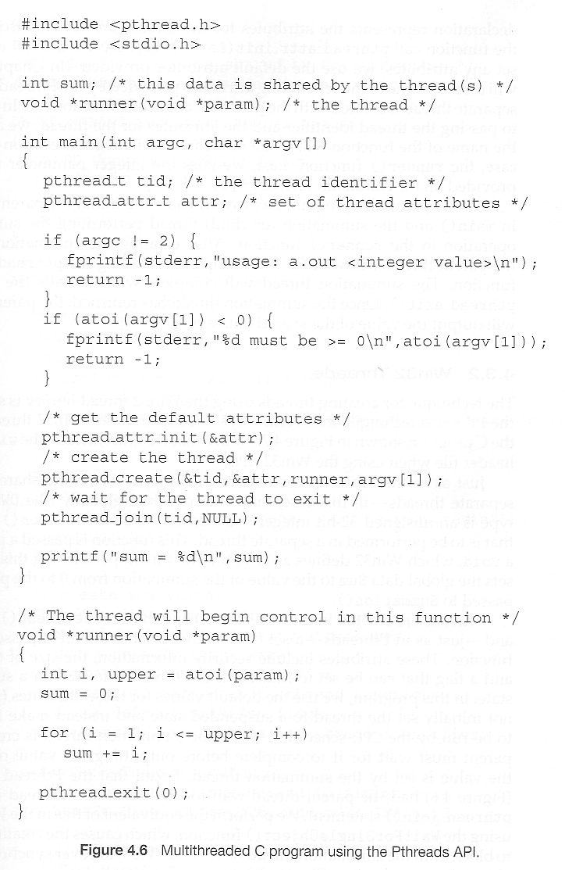  
**Figure 4.9**

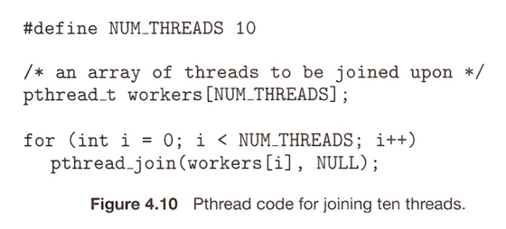  
**New**

**4.4.2 Windows Threads**

* Similar to pThreads. Examine the code example to see the differences, which are mostly syntactic & nomenclature:

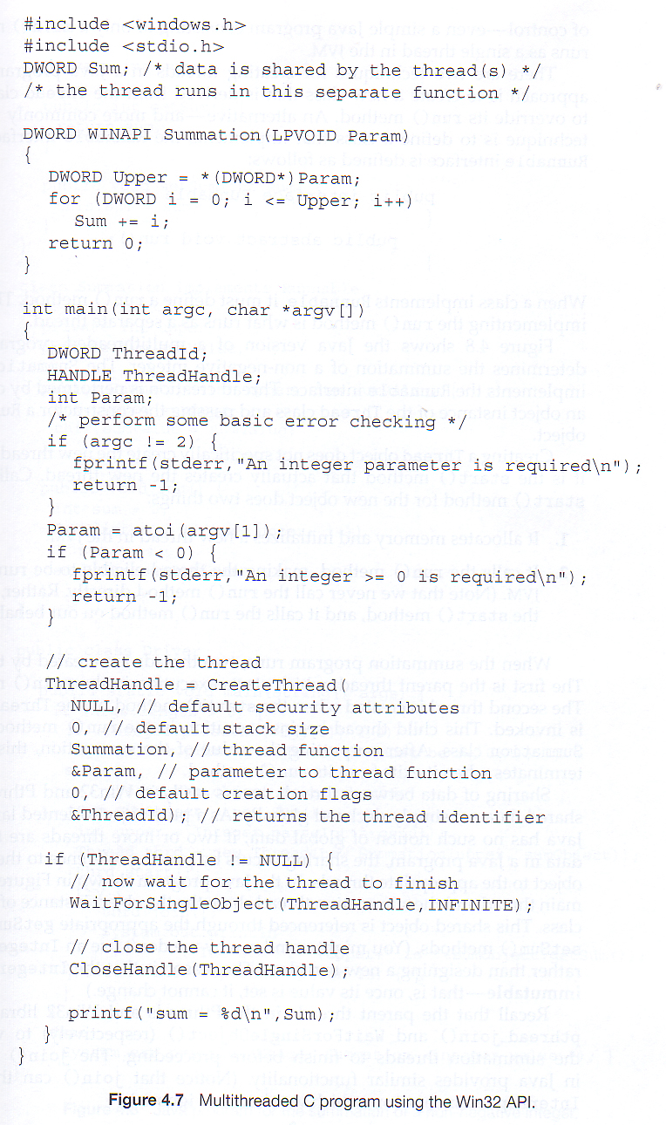  
**Figure 4.11**

**4.4.3 Java Threads**

* ALL Java programs use Threads - even "common" single-threaded ones.
* The creation of new Threads requires Objects that implement the Runnable Interface, which means they contain a method "public void run( )" . Any descendant of the Thread class will naturally contain such a method. ( In practice the run( ) method must be overridden / provided for the thread to have any practical functionality. )
* Creating a Thread Object does not start the thread running - To do that the program must call the Thread's "start( )" method. Start( ) allocates and initializes memory for the Thread, and then calls the run( ) method. ( Programmers do not call run( ) directly. )
* Because Java does not support global variables, Threads must be passed a reference to a shared Object in order to share data, in this example the "Sum" Object.
* Note that the JVM runs on top of a native OS, and that the JVM specification does not specify what model to use for mapping Java threads to kernel threads. This decision is JVM implementation dependant, and may be one-to-one, many-to-many, or many to one.. ( On a UNIX system the JVM normally uses PThreads and on a Windows system it normally uses windows threads. )

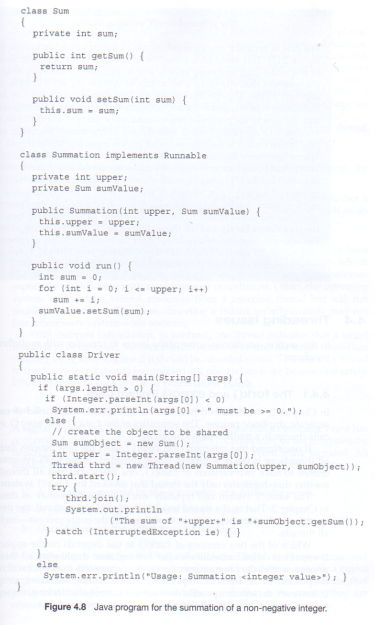  
**Figure 4.12**

**4.5 Implicit Threading ( Optional )**

Shifts the burden of addressing the programming challenges outlined in section 4.2.1 above from the application programmer to the compiler and run-time libraries.

**4.5.1 Thread Pools**

* Creating new threads every time one is needed and then deleting it when it is done can be inefficient, and can also lead to a very large ( unlimited ) number of threads being created.
* An alternative solution is to create a number of threads when the process first starts, and put those threads into a ***thread pool***.
  + Threads are allocated from the pool as needed, and returned to the pool when no longer needed.
  + When no threads are available in the pool, the process may have to wait until one becomes available.
* The ( maximum ) number of threads available in a thread pool may be determined by adjustable parameters, possibly dynamically in response to changing system loads.
* Win32 provides thread pools through the "PoolFunction" function. Java also provides support for thread pools through the java.util.concurrent package, and Apple supports thread pools under the Grand Central Dispatch architecture..

**4.5.2 OpenMP**

* OpenMP is a set of compiler directives available for C, C++, or FORTRAN programs that instruct the compiler to automatically generate parallel code where appropriate.
* For example, the directive:

#pragma omp parallel

{

/\* some parallel code here \*/

}

would cause the compiler to create as many threads as the machine has cores available, ( e.g. 4 on a quad-core machine ), and to run the parallel block of code, ( known as a **parallel region** ) on each of the threads.

* Another sample directive is "**#pragma omp parallel for**", which causes the for loop immediately following it to be parallelized, dividing the iterations up amongst the available cores.

**4.5.3 Grand Central Dispatch, GCD**

* GCD is an extension to C and C++ available on Apple's OSX and iOS operating systems to support parallelism.
* Similar to OpenMP, users of GCD define **blocks** of code to be executed either serially or in parallel by placing a carat just before an opening curly brace, i.e.**^{ printf( "I am a block.\n" ); }**
* GCD schedules blocks by placing them on one of several **dispatch queues**.
  + Blocks placed on a serial queue are removed one by one. The next block cannot be removed for scheduling until the previous block has completed.
  + There are three concurrent queues, corresponding roughly to low, medium, or high priority. Blocks are also removed from these queues one by one, but several may be removed and dispatched without waiting for others to finish first, depending on the availability of threads.
* Internally GCD manages a pool of POSIX threads which may fluctuate in size depending on load conditions.

**4.5.4 Other Approaches**

There are several other approaches available, including Microsoft's Threading Building Blocks ( TBB ) and other products, and Java's util.concurrent package.

**4.6 Threading Issues**

**4.6.1 The fork( ) and exec( ) System Calls**

* Q: If one thread forks, is the entire process copied, or is the new process single-threaded?
* A: System dependant.
* A: If the new process execs right away, there is no need to copy all the other threads. If it doesn't, then the entire process should be copied.
* A: Many versions of UNIX provide multiple versions of the fork call for this purpose.

**4.6.2 Signal Handling**

* Q: When a multi-threaded process receives a signal, to what thread should that signal be delivered?
* A: There are four major options:
  1. Deliver the signal to the thread to which the signal applies.
  2. Deliver the signal to every thread in the process.
  3. Deliver the signal to certain threads in the process.
  4. Assign a specific thread to receive all signals in a process.
* The best choice may depend on which specific signal is involved.
* UNIX allows individual threads to indicate which signals they are accepting and which they are ignoring. However the signal can only be delivered to one thread, which is generally the first thread that is accepting that particular signal.
* UNIX provides two separate system calls, **kill( pid, signal )** and **pthread\_kill( tid, signal )**, for delivering signals to processes or specific threads respectively.
* Windows does not support signals, but they can be emulated using Asynchronous Procedure Calls ( APCs ). APCs are delivered to specific threads, not processes.

**4.6.3 Thread Cancellation**

* Threads that are no longer needed may be cancelled by another thread in one of two ways:
  1. **Asynchronous Cancellation** cancels the thread immediately.
  2. **Deferred Cancellation** sets a flag indicating the thread should cancel itself when it is convenient. It is then up to the cancelled thread to check this flag periodically and exit nicely when it sees the flag set.
* ( Shared ) resource allocation and inter-thread data transfers can be problematic with asynchronous cancellation.

**4.6.4 Thread-Local Storage ( was 4.4.5 Thread-Specific Data )**

* Most data is shared among threads, and this is one of the major benefits of using threads in the first place.
* However sometimes threads need thread-specific data also.
* Most major thread libraries ( pThreads, Win32, Java ) provide support for thread-specific data, known as **thread-local storage** or **TLS.** Note that this is more like static data than local variables,because it does not cease to exist when the function ends.

**4.6.5 Scheduler Activations**

* Many implementations of threads provide a virtual processor as an interface between the user thread and the kernel thread, particularly for the many-to-many or two-tier models.
* This virtual processor is known as a "Lightweight Process", LWP.
  + There is a one-to-one correspondence between LWPs and kernel threads.
  + The number of kernel threads available, ( and hence the number of LWPs ) may change dynamically.
  + The application ( user level thread library ) maps user threads onto available LWPs.
  + kernel threads are scheduled onto the real processor(s) by the OS.
  + The kernel communicates to the user-level thread library when certain events occur ( such as a thread about to block ) via an ***upcall***, which is handled in the thread library by an ***upcall handler***. The upcall also provides a new LWP for the upcall handler to run on, which it can then use to reschedule the user thread that is about to become blocked. The OS will also issue upcalls when a thread becomes unblocked, so the thread library can make appropriate adjustments.
* If the kernel thread blocks, then the LWP blocks, which blocks the user thread.
* Ideally there should be at least as many LWPs available as there could be concurrently blocked kernel threads. Otherwise if all LWPs are blocked, then user threads will have to wait for one to become available.

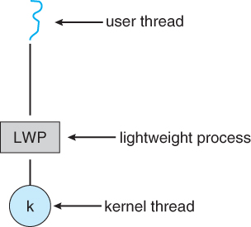  
**Figure 4.13 - Lightweight process ( LWP )**

**4.7 Operating-System Examples ( Optional )**

**4.7.1 Windows XP Threads**

* The Win32 API thread library supports the one-to-one thread model
* Win32 also provides the ***fiber*** library, which supports the many-to-many model.
* Win32 thread components include:
  + Thread ID
  + Registers
  + A user stack used in user mode, and a kernel stack used in kernel mode.
  + A private storage area used by various run-time libraries and dynamic link libraries ( DLLs ).
* The key data structures for Windows threads are the ETHREAD ( executive thread block ), KTHREAD ( kernel thread block ), and the TEB ( thread environment block ). The ETHREAD and KTHREAD structures exist entirely within kernel space, and hence are only accessible by the kernel, whereas the TEB lies within user space, as illustrated in Figure 4.10:

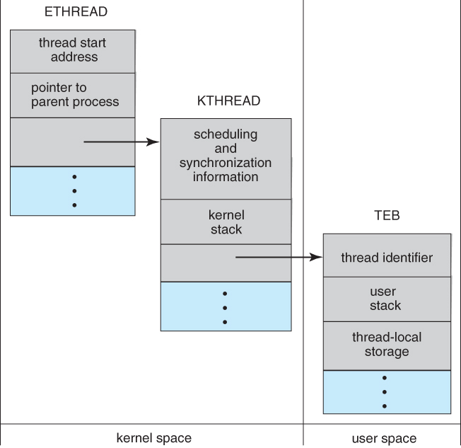  
**Figure 4.14 - Data structures of a Windows thread**

**4.7.2 Linux Threads**

* Linux does not distinguish between processes and threads - It uses the more generic term "tasks".
* The traditional fork( ) system call completely duplicates a process ( task ), as described earlier.
* An alternative system call, clone( ) allows for varying degrees of sharing between the parent and child tasks, controlled by flags such as those shown in the following table:

|  |  |
| --- | --- |
|  | |
| **flag** | **Meaning** |
| CLONE\_FS | File-system information is shared |
| CLONE\_VM | The same memory space is shared |
| CLONE\_SIGHAND | Signal handlers are shared |
| CLONE\_FILES | The set of open files is shared |

* Calling clone( )with no flags set is equivalent to fork( ). Calling clone( ) with CLONE\_FS, CLONE\_VM, CLONE\_SIGHAND, and CLONE\_FILES is equivalent to creating a thread, as all of these data structures will be shared.
* Linux implements this using a structure **task\_struct**, which essentially provides a level of indirection to task resources. When the flags are not set, then the resources pointed to by the structure are copied, but if the flags are set, then only the pointers to the resources are copied, and hence the resources are shared. ( Think of a deep copy versus a shallow copy in OO programming. )
* **( Removed from 9th edition )** Several distributions of Linux now support the NPTL ( Native POXIS Thread Library )
  + POSIX compliant.
  + Support for SMP ( symmetric multiprocessing ), NUMA ( non-uniform memory access ), and multicore processors.
  + Support for hundreds to thousands of threads.

**4.8 Summary**

Chapter 5\*\*\*\*\*\*\*\*\*\*\*\*\*\*\*\*\*\*\*\*\*\*\*\*\*\*\*\*\*\*\*\*\*\*\*\*\*\*\*\*\*\*\*\*\*\*\*\*\*\*\*\*\*\*\*\*\*\*\*\*

**Process Synchronization**

**References:**

1. Abraham Silberschatz, Greg Gagne, and Peter Baer Galvin, "Operating System Concepts, Ninth Edition ", Chapter 5

**Warning:** This chapter requires some heavy thought. As you read each of the algorithms below, you need to satisfy yourself that they do indeed work under all conditions. Think about it, and don't just accept them at face value.

**5.1 Background**

* Recall that back in Chapter 3 we looked at cooperating processes ( those that can effect or be effected by other simultaneously running processes ), and as an example, we used the producer-consumer cooperating processes:

**Producer code from chapter 3:**

item nextProduced;

while( true ) {

/\* Produce an item and store it in nextProduced \*/  
nextProduced = makeNewItem( . . . );   
  
/\* Wait for space to become available \*/   
while( ( ( in + 1 ) % BUFFER\_SIZE ) == out )  
      ; /\* Do nothing \*/  
  
/\* And then store the item and repeat the loop. \*/   
buffer[ in ] = nextProduced;  
in = ( in + 1 ) % BUFFER\_SIZE;

}

**Consumer code from chapter 3:**

item nextConsumed;

while( true ) {

/\* Wait for an item to become available \*/   
while( in == out )  
      ; /\* Do nothing \*/

/\* Get the next available item \*/   
nextConsumed = buffer[ out ];  
out = ( out + 1 ) % BUFFER\_SIZE;  
  
/\* Consume the item in nextConsumed  
     ( Do something with it ) \*/

}

* The only problem with the above code is that the maximum number of items which can be placed into the buffer is BUFFER\_SIZE - 1. One slot is unavailable because there always has to be a gap between the producer and the consumer.
* We could try to overcome this deficiency by introducing a counter variable, as shown in the following code segments:

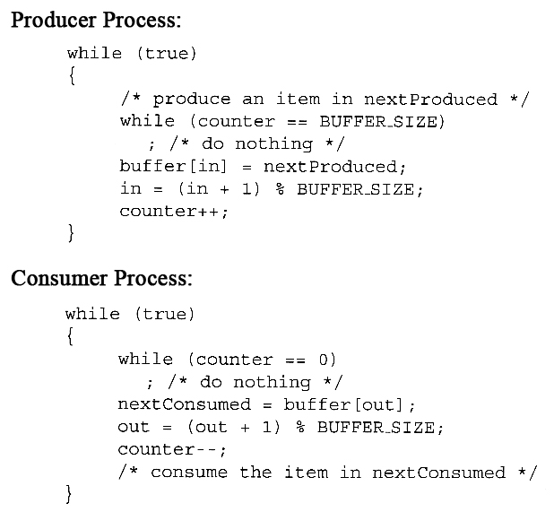

* Unfortunately we have now introduced a new problem, because both the producer and the consumer are adjusting the value of the variable counter, which can lead to a condition known as a***race condition***. In this condition a piece of code may or may not work correctly, depending on which of two simultaneous processes executes first, and more importantly if one of the processes gets interrupted such that the other process runs between important steps of the first process. ( Bank balance example discussed in class. )
* The particular problem above comes from the producer executing "counter++" at the same time the consumer is executing "counter--". If one process gets part way through making the update and then the other process butts in, the value of counter can get left in an incorrect state.
* But, you might say, "Each of those are single instructions - How can they get interrupted halfway through?" The answer is that although they are single instructions in C++, they are actually three steps each at the hardware level: (1) Fetch counter from memory into a register, (2) increment or decrement the register, and (3) Store the new value of counter back to memory. If the instructions from the two processes get interleaved, there could be serious problems, such as illustrated by the following:

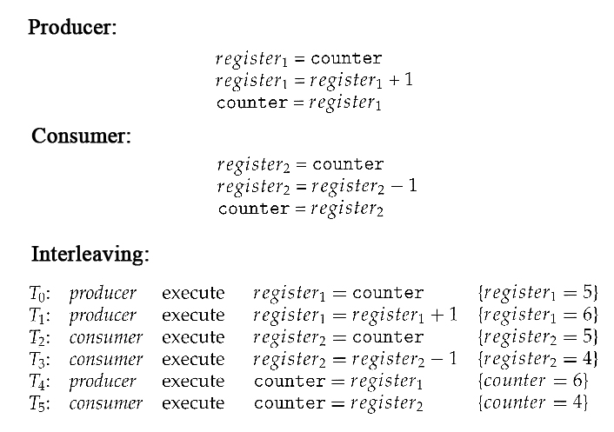

* **Exercise:**What would be the resulting value of counter if the order of statements T4 and T5 were reversed? ( What **should** the value of counter be after one producer and one consumer, assuming the original value was 5? )
* Note that race conditions are ***notoriously difficult*** to identify and debug, because by their very nature they only occur on rare occasions, and only when the timing is just exactly right. ( or wrong! :-) ) Race conditions are also very difficult to reproduce. :-(
* Obviously the solution is to only allow one process at a time to manipulate the value "counter". This is a very common occurrence among cooperating processes, so lets look at some ways in which this is done, as well as some classic problems in this area.

**5.2 The Critical-Section Problem**

* The producer-consumer problem described above is a specific example of a more general situation known as the ***critical section*** problem. The general idea is that in a number of cooperating processes, each has a critical section of code, with the following conditions and terminologies:
  + Only one process in the group can be allowed to execute in their critical section at any one time. If one process is already executing their critical section and another process wishes to do so, then the second process must be made to wait until the first process has completed their critical section work.
  + The code preceding the critical section, and which controls access to the critical section, is termed the entry section. It acts like a carefully controlled locking door.
  + The code following the critical section is termed the exit section. It generally releases the lock on someone else's door, or at least lets the world know that they are no longer in their critical section.
  + The rest of the code not included in either the critical section or the entry or exit sections is termed the remainder section.

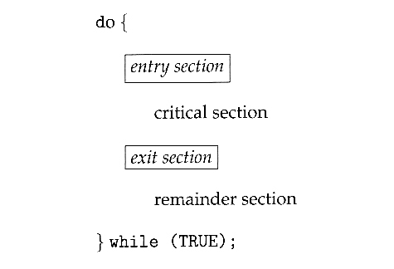  
**Figure 5.1 - General structure of a typical process Pi**

* A solution to the critical section problem must satisfy the following three conditions:
  1. **Mutual Exclusion** - Only one process at a time can be executing in their critical section.
  2. **Progress** - If no process is currently executing in their critical section, and one or more processes want to execute their critical section, then only the processes not in their remainder sections can participate in the decision, and the decision cannot be postponed indefinitely. ( I.e. processes cannot be blocked forever waiting to get into their critical sections. )
  3. **Bounded Waiting** - There exists a limit as to how many other processes can get into their critical sections after a process requests entry into their critical section and before that request is granted. ( I.e. a process requesting entry into their critical section will get a turn eventually, and there is a limit as to how many other processes get to go first. )
* We assume that all processes proceed at a non-zero speed, but no assumptions can be made regarding the ***relative*** speed of one process versus another.
* Kernel processes can also be subject to race conditions, which can be especially problematic when updating commonly shared kernel data structures such as open file tables or virtual memory management. Accordingly kernels can take on one of two forms:
  1. Non-preemptive kernels do not allow processes to be interrupted while in kernel mode. This eliminates the possibility of kernel-mode race conditions, but requires kernel mode operations to complete very quickly, and can be problematic for real-time systems, because timing cannot be guaranteed.
  2. Preemptive kernels allow for real-time operations, but must be carefully written to avoid race conditions. This can be especially tricky on SMP systems, in which multiple kernel processes may be running simultaneously on different processors.
* Non-preemptive kernels include Windows XP, 2000, traditional UNIX, and Linux prior to 2.6; Preemptive kernels include Linux 2.6 and later, and some commercial UNIXes such as Solaris and IRIX.

**5.3 Peterson's Solution**

* Peterson's Solution is a classic software-based solution to the critical section problem. It is unfortunately not guaranteed to work on modern hardware, due to vagaries of load and store operations, but it illustrates a number of important concepts.
* Peterson's solution is based on two processes, P0 and P1, which alternate between their critical sections and remainder sections. For convenience of discussion, "this" process is Pi, and the "other" process is Pj. ( I.e. j = 1 - i )
* Peterson's solution requires two shared data items:
  + **int turn** - Indicates whose turn it is to enter into the critical section. If turn = = i, then process i is allowed into their critical section.
  + **boolean flag[ 2 ]** - Indicates when a process ***wants to*** enter into their critical section. When process i wants to enter their critical section, it sets flag[ i ] to true.
* In the following diagram, the entry and exit sections are enclosed in boxes.
  + In the entry section, process i first raises a flag indicating a desire to enter the critical section.
  + Then turn is set to***j***to allow the ***other*** process to enter their critical section***if process j so desires.***
  + The while loop is a busy loop ( notice the semicolon at the end ), which makes process i wait as long as process j has the turn and wants to enter the critical section.
  + Process i lowers the flag[ i ] in the exit section, allowing process j to continue if it has been waiting.

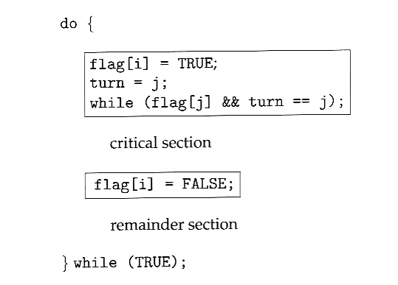  
**Figure 5.2 - The structure of process Pi in Peterson's solution.**

* To prove that the solution is correct, we must examine the three conditions listed above:
  1. **Mutual exclusion** - If one process is executing their critical section when the other wishes to do so, the second process will become blocked by the flag of the first process. If both processes attempt to enter at the same time, the last process to execute "turn = j" will be blocked.
  2. **Progress** - Each process can only be blocked at the while if the other process wants to use the critical section ( flag[ j ] = = true ), AND it is the other process's turn to use the critical section ( turn = = j ). If both of those conditions are true, then the other process ( j ) will be allowed to enter the critical section, and upon exiting the critical section, will set flag[ j ] to false, releasing process i. The shared variable turn assures that only one process at a time can be blocked, and the flag variable allows one process to release the other when exiting their critical section.
  3. **Bounded Waiting** - As each process enters their entry section, they set the turn variable to be the other processes turn. Since no process ever sets it back to their own turn, this ensures that each process will have to let the other process go first at most one time before it becomes their turn again.
* Note that the instruction "turn = j" is ***atomic,***that is it is a single machine instruction which cannot be interrupted.

**5.4 Synchronization Hardware**

* To generalize the solution(s) expressed above, each process when entering their critical section must set some sort of ***lock***, to prevent other processes from entering their critical sections simultaneously, and must release the lock when exiting their critical section, to allow other processes to proceed. Obviously it must be possible to attain the lock only when no other process has already set a lock. Specific implementations of this general procedure can get quite complicated, and may include hardware solutions as outlined in this section.
* One simple solution to the critical section problem is to simply prevent a process from being interrupted while in their critical section, which is the approach taken by non preemptive kernels. Unfortunately this does not work well in multiprocessor environments, due to the difficulties in disabling and the re-enabling interrupts on all processors. There is also a question as to how this approach affects timing if the clock interrupt is disabled.
* Another approach is for hardware to provide certain ***atomic*** operations. These operations are guaranteed to operate as a single instruction, without interruption. One such operation is the "Test and Set", which simultaneously sets a boolean lock variable and returns its previous value, as shown in Figures 5.3 and 5.4:

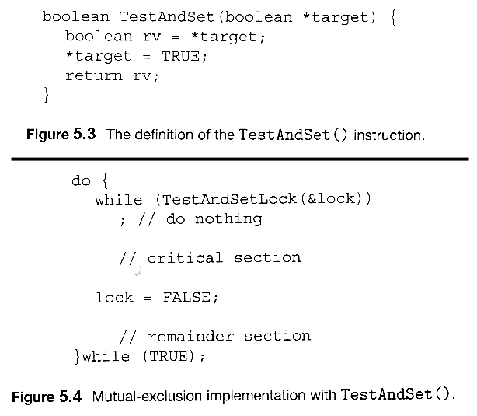  
**Figures 5.3 and 5.4 illustrate "test\_and\_set( )" function**

* Another variation on the test-and-set is an atomic swap of two booleans, as shown in Figures 5.5 and 5.6:

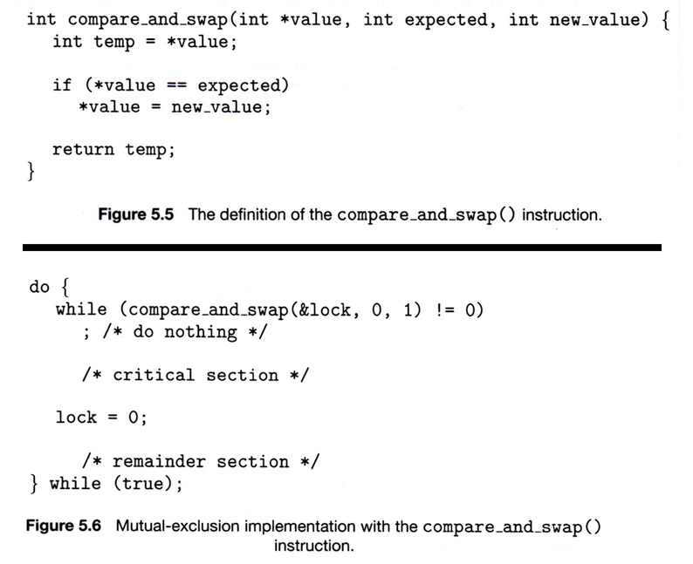

* The above examples satisfy the mutual exclusion requirement, but unfortunately do not guarantee bounded waiting. If there are multiple processes trying to get into their critical sections, there is no guarantee of what order they will enter, and any one process could have the bad luck to wait forever until they got their turn in the critical section. ( Since there is no guarantee as to the relative ***rates*** of the processes, a very fast process could theoretically release the lock, whip through their remainder section, and re-lock the lock before a slower process got a chance. As more and more processes are involved vying for the same resource, the odds of a slow process getting locked out completely increase. )
* Figure 5.7 illustrates a solution using test-and-set that does satisfy this requirement, using two shared data structures, boolean lock and boolean waiting[ N ], where N is the number of processes in contention for critical sections:

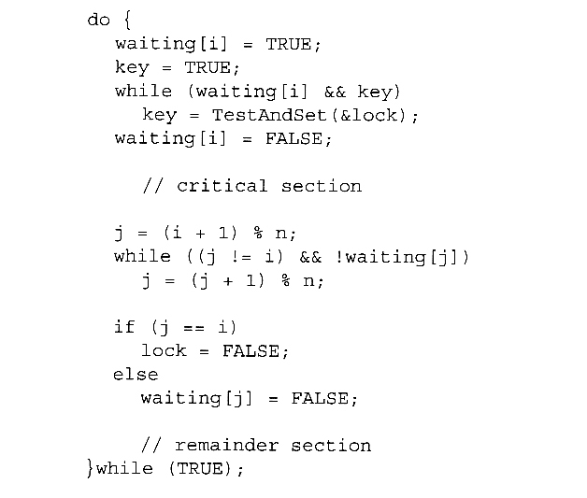  
**Figure 5.7 Bounded-waiting mutual exclusion with TestAndSet( ).**

* The key feature of the above algorithm is that a process blocks on the AND of the critical section being locked and that this process is in the waiting state. When exiting a critical section, the exiting process does not just unlock the critical section and let the other processes have a free-for-all trying to get in. Rather it first looks in an orderly progression ( starting with the next process on the list ) for a process that has been waiting, and if it finds one, then it releases that particular process from its waiting state, without unlocking the critical section, thereby allowing a specific process into the critical section while continuing to block all the others. Only if there are no other processes currently waiting is the general lock removed, allowing the next process to come along access to the critical section.
* Unfortunately, hardware level locks are especially difficult to implement in multi-processor architectures. Discussion of such issues is left to books on advanced computer architecture.

**5.5 Mutex Locks**

* The hardware solutions presented above are often difficult for ordinary programmers to access, particularly on multi-processor machines, and particularly because they are often platform-dependent.
* Therefore most systems offer a software API equivalent called ***mutex locks*** or simply ***mutexes.*** ( For mutual exclusion )
* The terminology when using mutexes is to ***acquire*** a lock prior to entering a critical section, and to ***release* it when exiting, as shown in Figure 5.8:**

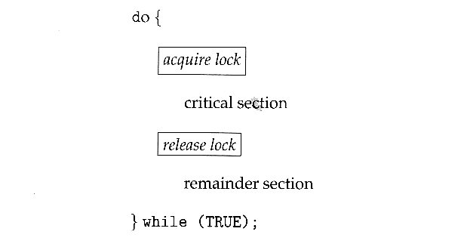  
**Figure 5.8 - Solution to the critical-section problem using mutex locks**

* Just as with hardware locks, the acquire step will block the process if the lock is in use by another process, and both the acquire and release operations are atomic.
* Acquire and release can be implemented as shown here, based on a boolean variable "available":

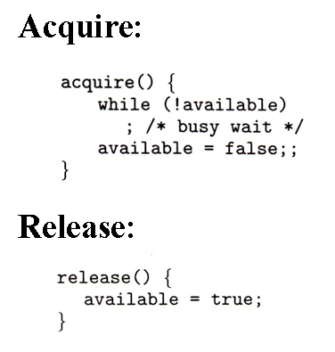

* One problem with the implementation shown here, ( and in the hardware solutions presented earlier ), is the busy loop used to block processes in the acquire phase. These types of locks are referred to as***spinlocks***, because the CPU just sits and spins while blocking the process.
* Spinlocks are wasteful of cpu cycles, and are a really bad idea on single-cpu single-threaded machines, because the spinlock blocks the entire computer, and doesn't allow any other process to release the lock. ( Until the scheduler kicks the spinning process off of the cpu. )
* On the other hand, spinlocks do not incur the overhead of a context switch, so they are effectively used on multi-threaded machines when it is expected that the lock will be released after a short time.

**5.6 Semaphores**

* A more robust alternative to simple mutexes is to use ***semaphores***, which are integer variables for which only two ( atomic ) operations are defined, the wait and signal operations, as shown in the following figure.
* Note that not only must the variable-changing steps ( S-- and S++ ) be indivisible, it is also necessary that for the wait operation when the test proves false that there be no interruptions before S gets decremented. It IS okay, however, for the busy loop to be interrupted when the test is true, which prevents the system from hanging forever.

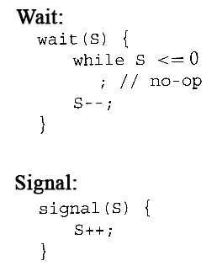

**5.6.1 Semaphore Usage**

* In practice, semaphores can take on one of two forms:
  + **Binary semaphores** can take on one of two values, 0 or 1. They can be used to solve the critical section problem as described above, and can be used as mutexes on systems that do not provide a separate mutex mechanism.. The use of mutexes for this purpose is shown in Figure 6.9 ( from the 8th edition ) below.

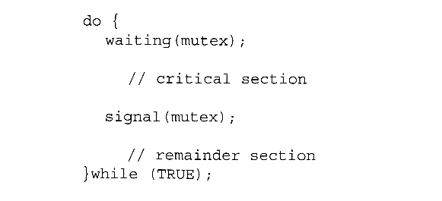  
**Mutual-exclusion implementation with semaphores. ( From 8th edition. )**

* + **Counting semaphores** can take on any integer value, and are usually used to count the number remaining of some limited resource. The counter is initialized to the number of such resources available in the system, and whenever the counting semaphore is greater than zero, then a process can enter a critical section and use one of the resources. When the counter gets to zero ( or negative in some implementations ), then the process blocks until another process frees up a resource and increments the counting semaphore with a signal call. ( The binary semaphore can be seen as just a special case where the number of resources initially available is just one. )
  + Semaphores can also be used to synchronize certain operations between processes. For example, suppose it is important that process P1 execute statement S1 before process P2 executes statement S2.
    - First we create a semaphore named synch that is shared by the two processes, and initialize it to zero.
    - Then in process P1 we insert the code:

S1;  
signal( synch );

* + - and in process P2 we insert the code:

wait( synch );  
S2;

* + - Because synch was initialized to 0, process P2 will block on the wait until after P1 executes the call to signal.

**5.6.2 Semaphore Implementation**

* The big problem with semaphores as described above is the busy loop in the wait call, which consumes CPU cycles without doing any useful work. This type of lock is known as a ***spinlock***, because the lock just sits there and spins while it waits. While this is generally a bad thing, it does have the advantage of not invoking context switches, and so it is sometimes used in multi-processing systems when the wait time is expected to be short - One thread spins on one processor while another completes their critical section on another processor.
* An alternative approach is to block a process when it is forced to wait for an available semaphore, and swap it out of the CPU. In this implementation each semaphore needs to maintain a list of processes that are blocked waiting for it, so that one of the processes can be woken up and swapped back in when the semaphore becomes available. ( Whether it gets swapped back into the CPU immediately or whether it needs to hang out in the ready queue for a while is a scheduling problem. )
* The new definition of a semaphore and the corresponding wait and signal operations are shown as follows:

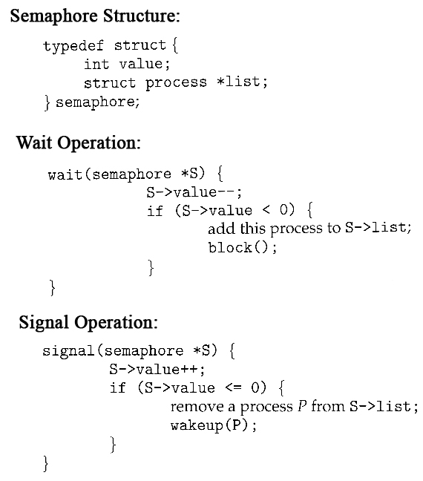

* Note that in this implementation the value of the semaphore can actually become negative, in which case its magnitude is the number of processes waiting for that semaphore. This is a result of decrementing the counter before checking its value.
* Key to the success of semaphores is that the wait and signal operations be atomic, that is no other process can execute a wait or signal on the same semaphore at the same time. ( Other processes could be allowed to do other things, including working with other semaphores, they just can't have access to **this**semaphore. ) On single processors this can be implemented by disabling interrupts during the execution of wait and signal; Multiprocessor systems have to use more complex methods, including the use of spinlocking.

**5.6.3 Deadlocks and Starvation**

* One important problem that can arise when using semaphores to block processes waiting for a limited resource is the problem of ***deadlocks***, which occur when multiple processes are blocked, each waiting for a resource that can only be freed by one of the other ( blocked ) processes, as illustrated in the following example. ( Deadlocks are covered more completely in chapter 7. )

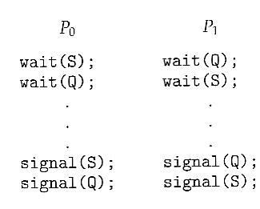

* Another problem to consider is that of ***starvation***, in which one or more processes gets blocked forever, and never get a chance to take their turn in the critical section. For example, in the semaphores above, we did not specify the algorithms for adding processes to the waiting queue in the semaphore in the wait( ) call, or selecting one to be removed from the queue in the signal( ) call. If the method chosen is a FIFO queue, then every process will eventually get their turn, but if a LIFO queue is implemented instead, then the first process to start waiting could starve.

**5.6.4 Priority Inversion**

* A challenging scheduling problem arises when a high-priority process gets blocked waiting for a resource that is currently held by a low-priority process.
* If the low-priority process gets pre-empted by one or more medium-priority processes, then the high-priority process is essentially made to wait for the medium priority processes to finish before the low-priority process can release the needed resource, causing a ***priority inversion.*** If there are enough medium-priority processes, then the high-priority process may be forced to wait for a very long time.
* One solution is a ***priority-inheritance protocol,***in which a low-priority process holding a resource for which a high-priority process is waiting will temporarily inherit the high priority from the waiting process. This prevents the medium-priority processes from preempting the low-priority process until it releases the resource, blocking the priority inversion problem.
* The book has an interesting discussion of how a priority inversion almost doomed the Mars Pathfinder mission, and how the problem was solved when the priority inversion was stopped. Full details are available online at [http://research.microsoft.com/en-us/um/people/mbj/mars\_pathfinder/authoritative\_account.htm](http://research.microsoft.com/en-us/um/people/mbj/mars_pathfinder/authoritative_account.html)

**5.7 Classic Problems of Synchronization**

The following classic problems are used to test virtually every new proposed synchronization algorithm.

**5.7.1 The Bounded-Buffer Problem**

* This is a generalization of the producer-consumer problem wherein access is controlled to a shared group of buffers of a limited size.
* In this solution, the two counting semaphores "full" and "empty" keep track of the current number of full and empty buffers respectively ( and initialized to 0 and N respectively. ) The binary semaphore mutex controls access to the critical section. The producer and consumer processes are nearly identical - One can think of the producer as producing full buffers, and the consumer producing empty buffers.

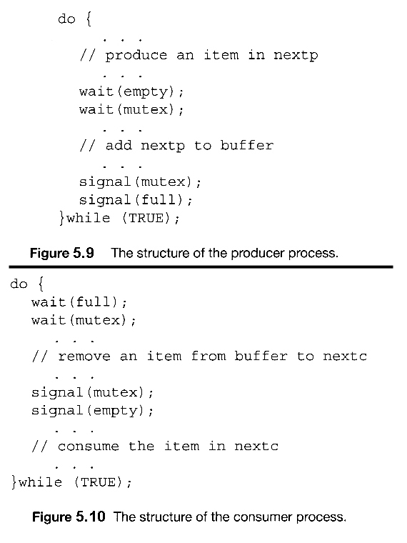  
**Figures 5.9 and 5.10 use variables next\_produced and next\_consumed**

**5.7.2 The Readers-Writers Problem**

* In the readers-writers problem there are some processes ( termed readers ) who only read the shared data, and never change it, and there are other processes ( termed writers ) who may change the data in addition to or instead of reading it. There is no limit to how many readers can access the data simultaneously, but when a writer accesses the data, it needs exclusive access.
* There are several variations to the readers-writers problem, most centered around relative priorities of readers versus writers.
  + The *first* readers-writers problem gives priority to readers. In this problem, if a reader wants access to the data, and there is not already a writer accessing it, then access is granted to the reader. A solution to this problem can lead to starvation of the writers, as there could always be more readers coming along to access the data. ( A steady stream of readers will jump ahead of waiting writers as long as there is currently already another reader accessing the data, because the writer is forced to wait until the data is idle, which may never happen if there are enough readers. )
  + The *second*readers-writers problem gives priority to the writers. In this problem, when a writer wants access to the data it jumps to the head of the queue - All waiting readers are blocked, and the writer gets access to the data as soon as it becomes available. In this solution the readers may be starved by a steady stream of writers.
* The following code is an example of the first readers-writers problem, and involves an important counter and two binary semaphores:
  + readcount is used by the reader processes, to count the number of readers currently accessing the data.
  + mutex is a semaphore used only by the readers for controlled access to readcount.
  + rw\_mutex is a semaphore used to block and release the writers. The first reader to access the data will set this lock and the last reader to exit will release it; The remaining readers do not touch rw\_mutex. ( Eighth edition called this variable wrt. )
  + Note that the first reader to come along will block on rw\_mutex if there is currently a writer accessing the data, and that all following readers will only block on mutex for their turn to increment readcount.

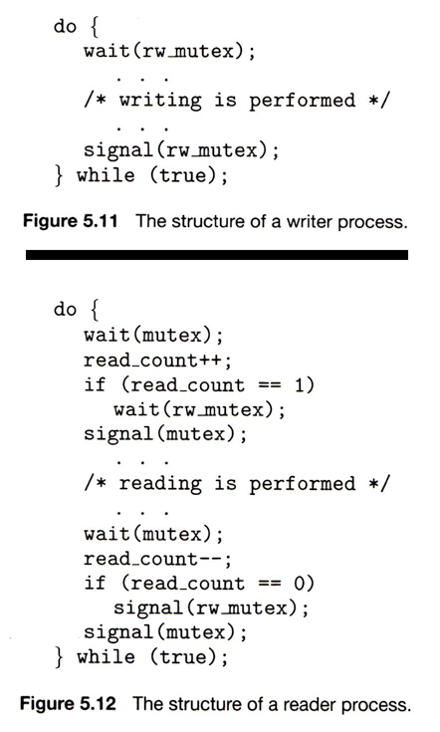

* Some hardware implementations provide specific reader-writer locks, which are accessed using an argument specifying whether access is requested for reading or writing. The use of reader-writer locks is beneficial for situation in which: (1) processes can be easily identified as either readers or writers, and (2) there are significantly more readers than writers, making the additional overhead of the reader-writer lock pay off in terms of increased concurrency of the readers.

**5.7.3 The Dining-Philosophers Problem**

* The dining philosophers problem is a classic synchronization problem involving the allocation of limited resources amongst a group of processes in a deadlock-free and starvation-free manner:
  + Consider five philosophers sitting around a table, in which there are five chopsticks evenly distributed and an endless bowl of rice in the center, as shown in the diagram below. ( There is exactly one chopstick between each pair of dining philosophers. )
  + These philosophers spend their lives alternating between two activities: eating and thinking.
  + When it is time for a philosopher to eat, it must first acquire two chopsticks - one from their left and one from their right.
  + When a philosopher thinks, it puts down both chopsticks in their original locations.

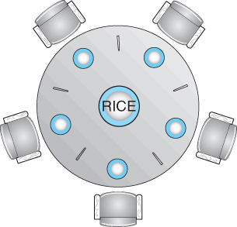  
**Figure 5.13 - The situation of the dining philosophers**

* One possible solution, as shown in the following code section, is to use a set of five semaphores ( chopsticks[ 5 ] ), and to have each hungry philosopher first wait on their left chopstick ( chopsticks[ i ] ), and then wait on their right chopstick ( chopsticks[ ( i + 1 ) % 5 ] )
* But suppose that all five philosophers get hungry at the same time, and each starts by picking up their left chopstick. They then look for their right chopstick, but because it is unavailable, they wait for it, forever, and eventually all the philosophers starve due to the resulting deadlock.

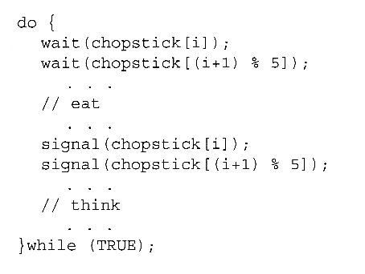  
**Figure 5.14 - The structure of philosopher i.**

* Some potential solutions to the problem include:
  + Only allow four philosophers to dine at the same time. ( Limited simultaneous processes. )
  + Allow philosophers to pick up chopsticks only when both are available, in a critical section. ( All or nothing allocation of critical resources. )
  + Use an asymmetric solution, in which odd philosophers pick up their left chopstick first and even philosophers pick up their right chopstick first. ( Will this solution always work? What if there are an even number of philosophers? )
* Note carefully that a deadlock-free solution to the dining philosophers problem does not necessarily guarantee a starvation-free one. ( While some or even most of the philosophers may be able to get on with their normal lives of eating and thinking, there may be one unlucky soul who never seems to be able to get both chopsticks at the same time. :-(

**5.8 Monitors**

* Semaphores can be very useful for solving concurrency problems, ***but only if programmers use them properly.*** If even one process fails to abide by the proper use of semaphores, either accidentally or deliberately, then the whole system breaks down. ( And since concurrency problems are by definition rare events, the problem code may easily go unnoticed and/or be heinous to debug. )
* For this reason a higher-level language construct has been developed, called ***monitors***.

**5.8.1 Monitor Usage**

* A monitor is essentially a class, in which all data is private, and with the special restriction that only one method within any given monitor object may be active at the same time. An additional restriction is that monitor methods may only access the shared data within the monitor and any data passed to them as parameters. I.e. they cannot access any data external to the monitor.

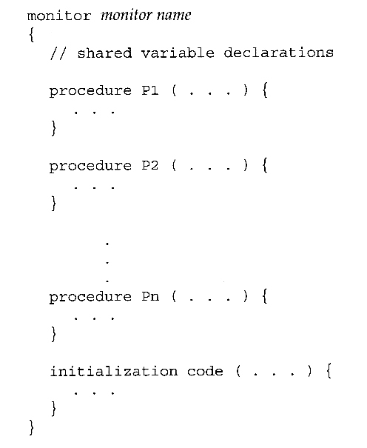  
**Figure 5.15 - Syntax of a monitor.**

* Figure 5.16 shows a schematic of a monitor, with an entry queue of processes waiting their turn to execute monitor operations ( methods. )

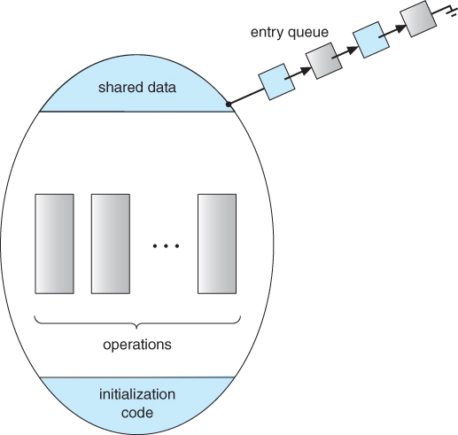  
**Figure 5.16 - Schematic view of a monitor**

* In order to fully realize the potential of monitors, we need to introduce one additional new data type, known as a ***condition***.
  + A variable of type condition has only two legal operations, ***wait*** and ***signal****.* I.e. if X was defined as type condition, then legal operations would be X.wait( ) and X.signal( )
  + The wait operation blocks a process until some other process calls signal, and adds the blocked process onto a list associated with that condition.
  + The signal process does nothing if there are no processes waiting on that condition. Otherwise it wakes up exactly one process from the condition's list of waiting processes. ( Contrast this with counting semaphores, which always affect the semaphore on a signal call. )
* Figure 6.18 below illustrates a monitor that includes condition variables within its data space. Note that the condition variables, along with the list of processes currently waiting for the conditions, are in the data space of the monitor - The processes on these lists are not "in" the monitor, in the sense that they are not executing any code in the monitor.

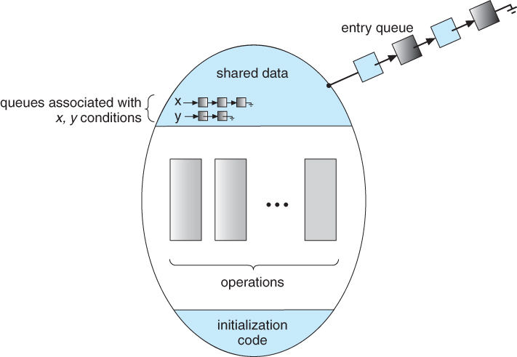  
**Figure 5.17 - Monitor with condition variables**

* But now there is a potential problem - If process P within the monitor issues a signal that would wake up process Q also within the monitor, then there would be two processes running simultaneously within the monitor, violating the exclusion requirement. Accordingly there are two possible solutions to this dilemma:

**Signal and wait** - When process P issues the signal to wake up process Q, P then waits, either for Q to leave the monitor or on some other condition.

**Signal and continue** - When P issues the signal, Q waits, either for P to exit the monitor or for some other condition.

There are arguments for and against either choice. Concurrent Pascal offers a third alternative - The signal call causes the signaling process to immediately exit the monitor, so that the waiting process can then wake up and proceed.

* Java and C# ( C sharp ) offer monitors bulit-in to the language. Erlang offers similar but different constructs.

**5.8.2 Dining-Philosophers Solution Using Monitors**

* This solution to the dining philosophers uses monitors, and the restriction that a philosopher may only pick up chopsticks when both are available. There are also two key data structures in use in this solution:
  1. **enum { THINKING, HUNGRY,EATING } state[ 5 ];** A philosopher may only set their state to eating when neither of their adjacent neighbors is eating. ( state[ ( i + 1 ) % 5 ] != EATING && state[ ( i + 4 ) % 5 ] != EATING ).
  2. **condition self[ 5 ];**This condition is used to delay a hungry philosopher who is unable to acquire chopsticks.
* In the following solution philosophers share a monitor, DiningPhilosophers, and eat using the following sequence of operations:
  1. DiningPhilosophers.pickup( ) - Acquires chopsticks, which may block the process.
  2. eat
  3. DiningPhilosophers.putdown( ) - Releases the chopsticks.

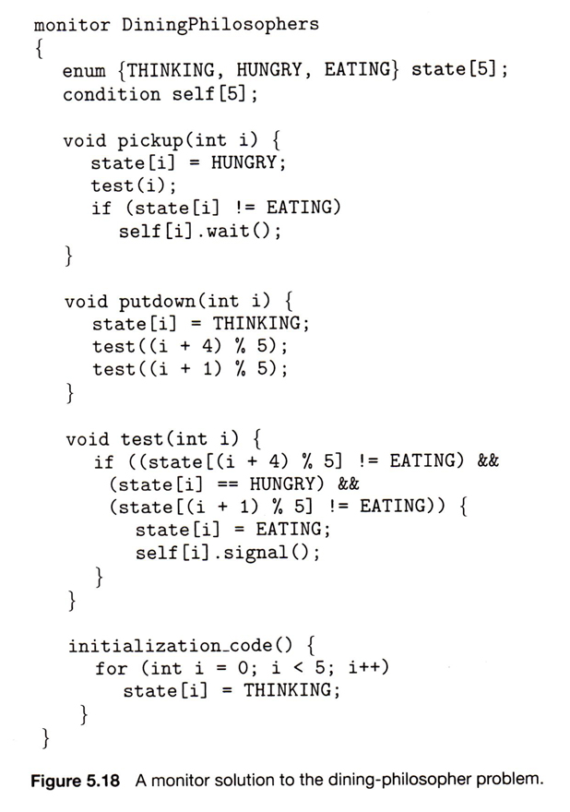

**5.8.3 Implementing a Monitor Using Semaphores**

* One possible implementation of a monitor uses a semaphore "mutex" to control mutual exclusionary access to the monitor, and a counting semaphore "next" on which processes can suspend themselves after they are already "inside" the monitor ( in conjunction with condition variables, see below. ) The integer next\_count keeps track of how many processes are waiting in the next queue. Externally accessible monitor processes are then implemented as:

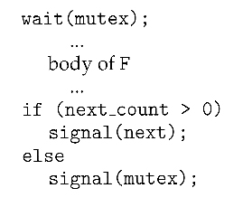

* Condition variables can be implemented using semaphores as well. For a condition x, a semaphore "x\_sem" and an integer "x\_count" are introduced, both initialized to zero. The wait and signal methods are then implemented as follows. ( This approach to the condition implements the signal-and-wait option described above for ensuring that only one process at a time is active inside the monitor. )

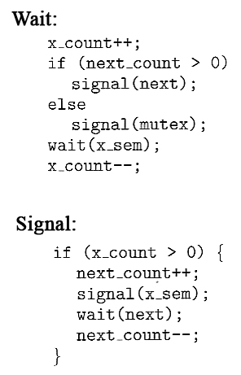

**5.8.4 Resuming Processes Within a Monitor**

* When there are multiple processes waiting on the same condition within a monitor, how does one decide which one to wake up in response to a signal on that condition? One obvious approach is FCFS, and this may be suitable in many cases.
* Another alternative is to assign ( integer ) priorities, and to wake up the process with the smallest ( best ) priority.
* Figure 5.19 illustrates the use of such a condition within a monitor used for resource allocation. Processes wishing to access this resource must specify the time they expect to use it using the acquire( time ) method, and must call the release( ) method when they are done with the resource.

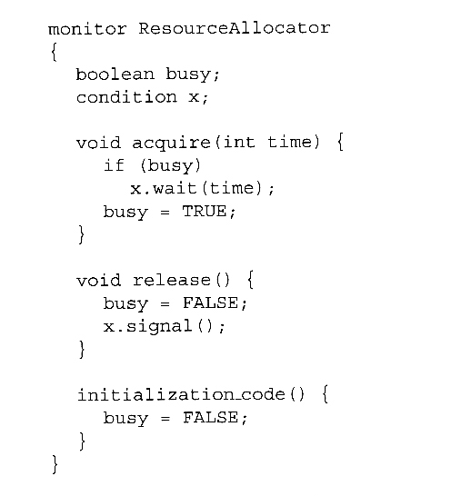  
**Figure 5.19 - A monitor to allocate a single resource.**

* Unfortunately the use of monitors to restrict access to resources still only works if programmers make the requisite acquire and release calls properly. One option would be to place the resource allocation code into the monitor, thereby eliminating the option for programmers to bypass or ignore the monitor, but then that would substitute the monitor's scheduling algorithms for whatever other scheduling algorithms may have been chosen for that particular resource. Chapter 14 on Protection presents more advanced methods for enforcing "nice" cooperation among processes contending for shared resources.
* Concurrent Pascal, Mesa, C#, and Java all implement monitors as described here. Erlang provides concurrency support using a similar mechanism.

**5.9 Synchronization Examples ( Optional )**

This section looks at how synchronization is handled in a number of different systems.

**5.9.1 Synchronization in Windows**

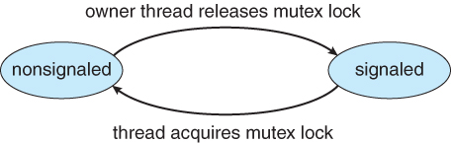  
**Figure 5.20 - Mutex dispatcher object**

**5.9.2 Synchronization in Linux**

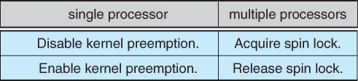

**5.9.3 Synchronization in Solaris**

* Solaris controls access to critical sections using five tools: semaphores, condition variables, adaptive mutexes, reader-writer locks, and turnstiles. The first two are as described above, and the other three are described here:

**Adaptive Mutexes**

* Adaptive mutexes are basically binary semaphores that are implemented differently depending upon the conditions:
  + On a single processor system, the semaphore sleeps when it is blocked, until the block is released.
  + On a multi-processor system, if the thread that is blocking the semaphore is running on the same processor as the thread that is blocked, or if the blocking thread is not running at all, then the blocked thread sleeps just like a single processor system.
  + However if the blocking thread is currently running on a different processor than the blocked thread, then the blocked thread does a spinlock, under the assumption that the block will soon be released.
  + Adaptive mutexes are only used for protecting short critical sections, where the benefit of not doing context switching is worth a short bit of spinlocking. Otherwise traditional semaphores and condition variables are used.

**Reader-Writer Locks**

* Reader-writer locks are used only for protecting longer sections of code which are accessed frequently but which are changed infrequently.

**Turnstiles**

* A ***turnstile*** is a queue of threads waiting on a lock.
* Each synchronized object which has threads blocked waiting for access to it needs a separate turnstile. For efficiency, however, the turnstile is associated with the thread currently holding the object, rather than the object itself.
* In order to prevent ***priority inversion,***the thread holding a lock for an object will temporarily acquire the highest priority of any process in the turnstile waiting for the blocked object. This is called a ***priority-inheritance protocol.***
* User threads are controlled the same as for kernel threads, except that the priority-inheritance protocol does not apply.

**5.9 4 Pthreads Synchronization( was 6.8.4 )**

**5.10 Alternate Approaches ( Optional )**

**5.10.1 Transactional Memory**

**5.10.2 OpenMP**

**5.10.3 Functional Programming Languages**

**5.11 Summary**

**Old 6.9 Atomic Transactions ( Optional, Not in Ninth Edition )**

* Database operations frequently need to carry out ***atomic transactions,*** in which the entire transaction must either complete or not occur at all. The classic example is a transfer of funds, which involves withdrawing funds from one account and depositing them into another - Either both halves of the transaction must complete, or neither must complete.
* Operating Systems can be viewed as having many of the same needs and problems as databases, in that an OS can be said to manage a small database of process-related information. As such, OSes can benefit from emulating some of the techniques originally developed for databases. Here we first look at some of those techniques, and then how they can be used to benefit OS development.

**6.9.1 System Model**

* A transaction is a series of actions that must either complete in its entirety or must be ***rolled-back*** as if it had never commenced.
* The system is considered to have three types of storage:
  + Volatile storage usually gets lost in a system crash.
  + Non-volatile storage usually survives system crashes, but may still get lost.
  + Stable storage "never" gets lost or damaged. In practice this is implemented using multiple copies stored on different media with different failure modes.

**6.9.2 Log-Based Recovery**

* ***Before*** each step of a transaction is conducted, a entry is written to a log on stable storage:
  + Each transaction has a unique serial number.
  + The first entry is a "start"
  + Every data changing entry specifies the transaction number, the old value, and the new value.
  + The final entry is a "commit".
  + All transactions are idempotent - The can be repeated any number of times and the effect is the same as doing them once. Likewise they can be undone any number of times and the effect is the same as undoing them once. ( I.e. "change x from 5 to 6", rather than "add 1 to x" ).
* After a crash, any transaction which has "commit" recorded in the log can be redone from the log information. Any which has "start" but not "commit" can be undone.

**6.9.3 Checkpoints**

* In the event of a crash, all data can be recovered using the system described above, by going through the entire log and performing either redo or undo operations on all the transactions listed there.
* Unfortunately this approach can be slow and wasteful, because many transactions are repeated that were not lost in the crash.
* Alternatively, one can periodically establish a ***checkpoint,***as follows:
  + Write all data that has been affected by recent transactions ( since the last checkpoint ) to stable storage.
  + Write a <checkpoint> entry to the log.
* Now for crash recovery one only needs to find transactions that did not commit prior to the most recent checkpoint. Specifically one looks backwards from the end of the log for the last <checkpoint> record, and then looks backward from there for the most recent transaction that started before the checkpoint. Only that transaction and the ones more recent need to be redone or undone.

**6.9.4 Concurrent Atomic Transactions**

* All of the previous discussion on log-based recovery assumed that only one transaction could be conducted at a time. We now relax that restriction, and allow multiple transactions to occur concurrently, while still keeping each individual transaction atomic.

**6.9.4.1 Serializability**

* Figure 6.22 below shows a ***schedule***in which transaction 0 reads and writes data items A and B, followed by transaction 1 which also reads and writes A and B.
* This is termed a***serial schedule***, because the two transactions are conducted serially. For any N transactions, there are N! possible serial schedules.
* A ***nonserial schedule*** is one in which the steps of the transactions are not completely serial, i.e. they interleave in some manner.
* Nonserial schedules are not necessarily bad or wrong, so long as they can be shown to be equivalent to some serial schedule. A nonserial schedule that can be converted to a serial one is said to be ***conflict serializable,***such as that shown in Figure 6.23 below. Legal steps in the conversion are as follows:
  + Two operations from different transactions are said to be ***conflicting*** if they involve the same data item and at least one of the operations is a write operations. Operations from two transactions are ***non-conflicting*** if they either involve different data items or do not involve any write operations.
  + Two operations in a schedule can be swapped if they are from two different transactions and if they are non-conflicting.
  + A schedules is conflict serializable if there exists a series of valid swap that converts the schedule into a serial schedule.

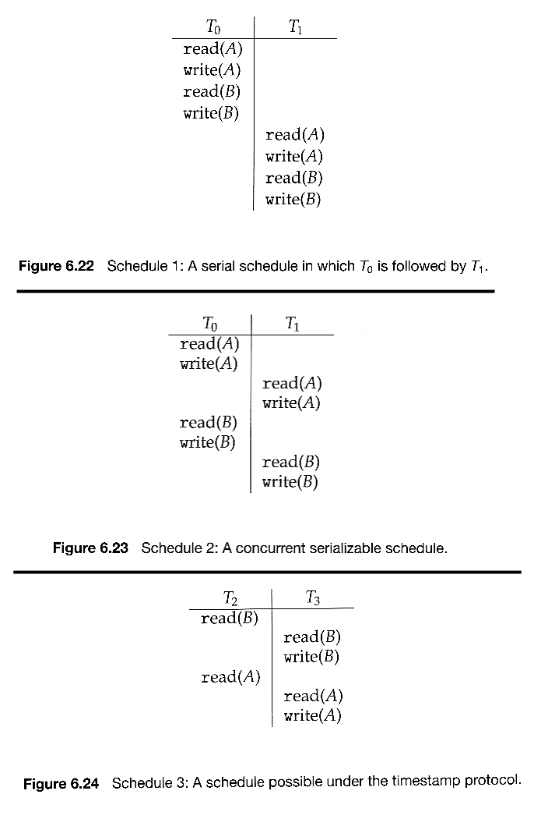

**6.9.4.2 Locking Protocol**

* One way to ensure serializability is to use locks on data items during atomic transactions.
* Shared and Exclusive locks correspond to the Readers and Writers problem discussed above.
* The ***two-phase locking protocol*** operates in two phases:
  + A ***growing phase,***in which the transaction continues to gain additional locks on data items as it needs them, and has not yet relinquished any of its locks.
  + A ***shrinking phase,***in which it relinquishes locks. Once a transaction releases any lock, then it is in the shrinking phase and cannot acquire any more locks.
* The two-phase locking protocol can be proven to yield serializable schedules, but it does not guarantee avoidance of deadlock. There may also be perfectly valid serializable schedules that are unobtainable with this protocol.

**6.9.4.3 Timestamp-Based Protocols**

* Under the timestamp protocol, each ***transaction*** is issued a unique timestamp entry before it begins execution. This can be the system time on systems where all process access the same clock, or some non-decreasing serial number. The timestamp for transaction Ti is denoted TS( Ti )
* The schedules generated are all equivalent to a serial schedule occurring in timestamp order.
* Each ***data item*** also has two timestamp values associated with it - The W-timestamp is the timestamp of the last transaction to successfully write the data item, and the R-timestamp is the stamp of the last transaction to successfully read from it. ( Note that these are the timestamps of the respective transactions, not the time at which the read or write occurred. )
* The timestamps are used in the following manner:
  + Suppose transaction Ti issues a read on data item Q:
    - If TS( Ti ) < the W-timestamp for Q, then it is attempting to read data that has been changed. Transaction Ti is rolled back, and restarted with a new timestamp.
    - If TS( Ti ) > the W-timestamp for Q, then the R-timestamp for Q is updated to the later of its current value and TS( Ti ).
  + Suppose Ti issues a write on Q:
    - If TS( Ti ) < the R-timestamp for Q, then it is attempting to change data that has already been read in its unaltered state. Ti is rolled back and restarted with a new timestamp.
    - If TS( Ti ) < the W-timestamp for Q it is also rolled back and restarted, for similar reasons.
    - Otherwise, the operation proceeds, and the W-timestamp for Q is updated to TS( Ti ).

Chapter 6\*\*\*\*\*\*\*\*\*\*\*\*\*\*\*\*\*\*\*\*\*\*\*\*\*\*\*\*\*\*\*\*\*\*\*\*\*\*\*\*\*\*\*\*\*\*\*\*\*\*\*\*\*\*\*\*\*\*\*\*

**CPU Scheduling**

**References:**

1. Abraham Silberschatz, Greg Gagne, and Peter Baer Galvin, "Operating System Concepts, Ninth Edition ", Chapter 6

**6.1 Basic Concepts**

* Almost all programs have some alternating cycle of CPU number crunching and waiting for I/O of some kind. ( Even a simple fetch from memory takes a long time relative to CPU speeds. )
* In a simple system running a single process, the time spent waiting for I/O is wasted, and those CPU cycles are lost forever.
* A scheduling system allows one process to use the CPU while another is waiting for I/O, thereby making full use of otherwise lost CPU cycles.
* The challenge is to make the overall system as "efficient" and "fair" as possible, subject to varying and often dynamic conditions, and where "efficient" and "fair" are somewhat subjective terms, often subject to shifting priority policies.

**6.1.1 CPU-I/O Burst Cycle**

* Almost all processes alternate between two states in a continuing***cycle***, as shown in Figure 6.1 below ***:***
  + A CPU burst of performing calculations, and
  + An I/O burst, waiting for data transfer in or out of the system.

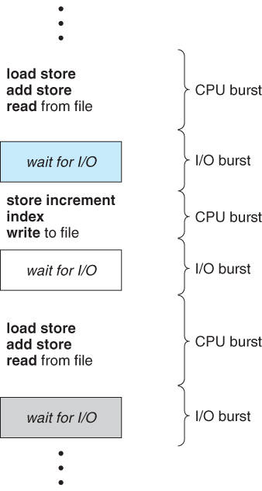  
**Figure 6.1 - Alternating sequence of CPU and I/O bursts.**

* CPU bursts vary from process to process, and from program to program, but an extensive study shows frequency patterns similar to that shown in Figure 6.2:

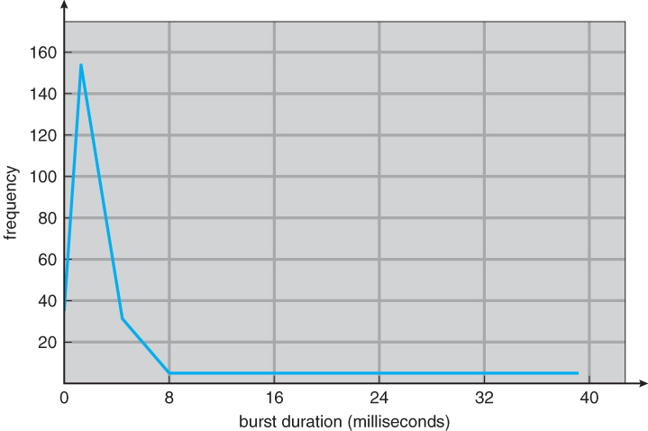  
**Figure 6.2 - Histogram of CPU-burst durations.**

**6.1.2 CPU Scheduler**

* Whenever the CPU becomes idle, it is the job of the CPU Scheduler ( a.k.a. the short-term scheduler ) to select another process from the ready queue to run next.
* The storage structure for the ready queue and the algorithm used to select the next process are not necessarily a FIFO queue. There are several alternatives to choose from, as well as numerous adjustable parameters for each algorithm, which is the basic subject of this entire chapter.

**6.1.3. Preemptive Scheduling**

* CPU scheduling decisions take place under one of four conditions:
  1. When a process switches from the running state to the waiting state, such as for an I/O request or invocation of the wait( ) system call.
  2. When a process switches from the running state to the ready state, for example in response to an interrupt.
  3. When a process switches from the waiting state to the ready state, say at completion of I/O or a return from wait( ).
  4. When a process terminates.
* For conditions 1 and 4 there is no choice - A new process must be selected.
* For conditions 2 and 3 there is a choice - To either continue running the current process, or select a different one.
* If scheduling takes place only under conditions 1 and 4, the system is said to be***non-preemptive***, or ***cooperative***. Under these conditions, once a process starts running it keeps running, until it either voluntarily blocks or until it finishes. Otherwise the system is said to be ***preemptive.***
* Windows used non-preemptive scheduling up to Windows 3.x, and started using pre-emptive scheduling with Win95. Macs used non-preemptive prior to OSX, and pre-emptive since then. Note that pre-emptive scheduling is only possible on hardware that supports a timer interrupt.
* Note that pre-emptive scheduling can cause problems when two processes share data, because one process may get interrupted in the middle of updating shared data structures. Chapter 5 examined this issue in greater detail.
* Preemption can also be a problem if the kernel is busy implementing a system call ( e.g. updating critical kernel data structures ) when the preemption occurs. Most modern UNIXes deal with this problem by making the process wait until the system call has either completed or blocked before allowing the preemption Unfortunately this solution is problematic for real-time systems, as real-time response can no longer be guaranteed.
* Some critical sections of code protect themselves from con currency problems by disabling interrupts before entering the critical section and re-enabling interrupts on exiting the section. Needless to say, this should only be done in rare situations, and only on very short pieces of code that will finish quickly, ( usually just a few machine instructions. )

**6.1.4 Dispatcher**

* The **dispatcher** is the module that gives control of the CPU to the process selected by the scheduler. This function involves:
  + Switching context.
  + Switching to user mode.
  + Jumping to the proper location in the newly loaded program.
* The dispatcher needs to be as fast as possible, as it is run on every context switch. The time consumed by the dispatcher is known as **dispatch latency.**

**6.2 Scheduling Criteria**

* There are several different criteria to consider when trying to select the "best" scheduling algorithm for a particular situation and environment, including:
  + **CPU utilization** - Ideally the CPU would be busy 100% of the time, so as to waste 0 CPU cycles. On a real system CPU usage should range from 40% ( lightly loaded ) to 90% ( heavily loaded. )
  + **Throughput** - Number of processes completed per unit time. May range from 10 / second to 1 / hour depending on the specific processes.
  + **Turnaround time** - Time required for a particular process to complete, from submission time to completion. ( Wall clock time. )
  + **Waiting time** - How much time processes spend in the ready queue waiting their turn to get on the CPU.
    - ( **Load average** - The average number of processes sitting in the ready queue waiting their turn to get into the CPU. Reported in 1-minute, 5-minute, and 15-minute averages by "uptime" and "who". )
  + **Response time** - The time taken in an interactive program from the issuance of a command to the ***commence*** of a response to that command.
* In general one wants to optimize the average value of a criteria ( Maximize CPU utilization and throughput, and minimize all the others. ) However some times one wants to do something different, such as to minimize the maximum response time.
* Sometimes it is most desirable to minimize the ***variance*** of a criteria than the actual value. I.e. users are more accepting of a consistent predictable system than an inconsistent one, even if it is a little bit slower.

**6.3 Scheduling Algorithms**

The following subsections will explain several common scheduling strategies, looking at only a single CPU burst each for a small number of processes. Obviously real systems have to deal with a lot more simultaneous processes executing their CPU-I/O burst cycles.

**6.3.1 First-Come First-Serve Scheduling, FCFS**

* FCFS is very simple - Just a FIFO queue, like customers waiting in line at the bank or the post office or at a copying machine.
* Unfortunately, however, FCFS can yield some very long average wait times, particularly if the first process to get there takes a long time. For example, consider the following three processes:

|  |  |
| --- | --- |
| **Process** | **Burst Time** |
| P1 | 24 |
| P2 | 3 |
| P3 | 3 |

* In the first Gantt chart below, process P1 arrives first. The average waiting time for the three processes is ( 0 + 24 + 27 ) / 3 = 17.0 ms.
* In the second Gantt chart below, the same three processes have an average wait time of ( 0 + 3 + 6 ) / 3 = 3.0 ms. The total run time for the three bursts is the same, but in the second case two of the three finish much quicker, and the other process is only delayed by a short amount.

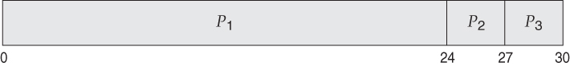

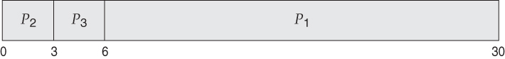

* FCFS can also block the system in a busy dynamic system in another way, known as the ***convoy effect***. When one CPU intensive process blocks the CPU, a number of I/O intensive processes can get backed up behind it, leaving the I/O devices idle. When the CPU hog finally relinquishes the CPU, then the I/O processes pass through the CPU quickly, leaving the CPU idle while everyone queues up for I/O, and then the cycle repeats itself when the CPU intensive process gets back to the ready queue.

**6.3.2 Shortest-Job-First Scheduling, SJF**

* The idea behind the SJF algorithm is to pick the quickest fastest little job that needs to be done, get it out of the way first, and then pick the next smallest fastest job to do next.
* ( Technically this algorithm picks a process based on the next shortest**CPU burst**, not the overall process time. )
* For example, the Gantt chart below is based upon the following CPU burst times, ( and the assumption that all jobs arrive at the same time. )

|  |  |
| --- | --- |
| **Process** | **Burst Time** |
| P1 | 6 |
| P2 | 8 |
| P3 | 7 |
| P4 | 3 |

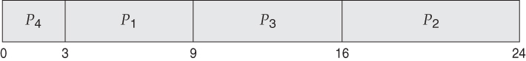

* In the case above the average wait time is ( 0 + 3 + 9 + 16 ) / 4 = 7.0 ms, ( as opposed to 10.25 ms for FCFS for the same processes. )
* SJF can be proven to be the fastest scheduling algorithm, but it suffers from one important problem: How do you know how long the next CPU burst is going to be?
  + For long-term batch jobs this can be done based upon the limits that users set for their jobs when they submit them, which encourages them to set low limits, but risks their having to re-submit the job if they set the limit too low. However that does not work for short-term CPU scheduling on an interactive system.
  + Another option would be to statistically measure the run time characteristics of jobs, particularly if the same tasks are run repeatedly and predictably. But once again that really isn't a viable option for short term CPU scheduling in the real world.
  + A more practical approach is to ***predict*** the length of the next burst, based on some historical measurement of recent burst times for this process. One simple, fast, and relatively accurate method is the ***exponential average***, which can be defined as follows. ( The book uses tau and t for their variables, but those are hard to distinguish from one another and don't work well in HTML. )

estimate[ i + 1 ] = alpha \* burst[ i ] + ( 1.0 - alpha ) \* estimate[ i ]

* + In this scheme the previous estimate contains the history of all previous times, and alpha serves as a weighting factor for the relative importance of recent data versus past history. If alpha is 1.0, then past history is ignored, and we assume the next burst will be the same length as the last burst. If alpha is 0.0, then all measured burst times are ignored, and we just assume a constant burst time. Most commonly alpha is set at 0.5, as illustrated in Figure 5.3:

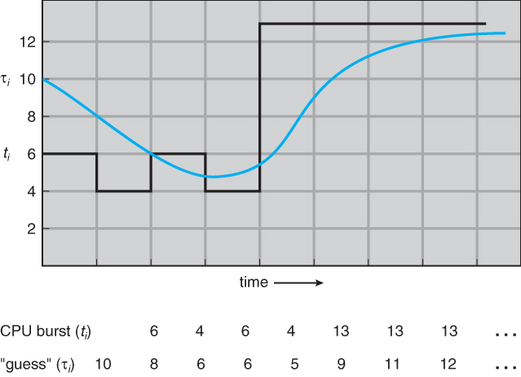  
**Figure 6.3 - Prediction of the length of the next CPU burst.**

* SJF can be either preemptive or non-preemptive. Preemption occurs when a new process arrives in the ready queue that has a predicted burst time shorter than the time remaining in the process whose burst is currently on the CPU. Preemptive SJF is sometimes referred to as ***shortest remaining time first scheduling.***
* For example, the following Gantt chart is based upon the following data:

|  |  |  |
| --- | --- | --- |
| **Process** | **Arrival Time** | **Burst Time** |
| P1 | 0 | 8 |
| P2 | 1 | 4 |
| P3 | 2 | 9 |
| p4 | 3 | 5 |

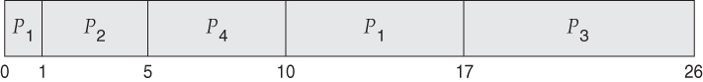

* The average wait time in this case is ( ( 5 - 3 ) + ( 10 - 1 ) + ( 17 - 2 ) ) / 4 = 26 / 4 = 6.5 ms. ( As opposed to 7.75 ms for non-preemptive SJF or 8.75 for FCFS. )

**6.3.3 Priority Scheduling**

* Priority scheduling is a more general case of SJF, in which each job is assigned a priority and the job with the highest priority gets scheduled first. ( SJF uses the inverse of the next expected burst time as its priority - The smaller the expected burst, the higher the priority. )
* Note that in practice, priorities are implemented using integers within a fixed range, but there is no agreed-upon convention as to whether "high" priorities use large numbers or small numbers. This book uses low number for high priorities, with 0 being the highest possible priority.
* For example, the following Gantt chart is based upon these process burst times and priorities, and yields an average waiting time of 8.2 ms:

|  |  |  |
| --- | --- | --- |
| **Process** | **Burst Time** | **Priority** |
| P1 | 10 | 3 |
| P2 | 1 | 1 |
| P3 | 2 | 4 |
| P4 | 1 | 5 |
| P5 | 5 | 2 |

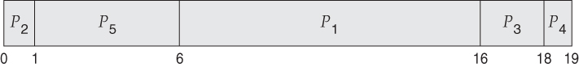

* Priorities can be assigned either internally or externally. Internal priorities are assigned by the OS using criteria such as average burst time, ratio of CPU to I/O activity, system resource use, and other factors available to the kernel. External priorities are assigned by users, based on the importance of the job, fees paid, politics, etc.
* Priority scheduling can be either preemptive or non-preemptive.
* Priority scheduling can suffer from a major problem known as ***indefinite blocking***, or ***starvation***, in which a low-priority task can wait forever because there are always some other jobs around that have higher priority.
  + If this problem is allowed to occur, then processes will either run eventually when the system load lightens ( at say 2:00 a.m. ), or will eventually get lost when the system is shut down or crashes. ( There are rumors of jobs that have been stuck for years. )
  + One common solution to this problem is ***aging***, in which priorities of jobs increase the longer they wait. Under this scheme a low-priority job will eventually get its priority raised high enough that it gets run.

**6.3.4 Round Robin Scheduling**

* Round robin scheduling is similar to FCFS scheduling, except that CPU bursts are assigned with limits called ***time quantum***.
* When a process is given the CPU, a timer is set for whatever value has been set for a time quantum.
  + If the process finishes its burst before the time quantum timer expires, then it is swapped out of the CPU just like the normal FCFS algorithm.
  + If the timer goes off first, then the process is swapped out of the CPU and moved to the back end of the ready queue.
* The ready queue is maintained as a circular queue, so when all processes have had a turn, then the scheduler gives the first process another turn, and so on.
* RR scheduling can give the effect of all processors sharing the CPU equally, although the average wait time can be longer than with other scheduling algorithms. In the following example the average wait time is 5.66 ms.

|  |  |
| --- | --- |
| **Process** | **Burst Time** |
| P1 | 24 |
| P2 | 3 |
| P3 | 3 |

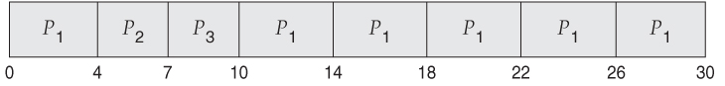

* The performance of RR is sensitive to the time quantum selected. If the quantum is large enough, then RR reduces to the FCFS algorithm; If it is very small, then each process gets 1/nth of the processor time and share the CPU equally.
* **BUT**, a real system invokes overhead for every context switch, and the smaller the time quantum the more context switches there are. ( See Figure 6.4 below. ) Most modern systems use time quantum between 10 and 100 milliseconds, and context switch times on the order of 10 microseconds, so the overhead is small relative to the time quantum.

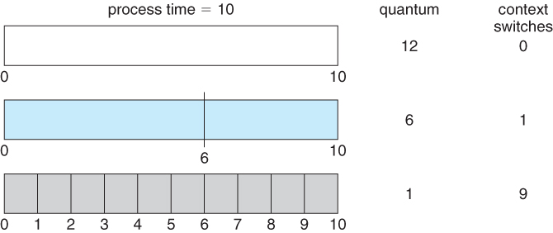  
**Figure 6.4 - The way in which a smaller time quantum increases context switches.**

* Turn around time also varies with quantum time, in a non-apparent manner. Consider, for example the processes shown in Figure 6.5:

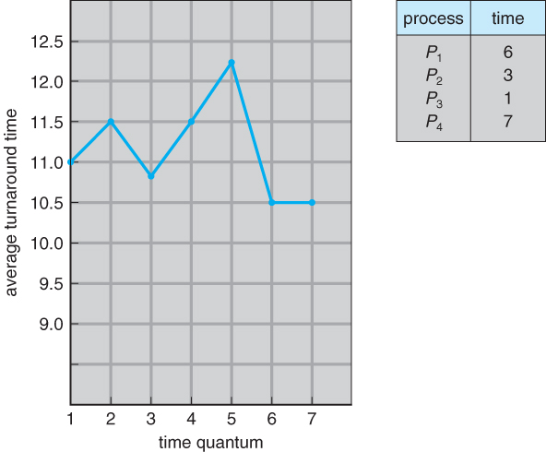  
**Figure 6.5 - The way in which turnaround time varies with the time quantum.**

* In general, turnaround time is minimized if most processes finish their next cpu burst within one time quantum. For example, with three processes of 10 ms bursts each, the average turnaround time for 1 ms quantum is 29, and for 10 ms quantum it reduces to 20. However, if it is made too large, then RR just degenerates to FCFS. A rule of thumb is that 80% of CPU bursts should be smaller than the time quantum.

**6.3.5 Multilevel Queue Scheduling**

* When processes can be readily categorized, then multiple separate queues can be established, each implementing whatever scheduling algorithm is most appropriate for that type of job, and/or with different parametric adjustments.
* Scheduling must also be done between queues, that is scheduling one queue to get time relative to other queues. Two common options are strict priority ( no job in a lower priority queue runs until all higher priority queues are empty ) and round-robin ( each queue gets a time slice in turn, possibly of different sizes. )
* Note that under this algorithm jobs cannot switch from queue to queue - Once they are assigned a queue, that is their queue until they finish.

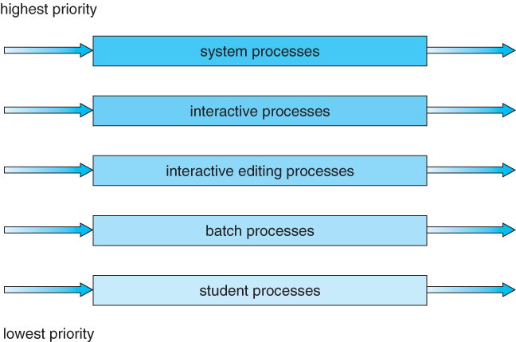  
**Figure 6.6 - Multilevel queue scheduling**

**6.3.6 Multilevel Feedback-Queue Scheduling**

* Multilevel feedback queue scheduling is similar to the ordinary multilevel queue scheduling described above, except jobs may be moved from one queue to another for a variety of reasons:
  + If the characteristics of a job change between CPU-intensive and I/O intensive, then it may be appropriate to switch a job from one queue to another.
  + Aging can also be incorporated, so that a job that has waited for a long time can get bumped up into a higher priority queue for a while.
* Multilevel feedback queue scheduling is the most flexible, because it can be tuned for any situation. But it is also the most complex to implement because of all the adjustable parameters. Some of the parameters which define one of these systems include:
  + The number of queues.
  + The scheduling algorithm for each queue.
  + The methods used to upgrade or demote processes from one queue to another. ( Which may be different. )
  + The method used to determine which queue a process enters initially.

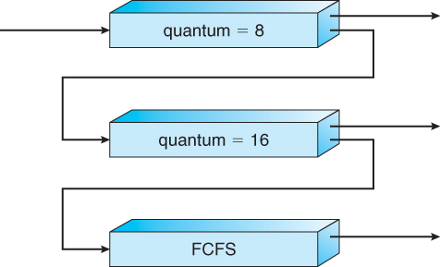  
**Figure 6.7 - Multilevel feedback queues.**

**6.4 Thread Scheduling**

* The process scheduler schedules only the kernel threads.
* User threads are mapped to kernel threads by the thread library - The OS ( and in particular the scheduler ) is unaware of them.

**6.4.1 Contention Scope**

* ***Contention scope*** refers to the scope in which threads compete for the use of physical CPUs.
* On systems implementing many-to-one and many-to-many threads, ***Process Contention Scope, PCS,***occurs, because competition occurs between threads that are part of the same process. ( This is the management / scheduling of multiple user threads on a single kernel thread, and is managed by the thread library. )
* ***System Contention Scope, SCS,***involves the system scheduler scheduling kernel threads to run on one or more CPUs. Systems implementing one-to-one threads ( XP, Solaris 9, Linux ), use only SCS.
* PCS scheduling is typically done with priority, where the programmer can set and/or change the priority of threads created by his or her programs. Even time slicing is not guaranteed among threads of equal priority.

**6.4.2 Pthread Scheduling**

* The Pthread library provides for specifying scope contention:
  + PTHREAD\_SCOPE\_PROCESS schedules threads using PCS, by scheduling user threads onto available LWPs using the many-to-many model.
  + PTHREAD\_SCOPE\_SYSTEM schedules threads using SCS, by binding user threads to particular LWPs, effectively implementing a one-to-one model.
* getscope and setscope methods provide for determining and setting the scope contention respectively:

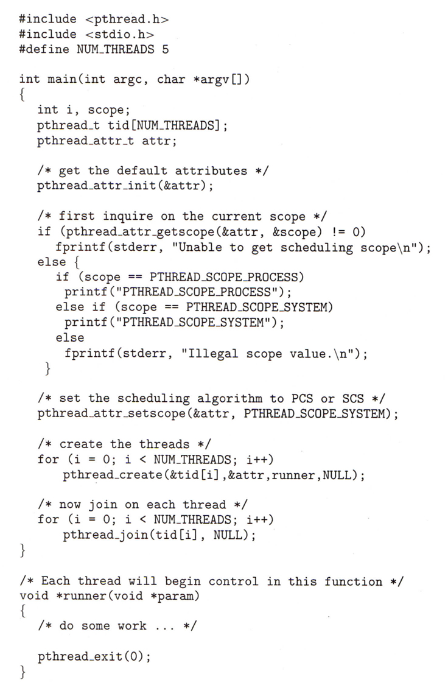  
**Figure 6.8 - Pthread scheduling API.**

**6.5 Multiple-Processor Scheduling**

* When multiple processors are available, then the scheduling gets more complicated, because now there is more than one CPU which must be kept busy and in effective use at all times.
* ***Load sharing*** revolves around balancing the load between multiple processors.
* Multi-processor systems may be **heterogeneous,**( different kinds of CPUs ), or **homogenous,**( all the same kind of CPU ). Even in the latter case there may be special scheduling constraints, such as devices which are connected via a private bus to only one of the CPUs. This book will restrict its discussion to homogenous systems.

**6.5.1 Approaches to Multiple-Processor Scheduling**

* One approach to multi-processor scheduling is ***asymmetric multiprocessing,***in which one processor is the master, controlling all activities and running all kernel code, while the other runs only user code. This approach is relatively simple, as there is no need to share critical system data.
* Another approach is ***symmetric multiprocessing, SMP,***where each processor schedules its own jobs, either from a common ready queue or from separate ready queues for each processor.
* Virtually all modern OSes support SMP, including XP, Win 2000, Solaris, Linux, and Mac OSX.

**6.5.2 Processor Affinity**

* Processors contain cache memory, which speeds up repeated accesses to the same memory locations.
* If a process were to switch from one processor to another each time it got a time slice, the data in the cache ( for that process ) would have to be invalidated and re-loaded from main memory, thereby obviating the benefit of the cache.
* Therefore SMP systems attempt to keep processes on the same processor, via ***processor affinity.*** ***Soft affinity*** occurs when the system attempts to keep processes on the same processor but makes no guarantees. Linux and some other OSes support ***hard affinity,***in which a process specifies that it is not to be moved between processors.
* Main memory architecture can also affect process affinity, if particular CPUs have faster access to memory on the same chip or board than to other memory loaded elsewhere. ( Non-Uniform Memory Access, NUMA. ) As shown below, if a process has an affinity for a particular CPU, then it should preferentially be assigned memory storage in "local" fast access areas.

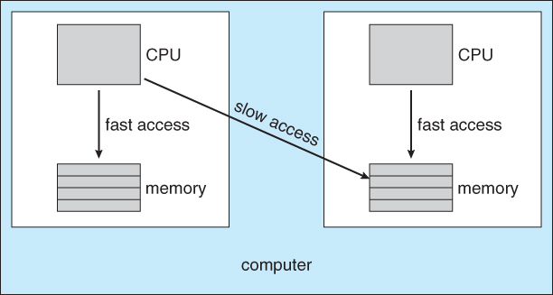  
**Figure 6.9 - NUMA and CPU scheduling.**

**6.5.3 Load Balancing**

* Obviously an important goal in a multiprocessor system is to balance the load between processors, so that one processor won't be sitting idle while another is overloaded.
* Systems using a common ready queue are naturally self-balancing, and do not need any special handling. Most systems, however, maintain separate ready queues for each processor.
* Balancing can be achieved through either ***push migration***or***pull migration:***
  + ***Push migration***involves a separate process that runs periodically, ( e.g. every 200 milliseconds ), and moves processes from heavily loaded processors onto less loaded ones.
  + ***Pull migration*** involves idle processors taking processes from the ready queues of other processors.
  + Push and pull migration are not mutually exclusive.
* Note that moving processes from processor to processor to achieve load balancing works against the principle of processor affinity, and if not carefully managed, the savings gained by balancing the system can be lost in rebuilding caches. One option is to only allow migration when imbalance surpasses a given threshold.

**6.5.4 Multicore Processors**

* Traditional SMP required multiple CPU chips to run multiple kernel threads concurrently.
* Recent trends are to put multiple CPUs ( cores ) onto a single chip, which appear to the system as multiple processors.
* Compute cycles can be blocked by the time needed to access memory, whenever the needed data is not already present in the cache. ( Cache misses. ) In Figure 5.10, as much as half of the CPU cycles are lost to memory stall.

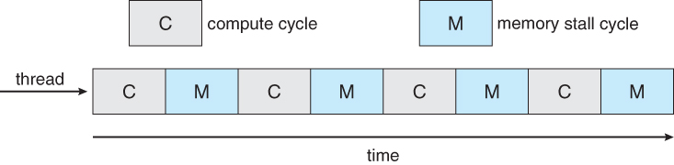  
**Figure 6.10 - Memory stall.**

* By assigning multiple kernel threads to a single processor, memory stall can be avoided ( or reduced ) by running one thread on the processor while the other thread waits for memory.

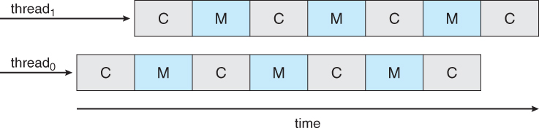  
**Figure 6.11 - Multithreaded multicore system.**

* A dual-threaded dual-core system has four logical processors available to the operating system. The UltraSPARC T1 CPU has 8 cores per chip and 4 hardware threads per core, for a total of 32 logical processors per chip.
* There are two ways to multi-thread a processor:
  1. ***Coarse-grained***multithreading switches between threads only when one thread blocks, say on a memory read. Context switching is similar to process switching, with considerable overhead.
  2. ***Fine-grained***multithreading occurs on smaller regular intervals, say on the boundary of instruction cycles. However the architecture is designed to support thread switching, so the overhead is relatively minor.
* Note that for a multi-threaded multi-core system, there are **two** levels of scheduling, **at the kernel level:**
  1. The OS schedules which kernel thread(s) to assign to which logical processors, and when to make context switches using algorithms as described above.
  2. On a lower level, the hardware schedules logical processors on each physical core using some other algorithm.
     + The UltraSPARC T1 uses a simple round-robin method to schedule the 4 logical processors ( kernel threads ) on each physical core.
     + The Intel Itanium is a dual-core chip which uses a 7-level priority scheme ( urgency ) to determine which thread to schedule when one of 5 different events occurs.

**/\* Old 5.5.5 Virtualization and Scheduling ( Optional, Omitted from 9th edition )**

* Virtualization adds another layer of complexity and scheduling.
* Typically there is one host operating system operating on "real" processor(s) and a number of guest operating systems operating on virtual processors.
* The Host OS creates some number of virtual processors and presents them to the guest OSes as if they were real processors.
* The guest OSes don't realize their processors are virtual, and make scheduling decisions on the assumption of real processors.
* As a result, interactive and especially real-time performance can be severely compromised on guest systems. The time-of-day clock will also frequently be off.

**\*/**

**6.6 Real-Time CPU Scheduling**

Real-time systems are those in which the time at which tasks complete is crucial to their performance

* ***Soft real-time systems*** have degraded performance if their timing needs cannot be met. Example: streaming video.
* ***Hard real-time systems*** have total failure if their timing needs cannot be met. Examples: Assembly line robotics, automobile air-bag deployment.

**6.6.1 Minimizing Latency**

* ***Event Latency*** is the time between the occurrence of a triggering event and the ( completion of ) the system's response to the event:

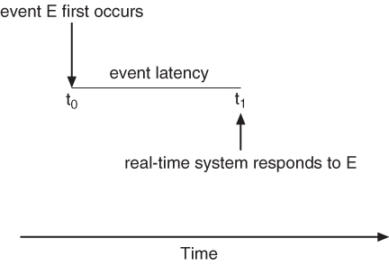  
**Figure 6.12 - Event latency.**

* In addition to the time it takes to actually process the event, there are two additional steps that must occur before the event handler ( Interrupt Service Routine, ISR ), can even start:
  + Interrupt processing determines which interrupt(s) have occurred, and which interrupt handler routine to run. In the event of simultaneous interrupts, a priority scheme is needed to determine which ISR has the highest priority and gets to go next.
  + Context switching involves removing a running process from the CPU, saving its state, and loading up the ISR so that it can run.

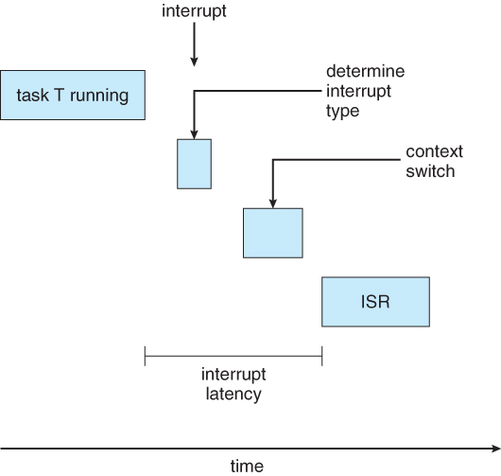  
**Figure 6.13 - Interrupt latency.**

* + The total dispatch latency ( context switching ) consists of two parts:
    - Removing the currently running process from the CPU, and freeing up any resources that are needed by the ISR. This step can be speeded up a lot by the use of pre-emptive kernels.
    - Loading the ISR up onto the CPU, ( dispatching )

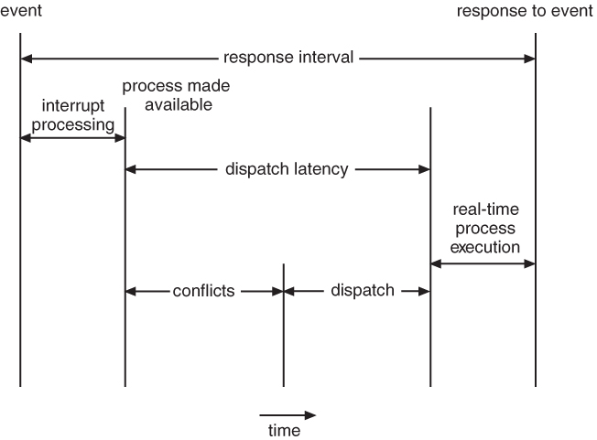  
**Figure 6.14 - Dispatch latency.**

**6.6.2 Priority-Based Scheduling**

* Real-time systems require pre-emptive priority-based scheduling systems.
* Soft real-time systems do the best they can, but make no guarantees. They are generally discussed elsewhere.
* Hard real-time systems, described here, must be able to provide firm guarantees that a tasks scheduling needs can be met.
  + One technique is to use a ***admission-control*** algorithm, in which each task must specify its needs at the time it attempts to launch, and the system will only launch the task if it can guarantee that its needs can be met.
* Hard real-time systems are often characterized by tasks that must run at regular periodic intervals, each having a period p, a constant time required to execute, ( CPU burst ), t, and a deadline after the beginning of each period by which the task must be completed, d.
* In all cases, t <= d <= p

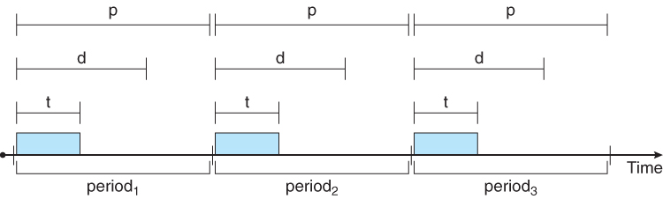  
**Figure 6.15 - Periodic task.**

**6.6.3 Rate-Monotonic Scheduling**

* The rate-monotonic scheduling algorithm uses pre-emptive scheduling with static priorities.
* Priorities are assigned inversely to the period of each task, giving higher ( better ) priority to tasks with shorter periods.
* Let's consider an example, first showing what can happen if the task with the longer period is given higher priority:
  + Suppose that process P1 has a period of 50, an execution time of 20, and a deadline that matches its period ( 50 ).
  + Similarly suppose that process P2 has period 100, execution time of 35, and deadline of 100.
  + The total CPU utilization time is 20 / 50 = 0.4 for P1, and 25 / 100 = 0.35 for P2, or 0.75 ( 75% ) overall.
  + However if P2 is allowed to go first, then P1 cannot complete before its deadline:

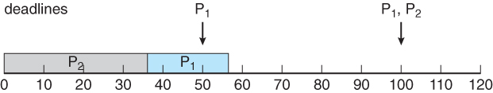  
**Figure 6.16 - Scheduling of tasks when P2 has a higher priority than P1.**

* + Now on the other hand, if P1 is given higher priority, it gets to go first, and P2 starts after P1 completes its burst.
  + At time 50 when the next period for P1 starts, P2 has only completed 30 of its 35 needed time units, but it gets pre-empted by P1.
  + At time 70, P1 completes its task for its second period, and the P2 is allowed to complete its last 5 time units.
  + Overall both processes complete at time 75, and the cpu is then idle for 25 time units, before the process repeats.

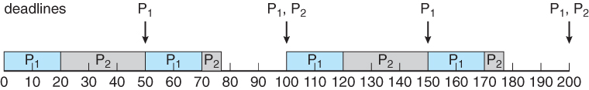  
**Figure 6.17 - Rate-monotonic scheduling.**

* + Rate-monotonic scheduling is considered optimal among algorithms that use static priorities, because any set of processes that cannot be scheduled with this algorithm cannot be scheduled with any other static-priority scheduling algorithm either.
  + There are, however, some sets of processes that cannot be scheduled with static priorities.
    - For example, supposing that P1 =50, T1 = 25, P2 = 80, T2 = 35, and the deadlines match the periods.
    - Overall CPU usage is 25/50 = 0.5 for P1, 35 / 80 =0.44 for P2, or 0.94 ( 94% ) overall, indicating it should be possible to schedule the processes.
    - With rate-monotonic scheduling, P1 goes first, and completes its first burst at time 25.
    - P2 goes next, and completes 25 out of its 35 time units before it gets pre-empted by P1 at time 50.
    - P1 completes its second burst at 75, and then P2 completes its last 10 time units at time 85, missing its deadline of 80 by 5 time units. :-(

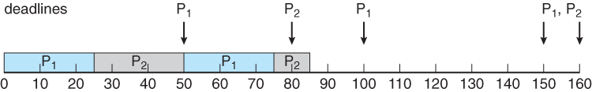  
**Figure 6.18 - Missing deadlines with rate-monotonic scheduling.**

* + The worst-case CPU utilization for scheduling N processes under this algorithm is N \* ( 2^(1/N) - 1 ), which is 100% for a single process, but drops to 75% for two processes and to 69% as N approaches infinity. Note that in our example above 94% is higher than 75%.

**6.6.4 Earliest-Deadline-First Scheduling**

* Earliest Deadline First ( EDF ) scheduling varies priorities dynamically, giving the highest priority to the process with the earliest deadline.
* Figure 6.19 shows our previous example repeated under EDF scheduling:
  + At time 0 P1 has the earliest deadline, highest priority, and goes first., followed by P2 at time 25 when P1 completes its first burst.
  + At time 50 process P1 begins its second period, but since P2 has a deadline of 80 and the deadline for P1 is not until 100, P2 is allowed to stay on the CPU and complete its burst, which it does at time 60.
  + P1 then starts its second burst, which it completes at time 85. P2 started its second period at time 80, but since P1 had an earlier deadline, P2 did not pre-empt P1.
  + P2 starts its second burst at time 85, and continues until time 100, at which time P1 starts its third period.
  + At this point P1 has a deadline of 150 and P2 has a deadline of 160, so P1 preempts P2.
  + P1 completes its third burst at time 125, at which time P2 starts, completing its third burst at time 145.
  + The CPU sits idle for 5 time units, until P1 starts its next period at 150 and P2 at 160.
  + **Question:**Which process will get to run at time 160, and why?
    - **Answer:** Process P2, because P1 now has a deadline of 200 and P2's new deadline is 240.

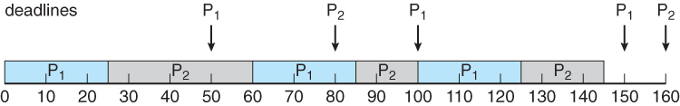  
**Figure 6.19 - Earliest-deadline-first scheduling.**

**6.6.5 Proportional Share Scheduling**

* Proportional share scheduling works by dividing the total amount of time available up into an equal number of shares, and then each process must request a certain share of the total when it tries to start.
* Say for example that the total shares, T, = 100, and then a particular process asks for N = 30 shares when it launches. It will then be guaranteed 30 / 100 or 30% of the available time.
* Proportional share scheduling works with an admission-control policy, not starting any task if it cannot guarantee the shares that the task says that it needs.

**6.6.6 POSIX Real-Time Scheduling**

* POSIX defines two scheduling classes for real time threads, SCHED\_FIFO and SCHED\_RR, depending on how threads ***of equal priority*** share time.
* SCHED\_FIFO schedules tasks in a first-in-first-out order, with no time slicing among threads of equal priority.
* SCHED\_RR performs round-robin time slicing among threads of equal priority.
* POSIX provides methods for getting and setting the thread scheduling policy, as shown below:

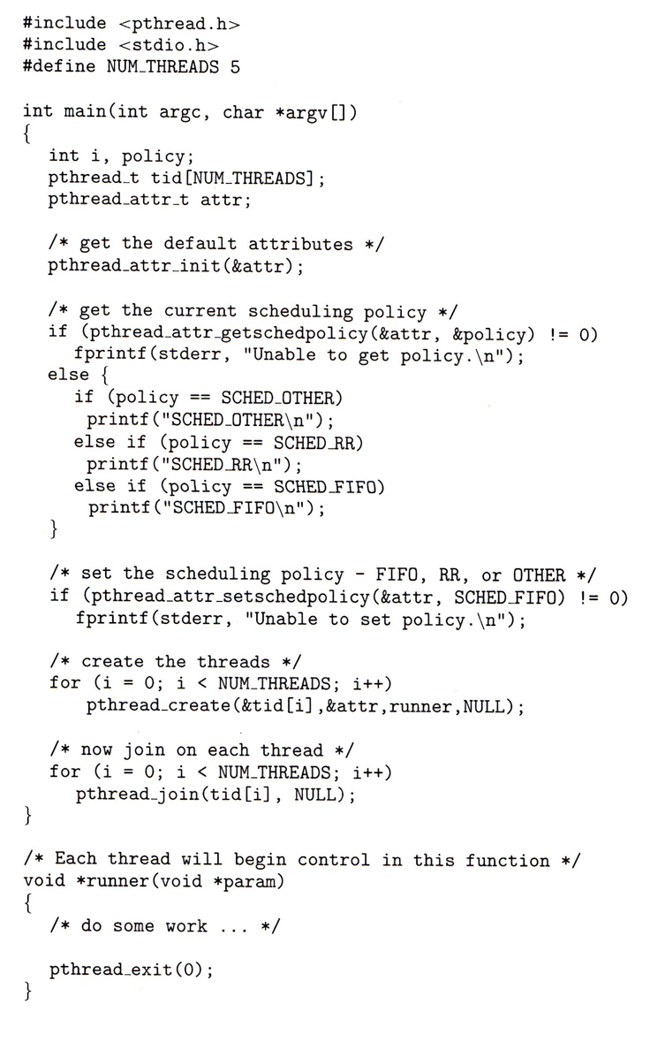  
**Figure 6.20 - POSIX real-time scheduling API.**

**6.7 Operating System Examples ( Optional )**

**6.7.1 Example: Linux Scheduling ( was 5.6.3 )**

* Prior to version 2.5, Linux used a traditional UNIX scheduling algorithm.
* Version 2.6 used an algorithm known as O(1), that ran in constant time regardless of the number of tasks, and provided better support for SMP systems. However it yielded poor interactive performance.
* Starting in 2.6.23, the ***Completely Fair Scheduler, CFS,***became the standard Linux scheduling system. See sidebar below

|  |
| --- |
| **CFS ( Completely Fair Scheduler ) Performance**  The Linux CFS scheduler provides an efficient algorithm for selecting which task to run next. Each runnable task is placed in a red-black tree—a balanced binary search tree whose key is based on the value of vruntime. This tree is shown below:  https://www.cs.uic.edu/~jbell/CourseNotes/OperatingSystems/images/Chapter6/6_vruntimeTree.jpg  When a task becomes runnable, it is added to the tree.  If a task on the  tree is not runnable ( for example, if it is blocked while waiting for I/O ), it is removed.  Generally speaking, tasks that have been given less processing time ( smaller values of vruntime ) are toward the left side of the tree, and tasks that have been given more processing time are on the right side. According to the properties of a binary search tree, the leftmost node has the smallest key value, which for the sake of the CFS scheduler means that it is the task with the highest priority . Because the red-black tree is balanced, navigating it to discover the leftmost node will require ***O(lgN)***operations (where ***N*** is the number of nodes in the tree). However, for efficiency reasons, the Linux scheduler caches this value in the variable rb\_leftmost, and thus determining which task to run next requires only retrieving the cached value. |

**New sidebar in ninth edition**

* The Linux scheduler is a preemptive priority-based algorithm with two priority ranges - ***Real time*** from 0 to 99 and a ***nice*** range from 100 to 140.
* Unlike Solaris or XP, Linux assigns longer time quantums to higher priority tasks.

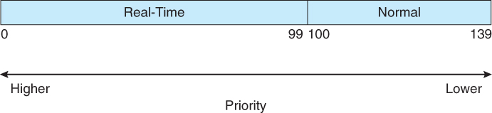  
**Figure 6.21 - Scheduling priorities on a Linux system.**

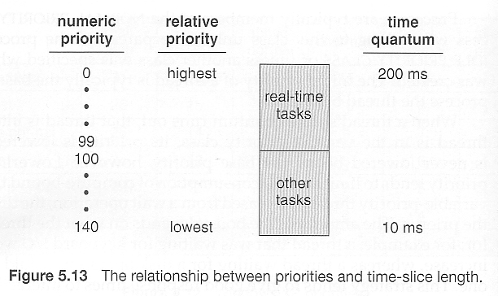  
**Replaced by Figure 6.21 in the ninth edition.**Was Figure 5.15 in eighth edition

**/\* The Following material was omitted from the ninth edition:**

* + A runnable task is considered eligible for execution as long as it has not consumed all the time available in it's time slice. Those tasks are stored in an ***active array***, indexed according to priority.
  + When a process consumes its time slice, it is moved to an ***expired array.*** The tasks priority may be re-assigned as part of the transferal.
  + When the active array becomes empty, the two arrays are swapped.
  + These arrays are stored in ***runqueue*** structures. On multiprocessor machines, each processor has its own scheduler with its own runqueue.

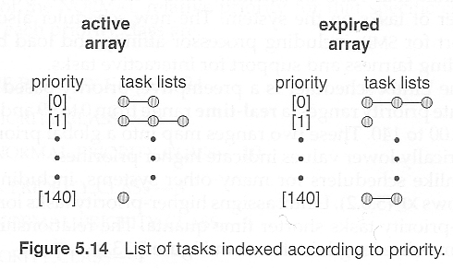  
**Omitted from ninth edition.**Figure 5.16 in eighth edition.

\*/

**6.7.2 Example: Windows XP Scheduling ( was 5.6.2 )**

* Windows XP uses a priority-based preemptive scheduling algorithm.
* The dispatcher uses a 32-level priority scheme to determine the order of thread execution, divided into two classes - ***variable class*** from 1 to 15 and ***real-time class*** from 16 to 31, ( plus a thread at priority 0 managing memory. )
* There is also a special ***idle***thread that is scheduled when no other threads are ready.
* Win XP identifies 7 priority classes ( rows on the table below ), and 6 relative priorities within each class ( columns. )
* Processes are also each given a **base priority** within their priority class. When variable class processes consume their entire time quanta, then their priority gets lowered, but not below their base priority.
* Processes in the foreground ( active window ) have their scheduling quanta multiplied by 3, to give better response to interactive processes in the foreground.

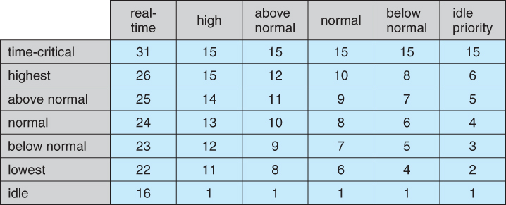  
**Figure 6.22 - Windows thread priorities.**

**6.7.1 Example: Solaris Scheduling**

* Priority-based kernel thread scheduling.
* Four classes ( real-time, system, interactive, and time-sharing ), and multiple queues / algorithms within each class.
* Default is time-sharing.
  + Process priorities and time slices are adjusted dynamically in a multilevel-feedback priority queue system.
  + Time slices are inversely proportional to priority - Higher priority jobs get smaller time slices.
  + Interactive jobs have higher priority than CPU-Bound ones.
  + See the table below for some of the 60 priority levels and how they shift. "Time quantum expired" and "return from sleep" indicate the new priority when those events occur. ( Larger numbers are a higher, i.e. better priority. )

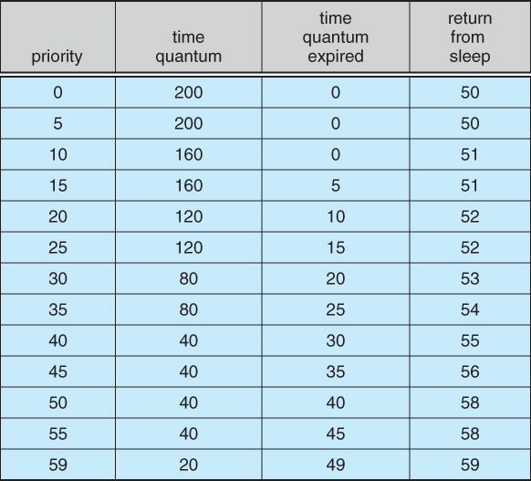  
**Figure 6.23 - Solaris dispatch table for time-sharing and interactive threads.**

* Solaris 9 introduced two new scheduling classes: Fixed priority and fair share.
  + Fixed priority is similar to time sharing, but not adjusted dynamically.
  + Fair share uses shares of CPU time rather than priorities to schedule jobs. A certain share of the available CPU time is allocated to a project, which is a set of processes.
* System class is reserved for kernel use. ( User programs running in kernel mode are NOT considered in the system scheduling class. )

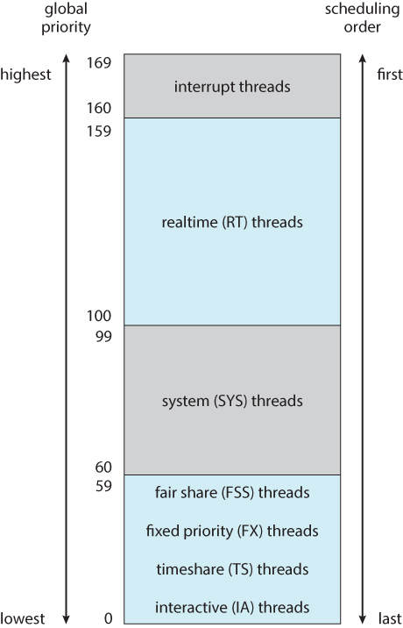  
**Figure 6.24 - Solaris scheduling.**

**6.8 Algorithm Evaluation**

* The first step in determining which algorithm ( and what parameter settings within that algorithm ) is optimal for a particular operating environment is to determine what criteria are to be used, what goals are to be targeted, and what constraints if any must be applied. For example, one might want to "maximize CPU utilization, subject to a maximum response time of 1 second".
* Once criteria have been established, then different algorithms can be analyzed and a "best choice" determined. The following sections outline some different methods for determining the "best choice".

**6.8.1 Deterministic Modeling**

* If a specific workload is known, then the exact values for major criteria can be fairly easily calculated, and the "best" determined. For example, consider the following workload ( with all processes arriving at time 0 ), and the resulting schedules determined by three different algorithms:

|  |  |
| --- | --- |
| **Process** | **Burst Time** |
| P1 | 10 |
| P2 | 29 |
| P3 | 3 |
| P4 | 7 |
| P5 | 12 |

|  |
| --- |
| **FCFS:** https://www.cs.uic.edu/~jbell/CourseNotes/OperatingSystems/images/Chapter6/6_deterministicFCFS.jpg  **Non-preemptive SJF: https://www.cs.uic.edu/~jbell/CourseNotes/OperatingSystems/images/Chapter6/6_deterministicSJF.jpg**  **Round Robin: https://www.cs.uic.edu/~jbell/CourseNotes/OperatingSystems/images/Chapter6/6_deterministicRoundRobin.jpg** |

* The average waiting times for FCFS, SJF, and RR are 28ms, 13ms, and 23ms respectively.
* Deterministic modeling is fast and easy, but it requires specific known input, and the results only apply for that particular set of input. However by examining multiple similar cases, certain trends can be observed. ( Like the fact that for processes arriving at the same time, SJF will always yield the shortest average wait time. )

**6.8.2 Queuing Models**

* Specific process data is often not available, particularly for future times. However a study of historical performance can often produce statistical descriptions of certain important parameters, such as the rate at which new processes arrive, the ratio of CPU bursts to I/O times, the distribution of CPU burst times and I/O burst times, etc.
* Armed with those probability distributions and some mathematical formulas, it is possible to calculate certain performance characteristics of individual waiting queues. For example, **Little's Formula** says that for an average queue length of N, with an average waiting time in the queue of W, and an average arrival of new jobs in the queue of Lambda, then these three terms can be related by:

N = Lambda \* W

* Queuing models treat the computer as a network of interconnected queues, each of which is described by its probability distribution statistics and formulas such as Little's formula. Unfortunately real systems and modern scheduling algorithms are so complex as to make the mathematics intractable in many cases with real systems.

**6.8.3 Simulations**

* Another approach is to run computer simulations of the different proposed algorithms ( and adjustment parameters ) under different load conditions, and to analyze the results to determine the "best" choice of operation for a particular load pattern.
* Operating conditions for simulations are often randomly generated using distribution functions similar to those described above.
* A better alternative when possible is to generate ***trace tapes***, by monitoring and logging the performance of a real system under typical expected work loads. These are better because they provide a more accurate picture of system loads, and also because they allow multiple simulations to be run with the identical process load, and not just statistically equivalent loads. A compromise is to randomly determine system loads and then save the results into a file, so that all simulations can be run against identical randomly determined system loads.
* Although trace tapes provide more accurate input information, they can be difficult and expensive to collect and store, and their use increases the complexity of the simulations significantly. There is also some question as to whether the future performance of the new system will really match the past performance of the old system. ( If the system runs faster, users may take fewer coffee breaks, and submit more processes per hour than under the old system. Conversely if the turnaround time for jobs is longer, intelligent users may think more carefully about the jobs they submit rather than randomly submitting jobs and hoping that one of them works out. )

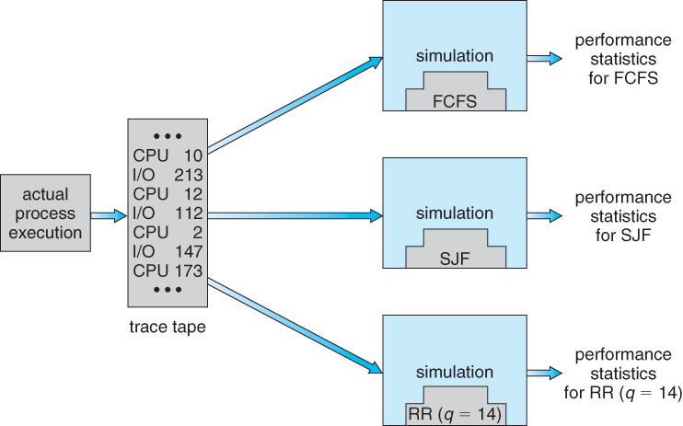  
**Figure 6.25 - Evaluation of CPU schedulers by simulation.**

**6.8.4 Implementation**

* The only real way to determine how a proposed scheduling algorithm is going to operate is to implement it on a real system.
* For experimental algorithms and those under development, this can cause difficulties and resistance among users who don't care about developing OSes and are only trying to get their daily work done.
* Even in this case, the measured results may not be definitive, for at least two major reasons: (1) System work loads are not static, but change over time as new programs are installed, new users are added to the system, new hardware becomes available, new work projects get started, and even societal changes. ( For example the explosion of the Internet has drastically changed the amount of network traffic that a system sees and the importance of handling it with rapid response times. ) (2) As mentioned above, changing the scheduling system may have an impact on the work load and the ways in which users use the system. ( The book gives an example of a programmer who modified his code to write an arbitrary character to the screen at regular intervals, just so his job would be classified as interactive and placed into a higher priority queue. )
* Most modern systems provide some capability for the system administrator to adjust scheduling parameters, either on the fly or as the result of a reboot or a kernel rebuild.

**6.9 Summary**

**Material Omitted from the Eighth Edition:**

**Was 5.4.4 Symmetric Multithreading ( Omitted from 8th edition )**

* An alternative strategy to SMP is***SMT, Symmetric Multi-Threading,***in which multiple virtual ( logical ) CPUs are used instead of ( or in combination with ) multiple physical CPUs.
* SMT must be supported in hardware, as each logical CPU has its own registers and handles its own interrupts. ( Intel refers to SMT as ***hyperthreading technology. )***
* To some extent the OS does not need to know if the processors it is managing are real or virtual. On the other hand, some scheduling decisions can be optimized if the scheduler knows the mapping of virtual processors to real CPUs. ( Consider the scheduling of two CPU-intensive processes on the architecture shown below. )

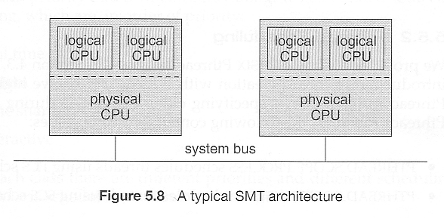  
omitted

Chapter 7

**Deadlocks**

**References:**

1. Abraham Silberschatz, Greg Gagne, and Peter Baer Galvin, "Operating System Concepts, Ninth Edition ", Chapter 7

**7.1 System Model**

* For the purposes of deadlock discussion, a system can be modeled as a collection of limited resources, which can be partitioned into different categories, to be allocated to a number of processes, each having different needs.
* Resource categories may include memory, printers, CPUs, open files, tape drives, CD-ROMS, etc.
* By definition, all the resources within a category are equivalent, and a request of this category can be equally satisfied by any one of the resources in that category. If this is not the case ( i.e. if there is some difference between the resources within a category ), then that category needs to be further divided into separate categories. For example, "printers" may need to be separated into "laser printers" and "color inkjet printers".
* Some categories may have a single resource.
* In normal operation a process must request a resource before using it, and release it when it is done, in the following sequence:
  1. Request - If the request cannot be immediately granted, then the process must wait until the resource(s) it needs become available. For example the system calls open( ), malloc( ), new( ), and request( ).
  2. Use - The process uses the resource, e.g. prints to the printer or reads from the file.
  3. Release - The process relinquishes the resource. so that it becomes available for other processes. For example, close( ), free( ), delete( ), and release( ).
* For all kernel-managed resources, the kernel keeps track of what resources are free and which are allocated, to which process they are allocated, and a queue of processes waiting for this resource to become available. Application-managed resources can be controlled using mutexes or wait( ) and signal( ) calls, ( i.e. binary or counting semaphores. )
* A set of processes is deadlocked when every process in the set is waiting for a resource that is currently allocated to another process in the set ( and which can only be released when that other waiting process makes progress. )

**7.2 Deadlock Characterization**

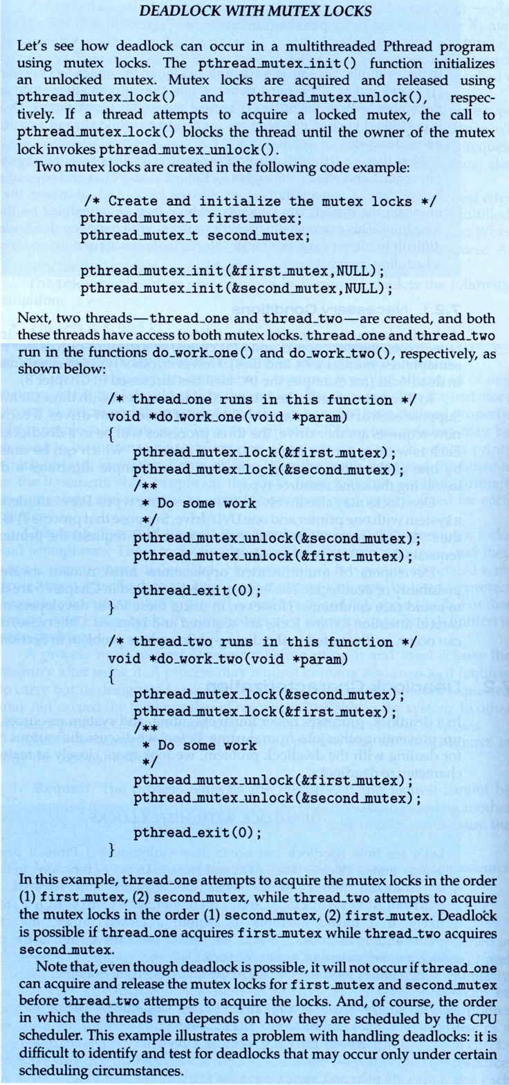  
**New Sidebar in Ninth Edition**

**7.2.1 Necessary Conditions**

* There are four conditions that are necessary to achieve deadlock:
  1. **Mutual Exclusion** - At least one resource must be held in a non-sharable mode; If any other process requests this resource, then that process must wait for the resource to be released.
  2. **Hold and Wait** - A process must be simultaneously holding at least one resource and waiting for at least one resource that is currently being held by some other process.
  3. **No preemption** - Once a process is holding a resource ( i.e. once its request has been granted ), then that resource cannot be taken away from that process until the process voluntarily releases it.
  4. **Circular Wait** - A set of processes { P0, P1, P2, . . ., PN } must exist such that every P[ i ] is waiting for P[ ( i + 1 ) % ( N + 1 ) ]. ( Note that this condition implies the hold-and-wait condition, but it is easier to deal with the conditions if the four are considered separately. )

**7.2.2 Resource-Allocation Graph**

* In some cases deadlocks can be understood more clearly through the use of **Resource-Allocation Graphs**, having the following properties:
  + A set of resource categories, { R1, R2, R3, . . ., RN }, which appear as square nodes on the graph. Dots inside the resource nodes indicate specific instances of the resource. ( E.g. two dots might represent two laser printers. )
  + A set of processes, { P1, P2, P3, . . ., PN }
  + **Request Edges -**A set of directed arcs from Pi to Rj, indicating that process Pi has requested Rj, and is currently waiting for that resource to become available.
  + **Assignment Edges -**A set of directed arcs from Rj to Pi indicating that resource Rj has been allocated to process Pi, and that Pi is currently holding resource Rj.
  + Note that a **request edge** can be converted into an **assignment edge** by reversing the direction of the arc when the request is granted. ( However note also that request edges point to the category box, whereas assignment edges emanate from a particular instance dot within the box. )
  + For example:

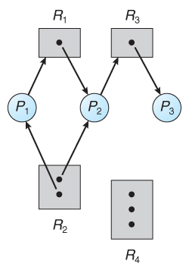  
**Figure 7.1 - Resource allocation graph**

* If a resource-allocation graph contains no cycles, then the system is not deadlocked. ( When looking for cycles, remember that these are ***directed*** graphs. ) See the example in Figure 7.2 above.
* If a resource-allocation graph does contain cycles **AND** each resource category contains only a single instance, then a deadlock exists.
* If a resource category contains more than one instance, then the presence of a cycle in the resource-allocation graph indicates the *possibility* of a deadlock, but does not guarantee one. Consider, for example, Figures 7.3 and 7.4 below:

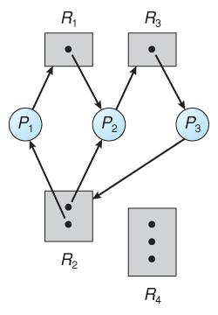  
**Figure 7.2 - Resource allocation graph with a deadlock**

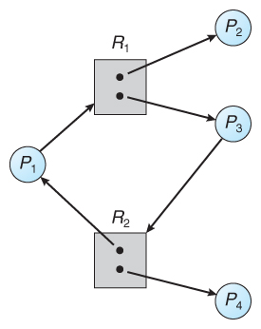  
**Figure 7.3 - Resource allocation graph with a cycle but no deadlock**

**7.3 Methods for Handling Deadlocks**

* Generally speaking there are three ways of handling deadlocks:
  1. Deadlock prevention or avoidance - Do not allow the system to get into a deadlocked state.
  2. Deadlock detection and recovery - Abort a process or preempt some resources when deadlocks are detected.
  3. Ignore the problem all together - If deadlocks only occur once a year or so, it may be better to simply let them happen and reboot as necessary than to incur the constant overhead and system performance penalties associated with deadlock prevention or detection. This is the approach that both Windows and UNIX take.
* In order to avoid deadlocks, the system must have additional information about all processes. In particular, the system must know what resources a process will or may request in the future. ( Ranging from a simple worst-case maximum to a complete resource request and release plan for each process, depending on the particular algorithm. )
* Deadlock detection is fairly straightforward, but deadlock recovery requires either aborting processes or preempting resources, neither of which is an attractive alternative.
* If deadlocks are neither prevented nor detected, then when a deadlock occurs the system will gradually slow down, as more and more processes become stuck waiting for resources currently held by the deadlock and by other waiting processes. Unfortunately this slowdown can be indistinguishable from a general system slowdown when a real-time process has heavy computing needs.

**7.4 Deadlock Prevention**

* Deadlocks can be prevented by preventing at least one of the four required conditions:

**7.4.1 Mutual Exclusion**

* Shared resources such as read-only files do not lead to deadlocks.
* Unfortunately some resources, such as printers and tape drives, require exclusive access by a single process.

**7.4.2 Hold and Wait**

* To prevent this condition processes must be prevented from holding one or more resources while simultaneously waiting for one or more others. There are several possibilities for this:
  + Require that all processes request all resources at one time. This can be wasteful of system resources if a process needs one resource early in its execution and doesn't need some other resource until much later.
  + Require that processes holding resources must release them before requesting new resources, and then re-acquire the released resources along with the new ones in a single new request. This can be a problem if a process has partially completed an operation using a resource and then fails to get it re-allocated after releasing it.
  + Either of the methods described above can lead to starvation if a process requires one or more popular resources.

**7.4.3 No Preemption**

* Preemption of process resource allocations can prevent this condition of deadlocks, when it is possible.
  + One approach is that if a process is forced to wait when requesting a new resource, then all other resources previously held by this process are implicitly released, ( preempted ), forcing this process to re-acquire the old resources along with the new resources in a single request, similar to the previous discussion.
  + Another approach is that when a resource is requested and not available, then the system looks to see what other processes currently have those resources *and* are themselves blocked waiting for some other resource. If such a process is found, then some of their resources may get preempted and added to the list of resources for which the process is waiting.
  + Either of these approaches may be applicable for resources whose states are easily saved and restored, such as registers and memory, but are generally not applicable to other devices such as printers and tape drives.

**7.4.4 Circular Wait**

* One way to avoid circular wait is to number all resources, and to require that processes request resources only in strictly increasing ( or decreasing ) order.
* In other words, in order to request resource Rj, a process must first release all Ri such that i >= j.
* One big challenge in this scheme is determining the relative ordering of the different resources

**7.5 Deadlock Avoidance**

* The general idea behind deadlock avoidance is to prevent deadlocks from ever happening, by preventing at least one of the aforementioned conditions.
* This requires more information about each process, AND tends to lead to low device utilization. ( I.e. it is a conservative approach. )
* In some algorithms the scheduler only needs to know the *maximum* number of each resource that a process might potentially use. In more complex algorithms the scheduler can also take advantage of the *schedule* of exactly what resources may be needed in what order.
* When a scheduler sees that starting a process or granting resource requests may lead to future deadlocks, then that process is just not started or the request is not granted.
* A resource allocation ***state*** is defined by the number of available and allocated resources, and the maximum requirements of all processes in the system.

**7.5.1 Safe State**

* A state is ***safe*** if the system can allocate all resources requested by all processes ( up to their stated maximums ) without entering a deadlock state.
* More formally, a state is safe if there exists a ***safe sequence*** of processes { P0, P1, P2, ..., PN } such that all of the resource requests for Pi can be granted using the resources currently allocated to Pi and all processes Pj where j < i. ( I.e. if all the processes prior to Pi finish and free up their resources, then Pi will be able to finish also, using the resources that they have freed up. )
* If a safe sequence does not exist, then the system is in an unsafe state, which ***MAY*** lead to deadlock. ( All safe states are deadlock free, but not all unsafe states lead to deadlocks. )

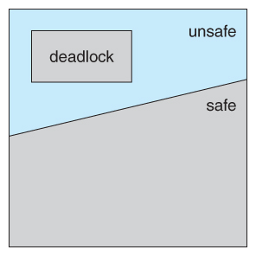  
**Figure 7.6 - Safe, unsafe, and deadlocked state spaces.**

* For example, consider a system with 12 tape drives, allocated as follows. Is this a safe state? What is the safe sequence?

|  |  |  |
| --- | --- | --- |
|  | **Maximum Needs** | **Current Allocation** |
| **P0** | 10 | 5 |
| **P1** | 4 | 2 |
| **P2** | 9 | 2 |

* What happens to the above table if process P2 requests and is granted one more tape drive?
* Key to the safe state approach is that when a request is made for resources, the request is granted only if the resulting allocation state is a safe one.

**7.5.2 Resource-Allocation Graph Algorithm**

* If resource categories have only single instances of their resources, then deadlock states can be detected by cycles in the resource-allocation graphs.
* In this case, unsafe states can be recognized and avoided by augmenting the resource-allocation graph with ***claim edges***, noted by dashed lines, which point from a process to a resource that it may request in the future.
* In order for this technique to work, all claim edges must be added to the graph for any particular process before that process is allowed to request any resources. ( Alternatively, processes may only make requests for resources for which they have already established claim edges, and claim edges cannot be added to any process that is currently holding resources. )
* When a process makes a request, the claim edge Pi->Rj is converted to a request edge. Similarly when a resource is released, the assignment reverts back to a claim edge.
* This approach works by denying requests that would produce cycles in the resource-allocation graph, taking claim edges into effect.
* Consider for example what happens when process P2 requests resource R2:

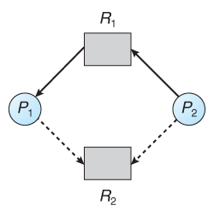  
**Figure 7.7 - Resource allocation graph for deadlock avoidance**

* The resulting resource-allocation graph would have a cycle in it, and so the request cannot be granted.

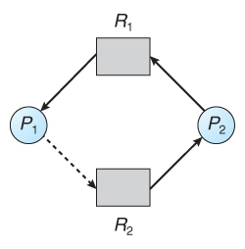  
**Figure 7.8 - An unsafe state in a resource allocation graph**

**7.5.3 Banker's Algorithm**

* For resource categories that contain more than one instance the resource-allocation graph method does not work, and more complex ( and less efficient ) methods must be chosen.
* The Banker's Algorithm gets its name because it is a method that bankers could use to assure that when they lend out resources they will still be able to satisfy all their clients. ( A banker won't loan out a little money to start building a house unless they are assured that they will later be able to loan out the rest of the money to finish the house. )
* When a process starts up, it must state in advance the maximum allocation of resources it may request, up to the amount available on the system.
* When a request is made, the scheduler determines whether granting the request would leave the system in a safe state. If not, then the process must wait until the request can be granted safely.
* The banker's algorithm relies on several key data structures: ( where n is the number of processes and m is the number of resource categories. )
  + Available[ m ] indicates how many resources are currently available of each type.
  + Max[ n ][ m ] indicates the maximum demand of each process of each resource.
  + Allocation[ n ][ m ] indicates the number of each resource category allocated to each process.
  + Need[ n ][ m ] indicates the remaining resources needed of each type for each process. ( Note that Need[ i ][ j ] = Max[ i ][ j ] - Allocation[ i ][ j ] for all i, j. )
* For simplification of discussions, we make the following notations / observations:
  + One row of the Need vector, Need[ i ], can be treated as a vector corresponding to the needs of process i, and similarly for Allocation and Max.
  + A vector X is considered to be <= a vector Y if X[ i ] <= Y[ i ] for all i.

**7.5.3.1 Safety Algorithm**

* In order to apply the Banker's algorithm, we first need an algorithm for determining whether or not a particular state is safe.
* This algorithm determines if the current state of a system is safe, according to the following steps:
  1. Let Work and Finish be vectors of length m and n respectively.
     + Work is a working copy of the available resources, which will be modified during the analysis.
     + Finish is a vector of booleans indicating whether a particular process can finish. ( or has finished so far in the analysis. )
     + Initialize Work to Available, and Finish to false for all elements.
  2. Find an i such that both (A) Finish[ i ] == false, and (B) Need[ i ] < Work. This process has not finished, but could with the given available working set. If no such i exists, go to step 4.
  3. Set Work = Work + Allocation[ i ], and set Finish[ i ] to true. This corresponds to process i finishing up and releasing its resources back into the work pool. Then loop back to step 2.
  4. If finish[ i ] == true for all i, then the state is a safe state, because a safe sequence has been found.
* ( JTB's Modification:
  1. In step 1. instead of making Finish an array of booleans initialized to false, make it an array of ints initialized to 0. Also initialize an int s = 0 as a step counter.
  2. In step 2, look for Finish[ i ] == 0.
  3. In step 3, set Finish[ i ] to ++s. S is counting the number of finished processes.
  4. For step 4, the test can be either Finish[ i ] > 0 for all i, or s >= n. The benefit of this method is that if a safe state exists, then Finish[ ] indicates one safe sequence ( of possibly many. ) )

**7.5.3.2 Resource-Request Algorithm ( The Bankers Algorithm )**

* Now that we have a tool for determining if a particular state is safe or not, we are now ready to look at the Banker's algorithm itself.
* This algorithm determines if a new request is safe, and grants it only if it is safe to do so.
* When a request is made ( that does not exceed currently available resources ), pretend it has been granted, and then see if the resulting state is a safe one. If so, grant the request, and if not, deny the request, as follows:
  1. Let Request[ n ][ m ] indicate the number of resources of each type currently requested by processes. If Request[ i ] > Need[ i ] for any process i, raise an error condition.
  2. If Request[ i ] > Available for any process i, then that process must wait for resources to become available. Otherwise the process can continue to step 3.
  3. Check to see if the request can be granted safely, by pretending it has been granted and then seeing if the resulting state is safe. If so, grant the request, and if not, then the process must wait until its request can be granted safely.The procedure for granting a request ( or pretending to for testing purposes ) is:
     + Available = Available - Request
     + Allocation = Allocation + Request
     + Need = Need - Request

**7.5.3.3 An Illustrative Example**

* Consider the following situation:

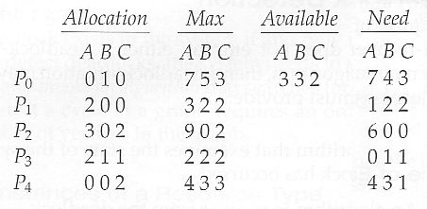

* And now consider what happens if process P1 requests 1 instance of A and 2 instances of C. ( Request[ 1 ] = ( 1, 0, 2 ) )

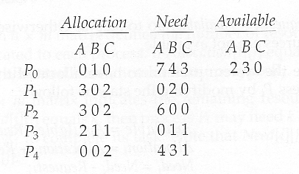

* What about requests of ( 3, 3,0 ) by P4? or ( 0, 2, 0 ) by P0? Can these be safely granted? Why or why not?

**7.6 Deadlock Detection**

* If deadlocks are not avoided, then another approach is to detect when they have occurred and recover somehow.
* In addition to the performance hit of constantly checking for deadlocks, a policy / algorithm must be in place for recovering from deadlocks, and there is potential for lost work when processes must be aborted or have their resources preempted.

**7.6.1 Single Instance of Each Resource Type**

* If each resource category has a single instance, then we can use a variation of the resource-allocation graph known as a ***wait-for graph***.
* A wait-for graph can be constructed from a resource-allocation graph by eliminating the resources and collapsing the associated edges, as shown in the figure below.
* An arc from Pi to Pj in a wait-for graph indicates that process Pi is waiting for a resource that process Pj is currently holding.

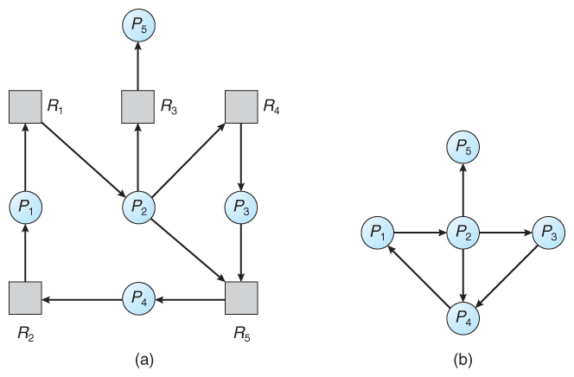  
**Figure 7.9 - (a) Resource allocation graph. (b) Corresponding wait-for graph**

* As before, cycles in the wait-for graph indicate deadlocks.
* This algorithm must maintain the wait-for graph, and periodically search it for cycles.

**7.6.2 Several Instances of a Resource Type**

* The detection algorithm outlined here is essentially the same as the Banker's algorithm, with two subtle differences:
  + In step 1, the Banker's Algorithm sets Finish[ i ] to false for all i. The algorithm presented here sets Finish[ i ] to false only if Allocation[ i ] is not zero. If the currently allocated resources for this process are zero, the algorithm sets Finish[ i ] to true. This is essentially assuming that IF all of the other processes can finish, then this process can finish also. Furthermore, this algorithm is specifically looking for which processes are involved in a deadlock situation, and a process that does not have any resources allocated cannot be involved in a deadlock, and so can be removed from any further consideration.
  + Steps 2 and 3 are unchanged
  + In step 4, the basic Banker's Algorithm says that if Finish[ i ] == true for all i, that there is no deadlock. This algorithm is more specific, by stating that if Finish[ i ] == false for any process Pi, then that process is specifically involved in the deadlock which has been detected.
* ( Note: An alternative method was presented above, in which Finish held integers instead of booleans. This vector would be initialized to all zeros, and then filled with increasing integers as processes are detected which can finish. If any processes are left at zero when the algorithm completes, then there is a deadlock, and if not, then the integers in finish describe a safe sequence. To modify this algorithm to match this section of the text, processes with allocation = zero could be filled in with N, N - 1, N - 2, etc. in step 1, and any processes left with Finish = 0 in step 4 are the deadlocked processes. )
* Consider, for example, the following state, and determine if it is currently deadlocked:

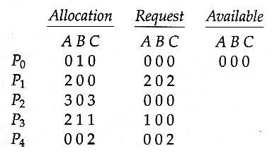

* Now suppose that process P2 makes a request for an additional instance of type C, yielding the state shown below. Is the system now deadlocked?

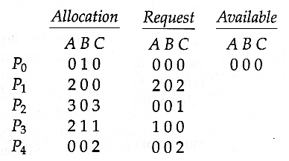

**7.6.3 Detection-Algorithm Usage**

* When should the deadlock detection be done? Frequently, or infrequently?
* The answer may depend on how frequently deadlocks are expected to occur, as well as the possible consequences of not catching them immediately. ( If deadlocks are not removed immediately when they occur, then more and more processes can "back up" behind the deadlock, making the eventual task of unblocking the system more difficult and possibly damaging to more processes. )
* There are two obvious approaches, each with trade-offs:
  1. Do deadlock detection after every resource allocation which cannot be immediately granted. This has the advantage of detecting the deadlock right away, while the minimum number of processes are involved in the deadlock. ( One might consider that the process whose request triggered the deadlock condition is the "cause" of the deadlock, but realistically all of the processes in the cycle are equally responsible for the resulting deadlock. ) The down side of this approach is the extensive overhead and performance hit caused by checking for deadlocks so frequently.
  2. Do deadlock detection only when there is some clue that a deadlock may have occurred, such as when CPU utilization reduces to 40% or some other magic number. The advantage is that deadlock detection is done much less frequently, but the down side is that it becomes impossible to detect the processes involved in the original deadlock, and so deadlock recovery can be more complicated and damaging to more processes.
  3. ( As I write this, a third alternative comes to mind: Keep a historical log of resource allocations, since that last known time of no deadlocks. Do deadlock checks periodically ( once an hour or when CPU usage is low?), and then use the historical log to trace through and determine when the deadlock occurred and what processes caused the initial deadlock. Unfortunately I'm not certain that breaking the original deadlock would then free up the resulting log jam. )

**7.7 Recovery From Deadlock**

* There are three basic approaches to recovery from deadlock:
  1. Inform the system operator, and allow him/her to take manual intervention.
  2. Terminate one or more processes involved in the deadlock
  3. Preempt resources.

**7.7.1 Process Termination**

* Two basic approaches, both of which recover resources allocated to terminated processes:
  + Terminate all processes involved in the deadlock. This definitely solves the deadlock, but at the expense of terminating more processes than would be absolutely necessary.
  + Terminate processes one by one until the deadlock is broken. This is more conservative, but requires doing deadlock detection after each step.
* In the latter case there are many factors that can go into deciding which processes to terminate next:
  + Process priorities.
  + How long the process has been running, and how close it is to finishing.
  + How many and what type of resources is the process holding. ( Are they easy to preempt and restore? )
  + How many more resources does the process need to complete.
  + How many processes will need to be terminated
  + Whether the process is interactive or batch.
  + ( Whether or not the process has made non-restorable changes to any resource. )

**7.7.2 Resource Preemption**

* When preempting resources to relieve deadlock, there are three important issues to be addressed:
  1. **Selecting a victim**- Deciding which resources to preempt from which processes involves many of the same decision criteria outlined above.
  2. **Rollback** - Ideally one would like to roll back a preempted process to a safe state prior to the point at which that resource was originally allocated to the process. Unfortunately it can be difficult or impossible to determine what such a safe state is, and so the only safe rollback is to roll back all the way back to the beginning. ( I.e. abort the process and make it start over. )
  3. **Starvation**- How do you guarantee that a process won't starve because its resources are constantly being preempted? One option would be to use a priority system, and increase the priority of a process every time its resources get preempted. Eventually it should get a high enough priority that it won't get preempted any more.

\*\*\*\*\*Ch 8 \*\*\*\*\*\*\*\*\*\*\*\*\*\*\*\*\*\*\*\*\*\*\*\*\*\*

**Operating Systems Test 2: Ch 8-13**

**Ch 8: Main Memory**

* To provide a detailed description of various ways of organizing memory hardware
* To discuss various memory-management techniques, including paging and segmentation
* To provide a detailed description of the Intel Pentium, which supports both pure segmentation and segmentation with paging

Background (352)

* CPU can be shares by a set of processes
* CPU scheduling can improve both utilization of CPU and speed of response time
* Must keep several process in memory (share memory)
* Various ways to manage memory
* Selection of memory management method depends on many factors, esp hardware
* Closely integrated hardware and os memory management
* Memory is central to operation of computer systems
* CPU fetches instructions from memory according to the value of the program counter
* Instructions can cause additional loading from and storing to specific memory addresses
* Instruction-execution cycle: fetch instruction from memory, decode , may cause operands fetched from memory, after instruction executed on operands, results may be stored in memory
* Memory unit sees a stream of addresses: focus on sequence of memory addresses generated by the running program
* Program must be brought (from disk) into memory and placed within a process for it to be run
* Memory unit only sees a stream of addresses + read requests, or address + data and write requests
* Register access in one CPU clock (or less)
* Main memory can take many cycles, causing a **stall**
* **Cache** sits between main memory and CPU registers
* Protection of memory required to ensure correct operation

**8.1.1 Basic Hardware (352)**

* **Main memory and registers** are only storage CPU can access directly
* There are machine instructions that take memory addresses as arguments, but none that take disk addresses.
* any instructions in execution, and any data being used by the instructions, must be in one of these direct-access storage devices
* If the data are not in memory, they must be moved there before the CPU can operate on them.
* Registers that are built into the CPU are generally accessible within on cycle of the CPU clock
* Most CPUs can decode instructions and perform simple operations on register contents at the rate of one or more operations per clock tick
* Main memory is accessed via a transaction on the memory bus – may take several cycles of the CPU clock (processor needs to stall since it doesn’t have data required to complete the instruction it is executing (intolerable bec of frequency of memory accesses)
* Remedy is to add cache (fast memory between the CPU and main memory)uusually on cpu chip
* To manage cache built into cpu, hardware speeds up memory access without os control
* Concerned with relative speed of accessing physical memory and correct operation
* Protect os from access by user processes and protect users from one another
* Protection provided by hardware because os doesn’t intervene between cpu and memory accesses(performance penalty) hardware implements in different ways
* Ensure each process has a separate memory space
* Separate per-process memory space protects the processes from each other (fundamental for concurrent execution)
* To separate memory spaces we need a range of legal addresses that the process may access and ensure the process can access only these addresses
* Can provide this protection by using 2 registers (base and limit)
* Base register holds the smallest legal physical memory address
* Limit register specifies the size of the range

353

* Protection of memory space is accomplished by having the CPU hardware compare every address generated in user mode with the registers.
* Any attempt by a program executing in user mode to access os memory or other user’s memory results in a trap to the os which treats the attempt as a fatal error
* Prevents user program from modifying the code or data structures of os or other users
* Basw & limit registers can only be loaded by os using a special privileged instruction
* Privileged instructions can be executed only in kernel mode, os executes in kernel mode

Base and Limit Registers

* A pair of **base** and **limit** **registers** define the logical address space
* CPU must check every memory access generated in user mode to be sure it is between base and limit for that user
* OS in kernel mode has unrestricted access to os & user memory
* Allows os to load users programs into users memory, dump out programs if error, access, modify parameters of system calls, perform io to and from user memory and other services

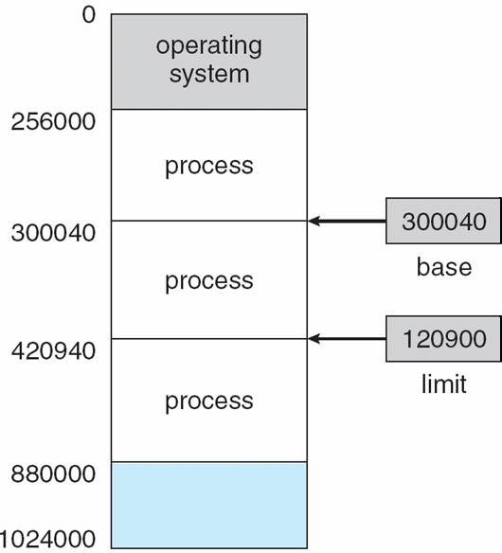

Hardware Address Protection with base and limit registers (353)

8.02.pdf

**8.1.2 Address Binding (354)**

* Programs on disk,(usually program on disk as binary executable file)
* To be executed, program must be brought into memory and placed within a process
* Depending on the memory management in use, the process may be moved between disk and memory during its execution
* Input queue = Processes on disk waiting to be brought into memory for execution
* ready to be brought into memory to execute form an **input queue**
  + Without support, must be loaded into address 0000
* Inconvenient to have first user process physical address always at 0000
  + How can it not be?
* Further, addresses represented in different ways at different stages of a program’s life
  + Source code addresses usually symbolic
  + Compiled code addresses **bind** to relocatable addresses **(bind symbolic address to relocatable address)**
    - i.e. “14 bytes from beginning of this module”
  + L**inker or loader will bind relocatable addresses to absolute addresses**
    - i.e. 74014
  + Each binding maps one address space to another

**Binding of Instructions and Data to Memory (354)**

* Address binding of instructions and data to memory addresses can happen at three different stages
  + **Compile time**: If memory location known a priori, **absolute code** can be generated; must recompile code if starting location changes (MS-DOS .com programs bound at compile time)
  + **Load time**: Must generate **relocatable code** if memory location is not known at compile time
  + **Execution time**: Binding delayed until run time if the process can be moved during its execution from one memory segment to another
    - Need hardware support for address maps (e.g., base and limitregisters)
    - Most general purpose os use this method

Multistep Processing of User Program

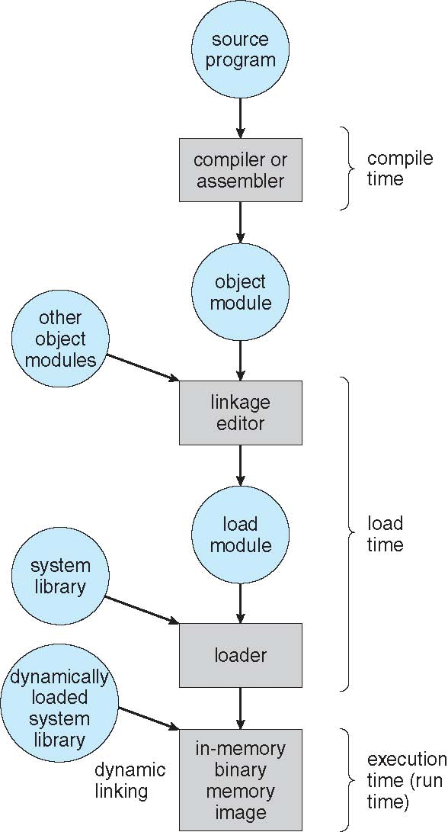

**Logical vs Physical Address Space**

* The concept of a logical address space that is bound to a separate **physical address space** is central to proper memory management
  + **Logical address** – generated by the CPU; also referred to as **virtual address**
  + **Physical address** – address seen by the memory unit (loaded into memory-address register of the memory)
* Compile-time and load-time address-binding methods generate identical logical and physical addresses
* Execution binding scheme results in differing logical and physical addresses (refer to logical address as virtual address)
* Logical and physical addresses are the same in compile-time and load-time address-binding schemes; logical (virtual) and physical addresses differ in execution-time address-binding scheme
* **Logical address space** is the set of all logical addresses generated by a program
* **Physical address space** is the set of all physical addresses generated by a program

**Memory-Management Unit (MMU)**

* Hardware device that **at run time maps virtual to physical address**
* Many methods possible, covered in the rest of this chapter
* To start, consider simple scheme where the value in the relocation register is added to every address generated by a user process at the time it is sent to memory
  + Base register now called **relocation register**
  + MS-DOS on Intel 80x86 used 4 relocation registers
* The user program deals with *logical* addresses; it never sees the *real* physical addresses
  + Execution-time binding occurs when reference is made to location in memory
  + Logical address bound to physical addresses

**8.1.4 Dynamic loading (page 357)**

Dynamic relocation using a relocation register

* Advantage: routine is loaded only when it is needed
* Useful when large amounts of code are needed to handle infrequently occurring cases, such as error routines (portion of code loaded is smaller thna large program)
* Routine is not loaded until it is called
* Better memory-space utilization; unused routine is never loaded
* All routines kept on disk in relocatable load format
* Useful when large amounts of code are needed to handle infrequently occurring cases
* No special support from the operating system is required
  + Implemented through program design
  + OS can help by providing libraries to implement dynamic loading
  + Responsibility of users to design programs to take advantage of such a method
  + Picture: dynamic relocation using a relocation register

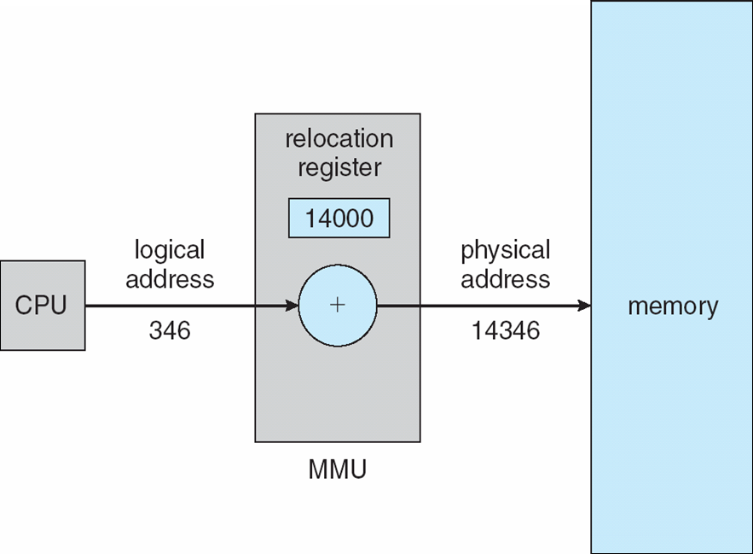

**8.1.5 Dynamic Linking and shared Libraries (357)**

Dynamic Linking

* Dynamically linked libraries are system libraries that are linked to user programs when the programs are run
* **Static linking** – system libraries and program code combined by the loader into the binary program image
* Dynamic linking –linking postponed until execution time

Without this facility, each program on a system must include a copy

of its language library (or at least the routines referenced by the program) in the executable image. This requirement wastes both disk space and main memory

* Small piece of code, **stub**, used to locate the appropriate memory-resident library routine
* Stub replaces itself with the address of the routine, and executes the routine
* Operating system checks if routine is in processes’ memory address
  + If not in address space, add to address space
* Dynamic linking is particularly useful for libraries

Thus, only programs that are compiled with

the new library version are affected by any incompatible changes incorporated

in it. Other programs linked before the new library was installed will continue

using the older library. System also known as **shared libraries**

* Consider applicability to patching system libraries
  + Versioning may be needed

Unlike dynamic loading, dynamic linking and shared libraries generally

require help from the operating system. If the processes in memory are

protected fromone another, then the operating system is the only entity that can

check to see whether the needed routine is in another process’s memory space

or that can allow multiple processes to access the same memory addresses

**8.2 Swapping (358)**

* A process can be **swapped** temporarily out of memory to a backing store, and then brought back into memory for continued execution
  + Total physical memory space of processes can exceed physical memory
* **Backing store** – fast disk large enough to accommodate copies of all memory images for all users; must provide direct access to these memory images
* **Roll out, roll in** – swapping variant used for priority-based scheduling algorithms; lower-priority process is swapped out so higher-priority process can be loaded and executed
* Major part of swap time is transfer time; total transfer time is directly proportional to the amount of memory swapped
* System maintains a **ready queue (359)** of ready-to-run processes which have memory images on disk
* Does the swapped out process need to swap back in to same physical addresses?
* Depends on address binding method
  + Plus consider pending I/O to / from process memory space
* Modified versions of swapping are found on many systems (i.e., UNIX, Linux, and Windows)
  + Swapping normally disabled
  + Started if more than threshold amount of memory allocated
  + Disabled again once memory demand reduced below threshold

**8.2.1 Standard Swapping (358)**

Swapping of 2 processes using a disk as a backing store

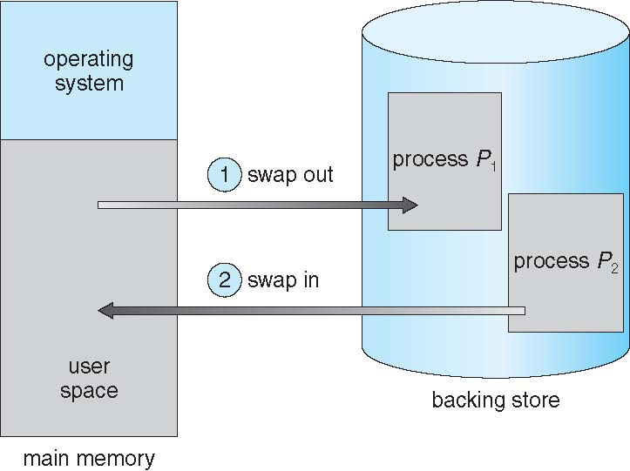

Context Switch Time including Swapping (359)

* If next processes to be put on CPU is not in memory, need to swap out a process and swap in target process
* Context switch time can then be very high
* 100MB process swapping to hard disk with transfer rate of 50MB/sec
  + Swap out time of 2000 ms
  + Plus swap in of same sized process
  + Total context switch swapping component time of 4000ms (4 seconds)
* Can reduce if reduce size of memory swapped – by knowing how much memory really being used
  + System calls to inform OS of memory use via request\_memory() and release\_memory()
* Other constraints as well on swapping
  + Pending I/O – can’t swap out as I/O would occur to wrong process
  + Or always transfer I/O to kernel space, then to I/O device
    - Known as **double buffering**, (359) adds overhead
* Standard swapping not used in modern operating systems (too much swap time & not enough execution time)
  + But modified version common
    - Swap only when free memory extremely low

**8.2.2 Swapping on Mobile Systems (360)**

* Not typically supported
  + Flash memory based
    - Small amount of space
    - Limited number of write cycles
    - Poor throughput between flash memory and CPU on mobile platform
* Instead use other methods to free memory if low
  + iOS ***asks*** apps to voluntarily relinquish allocated memory
    - Read-only data thrown out and reloaded from flash if needed
    - Failure to free can result in termination
  + Android terminates apps if low free memory, but first writes **application state** to flash for fast restart
  + Both OSes support paging as discussed below
  1. **Contiguous Memory Allocation (360-1)**

each process is contained in a single section of memory that is contiguous to the section containing the next process.

* Main memory must support both OS and user processes
* Limited resource, must allocate efficiently
* Contiguous allocation is one early method
* Main memory usually into two **partitions**:
  + Resident operating system, usually held in low memory with interrupt vector
  + User processes then held in high memory
  + Each process contained in single contiguous section of memory
* Relocation registers used to protect user processes from each other, and from changing operating-system code and data
  + Base register contains value of smallest physical address
  + Limit register contains range of logical addresses – each logical address must be less than the limit register
  + MMU maps logical address *dynamically*
  + Can then allow actions such as kernel code being **transient** and kernel changing size

**8.3.1 Memory Protection (361)**

* The relocation-register scheme provides an effective way to allow the

operating system’s size to change dynamically. This flexibility is desirable in

many situations. For example, the operating system contains code and buffer

space for device drivers

code is sometimes

called **transient** operating-system code; it comes and goes as needed. Thus,

using this code changes the size of the operating system during program

execution.

CPU memory

logical

address

trap: addressing error

no

yes

physical

address

relocation

Hardware Support for Relocation and Limit Registers

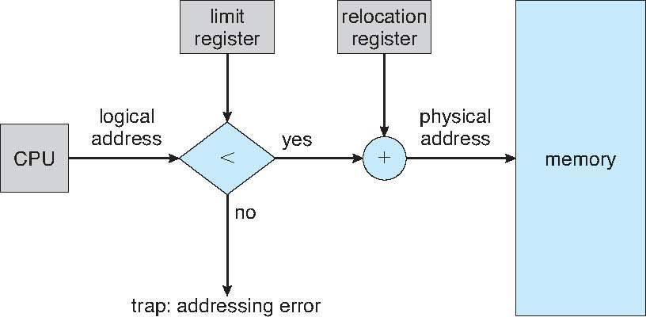

**8.3.2 Memory Allocation (362)**

Multiple-partition allocation

* Multiple-partition allocation
  + Degree of multiprogramming limited by number of partitions
  + **Variable-partition** sizes for efficiency (sized to a given process’ needs)
  + **Hole** – block of available memory; holes of various size are scattered throughout memory
  + When a process arrives, it is allocated memory from a hole large enough to accommodate it
  + Process exiting frees its partition, adjacent free partitions combined
  + Operating system maintains information about:  
    a) allocated partitions b) free partitions (hole)

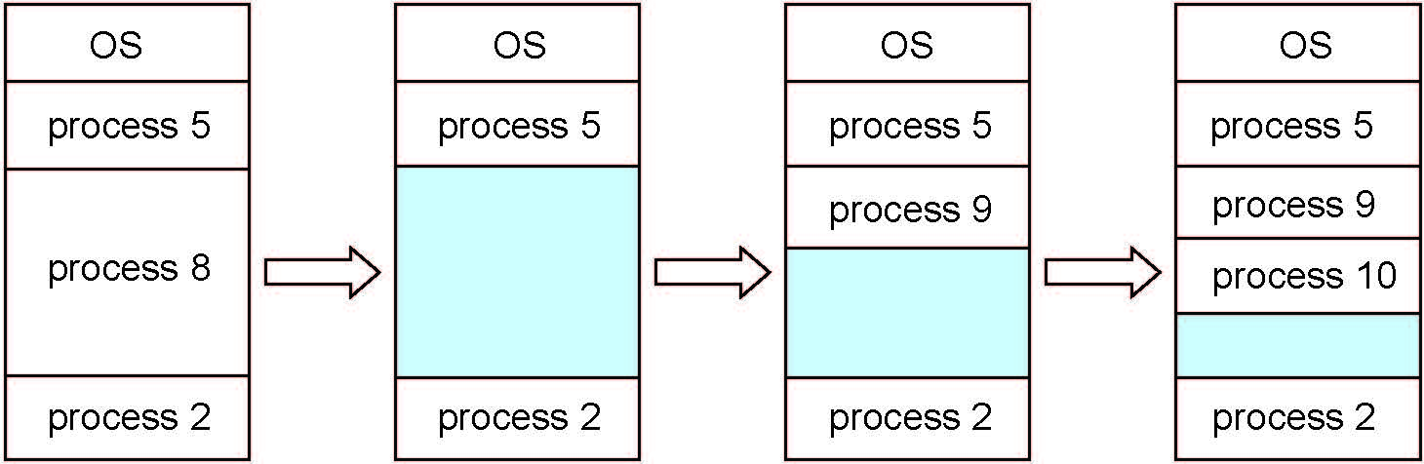

**Dynamic Storage-Allocation Problem (362)**

How to satisfy a request of size ***n*** from a list of free holes?

* **First-fit**: Allocate the ***first*** hole that is big enough
* **Best-fit**: Allocate the ***smallest*** hole that is big enough; must search entire list, unless ordered by size
  + Produces the smallest leftover hole
* **Worst-fit**: Allocate the ***largest*** hole; must also search entire list
  + Produces the largest leftover hole

First-fit and best-fit better than worst-fit in terms of speed and storage utilization

Neither first fit nor best fit is clearly better than the other in terms of storage utilization, but first fit is

generally faster.

**8.3.3 Fragmentation (363)**

**Both first-fit and best-fit strategies suffer from external fragmentation**

Whether we are using the first-fit or best-fit strategy can affect the amount

of fragmentation. (First fit is better for some systems, whereas best fit is better

for others.) Another factor is which end of a free block is allocated. (Which is

the leftover piece—the one on the top or the one on the bottom?) No matter

which algorithm is used, however, external fragmentation will be a problem.

* **External Fragmentation** – total memory space exists to satisfy a request, but it is not contiguous
* **Internal Fragmentation** – allocated memory may be slightly larger than requested memory; this size difference is memory internal to a partition, but not being used
* First fit analysis reveals that given *N* blocks allocated, 0.5 *N* blocks lost to fragmentation
  + 1/3 may be unusable -> **50-percent rule**
* Reduce external fragmentation by **compaction**
  + Shuffle memory contents to place all free memory together in one large block
  + Compaction is possible *only* if relocation is dynamic, and is done at execution time
  + I/O problem
    - Latch job in memory while it is involved in I/O
    - Do I/O only into OS buffers
* Now consider that backing store has same fragmentation problems

The general approach to avoiding this

problem is to break the physical memory into fixed-sized blocks and allocate

memory in units based on block size.With this approach, the memory allocated

to a process may be slightly larger than the requested memory. The difference

between these two numbers is **internal fragmentation**—unused memory that

is internal to a partition.

The simplest compaction

algorithm is to move all processes toward one end of memory; all holes move in

the other direction, producing one large hole of available memory. This scheme

can be expensive.

Another possible solution to the external-fragmentation problem is to

permit the logical address space of the processes to be noncontiguous, thus

allowing a process to be allocated physical memory wherever such memory is

available. Two complementary techniques achieve this solution: segmentation

(Section 8.4) and paging (Section 8.5). These techniques can also be combined.

Fragmentation is a general problem in computing that can occur wherever

we must manage blocks of data.

**8.4 Segmentation (364)- supports programmers view of memory**

* Memory-management scheme that supports user view of memory
* A program is a collection of segments
  + A segment is a logical unit such as:
    - main program
    - procedure
    - function
    - method
    - object
    - local variables, global variables
    - common block
    - stack
    - symbol table
    - arrays

Programmer/User’s View of a Program 365

A logical address space is a collection of segments.

Each segment has a name and a length.

The addresses specify both the segment name and the offset within the segment.

The programmer therefore specifies each address by two quantities: a segment name and an offset.

For simplicity of implementation, segments are numbered and are referred

to by a segment number, rather than by a segment name. Thus, a logical address

consists of a *two tuple:*

*<*segment-number, offset*>*.

Normally, when a program is compiled, the compiler automatically constructs

segments reflecting the input program.

A C compiler might create separate segments for the following:

**1.** The code

**2.** Global variables

**3.** The heap, from which memory is allocated

**4.** The stacks used by each thread

**5.** The standard C library

Libraries that are linked in during compile time might be assigned separate

segments. The loader would take all these segments and assign them segment

numbers.

Logical View of Segmentation

**8.4.2 Segmentation Hardware (365)**

Segment table: maps

the programmer can now refer to objects in the program by a

two-dimensional address, the actual physical memory is still, of course, a onedimensional

sequence of bytes. Thus, we must define an implementation to

map two-dimensional user-defined addresses into one-dimensional physical addresses

Segmentation Architecture (366)

* Logical address consists of a two tuple:
  + <segment-number, offset>,
* **Segment table** – maps two-dimensional physical addresses; each table entry has:
  + **base** – contains the starting physical address where the segments reside in memory
  + **limit** – specifies the length of the segment
* **Segment-table base register (STBR)** points to the segment table’s location in memory
* **Segment-table length register (STLR)** indicates number of segments used by a program;
  + segment number ***s*** is legal if ***s*** < **STLR**
* Protection
  + With each entry in segment table associate:
    - validation bit = 0 ⇒ illegal segment
    - read/write/execute privileges
* Protection bits associated with segments; code sharing occurs at segment level
* Since segments vary in length, memory allocation is a dynamic storage-allocation problem
* A segmentation example is shown in the following diagram

Users view of a program

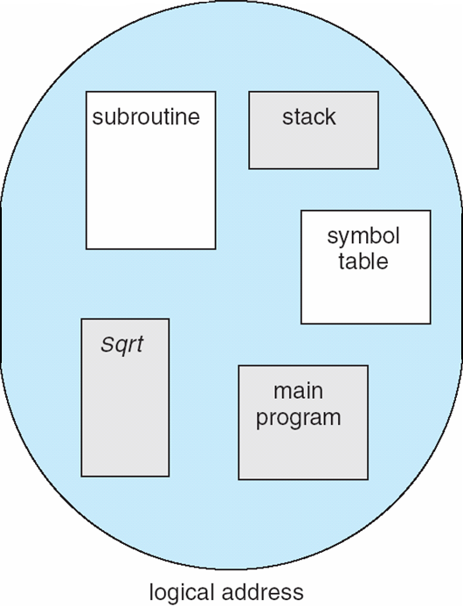

Segmentation Hardware

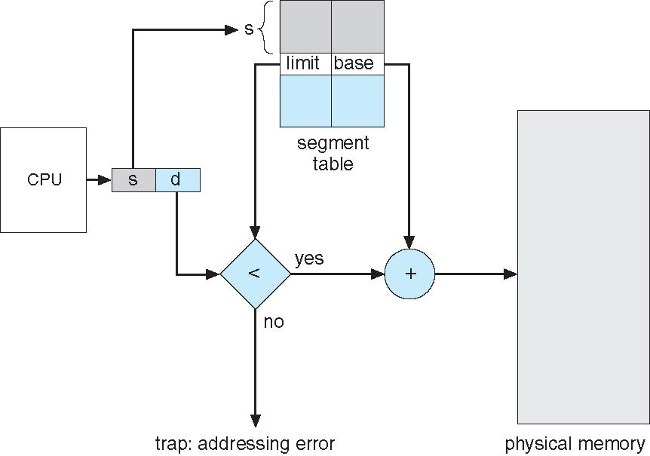

* 1. **Paging (367)**

Segmentation permits the physical address space of a process to be noncontiguous.

**Paging** is another memory-management scheme that offers this

advantage. However, paging avoids external fragmentation and the need for compaction, whereas segmentation does not.

It also solves the considerable

problem of fitting memory chunks of varying sizes onto the backing store.

Most memory-management schemes used before the introduction of paging

suffered from this problem. The problem arises because, when code fragments

or data residing in main memory need to be swapped out, space must be found

on the backing store. The backing store has the same fragmentation problems

discussed in connection with main memory, but access is much slower, so

compaction is impossible.

Because of its advantages over earlier methods,

paging in its various forms is used in most operating systems, from those for

mainframes through those for smartphones. Paging is implemented through

cooperation between the operating system and the computer hardware

* Physical address space of a process can be noncontiguous; process is allocated physical memory whenever the latter is available
  + Avoids external fragmentation
  + Avoids problem of varying sized memory chunks

**8.5.1 Basic Method (367)**

* Divide physical memory into fixed-sized blocks called **frames**
  + Size is power of 2, between 512 bytes and 16 Mbytes
* Divide logical memory into blocks of same size called **pages**
* Keep track of all free frames
* To run a program of size ***N***pages, need to find ***N*** free frames and load program
* Set up a **page table** to translate logical to physical addresses
* Backing store likewise split into pages
* Still have Internal fragmentation
* Calculating internal fragmentation
  + Page size = 2,048 bytes
  + Process size = 72,766 bytes
  + 35 pages + 1,086 bytes
  + Internal fragmentation of 2,048 - 1,086 = 962 bytes
  + Worst case fragmentation = 1 frame – 1 byte
  + On average fragmentation = 1 / 2 frame size
  + So small frame sizes desirable?
  + But each page table entry takes memory to track
  + Page sizes growing over time
    - Solaris supports two page sizes – 8 KB and 4 MB
* Process view and physical memory now very different
* By implementation process can only access its own memory

Because of its advantages over earlier methods,

paging in its various forms is used in most operating systems, from those for

mainframes through those for smartphones. Paging is implemented through

cooperation between the operating system and the computer hardware

**8.5.1 Basic method 367**

The basic method for implementing paging involves breaking physical memory

into fixed-sized blocks called **frames** and breaking logical memory into

blocks of the same size called **pages**. When a process is to be executed, its

pages are loaded into any available memory frames from their source (a file

system or the backing store). The backing store is divided into fixed-sized

blocks that are the same size as the memory frames or clusters of multiple

frames. This rather simple idea has great functionality and wide ramifications.

For example, the logical address space is now totally separate fromthe physical

address space, so a process can have a logical 64-bit address space even though

the system has less than 264 bytes of physical memory.

Address Translation Scheme

* Address generated by CPU is divided into: (367)
  + **Page number** (***p***) – used as an index into a **page table** which contains base address of each page in physical memory
  + **Page offset** (***d***) – combined with base address to define the physical memory address that is sent to the memory unit



* + For given logical address space 2*m* and page size*2*n

Paging Hardware

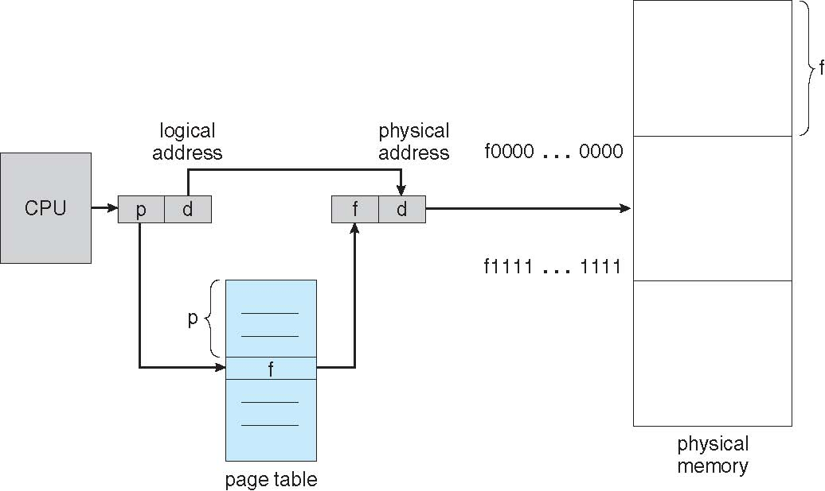

Paging Model of Logical and Physical Memory

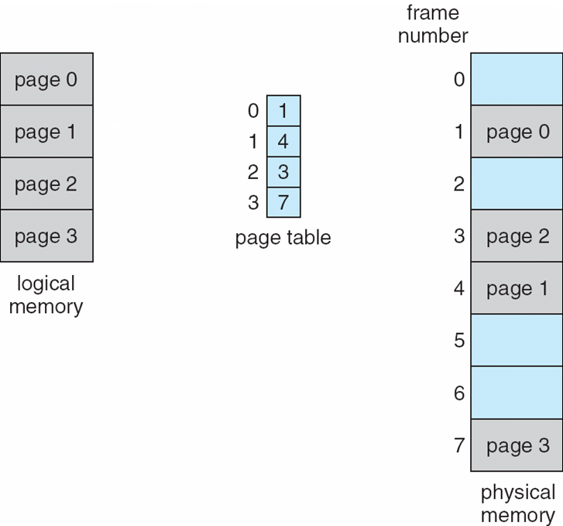

Paging Example

* *n*=2 and *m*=4 32-byte memory and 4-byte pages

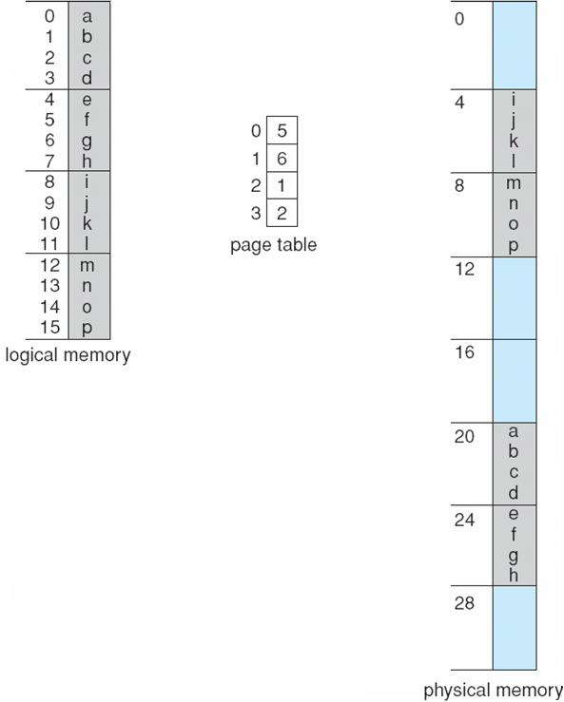

Free Frames

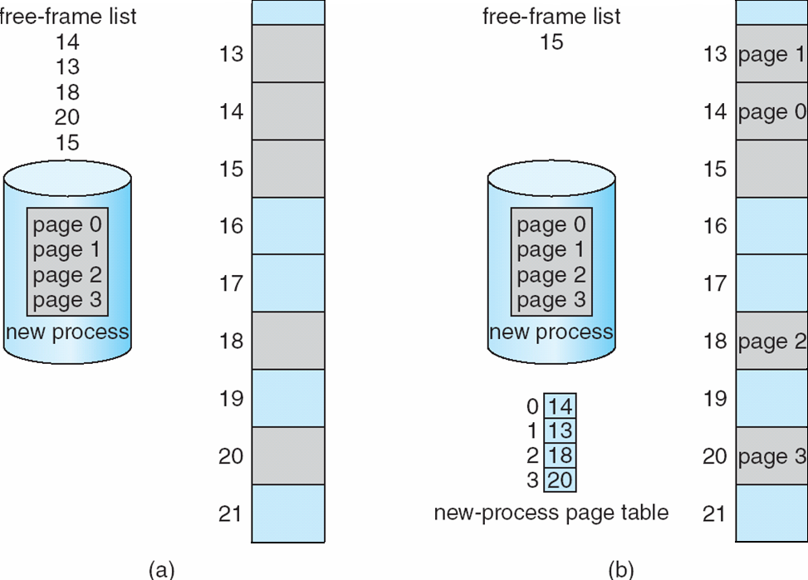

**8.5.2 Hardware Support (372)**

**Implementation of Page Table**

* Page table is kept in main memory
* **Page-table base register** (**PTBR**) points to the page table
* **Page-table length register** (**PTLR**) indicates size of the page table
* In this scheme every data/instruction access requires two memory accesses
  + One for the page table and one for the data / instruction
* The two memory access problem can be solved by the use of a special fast-lookup hardware cache called **associative memory** or **translation look-aside buffers** (**TLBs**)
* Some TLBs store **address-space identifiers** (**ASIDs**)in each TLB entry – uniquely identifies each process to provide address-space protection for that process
  + Otherwise need to flush at every context switch
* TLBs typically small (64 to 1,024 entries)
* On a TLB miss, value is loaded into the TLB for faster access next time
  + Replacement policies must be considered
  + Some entries can be **wired down** for permanent fast access

Associative Memory

* Associative memory – parallel search



* Address translation (p, d)
  + If p is in associative register, get frame # out
  + Otherwise get frame # from page table in memory

Paging Hardware with TLB

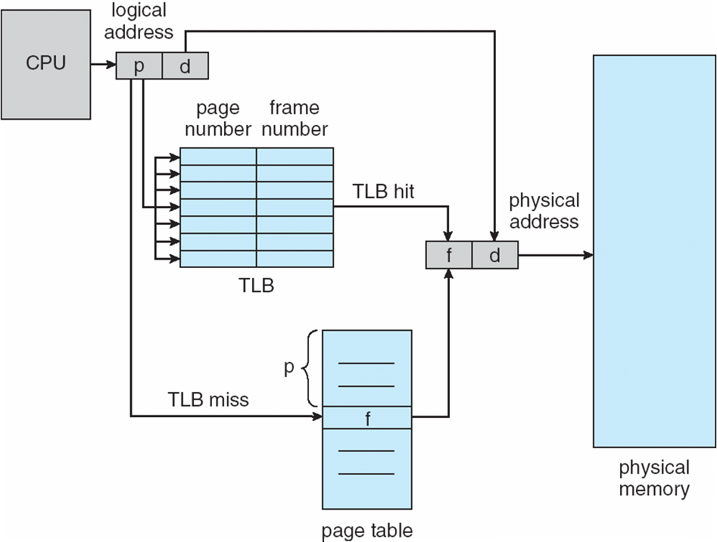

**Effective Access Time (effective memory-access time)**

* Associative Lookup = ε time unit
  + Can be < 10% of memory access time
* Hit ratio = α
  + Hit ratio – percentage of times that a page number is found in the associative registers; ratio related to number of associative registers
* Consider α = 80%, ε = 20ns for TLB search, 100ns for memory access
* **Effective Access Time** (**EAT**)

EAT = (1 + ε) α + (2 + ε)(1 – α)

= 2 + ε – α

* Consider α = 80%, ε = 20ns for TLB search, 100ns for memory access
  + EAT = 0.80 x 100 + 0.20 x 200 = 120ns
* Consider more realistic hit ratio -> α = 99%, ε = 20ns for TLB search, 100ns for memory access
  + EAT = 0.99 x 100 + 0.01 x 200 = 101ns

**8.5.3 Memory Protection (375)**

* Memory protection implemented by associating protection bit with each frame to indicate if read-only or read-write access is allowed
  + Can also add more bits to indicate page execute-only, and so on
* **Valid-invalid** bit attached to each entry in the page table:
  + “valid” indicates that the associated page is in the process’ logical address space, and is thus a legal page
  + “invalid” indicates that the page is not in the process’ logical address space
  + Or use **page-table length register** (**PTLR**)
* Any violations result in a trap to the kernel
* Rarely does a process use all its address range. In fact, many processes

use only a small fraction of the address space available to them. It would be

wasteful in these cases to create a page table with entries for every page in the

address range. Most of this table would be unused but would take up valuable

memory space. Some systems provide hardware, in the form of a **page-table**

**length register (PTLR)**, to indicate the size of the page table. This value is

checked against every logical address to verify that the address is in the valid

range for the process. Failure of this test causes an error trap to the operating

system

**Valid (v) or Invalid (i) Bit In A Page Table**

**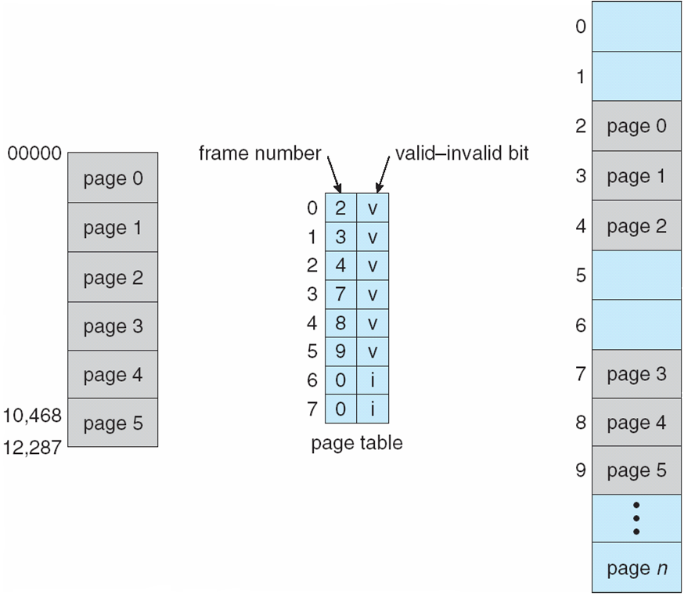**

**8.5.4 Shared Pages (page 376)**

* **Shared code**
  + One copy of read-only (**reentrant**) code shared among processes (i.e., text editors, compilers, window systems)
  + Similar to multiple threads sharing the same process space
  + Also useful for interprocess communication if sharing of read-write pages is allowed
* **Private code and data**
  + Each process keeps a separate copy of the code and data
  + The pages for the private code and data can appear anywhere in the logical address space

Shared Pages Example (377)

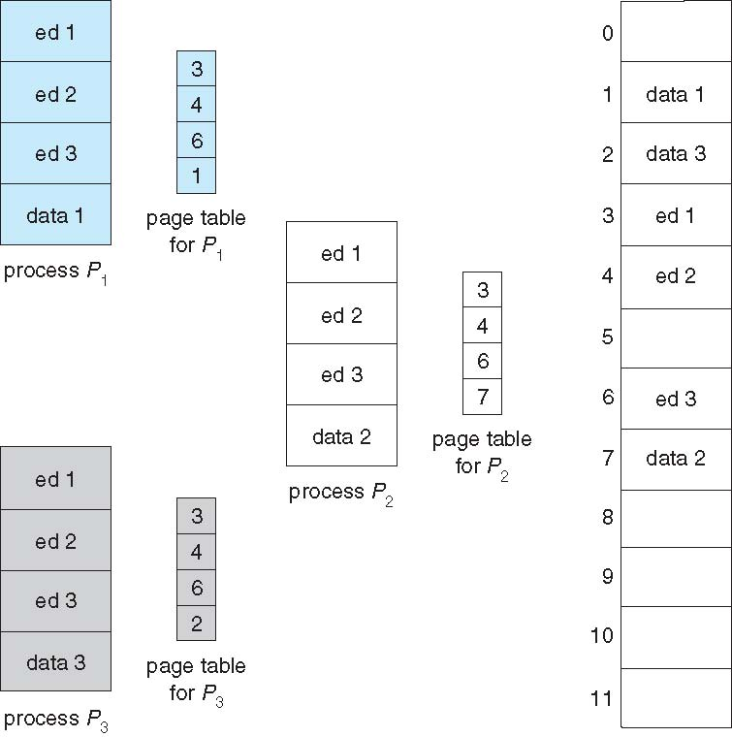

**8.6 Structure of the Page Table (378)**

* Memory structures for paging can get huge using straight-forward methods
  + Consider a 32-bit logical address space as on modern computers
  + Page size of 4 KB (212)
  + Page table would have 1 million entries (232 / 212)
  + If each entry is 4 bytes -> 4 MB of physical address space / memory for page table alone
    - That amount of memory used to cost a lot
    - Don’t want to allocate that contiguously in main memory
* Hierarchical Paging (378)
* Hashed Page Tables
* Inverted Page Tables

**Hierarchical Page Tables**

380 You can see from this example why, for 64-bit

architectures, hierarchical page tables are generally considered inappropriate.

* Break up the logical address space into multiple page tables
* A simple technique is a two-level page table
* We then page the page table

**Two-Level Page-Table Scheme (378)**

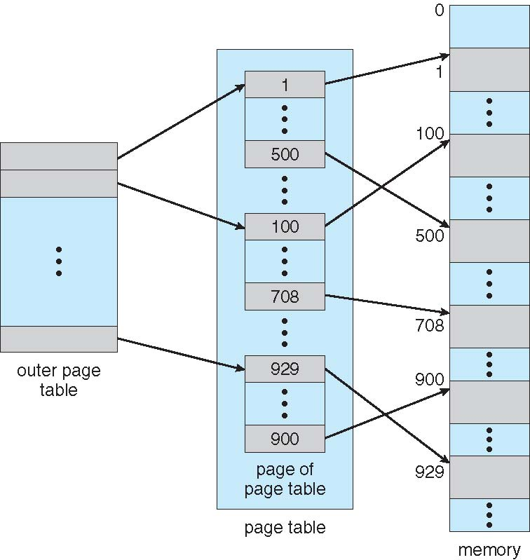

**Two-Level Paging Example**

* A logical address (on 32-bit machine with 1K page size) is divided into:
  + a page number consisting of 22 bits
  + a page offset consisting of 10 bits
  + Since the page table is paged, the page number is further divided into:
  + a 12-bit page number
  + a 10-bit page offset
  + Thus, a logical address is as follows:  
      
    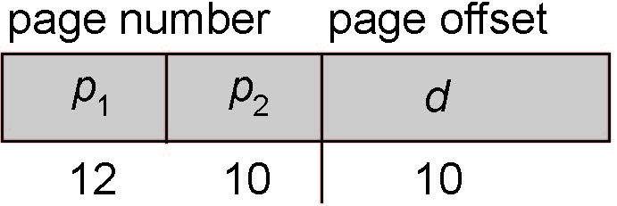
* where *p1* is an index into the outer page table, and *p2* is the displacement within the page of the inner page table
* Known as **forward-mapped page table**

Address-Translation scheme

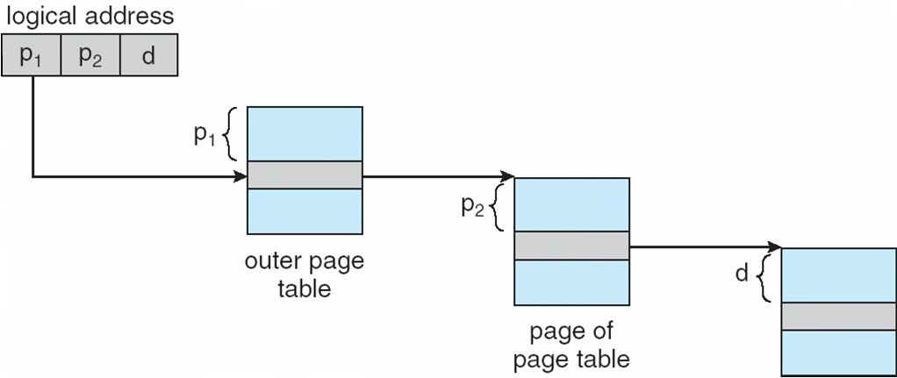

64-bit Logical Address Space

* Even two-level paging scheme not sufficient
* If page size is 4 KB (212)
  + Then page table has 252 entries
  + If two level scheme, inner page tables could be 210 4-byte entries
  + Address would look like

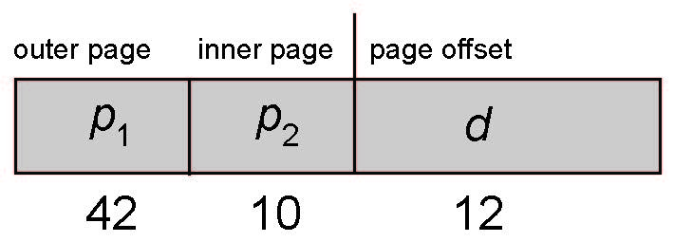

* + Outer page table has 242 entries or 244 bytes
  + One solution is to add a 2nd outer page table
  + But in the following example the 2nd outer page table is still 234 bytes in size
    - And possibly 4 memory access to get to one physical memory location

Three-level Paging Scheme

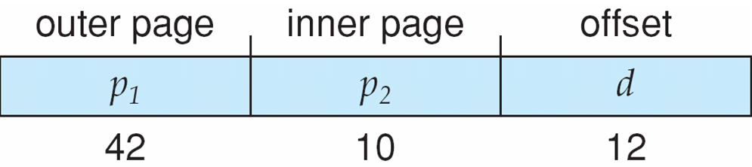

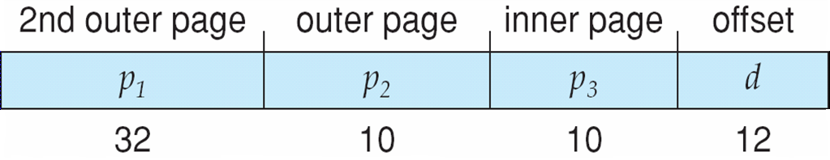

**8.6.2 Hashed Page Tables 380**

* Common in address spaces > 32 bits
* The virtual page number is hashed into a page table
  + This page table contains a chain of elements hashing to the same location
* Each element contains (1) the virtual page number (2) the value of the mapped page frame (3) a pointer to the next element
* Virtual page numbers are compared in this chain searching for a match
  + If a match is found, the corresponding physical frame is extracted
* Variation for 64-bit addresses is **clustered page tables**
  + Similar to hashed but each entry refers to several pages (such as 16) rather than 1
  + Especially useful for **sparse** address spaces (where memory references are non-contiguous and scattered)

Hashed Page Table

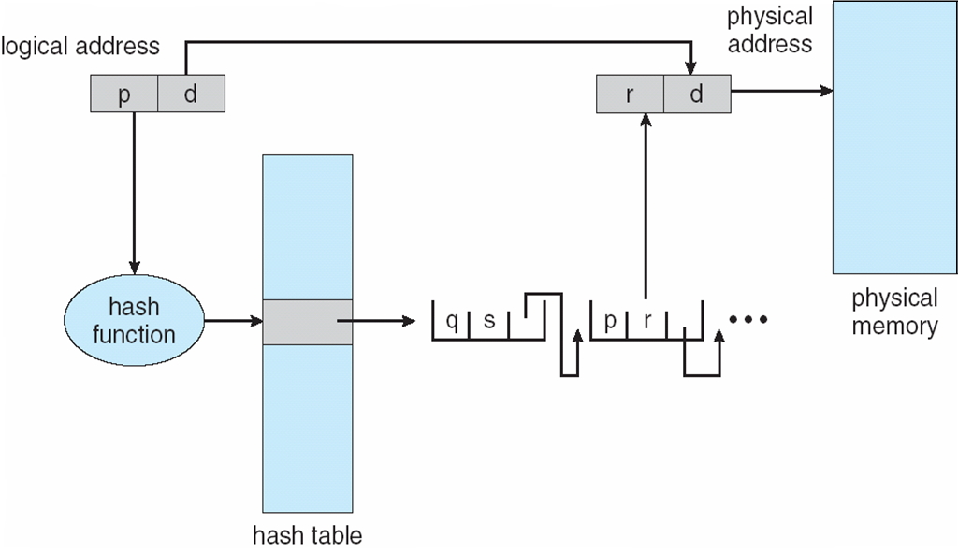

**8.6.3 Inverted Page Table (381)**

Examples of systems using inverted page

tables include the 64-bit UltraSPARC and PowerPC.

Systems that use inverted page tables have difficulty implementing shared

memory. Sharedmemory is usually implemented as multiple virtual addresses

(one for each process sharing the memory) that are mapped to one physical

address. This standard method cannot be used with inverted page tables;

because there is only one virtual page entry for every physical page, one

physical page cannot have two (or more) shared virtual addresses. A simple

technique for addressing this issue is to allow the page table to contain only

one mapping of a virtual address to the shared physical address. This means

that references to virtual addresses that are not mapped result in page faults.

* Rather than each process having a page table and keeping track of all possible logical pages, track all physical pages
* **One entry for each real page of memory**
* Entry consists of the virtual address of the page stored in that real memory location, with information about the process that owns that page
* Decreases memory needed to store each page table, but increases time needed to search the table when a page reference occurs
* Use hash table to limit the search to one — or at most a few — page-table entries
  + TLB can accelerate access
* But how to implement shared memory?
  + One mapping of a virtual address to the shared physical address

Inverted Page Table Architecture

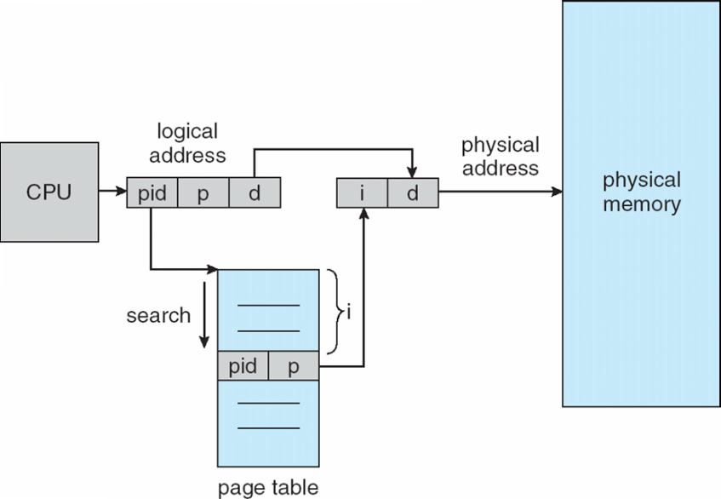

Oracle SPARC Solaris

* Consider modern, 64-bit operating system example with tightly integrated HW
  + Goals are efficiency, low overhead
* Based on hashing, but more complex
* Two hash tables
  + One kernel and one for all user processes
  + Each maps memory addresses from virtual to physical memory
  + Each entry represents a contiguous area of mapped virtual memory,
    - More efficient than having a separate hash-table entry for each page
  + Each entry has base address and span (indicating the number of pages the entry represents)
* TLB holds translation table entries (TTEs) for fast hardware lookups
  + A cache of TTEs reside in a translation storage buffer (TSB)
    - Includes an entry per recently accessed page
* Virtual address reference causes TLB search
  + If miss, hardware walks the in-memory TSB looking for the TTE corresponding to the address
    - If match found, the CPU copies the TSB entry into the TLB and translation completes
    - If no match found, kernel interrupted to search the hash table
      * The kernel then creates a TTE from the appropriate hash table and stores it in the TSB, Interrupt handler returns control to the MMU, which completes the address translation.

Example: Intel 32 and 64 bit Architecture

* Dominant industry chips
* Pentium CPUs are 32-bit and called IA-32 architecture
* Current Intel CPUs are 64-bit and called IA-64 architecture
* Many variations in the chips, cover the main ideas here

8.7.1 Example: The Intel IA-32 Architecture (384)

* Supports both segmentation and segmentation with paging
  + Each segment can be 4 GB
  + Up to 16 K segments per process
  + Divided into two partitions
    - First partition of up to 8 K segments are private to process (kept in **local descriptor table** (**LDT**))
    - Second partition of up to 8K segments shared among all processes (kept in **global descriptor table** (**GDT**))
* IA-32 Segmentation

CPU generates logical address

* + Selector given to segmentation unit
    - Which produces linear addresses

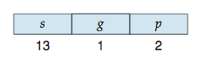

* + Linear address given to paging unit
    - Which generates physical address in main memory
    - Paging units form equivalent of MMU
    - Pages sizes can be 4 KB or 4 MB

Logical to Physical Address Translation in IA-32 (384)

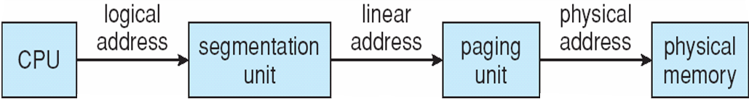

IA-32 Paging (385)

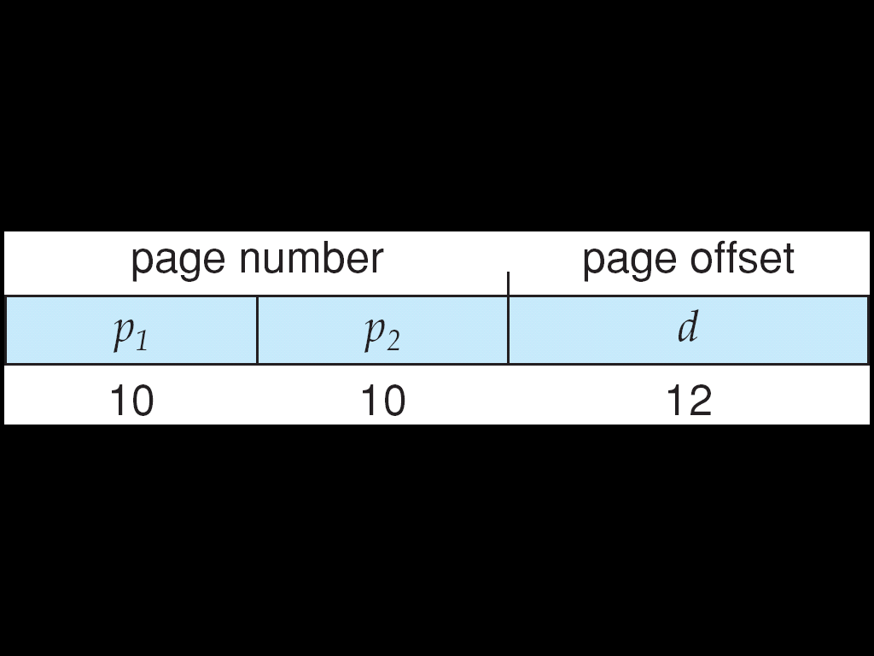

Intel IA-32 Segmentation (385)

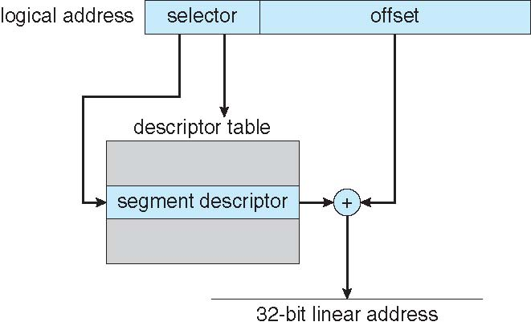

Intel IA-32 Paging Architecture (386)

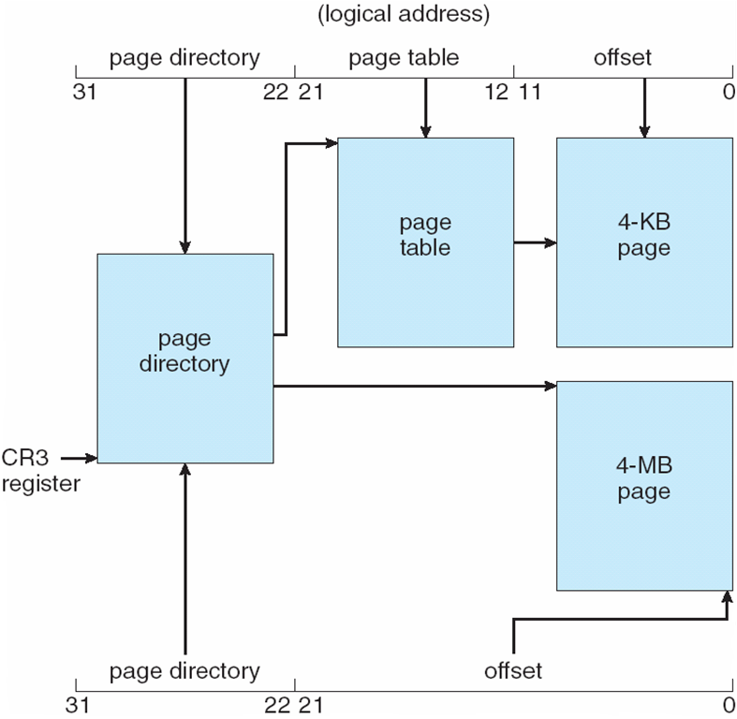

Intel IA-32 Page Address Exrensions (PAEs 386)

* 32-bit address limits led Intel to create **page address extension** (**PAE**), allowing 32-bit apps access to more than 4GB of memory space
  + Paging went to a 3-level scheme
  + Top two bits refer to a **page directory pointer table**
  + Page-directory and page-table entries moved to 64-bits in size
  + Net effect is increasing address space to 36 bits – 64GB of physical memory
  + Page address extensions:

8_24.pdf

Intel x86-64

* Current generation Intel x86 architecture
* 64 bits is ginormous (> 16 exabytes)
* In practice only implement 48 bit addressing
  + Page sizes of 4 KB, 2 MB, 1 GB
  + Four levels of paging hierarchy
* Can also use PAE so virtual addresses are 48 bits and physical addresses are 52 bits

8_25.pdf

Example: ARM Architectue

* Dominant mobile platform chip (Apple iOS and Google Android devices for example)
* Modern, energy efficient, 32-bit CPU
* 4 KB and 16 KB pages
* 1 MB and 16 MB pages (termed **sections**)
* One-level paging for sections, two-level for smaller pages
* Two levels of TLBs
  + Outer level has two micro TLBs (one data, one instruction)
  + Inner is single main TLB
  + First inner is checked, on miss outers are checked, and on miss page table walk performed by CPU

8_26.pdf

**\*\*\*\*\*CH 9: Virtual Memory\*\*\*\*\*\*\*\*\*\*\*\*\*\*\*\*\*\*\***

* To describe the benefits of a virtual memory system
* To explain the concepts of demand paging, page-replacement algorithms, and allocation of page frames
* To discuss the principle of the working-set model
* To examine the relationship between shared memory and memory-mapped files
* To explore how kernel memory is managed

**9.1 Background 397**

* Code needs to be in memory to execute, but entire program rarely used
  + Error code, unusual routines, large data structures
* Entire program code not needed at same time
* Consider ability to execute partially-loaded program
  + Program no longer constrained by limits of physical memory
  + Each program takes less memory while running -> more programs run at the same time
    - Increased CPU utilization and throughput with no increase in response time or turnaround time
  + Less I/O needed to load or swap programs into memory -> each user program runs faster
* **Virtual memory** 398– separation of user logical memory from physical memory
  + Only part of the program needs to be in memory for execution
  + Logical address space can therefore be much larger than physical address space
  + Allows address spaces to be shared by several processes
  + Allows for more efficient process creation
  + More programs running concurrently
  + Less I/O needed to load or swap processes
* **Virtual address space** 398– logical view of how process is stored in memory
  + Usually start at address 0, contiguous addresses until end of space
  + Meanwhile, physical memory organized in page frames
  + MMU must map logical to physical
* **Virtual memory can be implemented via:**
  + **Demand paging**
  + **Demand segmentation**

VM larger than physical memory

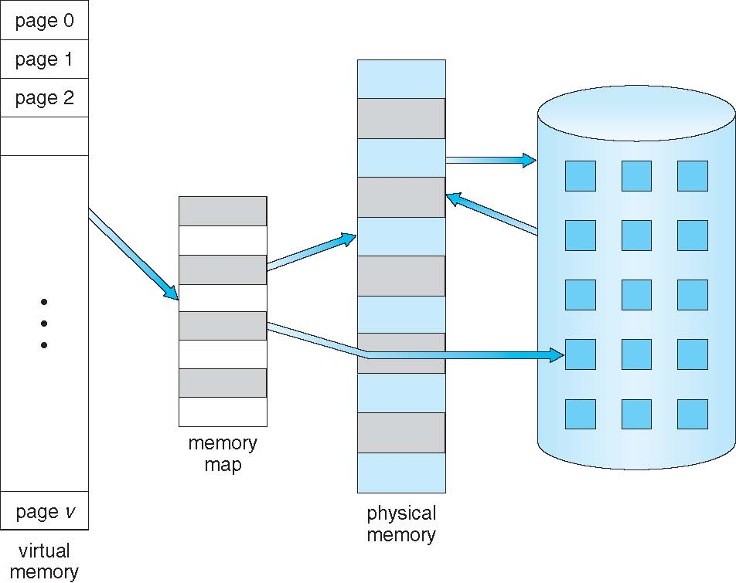

**Virtual-address Space 398**

* Usually design logical address space for stack to start at Max logical address and grow “down” while heap grows “up”
  + Maximizes address space use
  + Unused address space between the two is hole
    - No physical memory needed until heap or stack grows to a given new page
* Enables **sparse(400)** address spaces with holes left for growth, dynamically linked libraries, etc
* System libraries shared via mapping into virtual address space
* Shared memory by mapping pages read-write into virtual address space
* Pages can be shared during fork(), speeding process creation

Shared Library Using Virtual Memory

**9. 2 Basic Concepts 402**

Memory resident

**9.2 Demand Paging 401**

* Could bring entire process into memory at load time
* Or bring a page into memory only when it is needed
  + Less I/O needed, no unnecessary I/O
  + Less memory needed
  + Faster response
  + More users
* Similar to paging system with swapping (diagram on right)
* Page is needed ⇒ reference to it
  + invalid reference ⇒ abort
  + not-in-memory ⇒ bring to memory
* **Lazy swapper** – never swaps a page into memory unless page will be needed
  + Swapper that deals with pages is a **pager**

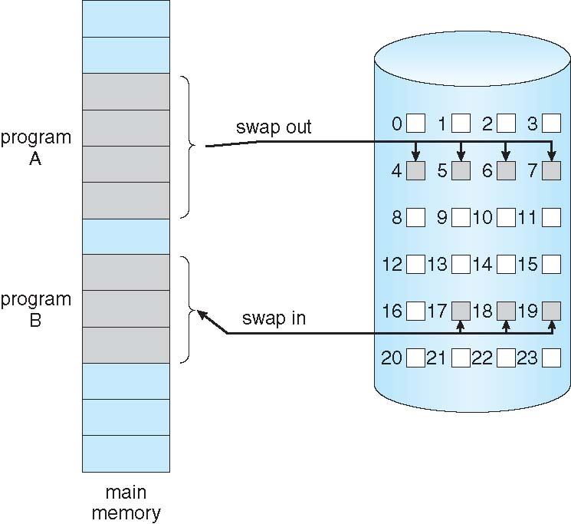

**9.2.1 Basic Concepts 402**

* With swapping, pager guesses which pages will be used before swapping out again
* Instead, pager brings in only those pages into memory
* How to determine that set of pages?
  + Need new MMU functionality to implement demand paging
* If pages needed are already **memory resident**
  + No difference from non demand-paging
* If page needed and not memory resident
  + Need to detect and load the page into memory from storage
    - Without changing program behavior
    - Without programmer needing to change code

Valid-Invalid Bit

* With each page table entry a valid–invalid bit is associated  
  (**v** ⇒ in-memory – **memory resident**, **i** ⇒ not-in-memory)
* Initially valid–invalid bit is set to **i** on all entries
* Example of a page table snapshot:  
  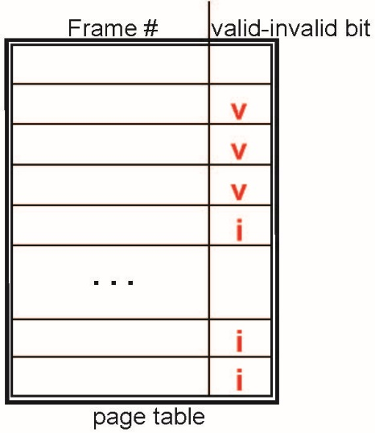
* During MMU address translation, if valid–invalid bit in page table entry is **i** ⇒ page fault

Page Table when Some Pages are not in memory

**Page Fault 403**

Access to a page marked invalid causes a **page fault**. The paging

hardware, in translating the address through the page table, will notice that

the invalid bit is set, causing a trap to the operating system. This trap is the

result of the operating system’s failure to bring the desired page into memory.

The procedure for handling this page fault is straightforward (Figure 9.6):

**1.** We check an internal table (usually kept with the process control block)

for this process to determine whether the reference was a valid or an

invalid memory access.

**2.** If the reference was invalid, we terminate the process. If it was valid but

we have not yet brought in that page, we now page it in.

**3.** We find a free frame (by taking one fromthe free-frame list, for example).

**4.** We schedule a disk operation to read the desired page into the newly

allocated frame.

**5.** When the disk read is complete, we modify the internal table kept with

the process and the page table to indicate that the page is now in memory.

**6.** We restart the instruction that was interrupted by the trap. The process

can now access the page as though it had always been in memory.

In the extreme case, we can start executing a process with ***no*** pages in

memory. When the operating system sets the instruction pointer to the first

* If there is a reference to a page, first reference to that page will trap to operating system:
* **page fault**
* Operating system looks at another table to decide:
  + Invalid reference ⇒ abort
  + Just not in memory
* Find free frame
* Swap page into frame via scheduled disk operation
* Reset tables to indicate page now in memory  
  Set validation bit = **v**
* Restart the instruction that caused the page fault

Steps in Handling a Page Fault

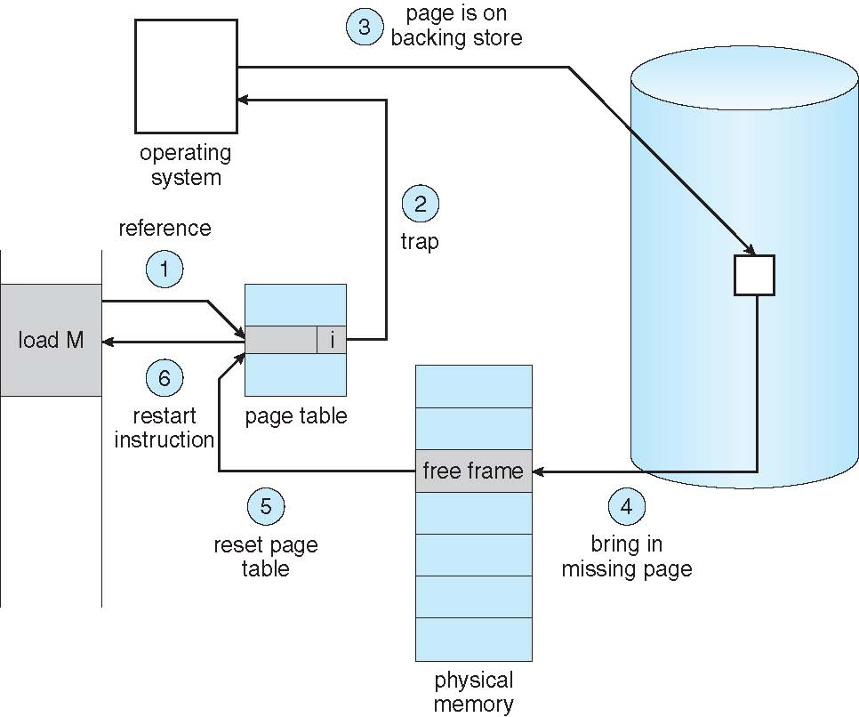

Aspects of Demand Paging

* Extreme case – start process with *no* pages in memory
  + OS sets instruction pointer to first instruction of process, non-memory-resident -> page fault
  + And for every other process pages on first access
  + **Pure demand paging**
* Actually, a given instruction could access multiple pages -> multiple page faults
  + Consider fetch and decode of instruction which adds 2 numbers from memory and stores result back to memory
  + Pain decreased because of **locality of reference**
* Hardware support needed for demand paging
  + Page table with valid / invalid bit
  + Secondary memory (swap device with **swap space**)
  + Instruction restart

Instruction Restart

* Consider an instruction that could access several different locations
  + block move
  + auto increment/decrement location
  + Restart the whole operation?
    - What if source and destination overlap?

**9.2.2 Performance of Demand Paging 405**

**Effective access time**

it is important to keep the page-fault rate low in a demand-paging system.

Otherwise, the effective access time increases, slowing process execution

dramatically.

**Stages in Demand Paging (worse case)**

1. Trap to the operating system
2. Save the user registers and process state
3. Determine that the interrupt was a page fault
4. Check that the page reference was legal and determine the location of the page on the disk
5. Issue a read from the disk to a free frame:
   1. Wait in a queue for this device until the read request is serviced
   2. Wait for the device seek and/or latency time
   3. Begin the transfer of the page to a free frame
6. While waiting, allocate the CPU to some other user
7. Receive an interrupt from the disk I/O subsystem (I/O completed)
8. Save the registers and process state for the other user
9. Determine that the interrupt was from the disk
10. Correct the page table and other tables to show page is now in memory
11. Wait for the CPU to be allocated to this process again
12. Restore the user registers, process state, and new page table, and then resume the interrupted instruction

**Three major activities (hree major components of the page-fault service time:))**

* + Service the interrupt – careful coding means just several hundred instructions needed
  + Read the page – lots of time
  + Restart the process – again just a small amount of time
* Page Fault Rate 0 ≤ *p* ≤ 1
  + if *p* = 0 no page faults
  + if *p* = 1, every reference is a fault
* Effective Access Time (EAT)

EAT = (1 – *p*) x memory access

+ *p* (page fault overhead

+ swap page out

+ swap page in )

Demand Paging Example

* Memory access time = 200 nanoseconds
* Average page-fault service time = 8 milliseconds
* EAT = (1 – p) x 200 + p (8 milliseconds)

= (1 – p x 200 + p x 8,000,000

= 200 + p x 7,999,800

* If one access out of 1,000 causes a page fault, then

EAT = 8.2 microseconds.

This is a slowdown by a factor of 40!!

* If want performance degradation < 10 percent
  + 220 > 200 + 7,999,800 x p  
    20 > 7,999,800 x p
  + p < .0000025
  + < one page fault in every 400,000 memory accesses

Demand Paging Optimizations

* Swap space I/O faster than file system I/O even if on the same device
  + Swap allocated in larger chunks, less management needed than file system
* Copy entire process image to swap space at process load time
  + Then page in and out of swap space
  + Used in older BSD Unix
* Demand page in from program binary on disk, but discard rather than paging out when freeing frame
* Used in Solaris and current BSD
* Still need to write to swap space
  + Pages not associated with a file (like stack and heap) – **anonymous** **memory (407)**
  + Pages modified in memory but not yet written back to the file system
* Mobile systems
  + Typically don’t support swapping
  + Instead, demand page from file system and reclaim read-only pages (such as code)

**9.3 Copy-on-write 408**

**Windows, linux solaris use it**

In Section 9.2, we illustratedhow a process can start quickly by demand-paging

in the page containing the first instruction. However, process creation using the

fork() system call may initially bypass the need for demand paging by using

a technique similar to page sharing (covered in Section 8.5.4). This technique

provides rapid process creation and minimizes the number of new pages that

must be allocated to the newly created process

the fork() system call creates a child process that is a duplicate

of its parent. Traditionally, fork() worked by creating a copy of the parent’s

address space for the child, duplicating the pages belonging to the parent.

However, considering that many child processes invoke the exec() system

call immediately after creation, the copying of the parent’s address space may

be unnecessary. Instead, we can use a technique known as **copy-on-write**,

which works by allowing the parent and child processes initially to share the

same pages. These shared pages are marked as copy-on-write pages, meaning

that if either process writes to a shared page, a copy of the shared page is

created.

* **Copy-on-Write** (COW) allows both parent and child processes to initially ***share*** the same pages in memory
  + If either process modifies a shared page, only then is the page copied
* COW allows more efficient process creation as only modified pages are copied
* In general, free pages are allocated from a **pool** (408)of **zero-fill-on-demand(409)** pages
  + Pool should always have free frames for fast demand page execution
    - Don’t want to have to free a frame as well as other processing on page fault
  + Why zero-out a page before allocating it?
* vfork() variation on fork() system call has parent suspend and child using copy-on-write address space of parent
  + Designed to have child call exec()
  + Very efficient

Before Process 1 Modifies Page C

After Process 1 Modifies Page C

What happens if there is no free frame

* Used up by process pages
* Also in demand from the kernel, I/O buffers, etc
* How much to allocate to each?
* Page replacement – find some page in memory, but not really in use, page it out
  + Algorithm – terminate? swap out? replace the page?
  + Performance – want an algorithm which will result in minimum number of page faults
* Same page may be brought into memory several times

**9.4 Page Replacement 409**

* Prevent **over-allocation** of memory by modifying page-fault service routine to include page replacement
* Use **modify** (**dirty**) **bit** to reduce overhead of page transfers – only modified pages are written to disk
* Page replacement completes separation between logical memory and physical memory – large virtual memory can be provided on a smaller physical memory

Need for Page Replacement

**9.4.1 Basic Page Replacement 411**

1. Find the location of the desired page on disk
2. Find a free frame:  
    - If there is a free frame, use it  
    - If there is no free frame, use a page replacement algorithm to select a **victim** **frame  
    -** Write victim frame to disk if dirty
3. Bring the desired page into the (newly) free frame; update the page and frame tables
4. Continue the process by restarting the instruction that caused the trap

Note now potentially 2 page transfers for page fault – increasing EAT

**Basic Page Replacement 411**

1. Find the location of the desired page on disk
2. Find a free frame:  
    - If there is a free frame, use it  
    - If there is no free frame, use a page replacement algorithm to select a **victim** **frame  
    -** Write victim frame to disk if dirty
3. Bring the desired page into the (newly) free frame; update the page and frame tables
4. Continue the process by restarting the instruction that caused the trap

Note now potentially 2 page transfers for page fault – increasing EAT

We can reduce this overhead by using a **modify bit** (or **dirty bit**). When

this scheme is used, each page or frame has a modify bit associated with it in

the hardware. The modify bit for a page is set by the hardware whenever any

byte in the page is written into, indicating that the page has been modified.

When we select a page for replacement, we examine its modify bit. If the bit

is set, we know that the page has been modified since it was read in from the

disk. In this case, we must write the page to the disk. If the modify bit is not set,

however, the page has ***not*** been modified since it was read into memory. In this

case, we need not write the memory page to the disk: it is already there. This

technique also applies to read-only pages (for example, pages of binary code).

Page Replacement 411

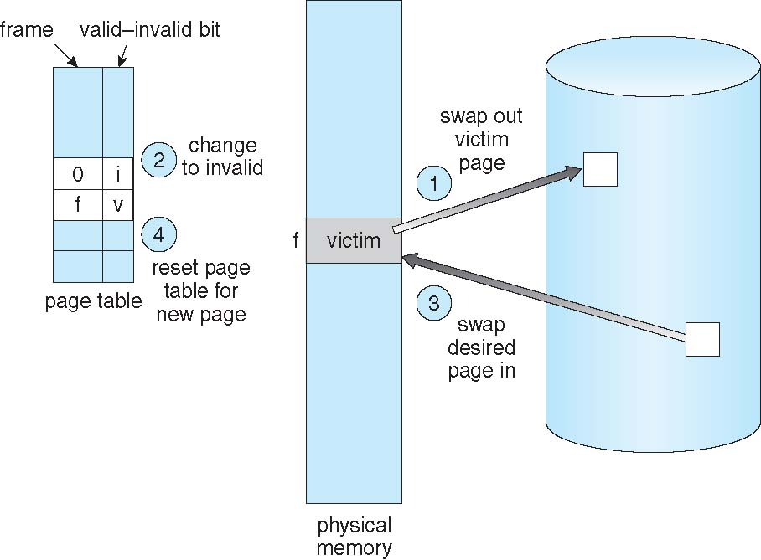

We must solve two major problems to implement demand paging: we must

develop a **frame-allocation algorithm** and a **page-replacement algorithm**.

That is, if we have multiple processes in memory, we must decide how many

frames to allocate to each process; and when page replacement is required,

we must select the frames that are to be replaced. Designing appropriate

algorithms to solve these problems is an important task, because disk I/O

is so expensive. Even slight improvements in demand-paging methods yield

large gains in system performance.

There are many different page-replacement algorithms. Every operating

system probably has its own replacement scheme. How do we select a

particular replacement algorithm? In general, we want the one with the lowest

page-fault rate

Page and Frame Replacement algorithms

* **Frame-allocation algorithm** determines
  + How many frames to give each process
  + Which frames to replace
* **Page-replacement algorithm**
  + Want lowest page-fault rate on both first access and re-access
* Evaluate algorithm by running it on a particular string of memory references (reference string) and computing the number of page faults on that string
  + String is just page numbers, not full addresses
  + Repeated access to the same page does not cause a page fault
  + Results depend on number of frames available
* In all our examples, the **reference string** of referenced page numbers is

**7,0,1,2,0,3,0,4,2,3,0,3,0,3,2,1,2,0,1,7,0,1**

Graph of page faults vs number of frames

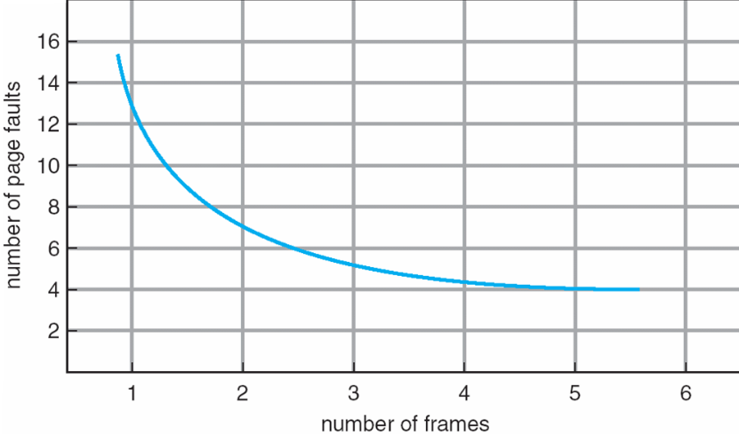

**9.4.2 FIFO Algorithm**

* Reference string: **7,0,1,2,0,3,0,4,2,3,0,3,0,3,2,1,2,0,1,7,0,1**
* 3 frames (3 pages can be in memory at a time per process)

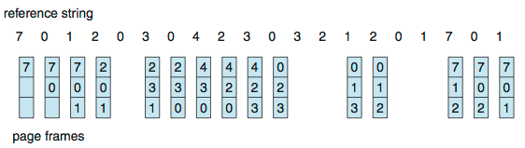

15 page faults

* Can vary by reference string: consider 1,2,3,4,1,2,5,1,2,3,4,5
  + Adding more frames can cause more page faults!
    - **Belady’s Anomaly**
* How to track ages of pages?
  + Just use a FIFO queue

FIFO illustrating Belady’s Anomoly

9_13.pdf

**9.4.3 Optimal page replacement (414)**

Optimal algorithm

* Replace page that will not be used for longest period of time
  + 9 is optimal for the example
* How do you know this?
  + Can’t read the future
* Used for measuring how well your algorithm performs

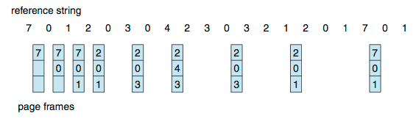

**9.4.4 Least Recently Used LRU Algorithm (416)**

* Use past knowledge rather than future
* Replace page that has not been used in the most amount of time
* Associate time of last use with each page

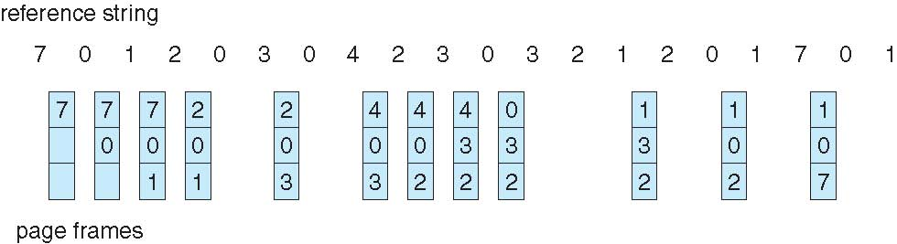

* 12 faults – better than FIFO but worse than OPT
* Generally good algorithm and frequently used
* But how to implement?
* Counter implementation
  + Every page entry has a counter; every time page is referenced through this entry, copy the clock into the counter
  + When a page needs to be changed, look at the counters to find smallest value
    - Search through table needed
* Stack implementation
  + Keep a stack of page numbers in a double link form:
  + Page referenced:
    - move it to the top
    - requires 6 pointers to be changed
  + But each update more expensive
  + No search for replacement
* LRU and OPT are cases of **stack algorithms** that don’t have Belady’s Anomaly

Use of a stack to record Most recent page references

**9.4.5 LRU Approximation Page Replacement Algorithms (418)**

* LRU needs special hardware and still slow
* **Reference bit (418)**
  + With each page associate a bit, initially = 0
  + When page is referenced bit set to 1
  + Replace any with reference bit = 0 (if one exists)
    - We do not know the order, however
* **Second-chance algorithm (418)**
* Generally FIFO, plus hardware-provided reference bit
* **Clock** replacement
* If page to be replaced has
* Reference bit = 0 -> replace it
  + reference bit = 1 then:
    - set reference bit 0, leave page in memory
    - replace next page, subject to same rules

**Second-Chance (clock) Page-Replacement Algorithm**

9_17.pdf

**9.4.5.3 Enhanced Second Chance Algorithm (419)**

* Improve algorithm by using reference bit and modify bit (if available) in concert
* Take ordered pair (reference, modify)

1. (0, 0) neither recently used not modified – best page to replace
2. (0, 1) not recently used but modified – not quite as good, must write out before replacement
3. (1, 0) recently used but clean – probably will be used again soon
4. (1, 1) recently used and modified – probably will be used again soon and need to write out before replacement

* When page replacement called for, use the clock scheme but use the four classes replace page in lowest non-empty class
  + Might need to search circular queue several times

**9.4.6 Counting-based page algorithms 420**

* Keep a counter of the number of references that have been made to each page
  + Not common
* **Least Frequently Used** (**LFU**) **Algorithm**: replaces page with smallest count
* **Most Frequently Used** (**MFU**) **Algorithm**: based on the argument that the page with the smallest count was probably just brought in and has yet to be used

**9.4.7 Page-Buffering Algorithms 420**

* Keep a pool of free frames, always
  + Then frame available when needed, not found at fault time
  + Read page into free frame and select victim to evict and add to free pool
  + When convenient, evict victim
* Possibly, keep list of modified pages
  + When backing store otherwise idle, write pages there and set to non-dirty
* Possibly, keep free frame contents intact and note what is in them
  + If referenced again before reused, no need to load contents again from disk
  + Generally useful to reduce penalty if wrong victim frame selected

**9.4.8 Applications and Page Replacement 421**

* All of these algorithms have OS guessing about future page access
* Some applications have better knowledge – i.e. databases
* Memory intensive applications can cause double buffering
  + OS keeps copy of page in memory as I/O buffer
  + Application keeps page in memory for its own work
* Operating system can given direct access to the disk, getting out of the way of the applications
  + **Raw disk** mode
* Bypasses buffering, locking, etc

**9.5 Allocation of Frames (421)**

**9.5.1 Minimum Number of Frames (422)**

* Each process needs ***minimum*** number of frames
* Example: IBM 370 – 6 pages to handle SS MOVE instruction:
  + instruction is 6 bytes, might span 2 pages
  + 2 pages to handle *from*
  + 2 pages to handle *to*
* ***Maximum***of course is total frames in the system
* Two major allocation schemes
  + fixed allocation
  + priority allocation
* Many variations

**9.5.2 Allocation Algorithms 423**

* **Equal allocation**
* **Proportional allocation**

**Fixed Allocation**

* Equal allocation – For example, if there are 100 frames (after allocating frames for the OS) and 5 processes, give each process 20 frames
  + Keep some as free frame buffer pool
* Proportional allocation – Allocate according to the size of process
  + Dynamic as degree of multiprogramming, process sizes change

 

**9.5.3 Global versus Local allocation**

* **Global replacement**
* **Local replacement**

**9.5.4 Non-Uniform Memory Access (424)**

**NUMA**

**Lgroups (latency groups)**

**9.6 Thrashing (425)**

* If a process does not have “enough” pages, the page-fault rate is very high
  + Page fault to get page
  + Replace existing frame
  + But quickly need replaced frame back
  + This leads to:
    - Low CPU utilization
    - Operating system thinking that it needs to increase the degree of multiprogramming
    - Another process added to the system
* **Thrashing** ≡ a process is busy swapping pages in and out

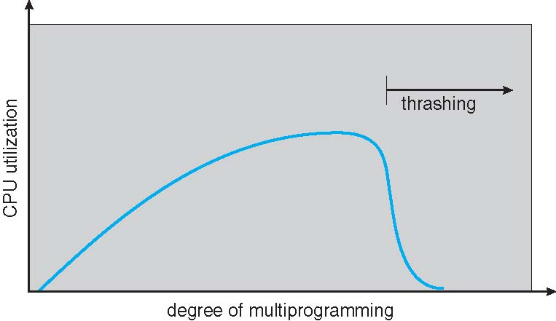

**Demand Paging and Thrashing 427**

**Can limit the effects of thrashing by using:**

* **Local replacement algorithm (or Priority replacement algorithm**)-one process starts thrashing, it cannot steal frames from another process and cause the latter to thrash as well. Problem not solved. If processes are thrashing, they will be in the queue for the paging device most of the time. The average service time for a page fault will increase because of longer average queue for the paging device. Effective access time will increase even for a process that is not thrashing

To prevent thrashing, we must provided a process with as many frames as it needs. But how do we know how many frames it needs? Several techniques

**Working-set strategy** starts by looking at how many frames a process is actually using. This approach defines a locality model of process execution

* Why does demand paging work?  
  **Locality model**
  + Process migrates from one locality to another
  + A locality is a set of pages that are actively used together
  + Program usually composed of several different localities
  + Localities may overlap
  + Localities are defined by the program structure and its data structures
  + Locality model states that all programs will exhibit this basic memory reference structures
  + Locality model is the unstated principle behind caching discussions so far in book
  + If accesses to any type of data were random rather than patterned, caching would be useless
* Why does thrashing occur?  
  Σ size of locality > total memory size
  + Limit effects by using local or priority page replacement

Locality in a memory reference pattern

9.6.2 Working-Set Model (427) – based on the assumption of locality

* Δ ≡ working-set window ≡ a fixed number of page references   
  Example: 10,000 instructions
* *WSSi* (working set of Process *Pi*) =  
  total number of pages referenced in the most recent Δ (varies in time)
  + if Δ too small will not encompass entire locality
  + if Δ too large will encompass several localities
  + if Δ = ∞ ⇒ will encompass entire program
* *D* = Σ *WSSi* ≡ total demand frames
  + Approximation of locality
* if *D* > *m* ⇒ Thrashing
* Policy if *D* > m, then suspend or swap out one of the processes

Keeping track of the working set

* Approximate with interval timer + a reference bit
* Example: Δ = 10,000
  + Timer interrupts after every 5000 time units
  + Keep in memory 2 bits for each page
  + Whenever a timer interrupts copy and sets the values of all reference bits to 0
  + If one of the bits in memory = 1 ⇒ page in working set
* Why is this not completely accurate?
* Improvement = 10 bits and interrupt every 1000 time units

**9.6.3 Page fault frequency (429)**

The working-set model is successful, and knowledge of the working set can

be useful for prepaging (Section 9.9.1), but it seems a clumsy way to control

thrashing. A strategy that uses the **page-fault frequency (PFF)** takes a more

direct approach.

The specific problem is how to prevent thrashing. Thrashing has a high

page-fault rate. Thus, we want to control the page-fault rate. When it is too

high,weknow that the process needs more frames. Conversely, if the page-fault

rate is too low, then the process may have too many frames

* More direct approach than WSS
* Establish “acceptable” **page-fault frequency** (**PFF**)rate and use local replacement policy
  + If actual rate too low, process loses frame
  + If actual rate too high, process gains frame

Working sets and page fault rates

Direct relationship between working set of a process and its page-fault rate

Working set changes over time

Peaks and valleys over time

Practically speaking, thrashing and the resulting swapping have a disagreeably

large impact on performance. The current best practice in implementing a

computer facility is to include enough physical memory, whenever possible,

to avoid thrashing and swapping. From smartphones through mainframes,

providing enough memory to keep all working sets in memory concurrently,

except under extreme conditions, gives the best user experience.

**9.7 Memory mapped files 430**

**Memory mapping-**

**named shared-memory object**

* Memory-mapped file I/O allows file I/O to be treated as routine memory access by **mapping** a disk block to a page in memory
* A file is initially read using demand paging
  + A page-sized portion of the file is read from the file system into a physical page
  + Subsequent reads/writes to/from the file are treated as ordinary memory accesses
* Simplifies and speeds file access by driving file I/O through memory rather than read()and write() system calls
* Also allows several processes to map the same file allowing the pages in memory to be shared
* But when does written data make it to disk?
  + Periodically and / or at file close() time
  + For example, when the pager scans for dirty pages

**9.7.3 Memory-Mapped I/O (435)**

Memory mapped file technique for all IO

* Some OSes uses memory mapped files for standard I/O
* Process can explicitly request memory mapping a file via mmap() system call
  + Now file mapped into process address space
* For standard I/O (open(), read(), write(), close()), mmap anyway
  + But map file into kernel address space
  + Process still does read() and write()
    - Copies data to and from kernel space and user space
  + Uses efficient memory management subsystem
    - Avoids needing separate subsystem
* COW can be used for read/write non-shared pages
* Memory mapped files can be used for shared memory (although again via separate system calls)

Shared Memory in Windows API

* First create a **file mapping** for file to be mapped
  + Then establish a view of the mapped file in process’s virtual address space
* Consider producer / consumer
  + Producer create shared-memory object using memory mapping features
  + Open file via CreateFile(), returning a HANDLE
  + Create mapping via CreateFileMapping() creating a **named shared-memory object**
  + Create view via MapViewOfFile()
* Sample code in Textbook

**9.8 Allocating kernel memory (436)**

* Treated differently from user memory
* Often allocated from a free-memory pool
  + Kernel requests memory for structures of varying sizes
  + Some kernel memory needs to be contiguous
    - I.e. for device I/O

**9.8.1 Buddy System (436)**

* Allocates memory from fixed-size segment consisting of physically-contiguous pages
* Memory allocated using **power-of-2 allocator**
  + Satisfies requests in units sized as power of 2
  + Request rounded up to next highest power of 2
  + When smaller allocation needed than is available, current chunk split into two buddies of next-lower power of 2
    - Continue until appropriate sized chunk available
* For example, assume 256KB chunk available, kernel requests 21KB
  + Split into AL and AR of 128KB each
    - One further divided into BL and BR of 64KB
      * One further into CL and CR of 32KB each – one used to satisfy request
* Advantage – quickly **coalesce** unused chunks into larger chunk
* Disadvantage - fragmentation

Buddy System Allocator

**9.8.2 Slab Allocator 437**

memory allocation scheme where no space is lost due to fragmentation

* Alternate strategy
* **Slab** is one or more physically contiguous pages
* **Cache** consists of one or more slabs
* Single cache for each unique kernel data structure
  + Each cache filled with **objects** – instantiations of the data structure
* When cache created, filled with objects marked as **free**
* When structures stored, objects marked as **used**
* If slab is full of used objects, next object allocated from empty slab
  + If no empty slabs, new slab allocated
* Benefits include no fragmentation, fast memory request satisfaction

Slab Allocator in linux

* For example process descriptor is of type struct task\_struct
* Approx 1.7KB of memory
* New task -> allocate new struct from cache
  + Will use existing free struct task\_struct
* Slab can be in three possible states
  1. Full – all used
  2. Empty – all free
  3. Partial – mix of free and used
* Upon request, slab allocator
  1. Uses free struct in partial slab
  2. If none, takes one from empty slab
  3. If no empty slab, create new empty
* Slab started in Solaris, now wide-spread for both kernel mode and user memory in various OSes
* Linux 2.2 had SLAB, now has both SLOB and SLUB allocators
  1. SLOB for systems with limited memory
     + Simple List of Blocks – maintains 3 list objects for small, medium, large objects
  2. SLUB is performance-optimized SLAB removes per-CPU queues, metadata stored in page structure

**9.9 Other Considerations- Prepaging 439**

* Prepaging
  + To reduce the large number of page faults that occurs at process startup
  + Prepage all or some of the pages a process will need, before they are referenced
  + But if prepaged pages are unused, I/O and memory was wasted
  + Assume *s* pages are prepaged and *α* of the pages is used
    - Is cost of ***s \* α*** save pages faults > or < than the cost of prepaging***s \* (1- α)*** unnecessary pages*?*
    - ***α***near zero ⇒ prepaging loses

**9.9.2 Other Issues- Page Size 440**

Modern systems may now use much larger page

sizes, as we will see in the following section.

* Sometimes OS designers have a choice
  + Especially if running on custom-built CPU
* Page size selection must take into consideration:
  + Fragmentation
  + Page table size
  + **Resolution**
  + I/O overhead
  + Number of page faults
  + Locality
  + TLB size and effectiveness
* Always power of 2, usually in the range 212 (4,096 bytes) to 222 (4,194,304 bytes)
* On average, growing over time

**9.9.3 Other Issues- TLB Reach**

* TLB Reach - The amount of memory accessible from the TLB
* TLB Reach = (TLB Size) X (Page Size)
* Ideally, the working set of each process is stored in the TLB
  + Otherwise there is a high degree of page faults
  + Increase the Page Size
  + This may lead to an increase in fragmentation as not all applications require a large page size
  + Provide Multiple Page Sizes
  + This allows applications that require larger page sizes the opportunity to use them without an increase in fragmentation

**9.9.4 Other Issues – Inverted page Tables 442**

the inverted page table

no longer contains complete information about the logical address space of a

process, and that information is required if a referenced page is not currently

in memory. Demand paging requires this information to process page faults.

For the information to be available, an external page table (one per process)

must be kept. Each such table looks like the traditional per-process page table

and contains information on where each virtual page is located.

But do external page tables negate the utility of inverted page tables? Since

these tables are referenced only when a page fault occurs, they do not need to

be available quickly. Instead, they are themselves paged in and out of memory

as necessary. Unfortunately, a page fault may now cause the virtual memory

manager to generate another page fault as it pages in the external page table it

needs to locate the virtual page on the backing store. This special case requires

careful handling in the kernel and a delay in the page-lookup processing.

**9.9.5 Other Issues – Program Structure 442**

* Program structure
  + int[128,128] data;
  + Each row is stored in one page
  + Program 1

for (j = 0; j <128; j++)  
 for (i = 0; i < 128; i++)  
 data[i,j] = 0;

128 x 128 = 16,384 page faults

* + Program 2

for (i = 0; i < 128; i++)  
 for (j = 0; j < 128; j++)  
 data[i,j] = 0;

128 page faults

**9.9.6 Other Issues- I/O interlock and Page Locking 444**

* **I/O Interlock** – Pages must sometimes be locked into memory
* Consider I/O - Pages that are used for copying a file from a device must be locked from being selected for eviction by a page replacement algorithm
* **Pinning** of pages to lock into memory

**9.10 OS examples**

Windows

* Uses demand paging with **clustering**. Clustering brings in pages surrounding the faulting page
* Processes are assigned **working set minimum** and **working set maximum**
* Working set minimum is the minimum number of pages the process is guaranteed to have in memory
* A process may be assigned as many pages up to its working set maximum
* When the amount of free memory in the system falls below a threshold, **automatic working set trimming** is performed to restore the amount of free memory
* Working set trimming removes pages from processes that have pages in excess of their working set minimum

Solaris

* Maintains a list of free pages to assign faulting processes
* **Lotsfree** – threshold parameter (amount of free memory) to begin paging
* **Desfree** – threshold parameter to increasing paging
* **Minfree** – threshold parameter to being swapping
* Paging is performed by **pageout** process
* **Pageout** scans pages using modified clock algorithm
* **Scanrate** is the rate at which pages are scanned. This ranges from **slowscan** to **fastscan**
* **Pageout** is called more frequently depending upon the amount of free memory available
* **Priority paging** gives priority to process code pages

Solaris 2 Page scanner

9_29.pdf

**\*\*\*\*Chapter 10 Mass Storage Systems\*\*\*\*\*\*\* 467**

* To describe the physical structure of secondary storage devices and its effects on the uses of the devices
* To explain the performance characteristics of mass-storage devices
* To evaluate disk scheduling algorithms
* To discuss operating-system services provided for mass storage, including RAID

**10.1 Overview of Mass Storage Structure 467**

* **Magnetic disks** provide bulk of secondary storage of modern computers
  + Drives rotate at 60 to 250 times per second
  + **Transfer rate** is rate at which data flow between drive and computer
  + **Positioning time** (**random-access time**) is time to move disk arm to desired cylinder (**seek time**) and time for desired sector to rotate under the disk head (**rotational latency**)
  + **Positioning time cosists of 2 parts: seek time &rotational latency 468**
  + **Head crash** results from disk head making contact with the disk surface -- That’s bad
* Disks can be removable, allowing different disks to be mounted as needed
* Drive attached to computer via **I/O bus**
  + Busses vary, including **EIDE**, **ATA**, **SATA**, **USB**, **Fibre Channel**, **SCSI, SAS, Firewire**
  + **Host controller** 469 in computer uses bus to talk to **disk controller** built into drive or storage array

Hard Disks

* Platters range from .85” to 14” (historically)
  + Commonly 3.5”, 2.5”, and 1.8”
* Range from 30GB to 3TB per drive
* Performance
  + Transfer Rate – theoretical – 6 Gb/sec
  + Effective Transfer Rate – real – 1Gb/sec
  + Seek time from 3ms to 12ms – 9ms common for desktop drives
  + Average seek time measured or calculated based on 1/3 of tracks
  + Latency based on spindle speed
    - 1 / (RPM / 60) = 60 / RPM
  + Average latency = ½ latency

Hard disk Performance

* **Access Latency** = **Average access time** = average seek time + average latency
  + For fastest disk 3ms + 2ms = 5ms
  + For slow disk 9ms + 5.56ms = 14.56ms
* Average I/O time = average access time + (amount to transfer / transfer rate) + controller overhead
* For example to transfer a 4KB block on a 7200 RPM disk with a 5ms average seek time, 1Gb/sec transfer rate with a .1ms controller overhead =
  + 5ms + 4.17ms + 0.1ms + transfer time =
  + Transfer time = 4KB / 1Gb/s \* 8Gb / GB \* 1GB / 10242KB = 32 / (10242) = 0.031 ms
  + Average I/O time for 4KB block = 9.27ms + .031ms = 9.301ms

**First commercial disk drive**

1956

IBM RAMDAC computer included the IBM Model 350 disk storage system

5M (7 bit) characters

50 x 24” platters

Access time = < 1 second

**10.1.2 Solid-State disks 469**

Because SSDs can be much faster than magnetic disk drives, standard bus

interfaces can cause a major limit on throughput. Some SSDs are designed to

connect directly to the system bus (PCI, for example). SSDs are changing other

traditional aspects of computer design as well. Some systems use them as

a direct replacement for disk drives, while others use them as a new cache

tier, moving data between magnetic disks, SSDs, and memory to optimize

performance.

because SSDs have no disk head, disk-scheduling

algorithms largely do not apply. Throughput and formatting, however, do

apply

* Nonvolatile memory used like a hard drive
  + Many technology variations
* Can be more reliable than HDDs
* More expensive per MB
* Maybe have shorter life span
* Less capacity
* But much faster
* Busses can be too slow -> connect directly to PCI for example
* No moving parts, so no seek time or rotational latency

**10.1.3 Magnetic Tape 469**

* Was early secondary-storage medium
  + Evolved from open spools to cartridges
* Relatively permanent and holds large quantities of data
* Access time slow
* Random access ~1000 times slower than disk
* Mainly used for backup, storage of infrequently-used data, transfer medium between systems
* Kept in spool and wound or rewound past read-write head
* Once data under head, transfer rates comparable to disk
  + 140MB/sec and greater
* 200GB to 1.5TB typical storage
* Common technologies are LTO-{3,4,5} and T10000

**10.2 Disk Structure 470**

* Disk drives are addressed as large 1-dimensional arrays of **logical blocks**, where the logical block is the smallest unit of transfer
  + **Low-level formattin**g creates **logical blocks** on physical media
* The 1-dimensional array of logical blocks is mapped into the sectors of the disk sequentially
  + Sector 0 is the first sector of the first track on the outermost cylinder
  + Mapping proceeds in order through that track, then the rest of the tracks in that cylinder, and then through the rest of the cylinders from outermost to innermost
  + Logical to physical address should be easy
    - Except for bad sectors
    - Non-constant # of sectors per track via constant angular velocity

By using this mapping, we can—at least in theory—convert a logical block

number into an old-style disk address that consists of a cylinder number, a track

number within that cylinder, and a sector number within that track In practice,

it is difficult to perform this translation, for two reasons. First, most disks have

some defective sectors, but the mapping hides this by substituting spare sectors

from elsewhere on the disk. Second, the number of sectors per track is not a

constant on some drives.

Let’s look more closely at the second reason. On media that use **constant**

**linear velocity (CLV)**, the density of bits per track is uniform. The farther a

track is from the center of the disk, the greater its length, so the more sectors it

can hold. As we move from outer zones to inner zones, the number of sectors

per track decreases. Tracks in the outermost zone typically hold 40 percent

more sectors than do tracks in the innermost zone. The drive increases its

rotation speed as the head moves from the outer to the inner tracks to keep

the same rate of data moving under the head. This method is used in CD-ROM

**10.3 Disk Attachment 471**

Computers access disk storage in two ways.

One way is via I/O ports (or **host-attached storage**); this is common on small systems.

The other way is via a remote host in a distributed file system; this is referred to as **network-attached**

**storage**.

* Host-attached storage accessed through I/O ports talking to I/O busses
* SCSI itself is a bus, up to 16 devices on one cable, **SCSI initiator** requests operation and **SCSI targets** perform tasks
  + Each target can have up to 8 **logical units** (disks attached to device controller)
* FC is high-speed serial architecture
  + Can be switched fabric with 24-bit address space – the basis of **storage** **area networks (SAN**s**)** in which many hosts attach to many storage units
* I/O directed to bus ID, device ID, logical unit (LUN)

10.3.2 Network Attached Storage (471)

A network-attached storage (NAS) device is a special-purpose storage system

that is accessed remotely over a data network (Figure 10.2). Clients access

network-attached storage via a remote-procedure-call interface such as NFS

for UNIX systems or CIFS for Windows machines. The remote procedure calls

(RPCs) are carried via TCP or UDP over an IP network—usually the same localarea

network (LAN) that carries all data traffic to the clients. Thus, it may be

easiest to think of NAS as simply another storage-access protocol. The networkattached

storage unit is usually implemented as a RAID array with software

that implements the RPC interface.

Network-Attached Storage

* Network-attached storage (**NAS**) is storage made available over a network rather than over a local connection (such as a bus)
  + Remotely attaching to file systems
* NFS and CIFS are common protocols
* Implemented via remote procedure calls (RPCs) between host and storage over typically TCP or UDP on IP network
* **iSCSI** protocol uses IP network to carry the SCSI protocol
  + Remotely attaching to devices (blocks)

Storage Array

* Can just attach disks, or arrays of disks
* Storage Array has controller(s), provides features to attached host(s)
  + Ports to connect hosts to array
  + Memory, controlling software (sometimes NVRAM, etc)
  + A few to thousands of disks
  + RAID, hot spares, hot swap (discussed later)
  + Shared storage -> more efficiency
  + Features found in some file systems
    - Snaphots, clones, thin provisioning, replication, deduplication, etc

10.3.3 Storage Area Network 472

* Common in large storage environments
* Multiple hosts attached to multiple storage arrays - flexible
* SAN is one or more storage arrays
  + Connected to one or more Fibre Channel switches
* Hosts also attach to the switches
* Storage made available via **LUN Masking** from specific arrays to specific servers
* Easy to add or remove storage, add new host and allocate it storage
  + Over low-latency Fibre Channel fabric
* Why have separate storage networks and communications networks?
  + Consider iSCSI, FCOE

**10.4 Disk Scheduling 472**

The **seek time** is the time for the disk arm to move the heads to the cylinder containing the desired

sector.

The **rotational latency** is the additional time for the disk to rotate the desired sector to the disk head.

The disk **bandwidth** is the total number of bytes transferred, divided by the total time between the first request for service and the completion of the last transfer

* The operating system is responsible for using hardware efficiently — for the disk drives, this means having a fast access time and disk bandwidth
* Minimize seek time
* Seek time ≈ seek distance
* Disk **bandwidth** is the total number of bytes transferred, divided by the total time between the first request for service and the completion of the last transfer
* There are many sources of disk I/O request
  + OS
  + System processes
  + Users processes
* I/O request includes input or output mode, disk address, memory address, number of sectors to transfer
* OS maintains queue of requests, per disk or device
* Idle disk can immediately work on I/O request, busy disk means work must queue
  + Optimization algorithms only make sense when a queue exists
* Note that drive controllers have small buffers and can manage a queue of I/O requests (of varying “depth”)
* Several algorithms exist to schedule the servicing of disk I/O requests
* The analysis is true for one or many platters
* We illustrate scheduling algorithms with a request queue (0-199)

98, 183, 37, 122, 14, 124, 65, 67

Head pointer 53

**10.4.1 FCFS Scheduling 473**

The simplest form of disk scheduling is, of course, the first-come, first-served

(FCFS) algorithm. This algorithm is intrinsically fair, but it generally does not

provide the fastest service.

**10.4.2 SSTF Scheduling 474**

SSTF scheduling is essentially a form of shortest-job-first (SJF) scheduling;

and like SJF scheduling, it may cause starvation of some requests

* Shortest Seek Time First selects the request with the minimum seek time from the current head position
* SSTF scheduling is a form of SJF scheduling; may cause starvation of some requests
* Illustration shows total head movement of 236 cylinders

**10.4.3 SCAN Scheduling 475**

* The disk arm starts at one end of the disk, and moves toward the other end, servicing requests until it gets to the other end of the disk, where the head movement is reversed and servicing continues.
* **SCAN algorithm** Sometimes called the **elevator algorithm**
* Illustration shows total head movement of 208 cylinders
* But note that if requests are uniformly dense, largest density at other end of disk and those wait the longest

**10.4.4 C-SCAN (Circular Scan Scheduling) 476**

* Provides a more uniform wait time than SCAN
* The head moves from one end of the disk to the other, servicing requests as it goes
  + When it reaches the other end, however, it immediately returns to the beginning of the disk, without servicing any requests on the return trip
* Treats the cylinders as a circular list that wraps around from the last cylinder to the first one
* Total number of cylinders?

**10.4.5 Look and C-Look 477**

* LOOK a version of SCAN, C-LOOK a version of C-SCAN
* Arm only goes as far as the last request in each direction, then reverses direction immediately, without first going all the way to the end of the disk
* Total number of cylinders?

**10.4.6 Selecting a Disk Scheduling Algorithm 477**

* SSTF is common and has a natural appeal
* SCAN and C-SCAN perform better for systems that place a heavy load on the disk
  + Less starvation
* Performance depends on the number and types of requests
* Requests for disk service can be influenced by the file-allocation method
  + And metadata layout
* The disk-scheduling algorithm should be written as a separate module of the operating system, allowing it to be replaced with a different algorithm if necessary
* Either SSTF or LOOK is a reasonable choice for the default algorithm
* What about rotational latency?
  + Difficult for OS to calculate
* How does disk-based queueing effect OS queue ordering efforts?

**10.5 Disk Management 478**

**10.5.1 Disk formatting**

* **Low-level formatting**, or **physical formatting** — Dividing a disk into sectors that the disk controller can read and write
  + Each sector can hold header information, plus data, plus **error correction code** (**ECC**)
  + Usually 512 bytes of data but can be selectable
* To use a disk to hold files, the operating system still needs to record its own data structures on the disk
  + **Partition** the disk into one or more groups of cylinders, each treated as a logical disk
  + **Logical formatting** or “making a file system”
  + To increase efficiency most file systems group blocks into **clusters**
    - Disk I/O done in blocks
    - File I/O done in clusters
* Raw disk access for apps that want to do their own block management, keep OS out of the way (databases for example)
* Boot block initializes system
  + The bootstrap is stored in ROM
  + **Bootstrap loader** program stored in boot blocks of boot partition
* Methods such as **sector sparing** or **forwarding** used to handle bad blocks 481
* As an alternative to sector sparing, some controllers can be instructed to replace a bad block by **sector slipping**.

The replacement of a bad block generally is not totally automatic, because

the data in the bad block are usually lost. Soft errors may trigger a process in

which a copy of the block data is made and the block is spared or slipped.

An unrecoverable **hard error**, however, results in lost data. Whatever file was

using that block must be repaired (for instance, by restoration from a backup

tape), and that requires manual intervention.

**10.5.2 Boot Block 480**

* Bootstrap
* ROM  
  boot disk or system disk
* Boot partition
* MBR – master boot record
* Boot sector

Booting from a Disk to windows

**10.6 Swap-Space Management 482**

**Swap-space management** is another low-level task of the operating

system. Virtual memory uses disk space as an extension of main memory.

Since disk access is much slower than memory access, using swap space

significantly decreases system performance. The main goal for the design and

implementation of swap space is to provide the best throughput for the virtual

memory system. In this section, we discuss how swap space is used, where

swap space is located on disk, and how swap space is managed.

* Swap-space — Virtual memory uses disk space as an extension of main memory
  + Less common now due to memory capacity increases
* Swap-space can be carved out of the normal file system, or, more commonly, it can be in a separate disk partition (raw)
* Swap-space management
  + 4.3BSD allocates swap space when process starts; holds text segment (the program) and data segment
  + Kernel uses **swap maps** to track swap-space use
  + Solaris 2 allocates swap space only when a dirty page is forced out of physical memory, not when the virtual memory page is first created
    - File data written to swap space until write to file system requested
    - Other dirty pages go to swap space due to no other home
    - Text segment pages thrown out and reread from the file system as needed
* What if a system runs out of swap space?

Some systems allow multiple swap spaces

A swap space can reside in one of two places: it can be carved out of the

normal file system, or it can be in a separate disk partition. If the swap space

is simply a large file within the file system, normal file-system routines can be

used to create it, name it, and allocate its space. This approach, though easy

to implement, is inefficient. Navigating the directory structure and the diskallocation

data structures takes time and (possibly) extra disk accesses. External

fragmentation can greatly increase swapping times by forcing multiple seeks

during reading or writing of a process image. We can improve performance

by caching the block location information in physical memory and by using

special tools to allocate physically contiguous blocks for the swap file, but the

cost of traversing the file-system data structures remains.

Alternatively, swap space can be created in a separate **raw partition**. No

file system or directory structure is placed in this space. Rather, a separate

swap-space storage manager is used to allocate and deallocate the blocks

from the raw partition. This manager uses algorithms optimized for speed

rather than for storage efficiency, because swap space is accessed much more

frequently than file systems (when it is used). Internal fragmentation may

increase, but this trade-off is acceptable because the life of data in the swap

space generally is much shorter than that of files in the file system. Since

swap space is reinitialized at boot time, any fragmentation is short-lived. The

raw-partition approach creates a fixed amount of swap space during disk

partitioning. Adding more swap space requires either repartitioning the disk

(which involves moving the other file-system partitions or destroying them

and restoring them from backup) or adding another swap space elsewhere.

Some operating systems are flexible and can swap both in raw partitions

and in file-system space.

Data structures for Swapping on Linux Systems

Linux is similar to Solaris in that swap space is used only for anonymous

memory—that is, memory not backed by any file. Linux allows one or more

swap areas to be established. A swap area may be in either a swap file on a

regular file system or a dedicated swap partition. Each swap area consists of a

series of 4-KB **page slots**, which are used to hold swapped pages. Associated

with each swap area is a **swap map**—an array of integer counters, each

corresponding to a page slot in the swap area. If the value of a counter is 0,

the corresponding page slot is available. Values greater than 0 indicate that the

page slot is occupied by a swapped page. The value of the counter indicates the

number of mappings to the swapped page. For example, a value of 3 indicates

that the swapped page is mapped to three different processes (which can occur

if the swapped page is storing a region of memory shared by three processes).

**10.7 RAID Structure 484**

**10.7.1 Improvement of Reliability via redundancy 485**

* **mirroring**

10.7.2 Improvement in Performance via Parallelism

* Data striping
* Bit level striping
* RAID – redundant array of inexpensive disks
  + multiple disk drives provides reliability via **redundancy**
* Increases the **mean time to failure**
* **Mean time to repair –** exposure time when another failure could cause data loss
* **Mean time to data loss** based on above factors
* If mirrored disks fail independently, consider disk with 1300,000 mean time to failure and 10 hour mean time to repair
  + Mean time to data loss is 100, 0002 / (2 ∗ 10) = 500 ∗ 106 hours, or 57,000 years!
* Frequently combined with **NVRAM** to improve write performance
* Several improvements in disk-use techniques involve the use of multiple disks working cooperatively
* Disk **striping** uses a group of disks as one storage unit
* RAID is arranged into six different levels
* RAID schemes improve performance and improve the reliability of the storage system by storing redundant data
  + **Mirroring** or **shadowing** (**RAID 1**) keeps duplicate of each disk
  + Striped mirrors (**RAID 1+0**) or mirrored stripes (**RAID 0+1**) provides high performance and high reliability
  + **Block interleaved parity** (**RAID 4, 5, 6**) uses much less redundancy
* RAID within a storage array can still fail if the array fails, so automatic **replication** of the data between arrays is common
* Frequently, a small number of **hot-spare** disks are left unallocated, automatically replacing a failed disk and having data rebuilt onto them

10.7.3 Raid Levels 487

Mirroring provides high reliability, but it is expensive.

Striping provides high data-transfer rates, but it does not improve reliability.

Numerous schemes to provide redundancy at lower cost by using disk striping combined with

“parity” bits (which we describe shortly) have been proposed. These schemes

have different cost–performance trade-offs and are classified according to

levels called **RAID levels**.

**RAID level 0**. RAID level 0 refers to disk arrays with striping at the level of

blocks but without any redundancy (such as mirroring or parity bits), as

shown in Figure 10.11(a).

• **RAID level 1**. RAID level 1 refers to disk mirroring. Figure 10.11(b) shows

a mirrored organization.

• **RAID level 2**. RAID level 2 is also known as memory-style error-correctingcode

(ECC) organization. Memory systems have long detected certain

errors by using parity bits. Each byte in a memory system may have a

parity bit associated with it that records whether the number of bits in the

byte set to 1 is even (parity = 0) or odd (parity = 1). If one of the bits in the

byte is damaged (either a 1 becomes a 0, or a 0 becomes a 1), the parity of

the byte changes and thus does not match the stored parity. Similarly, if the

stored parity bit is damaged, it does not match the computed parity. Thus,

all single-bit errors are detected by the memory system. Error-correcting

schemes store two or more extra bits and can reconstruct the data if a single

bit is damaged.

The idea of ECC can be used directly in disk arrays via striping of

bytes across disks. For example, the first bit of each byte can be stored in

disk 1, the second bit in disk 2, and so on until the eighth bit is stored in

disk 8; the error-correction bits are stored in further disks. This scheme

is shown in Figure 10.11(c), where the disks labeled *P* store the errorcorrection

bits. If one of the disks fails, the remaining bits of the byte and

the associated error-correction bits can be read from other disks and used

to reconstruct the damaged data. Note that RAID level 2 requires only three

disks’ overhead for four disks of data, unlike RAID level 1, which requires

four disks’ overhead

**RAID level 3**. RAID level 3, or bit-interleaved parity organization, improves

on level 2 by taking into account the fact that, unlike memory systems, disk

controllers can detect whether a sector has been read correctly, so a single

parity bit can be used for error correction as well as for detection. The idea

is as follows: If one of the sectors is damaged, we know exactly which

sector it is, and we can figure out whether any bit in the sector is a 1 or

a 0 by computing the parity of the corresponding bits from sectors in the

other disks. If the parity of the remaining bits is equal to the stored parity,

the missing bit is 0; otherwise, it is 1. RAID level 3 is as good as level 2 but is

less expensive in the number of extra disks required (it has only a one-disk

overhead), so level 2 is not used in practice. Level 3 is shown pictorially in

Figure 10.11(d).

RAID level 3 has two advantages over level 1. First, the storage overhead

is reduced because only one parity disk is needed for several regular

disks, whereas one mirror disk is needed for every disk in level 1. Second,

since reads and writes of a byte are spread out over multiple disks with

*N*-way striping of data, the transfer rate for reading or writing a single

block is *N* times as fast as with RAID level 1. On the negative side, RAID

level 3 supports fewer I/Os per second, since every disk has to participate

in every I/O request.

A further performance problem with RAID 3—and with all paritybased

RAID levels—is the expense of computing and writing the parity.

This overhead results in significantly slower writes than with non-parity

RAID arrays. To moderate this performance penalty, many RAID storage

arrays include a hardware controllerwith dedicated parity hardware. This

controller offloads the parity computation from the CPU to the array. The

array has an NVRAM cache as well, to store the blocks while the parity is

computed and to buffer the writes from the controller to the spindles. This

combination can make parity RAID almost as fast as non-parity. In fact, a

caching array doing parity RAID can outperform a non-caching non-parity

RAID.

• **RAID level 4**. RAID level 4, or block-interleaved parity organization, uses

block-level striping, as in RAID 0, and in addition keeps a parity block on

a separate disk for corresponding blocks from *N* other disks. This scheme

is diagrammed in Figure 10.11(e). If one of the disks fails, the parity block

can be used with the corresponding blocks from the other disks to restore

the blocks of the failed disk.

A block read accesses only one disk, allowing other requests to be

processed by the other disks. Thus, the data-transfer rate for each access

is slower, but multiple read accesses can proceed in parallel, leading to a

higher overall I/O rate. The transfer rates for large reads are high, since all

the disks can be read in parallel. Large writes also have high transfer rates,

since the data and parity can be written in parallel.

Small independentwrites cannot be performed in parallel. An operatingsystem

write of data smaller than a block requires that the block be read,

modified with the new data, and written back. The parity block has to be

updated as well. This is known as the **read-modify-write cycle**. Thus, a

single write requires four disk accesses: two to read the two old blocks and

two to write the two new blocks.

WAFL (which we cover in Chapter 12) uses RAID level 4 because this RAID

level allows disks to be added to a RAID set seamlessly. If the added disks

are initialized with blocks containing only zeros, then the parity value does

not change, and the RAID set is still correct.

• **RAID level 5**. RAID level 5, or block-interleaved distributed parity, differs

from level 4 in that it spreads data and parity among all *N*+1 disks, rather

than storing data in *N* disks and parity in one disk. For each block, one of

the disks stores the parity and the others store data. For example, with an

array of five disks, the parity for the *n*th block is stored in disk (*n* mod 5)+1.

The *n*th blocks of the other four disks store actual data for that block. This

setup is shown in Figure 10.11(f), where the *P*s are distributed across all

the disks. A parity block cannot store parity for blocks in the same disk,

because a disk failure would result in loss of data as well as of parity, and

hence the loss would not be recoverable. By spreading the parity across

all the disks in the set, RAID 5 avoids potential overuse of a single parity

disk, which can occur with RAID 4. RAID 5 is the most common parity RAID

system.

• **RAID level 6**. RAID level 6, also called the **P + Q redundancy scheme**, is

much like RAID level 5 but stores extra redundant information to guard

against multiple disk failures. Instead of parity, error-correcting codes such

as the **Reed–Solomon codes** are used. In the scheme shown in Figure

10.11(g), 2 bits of redundant data are stored for every 4 bits of data—

compared with 1 parity bit in level 5—and the system can tolerate two

disk failures.

• **RAID levels 0 + 1 and1 + 0**. RAID level 0 + 1 refers to a combination of RAID

levels 0 and 1. RAID 0 provides the performance, while RAID 1 provides

the reliability. Generally, this level provides better performance than RAID

5. It is common in environments where both performance and reliability

are important. Unfortunately, like RAID 1, it doubles the number of disks

needed for storage, so it is also relatively expensive. In RAID 0 + 1, a set

of disks are striped, and then the stripe is mirrored to another, equivalent

stripe.

Another RAID option that is becoming available commercially is RAID

level 1 + 0, in which disks are mirrored in pairs and then the resulting

mirrored pairs are striped. This scheme has some theoretical advantages

over RAID 0 + 1. For example, if a single disk fails in RAID 0 + 1, an entire

stripe is inaccessible, leaving only the other stripe.With a failure in RAID 1

+ 0, a single disk is unavailable, but the disk that mirrors it is still available,

as are all the rest of the disks (Figure 10.12).

10_11.pdf

Raid (0+1) and (1+0)

10_12.pdf

The implementation of RAID is another area of variation. Consider the

following layers at which RAID can be implemented.

• Volume-management software can implement RAID within the kernel or

at the system software layer. In this case, the storage hardware can provide

minimal features and still be part of a full RAID solution. Parity RAID is

fairly slow when implemented in software, so typically RAID 0, 1, or 0 + 1

is used.

• RAID can be implemented in the host bus-adapter (HBA) hardware. Only

the disks directly connected to the HBA can be part of a given RAID set.

This solution is low in cost but not very flexible.

• RAID can be implemented in the hardware of the storage array. The storage

array can create RAID sets of various levels and can even slice these sets

into smaller volumes, which are then presented to the operating system.

The operating system need only implement the file system on each of the

volumes. Arrays can have multiple connections available or can be part of

a SAN, allowing multiple hosts to take advantage of the array’s features.

• RAID can be implemented in the SAN interconnect layer by disk virtualization

devices. In this case, a device sits between the hosts and the storage.

It accepts commands from the servers and manages access to the storage.

It could provide mirroring, for example, by writing each block to two

separate storage devices

**Other Features 491**

* Regardless of where RAID implemented, other useful features can be added
* **Snapshot** is a view of file system before a set of changes take place (i.e. at a point in time)
  + More in Ch 12
* Replication is automatic duplication of writes between separate sites
  + For redundancy and disaster recovery
  + Can be synchronous or asynchronous
* Hot spare disk is unused, automatically used by RAID production if a disk fails to replace the failed disk and rebuild the RAID set if possible
  + Decreases mean time to repair

**10.7.5 Extensions 492**

* RAID alone does not prevent or detect data corruption or other errors, just disk failures
* Solaris ZFS adds **checksums** of all data and metadata
* Checksums kept with pointer to object, to detect if object is the right one and whether it changed
* Can detect and correct data and metadata corruption
* ZFS also removes volumes, partitions
  + Disks allocated in **pools**
  + Filesystems with a pool share that pool, use and release space like **malloc()** and **free()** memory allocate / release calls

ZFS Checksums All Metadata and Data

10_13.pdf

Traditional and Pooled Storage

10_14.pdf

**10.8 Stable-Storage Implementation 494**

A disk write results in one of three outcomes:

**1. Successful completion**. The data were written correctly on disk.

**2. Partial failure**. A failure occurred in the midst of transfer, so only some of

the sectors were written with the new data, and the sector being written

during the failure may have been corrupted.

**3. Total failure**. The failure occurred before the disk write started, so the

previous data values on the disk remain intact.

* Write-ahead log scheme requires stable storage
* Stable storage means data is never lost (due to failure, etc)
* To implement stable storage:
  + Replicate information on more than one nonvolatile storage media with independent failure modes
  + Update information in a controlled manner to ensure that we can recover the stable data after any failure during data transfer or recovery
* Disk write has 1 of 3 outcomes
  + **Successful completion -** The data were written correctly on disk
  + **Partial failure -** A failure occurred in the midst of transfer, so only some of the sectors were written with the new data, and the sector being written during the failure may have been corrupted
  + **Total failure -** The failure occurred before the disk write started, so the previous data values on the disk remain intact
* If failure occurs during block write, recovery procedure restores block to consistent state
  + System maintains 2 physical blocks per logical block and does the following:
    - Write to 1st physical
    - When successful, write to 2nd physical
    - Declare complete only after second write completes successfully

Systems frequently use NVRAM as one physical to accelerate

**\*\*\*\*Chapter 11: File-System Interface\*\*\*\*\*\*\*\*\*\*\*\*\*\*\*\*\*\*\*\*\*\*\*\*\***

* To explain the function of file systems
* To describe the interfaces to file systems
* To discuss file-system design tradeoffs, including access methods, file sharing, file locking, and directory structures
* To explore file-system protection

File Concept

* Contiguous logical address space
* Types:
  + Data
    - numeric
    - character
    - binary
  + Program
* Contents defined by file’s creator
  + Many types
    - Consider **text file, source file, executable file**

File Attributes

* **Name** – only information kept in human-readable form
* **Identifier** – unique tag (number) identifies file within file system
* **Type** – needed for systems that support different types
* **Location** – pointer to file location on device
* **Size** – current file size
* **Protection** – controls who can do reading, writing, executing
* **Time, date, and user identification** – data for protection, security, and usage monitoring
* Information about files are kept in the directory structure, which is maintained on the disk
* Many variations, including extended file attributes such as file checksum
* Information kept in the directory structure

File Operations

* File is an **abstract data type**
* **Create**
* **Write –** at **write pointer** location
* **Read –** at **read pointer** location
* **Reposition within file - seek**
* **Delete**
* **Truncate**
* ***Open(Fi)*** – search the directory structure on disk for entry ***Fi***, and move the content of entry to memory
* ***Close (Fi)*** – move the content of entry ***Fi*** in memory to directory structure on disk

Open Files

* Several pieces of data are needed to manage open files:
  + **Open-file table**: tracks open files
  + File pointer: pointer to last read/write location, per process that has the file open
  + **File-open count**: counter of number of times a file is open – to allow removal of data from open-file table when last processes closes it
  + Disk location of the file: cache of data access information
  + Access rights: per-process access mode information

Open File Locking

* Provided by some operating systems and file systems
  + Similar to reader-writer locks
  + **Shared** **lock** similar to reader lock – several processes can acquire concurrently
  + **Exclusive lock** similar to writer lock
* Mediates access to a file
* Mandatory or advisory:
  + **Mandatory** – access is denied depending on locks held and requested
  + **Advisory** – processes can find status of locks and decide what to do

File Locking Example – Java API

File Types – Name, Extension

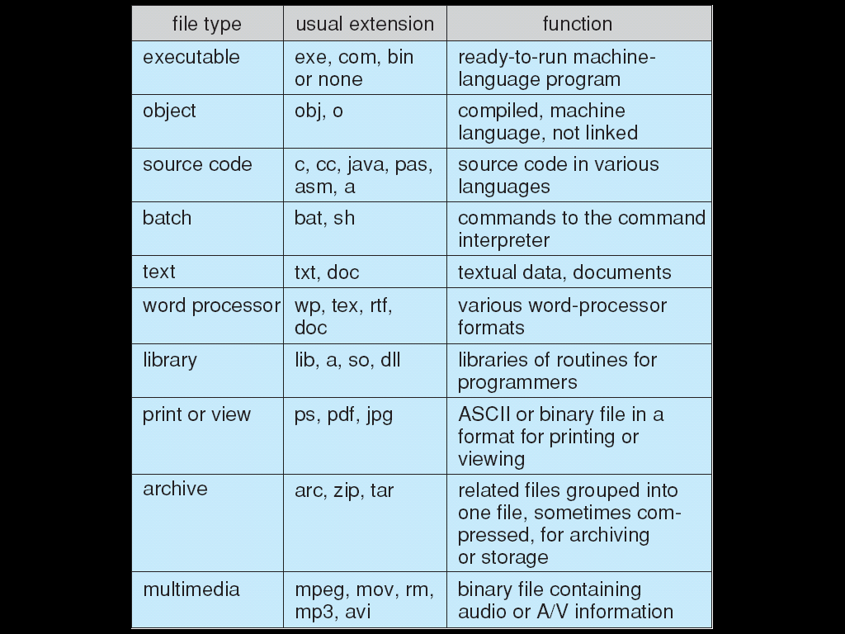

File Structure

* None - sequence of words, bytes
* Simple record structure
  + Lines
  + Fixed length
  + Variable length
* Complex Structures
  + Formatted document
  + Relocatable load file
* Can simulate last two with first method by inserting appropriate control characters
* Who decides:
  + Operating system
  + Program

Sequential access file

Access Methods

* **Sequential Access**

**read next**

**write next**

**reset**

no read after last write

(rewrite)

* **Direct Access –** file is fixed length logical records

**read *n***

**write *n***

**position to *n***

**read next**

**write next**

**rewrite *n***

* + - * + *n* = relative block number
* Relative block numbers allow OS to decide where file should be placed
  + See allocation problem in Ch 12

Simulation of Sequential Access on Direct-access File

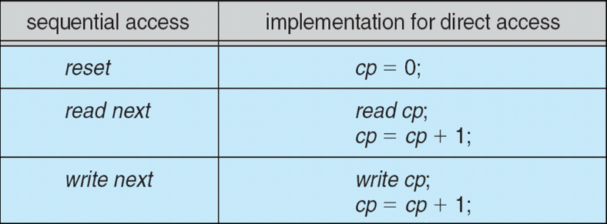

Other Access Methods

* Can be built on top of base methods
* General involve creation of an index for the file
* Keep index in memory for fast determination of location of data to be operated on (consider UPC code plus record of data about that item)
* If too large, index (in memory) of the index (on disk)
* IBM indexed sequential-access method (ISAM)
  + Small master index, points to disk blocks of secondary index
  + File kept sorted on a defined key
  + All done by the OS
* VMS operating system provides index and relative files as another example (see next slide)

Directory Structure

* A collection of nodes containing information about all files
* Both the directory structure and the files reside on disk

Disk Structure

* Disk can be subdivided into **partitions**
* Disks or partitions can be **RAID** protected against failure
* Disk or partition can be used **raw** – without a file system, or **formatted** with a file system
* Partitions also known as minidisks, slices
* Entity containing file system known as a **volume**
* Each volume containing file system also tracks that file system’s info in **device directory** or **volume table of contents**
* As well as **general-purpose file systems** there are many **special-purpose file systems**, frequently all within the same operating system or computer

Types of File Systems

* We mostly talk of general-purpose file systems
* But systems frequently have may file systems, some general- and some special- purpose
* Consider Solaris has
  + tmpfs – memory-based volatile FS for fast, temporary I/O
  + objfs – interface into kernel memory to get kernel symbols for debugging
  + ctfs – contract file system for managing daemons
  + lofs – loopback file system allows one FS to be accessed in place of another
  + procfs – kernel interface to process structures
  + ufs, zfs – general purpose file systems

Operations Performed on Directory

* Search for a file
* Create a file
* Delete a file
* List a directory
* Rename a file
* Traverse the file system

Directory Organization

The directory is organized logically to obtain

* Efficiency – locating a file quickly
* Naming – convenient to users
  + Two users can have same name for different files
  + The same file can have several different names
* Grouping – logical grouping of files by properties, (e.g., all Java programs, all games, …)

Single-Level Directory

* A single directory for all users

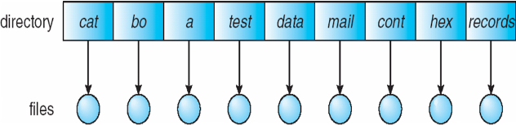

* Naming problem
* Grouping problem

Two-Level Directory

* Separate directory for each user

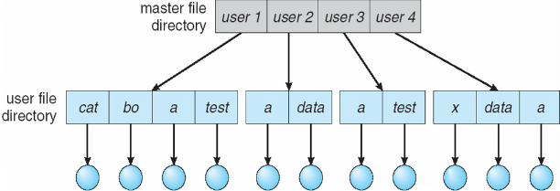

* Path name
* Can have the same file name for different user
* Efficient searching
* No grouping capability

Tree-Structured Directories

* Efficient searching
* Grouping Capability
* Current directory (working directory)
  + **cd /spell/mail/prog**
  + **type list**
* **Absolute** or **relative** path name
* Creating a new file is done in current directory
* Delete a file

**rm <file-name>**

* Creating a new subdirectory is done in current directory

**mkdir <dir-name>**

* + - * + Example: if in current directory **/mail**

**mkdir count**

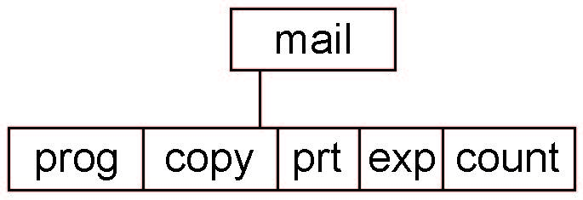

Deleting “mail” ⇒ deleting the entire subtree rooted by “mail”

Acyclic-Graph Directories

* Have shared subdirectories and files

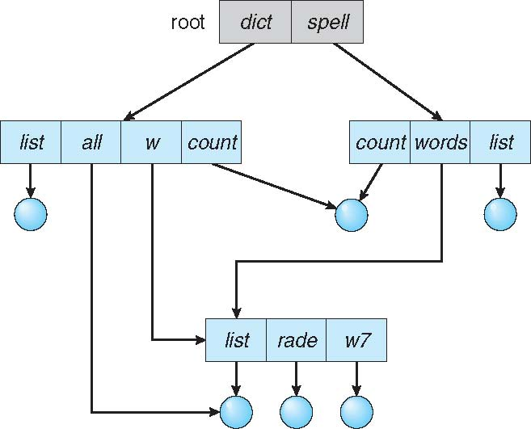

* Two different names (aliasing)
* If ***dict*** deletes ***list*** ⇒ dangling pointer
  + - * + Solutions:
  + Backpointers, so we can delete all pointers  
    Variable size records a problem
  + Backpointers using a daisy chain organization
  + Entry-hold-count solution
* New directory entry type
  + **Link** – another name (pointer) to an existing file
  + **Resolve the link** – follow pointer to locate the file

General Graph Directory

* How do we guarantee no cycles?
  + Allow only links to file not subdirectories
  + **Garbage collection**
  + Every time a new link is added use a cycle detection algorithm to determine whether it is OK

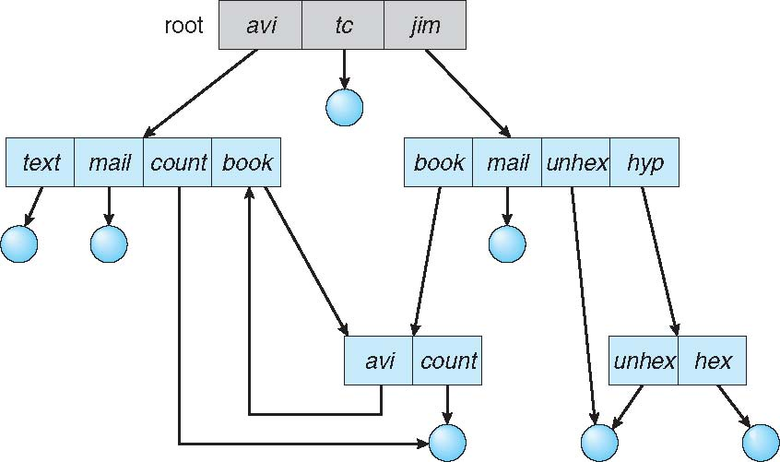

File System Mounting

* A file system must be **mounted** before it can be accessed
* A unmounted file system (i.e., Fig. 11-11(b)) is mounted at a **mount point**

Mount Point

File Sharing

* Sharing of files on multi-user systems is desirable
* Sharing may be done through a **protection** scheme
* On distributed systems, files may be shared across a network
* Network File System (NFS) is a common distributed file-sharing method
* If multi-user system
  + **User IDs** identify users, allowing permissions and protections to be per-user  
    **Group IDs** allow users to be in groups, permitting group access rights
  + Owner of a file / directory
  + Group of a file / directory

File Sharing – Remote File Systems

* Uses networking to allow file system access between systems
  + Manually via programs like FTP
  + Automatically, seamlessly using **distributed file systems**
  + Semi automatically via the **world wide web**
* **Client-server** model allows clients to mount remote file systems from servers
  + Server can serve multiple clients
  + Client and user-on-client identification is insecure or complicated
  + **NFS** is standard UNIX client-server file sharing protocol
  + **CIFS** is standard Windows protocol
  + Standard operating system file calls are translated into remote calls
* Distributed Information Systems **(distributed naming services)** such as LDAP, DNS, NIS, Active Directory implement unified access to information needed for remote computing

File Sharing – failure modes

* All file systems have failure modes
  + For example corruption of directory structures or other non-user data, called **metadata**
* Remote file systems add new failure modes, due to network failure, server failure
* Recovery from failure can involve **state information** about status of each remote request
* **Stateless** protocols such as NFS v3 include all information in each request, allowing easy recovery but less security
* Specify how multiple users are to access a shared file simultaneously
  + Similar to Ch 5 process synchronization algorithms
    - Tend to be less complex due to disk I/O and network latency (for remote file systems
  + Andrew File System (AFS) implemented complex remote file sharing semantics
  + Unix file system (UFS) implements:
    - Writes to an open file visible immediately to other users of the same open file
    - Sharing file pointer to allow multiple users to read and write concurrently
  + AFS has session semantics
    - Writes only visible to sessions starting after the file is closed

Protection

* File owner/creator should be able to control:
  + what can be done
  + by whom
* Types of access
  + **Read**
  + **Write**
  + **Execute**
  + **Append**
  + **Delete**
  + **List**

Access Lists and Groups

* Mode of access: read, write, execute
* Three classes of users on Unix / Linux

RWX

a) **owner access** 7 ⇒ 1 1 1  
 RWX

b) **group access** 6 ⇒ 1 1 0

RWX

c) **public access** 1 ⇒ 0 0 1

* Ask manager to create a group (unique name), say G, and add some users to the group.
* For a particular file (say *game*) or subdirectory, define an appropriate access.

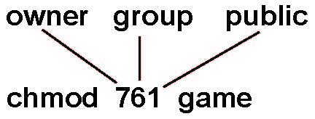

Attach a group to a file  
 **chgrp G game**

Windows 7 Access-Control List Management

Unix directory listing

\*\*\*\*\*\*Chapter 12 File System Implementation\*\*\*\*\*\*\*\*\*\*\*\*\*\*\*\*\*\*

* To describe the details of implementing local file systems and directory structures
* To describe the implementation of remote file systems
* To discuss block allocation and free-block algorithms and trade-offs

File-System Structure

* File structure
  + Logical storage unit
  + Collection of related information
* **File system** resides on secondary storage (disks)
  + Provided user interface to storage, mapping logical to physical
  + Provides efficient and convenient access to disk by allowing data to be stored, located retrieved easily
* Disk provides in-place rewrite and random access
  + I/O transfers performed in **blocks** of **sectors** (usually 512 bytes)
* **File control block** – storage structure consisting of information about a file
* **Device driver** controls the physical device
* File system organized into layers

Layered File System

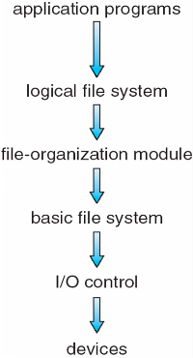

* **Device drivers** manage I/O devices at the I/O control layer
  + Given commands like “read drive1, cylinder 72, track 2, sector 10, into memory location 1060” outputs low-level hardware specific commands to hardware controller
* **Basic file system** given command like “retrieve block 123” translates to device driver
* Also manages memory buffers and caches (allocation, freeing, replacement)
  + Buffers hold data in transit
  + Caches hold frequently used data
* **File organization module** understands files, logical address, and physical blocks
  + Translates logical block # to physical block #
  + Manages free space, disk allocation
* **Logical file system** manages metadata information
  + Translates file name into file number, file handle, location by maintaining file control blocks (**inodes** in UNIX)
  + Directory management
  + Protection
* Layering useful for reducing complexity and redundancy, but adds overhead and can decrease performanceTranslates file name into file number, file handle, location by maintaining file control blocks (**inodes** in UNIX)
  + Logical layers can be implemented by any coding method according to OS designer
* Many file systems, sometimes many within an operating system
  + Each with its own format (CD-ROM is ISO 9660; Unix has **UFS**, FFS; Windows has FAT, FAT32, NTFS as well as floppy, CD, DVD Blu-ray, Linux has more than 40 types, with **extended file system** ext2 and ext3 leading; plus distributed file systems, etc.)
  + New ones still arriving – ZFS, GoogleFS, Oracle ASM, FUSE

File System Implementation

* We have system calls at the API level, but how do we implement their functions?
  + On-disk and in-memory structures
* **Boot control block** contains info needed by system to boot OS from that volume
  + Needed if volume contains OS, usually first block of volume
* **Volume control block (superblock, master file table)** contains volume details
  + Total # of blocks, # of free blocks, block size, free block pointers or array
* Directory structure organizes the files
  + Names and inode numbers, master file table
* Per-file **File Control Block (FCB)** contains many details about the file
  + inode number, permissions, size, dates
  + NFTS stores into in master file table using relational DB structures

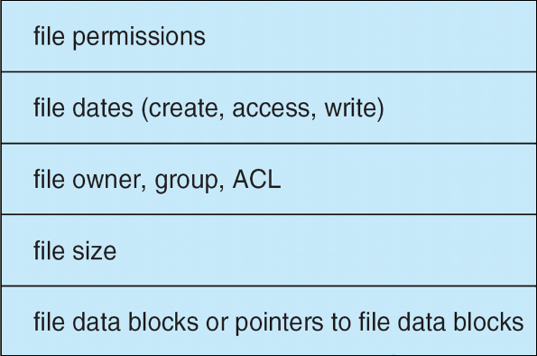

In-Memory File System Structures

* Mount table storing file system mounts, mount points, file system types
* The following figure illustrates the necessary file system structures provided by the operating systems
* Figure 12-3(a) refers to opening a file
* Figure 12-3(b) refers to reading a file
* Plus buffers hold data blocks from secondary storage
* Open returns a file handle for subsequent use
* Data from read eventually copied to specified user process memory address

Partitions and Mounting

* Partition can be a volume containing a file system (“cooked”) or **raw** – just a sequence of blocks with no file system
* Boot block can point to boot volume or boot loader set of blocks that contain enough code to know how to load the kernel from the file system
  + Or a boot management program for multi-os booting
* **Root partition** contains the OS, other partitions can hold other Oses, other file systems, or be raw
  + Mounted at boot time
  + Other partitions can mount automatically or manually
* At mount time, file system consistency checked
  + Is all metadata correct?
    - If not, fix it, try again
    - If yes, add to mount table, allow access

Virtual File Systems

* **Virtual File Systems** (**VFS**) on Unix provide an object-oriented way of implementing file systems
* VFS allows the same system call interface (the API) to be used for different types of file systems
  + Separates file-system generic operations from implementation details
  + Implementation can be one of many file systems types, or network file system
    - Implements **vnodes** which hold inodes or network file details
  + Then dispatches operation to appropriate file system implementation routines
* The API is to the VFS interface, rather than any specific type of file system

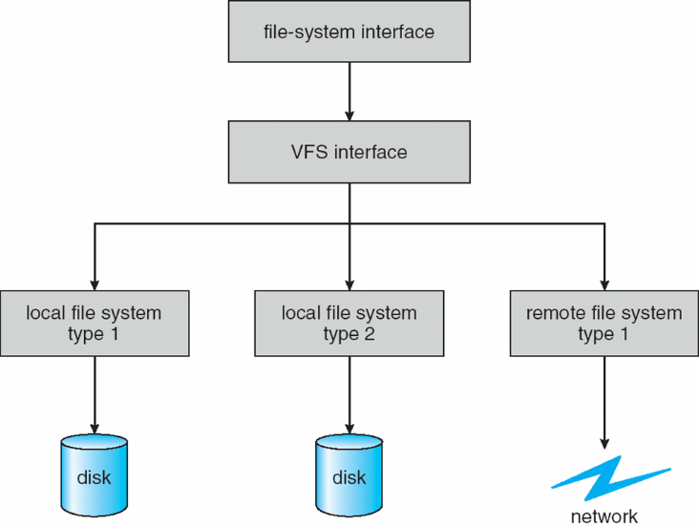

Virtual File System Implementation

* For example, Linux has four object types:
  + inode, file, superblock, dentry
* VFS defines set of operations on the objects that must be implemented
  + Every object has a pointer to a function table
    - Function table has addresses of routines to implement that function on that object
    - For example:
      * **int open(. . .)**—Open a file
      * **int close(. . .)**—Close an already-open file
      * **ssize t read(. . .)**—Read from a file
      * **ssize t write(. . .)**—Write to a file
      * **int mmap(. . .)**—Memory-map a file

Directory Implementation

* **Linear list** of file names with pointer to the data blocks
  + Simple to program
  + Time-consuming to execute
    - Linear search time
    - Could keep ordered alphabetically via linked list or use B+ tree
* **Hash Table** – linear list with hash data structure
  + Decreases directory search time
  + **Collisions** – situations where two file names hash to the same location
  + Only good if entries are fixed size, or use chained-overflow method

Allocation Methods – Contiguous

* An allocation method refers to how disk blocks are allocated for files:
* **Contiguous allocation** – each file occupies set of contiguous blocks
  + Best performance in most cases
  + Simple – only starting location (block #) and length (number of blocks) are required
  + Problems include finding space for file, knowing file size, external fragmentation, need for **compaction off-line** (**downtime**) or **on-line**

Contiguous Allocation

Extent-Based Systems

* Many newer file systems (i.e., Veritas File System) use a modified contiguous allocation scheme
* Extent-based file systems allocate disk blocks in extents
* An **extent** is a contiguous block of disks
  + Extents are allocated for file allocation
  + A file consists of one or more extents

Allocation Methods – Linked

* **Linked allocation** – each file a linked list of blocks
  + File ends at nil pointer
  + No external fragmentation
  + Each block contains pointer to next block
  + No compaction, external fragmentation
  + Free space management system called when new block needed
  + Improve efficiency by clustering blocks into groups but increases internal fragmentation
  + Reliability can be a problem
  + Locating a block can take many I/Os and disk seeks
* FAT (File Allocation Table) variation
  + Beginning of volume has table, indexed by block number
  + Much like a linked list, but faster on disk and cacheable
  + New block allocation simple

Linked Allocation

* Each file is a linked list of disk blocks: blocks may be scattered anywhere on the disk
* Mapping

Block to be accessed is the Qth block in the linked chain of blocks representing the file.

Displacement into block = R + 1

File Allocation Table

Allocation Methods – Indexed

* **Indexed allocation**
  + Each file has its own **index block**(s) of pointers to its data blocks
* Logical view

Indexed Allocation

* Need index table
* Random access
* Dynamic access without external fragmentation, but have overhead of index block
* Mapping from logical to physical in a file of maximum size of 256K bytes and block size of 512 bytes. We need only 1 block for index table
  + Q = displacement into index table
  + R = displacement into block

Indexed Allocation

* Mapping from logical to physical in a file of unbounded length (block size of 512 words)
* Linked scheme – Link blocks of index table (no limit on size)

Indexed Allocation

* Two-level index (4K blocks could store 1,024 four-byte pointers in outer index -> 1,048,567 data blocks and file size of up to 4GB)

Combined Scheme: Unix UFS

4K bytes per block, 32-bit addresses

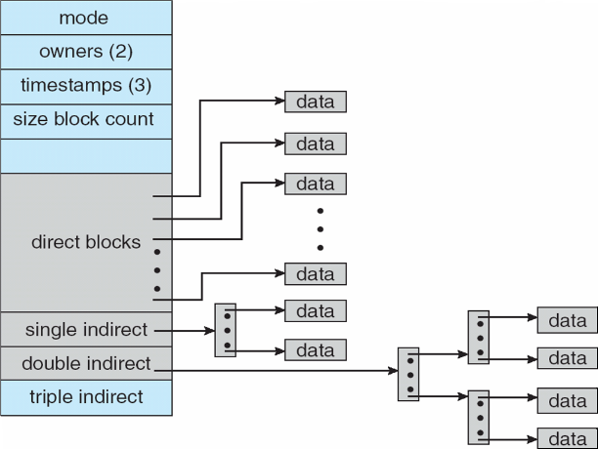

More index blocks than can be addressed with 32-bit file pointer

Performance

* Best method depends on file access type
  + Contiguous great for sequential and random
* Linked good for sequential, not random
* Declare access type at creation -> select either contiguous or linked
* Indexed more complex
  + Single block access could require 2 index block reads then data block read
  + Clustering can help improve throughput, reduce CPU overhead
* Adding instructions to the execution path to save one disk I/O is reasonable
  + Intel Core i7 Extreme Edition 990x (2011) at 3.46Ghz = 159,000 MIPS
    - http://en.wikipedia.org/wiki/Instructions\_per\_second
  + Typical disk drive at 250 I/Os per second
    - 159,000 MIPS / 250 = 630 million instructions during one disk I/O
  + Fast SSD drives provide 60,000 IOPS
    - 159,000 MIPS / 60,000 = 2.65 millions instructions during one disk I/O

Free Space Management

* Bit map requires extra space
  + Example:

block size = 4KB = 212 bytes

disk size = 240 bytes (1 terabyte)

***n*** = 240/212 = 228 bits (or 32MB)

if clusters of 4 blocks -> 8MB of memory

* Easy to get contiguous files
* Grouping
  + Modify linked list to store address of next *n-1* free blocks in first free block, plus a pointer to next block that contains free-block-pointers (like this one)
* Counting
  + Because space is frequently contiguously used and freed, with contiguous-allocation allocation, extents, or clustering
    - Keep address of first free block and count of following free blocks
    - Free space list then has entries containing addresses and counts
* Space Maps
  + Used in **ZFS**
  + Consider meta-data I/O on very large file systems
    - Full data structures like bit maps couldn’t fit in memory -> thousands of I/Os
  + Divides device space into **metaslab** units and manages metaslabs
    - Given volume can contain hundreds of metaslabs
  + Each metaslab has associated space map
    - Uses counting algorithm
  + But records to log file rather than file system
    - Log of all block activity, in time order, in counting format
  + Metaslab activity -> load space map into memory in balanced-tree structure, indexed by offset
    - Replay log into that structure
    - Combine contiguous free blocks into single entry

Linked Free Space List on Disk

* Linked list (free list)
  + Cannot get contiguous space easily
  + No waste of space
  + No need to traverse the entire list (if # free blocks recorded)

Efficiency and performance

* Efficiency dependent on:
  + Disk allocation and directory algorithms
  + Types of data kept in file’s directory entry
  + Pre-allocation or as-needed allocation of metadata structures
  + Fixed-size or varying-size data structures
* Performance
  + Keeping data and metadata close together
  + **Buffer cache** – separate section of main memory for frequently used blocks
  + **Synchronous** writes sometimes requested by apps or needed by OS
    - No buffering / caching – writes must hit disk before acknowledgement
    - **Asynchronous** writes more common, buffer-able, faster
  + **Free-behind** and **read-ahead** – techniques to optimize sequential access
  + Reads frequently slower than writes

Page Cache

* A **page cache** caches pages rather than disk blocks using virtual memory techniques and addresses
* Memory-mapped I/O uses a page cache
* Routine I/O through the file system uses the buffer (disk) cache
* This leads to the following figure

I/O without a Unified Buffer Cache

Unified buffer cache

* A **unified buffer cache** uses the same page cache to cache both memory-mapped pages and ordinary file system I/O to avoid **double caching**
  + But which caches get priority, and what replacement algorithms to use?

Recovery

* **Consistency checking** – compares data in directory structure with data blocks on disk, and tries to fix inconsistencies
  + Can be slow and sometimes fails
* Use system programs to **back up** data from disk to another storage device (magnetic tape, other magnetic disk, optical)
* Recover lost file or disk by **restoring** data from backup

Log Structures File Systems

* **Log structured** (or **journaling**) file systems record each metadata update to the file system as a **transaction**
* All transactions are written to a log
  + - A transaction is considered committed once it is written to the log (sequentially)
  + Sometimes to a separate device or section of disk
  + However, the file system may not yet be updated
* The transactions in the log are asynchronously written to the file system structures
  + - When the file system structures are modified, the transaction is removed from the log
* If the file system crashes, all remaining transactions in the log must still be performed
* Faster recovery from crash, removes chance of inconsistency of metadata

The Sun Network File System (NFS)

* An implementation and a specification of a software system for accessing remote files across LANs (or WANs)
* The implementation is part of the Solaris and SunOS operating systems running on Sun workstations using an unreliable datagram protocol (UDP/IP protocol and Ethernet
* Interconnected workstations viewed as a set of independent machines with independent file systems, which allows sharing among these file systems in a transparent manner
  + A remote directory is mounted over a local file system directory
    - The mounted directory looks like an integral subtree of the local file system, replacing the subtree descending from the local directory
  + Specification of the remote directory for the mount operation is nontransparent; the host name of the remote directory has to be provided
    - Files in the remote directory can then be accessed in a transparent manner
  + Subject to access-rights accreditation, potentially any file system (or directory within a file system), can be mounted remotely on top of any local directory
* NFS is designed to operate in a heterogeneous environment of different machines, operating systems, and network architectures; the NFS specifications independent of these media
* This independence is achieved through the use of RPC primitives built on top of an External Data Representation (XDR) protocol used between two implementation-independent interfaces
* The NFS specification distinguishes between the services provided by a mount mechanism and the actual remote-file-access services
* NFS is designed to operate in a heterogeneous environment of different machines, operating systems, and network architectures; the NFS specifications independent of these media
* This independence is achieved through the use of RPC primitives built on top of an External Data Representation (XDR) protocol used between two implementation-independent interfaces
* The NFS specification distinguishes between the services provided by a mount mechanism and the actual remote-file-access services

NFS Mount Protocol

* Establishes initial logical connection between server and client
* Mount operation includes name of remote directory to be mounted and name of server machine storing it
  + Mount request is mapped to corresponding RPC and forwarded to mount server running on server machine
  + Export list – specifies local file systems that server exports for mounting, along with names of machines that are permitted to mount them
* Following a mount request that conforms to its export list, the server returns a file handle—a key for further accesses
* File handle – a file-system identifier, and an inode number to identify the mounted directory within the exported file system
* The mount operation changes only the user’s view and does not affect the server side

NFS Protocol

* Provides a set of remote procedure calls for remote file operations. The procedures support the following operations:
  + searching for a file within a directory
  + reading a set of directory entries
  + manipulating links and directories
  + accessing file attributes
  + reading and writing files
* NFS servers are **stateless**; each request has to provide a full set of arguments (NFS V4 is just coming available – very different, stateful)
* Modified data must be committed to the server’s disk before results are returned to the client (lose advantages of caching)
* The NFS protocol does not provide concurrency-control mechanisms

Three Major Layers of NFS Architecture

* UNIX file-system interface (based on the **open, read, write**, and **close** calls, and **file descriptors**)
* Virtual File System (VFS) layer – distinguishes local files from remote ones, and local files are further distinguished according to their file-system types
  + The VFS activates file-system-specific operations to handle local requests according to their file-system types
  + Calls the NFS protocol procedures for remote requests
* NFS service layer – bottom layer of the architecture
  + Implements the NFS protocol

NFS Architecture

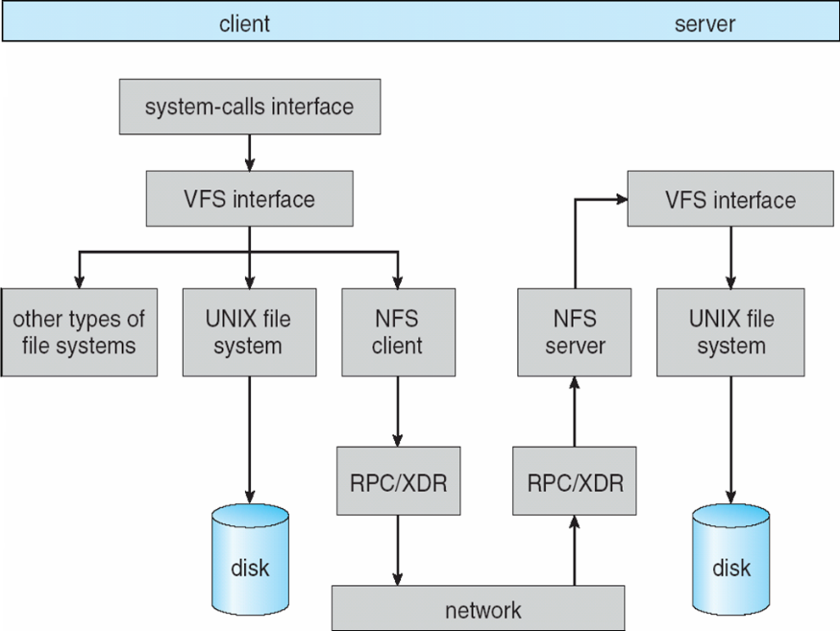

NFS Path-Name Translation

* Performed by breaking the path into component names and performing a separate NFS lookup call for every pair of component name and directory vnode
* To make lookup faster, a directory name lookup cache on the client’s side holds the vnodes for remote directory names

NFS Remote Operations

* Nearly one-to-one correspondence between regular UNIX system calls and the NFS protocol RPCs (except opening and closing files)
* NFS adheres to the remote-service paradigm, but employs buffering and caching techniques for the sake of performance
* File-blocks cache – when a file is opened, the kernel checks with the remote server whether to fetch or revalidate the cached attributes
  + Cached file blocks are used only if the corresponding cached attributes are up to date
* File-attribute cache – the attribute cache is updated whenever new attributes arrive from the server
* Clients do not free delayed-write blocks until the server confirms that the data have been written to disk

WAFL File System

* Used on Network Appliance “Filers” – distributed file system appliances
* “Write-anywhere file layout”
* Serves up NFS, CIFS, http, ftp
* Random I/O optimized, write optimized
  + NVRAM for write caching
* Similar to Berkeley Fast File System, with extensive modifications

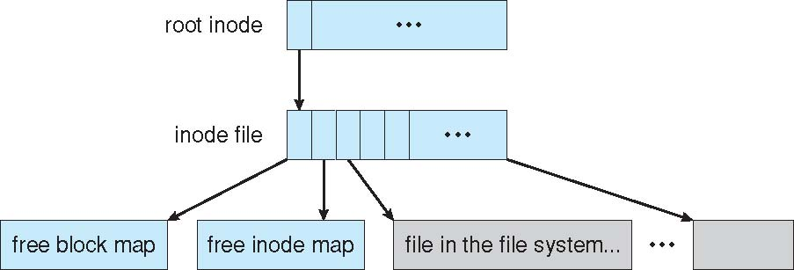

Snapshots in wafl

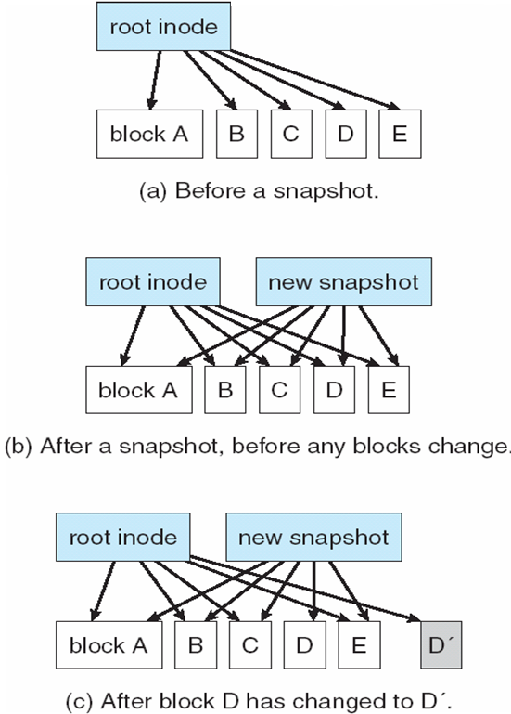

\*\*\*\*\*Chapter 13: I/O Systems\*\*\*\*\*\*\*\*\*\*\*\*\*\*\*\*\*\*\*

* Explore the structure of an operating system’s I/O subsystem
* Discuss the principles of I/O hardware and its complexity
* Provide details of the performance aspects of I/O hardware and software

Overview:

* I/O management is a major component of operating system design and operation
  + Important aspect of computer operation
  + I/O devices vary greatly
  + Various methods to control them
  + Performance management
  + New types of devices frequent
* Ports, busses, device controllers connect to various devices
* **Device drivers** encapsulate device details
  + Present uniform device-access interface to I/O subsystem

I/O Hardware

* Incredible variety of I/O devices
  + Storage
  + Transmission
  + Human-interface
* Common concepts – signals from I/O devices interface with computer
  + **Port** – connection point for device
  + **Bus** - **daisy chain** or shared direct access
    - **PCI** bus common in PCs and servers, PCI Express (**PCIe**)
    - **expansion** **bus** connects relatively slow devices
  + **Controller** (**host adapter**) – electronics that operate port, bus, device
    - Sometimes integrated
    - Sometimes separate circuit board (host adapter)
    - Contains processor, microcode, private memory, bus controller, etc
      * Some talk to per-device controller with bus controller, microcode, memory, etc
* I/O instructions control devices
* Devices usually have registers where device driver places commands, addresses, and data to write, or read data from registers after command execution
  + Data-in register, data-out register, status register, control register
  + Typically 1-4 bytes, or FIFO buffer
* Devices have addresses, used by
  + Direct I/O instructions
  + **Memory-mapped I/O**
    - Device data and command registers mapped to processor address space
    - Especially for large address spaces (graphics)

Device I/O Port Locations on PCs (partial)

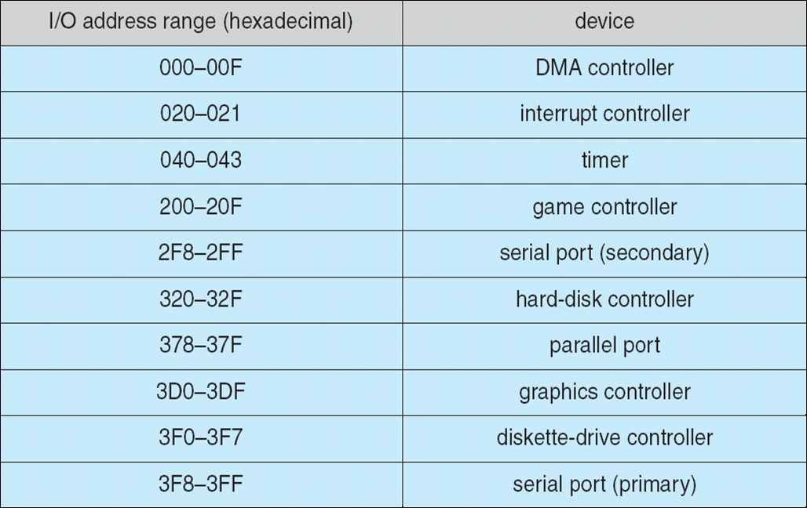

Polling

* For each byte of I/O
  + Read busy bit from status register until 0
  + Host sets read or write bit and if write copies data into data-out register
  + Host sets command-ready bit
  + Controller sets busy bit, executes transfer
  + Controller clears busy bit, error bit, command-ready bit when transfer done
* Step 1 is **busy-wait** cycle to wait for I/O from device
  + Reasonable if device is fast
  + But inefficient if device slow
  + CPU switches to other tasks?
    - But if miss a cycle data overwritten / lost

Interrupts

* Polling can happen in 3 instruction cycles
  + Read status, logical-and to extract status bit, branch if not zero
  + How to be more efficient if non-zero infrequently?
* CPU **Interrupt-request line** triggered by I/O device
  + Checked by processor after each instruction
* **Interrupt handler** receives interrupts
  + **Maskable** to ignore or delay some interrupts
* **Interrupt vector** to dispatch interrupt to correct handler
  + Context switch at start and end
  + Based on priority
  + Some **nonmaskable**
  + Interrupt chaining if more than one device at same interrupt number
* Interrupt mechanism also used for **exceptions**
  + Terminate process, crash system due to hardware error
* Page fault executes when memory access error
* System call executes via **trap** to trigger kernel to execute request
* Multi-CPU systems can process interrupts concurrently
  + If operating system designed to handle it
* Used for time-sensitive processing, frequent, must be fast

Interrupt-Driven I/O Cycle

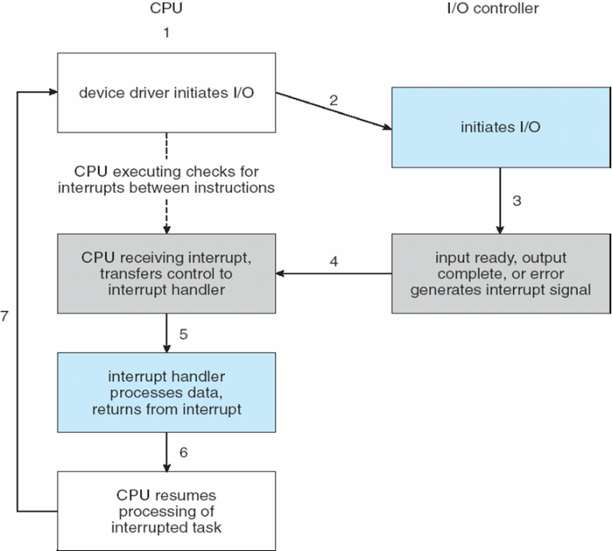

Direct Memory Access

* Used to avoid **programmed I/O** (one byte at a time) for large data movement
* Requires **DMA** controller
* Bypasses CPU to transfer data directly between I/O device and memory
* OS writes DMA command block into memory
  + Source and destination addresses
  + Read or write mode
  + Count of bytes
  + Writes location of command block to DMA controller
  + Bus mastering of DMA controller – grabs bus from CPU
    - **Cycle stealing** from CPU but still much more efficient
  + When done, interrupts to signal completion
* Version that is aware of virtual addresses can be even more efficient - **DVMA**

Six Step Process to Perform DMA Transfer

13_05.pdf

Application I/O Interface

* I/O system calls encapsulate device behaviors in generic classes
* Device-driver layer hides differences among I/O controllers from kernel
* New devices talking already-implemented protocols need no extra work
* Each OS has its own I/O subsystem structures and device driver frameworks
* Devices vary in many dimensions
  + **Character-stream** or **block**
  + **Sequential** or **random-access**
  + **Synchronous** or **asynchronous** (or both)
  + **Sharable** or **dedicated**
  + **Speed of operation**
  + **read-write, read only,** or **write only**

Kernel I/O Structure

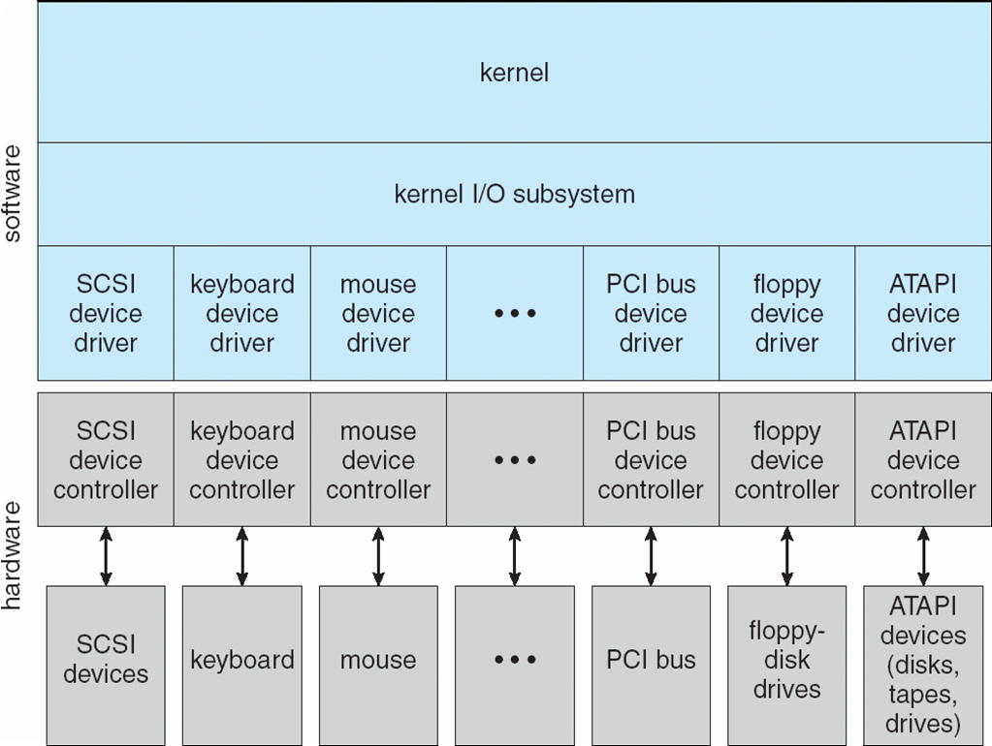

Characteristics of I/O devices

* Subtleties of devices handled by device drivers
* Broadly I/O devices can be grouped by the OS into
  + Block I/O
  + Character I/O (Stream)
  + Memory-mapped file access
  + Network sockets
* For direct manipulation of I/O device specific characteristics, usually an escape / back door
  + Unix **ioctl()** call to send arbitrary bits to a device control register and data to device data register

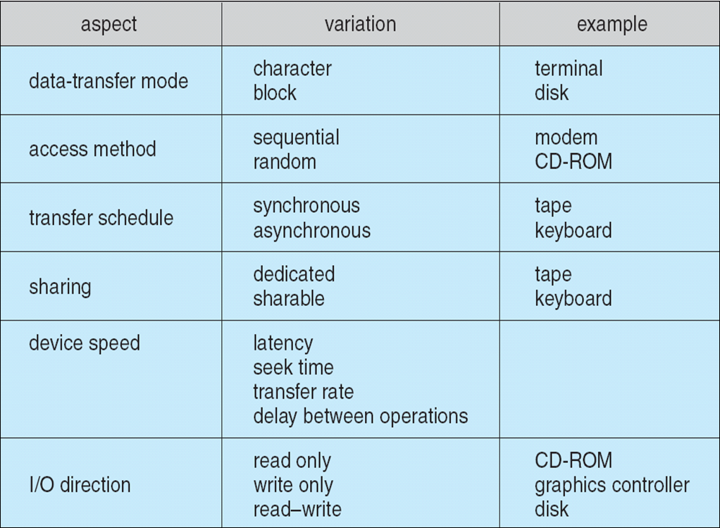

Block and character devices

* Block devices include disk drives
  + Commands include read, write, seek
  + **Raw I/O**, **direct I/O**,or file-system access
  + Memory-mapped file access possible
    - File mapped to virtual memory and clusters brought via demand paging
  + DMA
* Character devices include keyboards, mice, serial ports
  + Commands include **get()**, **put()**
  + Libraries layered on top allow line editing

Network Devices

* Varying enough from block and character to have own interface
* Linux, Unix, Windows and many others include **socket** interface
  + Separates network protocol from network operation
  + Includes **select()** functionality
* Approaches vary widely (pipes, FIFOs, streams, queues, mailboxes)

Clocks and Timers

* Provide current time, elapsed time, timer
* Normal resolution about 1/60 second
* Some systems provide higher-resolution timers
* **Programmable interval timer** used for timings, periodic interrupts
* **ioctl()** (on UNIX) covers odd aspects of I/O such as clocks and timers

Nonblocking and Asynchronous I/O

* **Blocking** - process suspended until I/O completed
  + Easy to use and understand
  + Insufficient for some needs
* **Nonblocking** - I/O call returns as much as available
  + User interface, data copy (buffered I/O)
  + Implemented via multi-threading
  + Returns quickly with count of bytes read or written
  + **select()** to find if data ready then **read()** or **write()** to transfer
* **Asynchronous** - process runs while I/O executes
  + Difficult to use
  + I/O subsystem signals process when I/O completed

Two I/O methods

* Synchronous
* Asynchronous

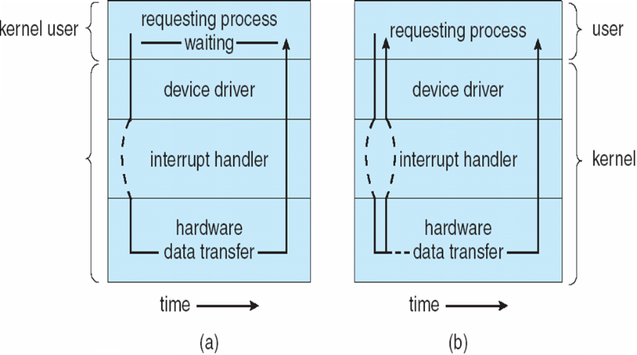

Vectored I/O

* **Vectored I/O** allows one system call to perform multiple I/O operations
* For example, Unix **readve()** accepts a vector of multiple buffers to read into or write from
* This scatter-gather method better than multiple individual I/O calls
  + Decreases context switching and system call overhead
  + Some versions provide atomicity
    - Avoid for example worry about multiple threads changing data as reads / writes occurring

Kernel I/O Subsystem

* Scheduling
  + Some I/O request ordering via per-device queue
  + Some OSs try fairness
  + Some implement Quality Of Service (i.e. IPQOS)
* **Buffering** - store data in memory while transferring between devices
  + To cope with device speed mismatch
  + To cope with device transfer size mismatch
  + To maintain “copy semantics”
  + **Double buffering** – two copies of the data
    - Kernel and user
    - Varying sizes
    - Full / being processed and not-full / being used
    - Copy-on-write can be used for efficiency in some cases

Device-status Table

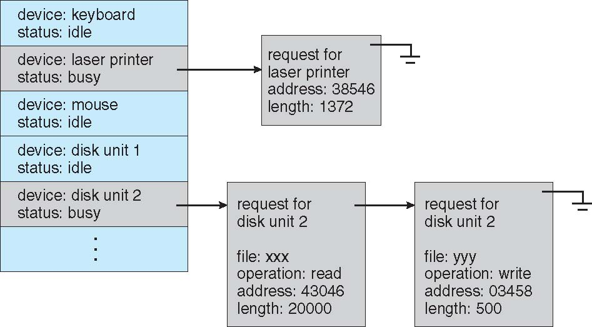

Kernel I/O Subsystem

* **Caching** - faster device holding copy of data
  + Always just a copy
  + Key to performance
  + Sometimes combined with buffering
* **Spooling** - hold output for a device
  + If device can serve only one request at a time
  + i.e., Printing
* **Device reservation** - provides exclusive access to a device
  + System calls for allocation and de-allocation
  + Watch out for deadlock

Error handling

* OS can recover from disk read, device unavailable, transient write failures
  + Retry a read or write, for example
  + Some systems more advanced – Solaris FMA, AIX
    - Track error frequencies, stop using device with increasing frequency of retry-able errors
* Most return an error number or code when I/O request fails
* System error logs hold problem reports

I/O Protection

* User process may accidentally or purposefully attempt to disrupt normal operation via illegal I/O instructions
  + All I/O instructions defined to be privileged
  + I/O must be performed via system calls
    - Memory-mapped and I/O port memory locations must be protected too

Use of a System Call to Perform I/O

Kernel Data Structures

* Kernel keeps state info for I/O components, including open file tables, network connections, character device state
* Many, many complex data structures to track buffers, memory allocation, “dirty” blocks
* Some use object-oriented methods and message passing to implement I/O
  + Windows uses message passing
    - Message with I/O information passed from user mode into kernel
    - Message modified as it flows through to device driver and back to process
    - Pros / cons?

Unix I/O Kernel Structure

13_12.pdf

Poser Management

* Not strictly domain of I/O, but much is I/O related
* Computers and devices use electricity, generate heat, frequently require cooling
* OSes can help manage and improve use
  + Cloud computing environments move virtual machines between servers
    - Can end up evacuating whole systems and shutting them down
* Mobile computing has power management as first class OS aspect
* For example, Android implements
  + Component-level power management
    - Understands relationship between components
    - Build device tree representing physical device topology
    - System bus -> I/O subsystem -> {flash, USB storage}
    - Device driver tracks state of device, whether in use
    - Unused component – turn it off
    - All devices in tree branch unused – turn off branch
  + Wake locks – like other locks but prevent sleep of device when lock is held
  + Power collapse – put a device into very deep sleep
    - Marginal power use
    - Only awake enough to respond to external stimuli (button press, incoming call)
* For example, Android implements
  + Component-level power management
    - Understands relationship between components
    - Build device tree representing physical device topology
    - System bus -> I/O subsystem -> {flash, USB storage}
    - Device driver tracks state of device, whether in use
    - Unused component – turn it off
    - All devices in tree branch unused – turn off branch
  + Wake locks – like other locks but prevent sleep of device when lock is held
  + Power collapse – put a device into very deep sleep
    - Marginal power use
    - Only awake enough to respond to external stimuli (button press, incoming call)

I/O Requests to Hardware Operations

* Consider reading a file from disk for a process:
  + Determine device holding file
  + Translate name to device representation
  + Physically read data from disk into buffer
  + Make data available to requesting process
  + Return control to process

Life Cycle of an I/O request

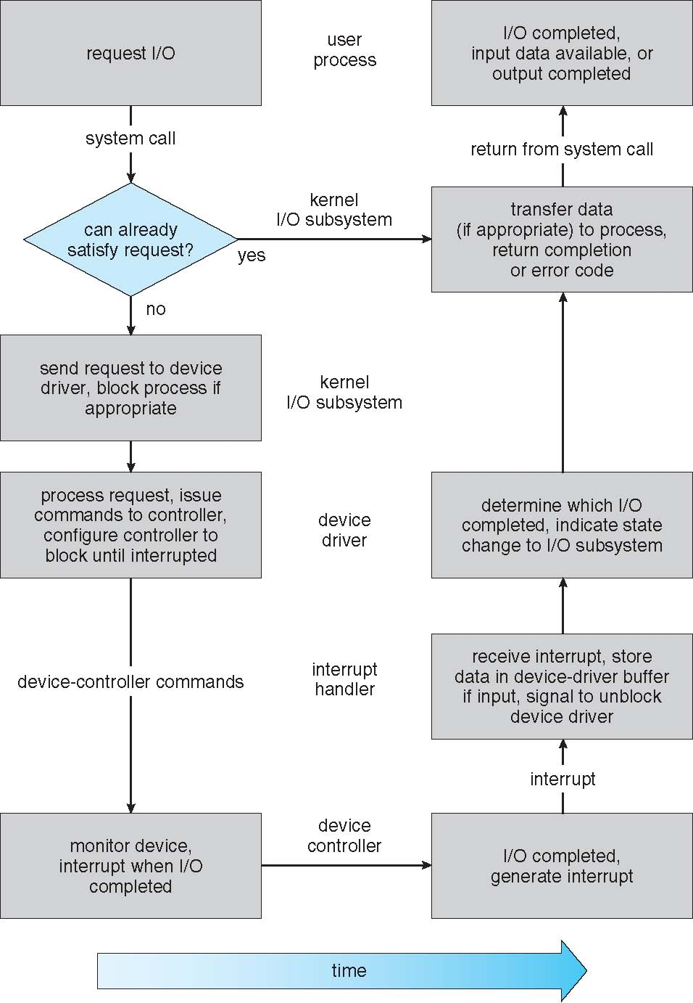

Streams

* **STREAM** – a full-duplex communication channel between a user-level process and a device in Unix System V and beyond
* A STREAM consists of:
  + STREAM head interfaces with the user process
  + driver end interfaces with the device
  + zero or more STREAM modules between them
* Each module contains a **read queue** and a **write queue**
* Message passing is used to communicate between queues
  + **Flow control** option to indicate available or busy
* Asynchronous internally, synchronous where user process communicates with stream head

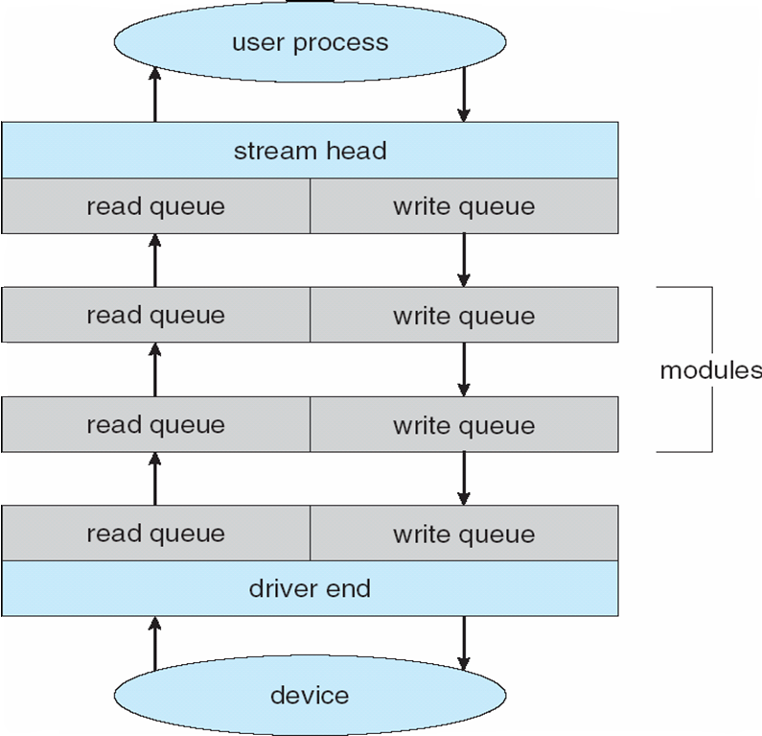

Performance

* I/O a major factor in system performance:
  + Demands CPU to execute device driver, kernel I/O code
  + Context switches due to interrupts
  + Data copying
  + Network traffic especially stressful

Intercomputer Communications

13_15.pdf

Improving Performance

* Reduce number of context switches
* Reduce data copying
* Reduce interrupts by using large transfers, smart controllers, polling
* Use DMA
* Use smarter hardware devices
* Balance CPU, memory, bus, and I/O performance for highest throughput
* Move user-mode processes / daemons to kernel threads

Device Functionality Progression

13_16.pdf

\*\*\*\*Ch 14: Protection \*\*\*\*\*\*\*\*\*\*\*\*\*\*\*\*\*\*\*\*\*\*\*\*\*\*\*

Processes must be protected from one another’s activities

Via various mechanisms to ensure proper authorization from os on

* Files
* Memory segments
* Cpu
* Other resources

Protection first was with multiprogramming to keep untrustworthy users can safely share a logical namespace, dir or files, share a common physical namespace such as memory

Evolved to increase reliability of any complex system that makes use of shared resources

626 Protection”

* To prevent mischievous, intentional violation of an access restriction by an user
* Ensure each program component active in a system uses system resources only in ways consistent with stated policies (absolute requirement)
* Can detect latent errors at the interfaces between component subsystems (early detection can prevent contamination)
* Protection-oriented system provides means to distinguish between authorized and unauth usage
* Role of protection is to provide a mechanism for the enforcement of the policies governing resource use
* Policies can be fixed in the design, or formulated by the management of the system, Or designed by users
* Protection system must have flexibility to enforce files

**Goals of Protection**

* In one protection model, computer consists of a collection of objects, hardware or software
* Each object has a unique name and can be accessed through a well-defined set of operations
* Protection problem - ensure that each object is accessed correctly and only by those processes that are allowed to do so

**14.2 Principles of Protection 626**

* Guiding principle – **principle of least privilege**
  + Programs, users and systems should be given just enough **privileges** to perform their tasks
  + Limits damage if entity has a bug, gets abused
  + Can be static (during life of system, during life of process)
  + Or dynamic (changed by process as needed) – **domain switching**, **privilege escalation**
  + “Need to know” a similar concept regarding access to data
* Must consider “grain” aspect
  + Rough-grained privilege management easier, simpler, but least privilege now done in large chunks
    - For example, traditional Unix processes either have abilities of the associated user, or of root
  + Fine-grained management more complex, more overhead, but more protective
    - File ACL lists, RBAC
* Domain can be user, process, procedure
* Mechanisms are distinct frompolicies
* Mechanisms determine how something will be done
* Policies decide what will be done
* The separation of policy anad mechanism is important for flexibility
* Policies are likely to change from place to place or time to time
* Using general mechanisms avoids having to change underlying mechanism when policies change

**14.3 Domain of Protection 627**

A computer system is a collection of processes and objects(hardware & software objects)

Operations depend on objects

Cpu: we can only execute

Memory segments can read and write

A process should be allowed to access only those resources for which it has authorization

At any time, a process should be able to access only those resources that it currently requires to complete a task(Need-to-know principle )

**14.3.1 Domain Structure 628**

* A process operates within a protection domain, which specifies the resources the process may access
* Each domain defines a set of objects and the types of operations that may be invoked on each object
* Access right is the ability to execute an operation on an object
* A domain is a collection of access rights, each which is an ordered pair <object-name, rights-set>
* Domains may share access rights
* Association between process and domain may be
* Static: the set of resources available to the process is fixed throughout the processes lifetime
* Dynamic protection domains are more complicated to establish
* Domain switching, if dynamic, enables process to switch form one domain to another
* Allow the content of the domain to be changed
* Or create a new domain with the changed content and switching that new domain when we want to change domain content
* Access-right = <*object-name*, *rights-set*>  
  where *rights-set* is a subset of all valid operations that can be performed on the object
* Domain = set of access-rights

A domain may be realized I a variety of ways:

Each User may be a domain (domain switching when user changed ( logout/login)

Each process may be a domain (domain switching occurs when one process sends a message to another process and waits for a response)

Each procedure may be a domain (domain switching when a procedure call is made.)

In a multiprogrammed os, 2 domains are insufficient

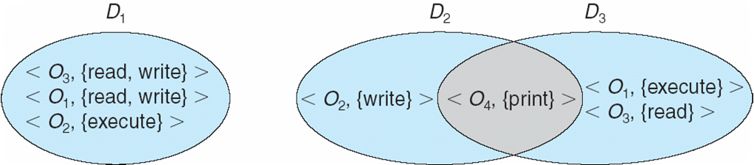

**14.3.2 Domain Implementation (Unix) 629**

* Domain = user-id
* Domain switch accomplished via file system
  + - Each file has associated with it a domain bit (setuid bit)
    - When file is executed and setuid = on, then user-id is set to owner of the file being executed
      * When execution completes user-id is reset
* Domain switch accomplished via passwords
  + su command temporarily switches to another user’s domain when other domain’s password provided
* Domain switching via commands
  + sudo command prefix executes specified command in another domain (if original domain has privilege or password given)

Domain Implementation (Multics)

* Let *Di* and *Dj*be any two domain rings
* If *j* < *I* ⇒ *Di* ⊆ *Dj*

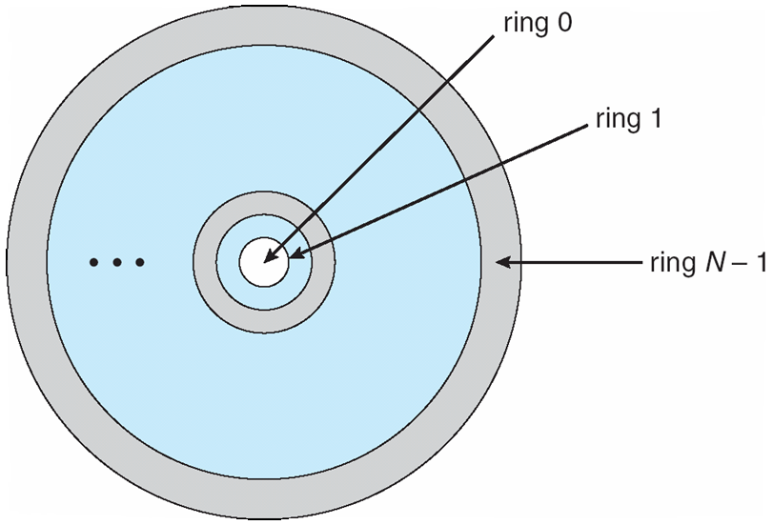

**Multics benefits and limits**

* Ring / hierarchical structure provided more than the basic kernel / user or root / normal user design
* Fairly complex -> more overhead
* But does not allow strict need-to-know
  + Object accessible in Dj but not in Di, then ***j*** must be < ***i***
  + But then every segment accessible in Di also accessible in Dj

**14.4 Access Matirx 632 provides us with the mechanism for specifying a variety of policies**

**Implement access matrix and ensure that the semantic properties we have outlined hold**

**Users normally decide the contenets of the access-matrix entries**

* View protection as a matrix (**access matrix**)
* Rows represent domains
* Columns represent objects
* **Access(i, j)** is the set of operations that a process executing in Domain**i** can invoke on Object**j**

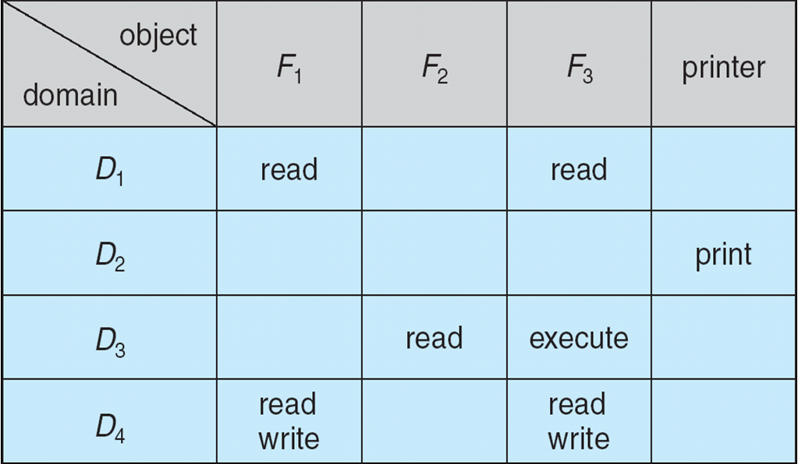

**Use of access matrix**

* If a process in Domain *Di* tries to do “op” on object *Oj*, then “op” must be in the access matrix
* User who creates object can define access column for that object
* Can be expanded to dynamic protection
  + Operations to add, delete access rights
  + Special access rights:
    - *owner of Oi*
    - *copy op from Oi to Oj (denoted by “\*”)*
    - *control – Di can modify Dj access rights*
    - *transfer – switch from domain Di to Dj*
  + *Copy* and *Owner* applicable to an object
  + *Control* applicable to domain object
* **Access matrix** design separates mechanism from policy
  + Mechanism
    - Operating system provides access-matrix + rules
    - If ensures that the matrix is only manipulated by authorized agents and that rules are strictly enforced
  + Policy
    - User dictates policy
    - Who can access what object and in what mode
* But doesn’t solve the general confinement problem

635 The problem of

guaranteeing that no information initially held in an object can migrate outside

of its execution environment is called the **confinement problem**. This problem

* is in general unsolvable (

Access Matrix a figure with Domains as Objects

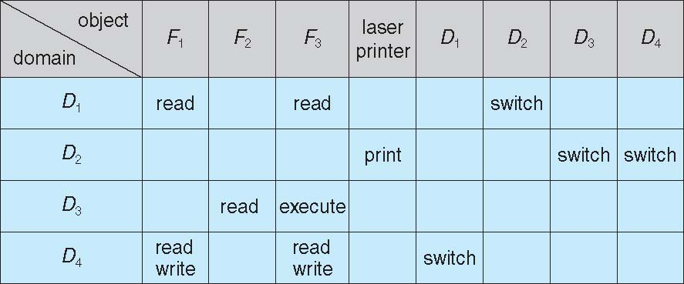

Access Matrix with Copy Rights

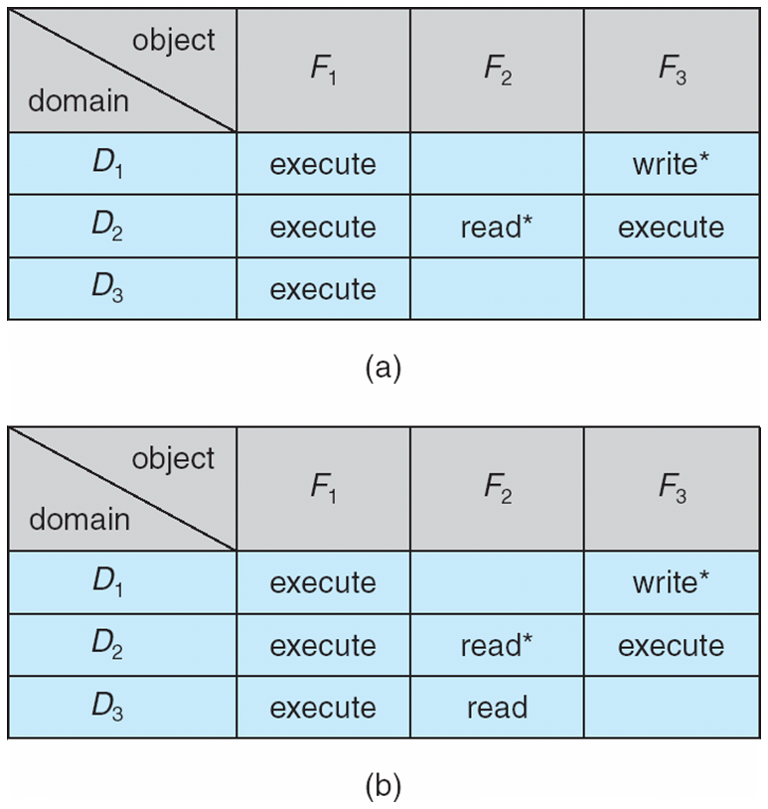

Access Matrix with Owner Rights

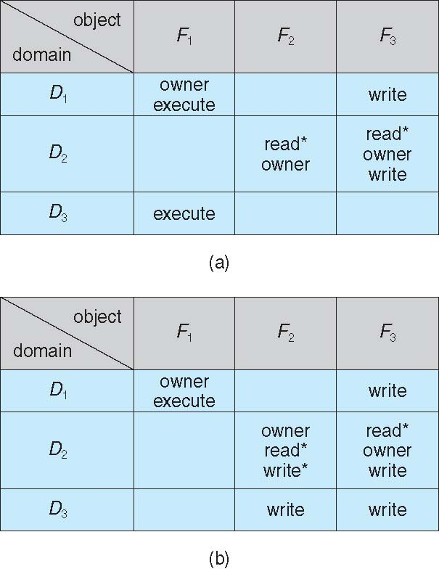

Modified Access Matrix of Figure B

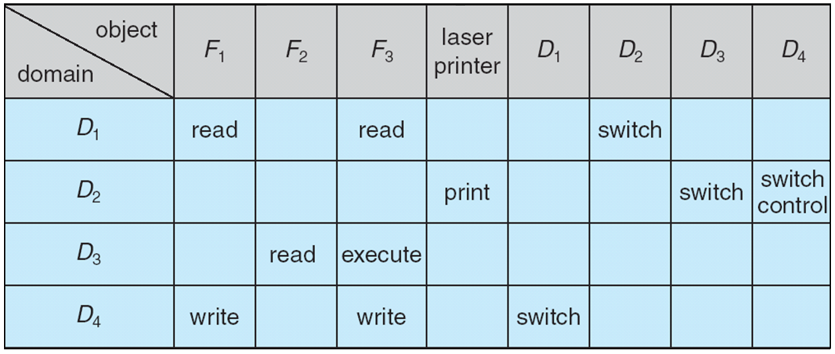

**14.5 Implementation of Access Matrix 636**

* Generally, a sparse matrix
* Option 1 – Global table
  + Store ordered triples **<domain, object, rights-set>** in table
  + A requested operation M on object *Oj* within domain *Di* -> search table for *< Di, Oj, Rk >*
  + with M ∈ Rk
  + But table could be large -> won’t fit in main memory
  + Difficult to group objects (consider an object that all domains can read)
* Option 2 – Access lists for objects 636
  + Each column implemented as an access list for one object
  + Resulting per-object list consists of ordered pairs **<domain, rights-set>** defining all domains with non-empty set of access rights for the object
  + Easily extended to contain default set -> If M ∈ default set, also allow access
* Each column = Access-control list for one object   
  Defines who can perform what operation  
    
   Domain 1 = Read, Write  
   Domain 2 = Read  
   Domain 3 = Read
* Each Row = Capability List (like a key)  
  For each domain, what operations allowed on what objects

Object F1 – Read

Object F4 – Read, Write, Execute

Object F5 – Read, Write, Delete, Copy

* **Option 3 – Capability list for domains 637**
  + Instead of object-based, list is domain based
  + **Capability list** for domain is list of objects together with operations allows on them
  + Object represented by its name or address, called a **capability**
  + Execute operation M on object Oj, process requests operation and specifies capability as parameter
    - Possession of capability means access is allowed
  + Capability list associated with domain but never directly accessible by domain
    - Rather, protected object, maintained by OS and accessed indirectly
    - Like a “secure pointer”
    - Idea can be extended up to applications
* **Option 4 – Lock-key 638**
  + Compromise between access lists and capability lists
  + Each object has list of unique bit patterns, called **locks**
  + Each domain as list of unique bit patterns called **keys**
  + Process in a domain can only access object if domain has key that matches one of the locks

**Comparisions of Implementations 638**

* Many trade-offs to consider
  + Global table is simple, but can be large
  + Access lists correspond to needs of users
    - Determining set of access rights for domain non-localized so difficult
    - Every access to an object must be checked
      * Many objects and access rights -> slow
  + Capability lists useful for localizing information for a given process
    - But revocation capabilities can be inefficient
  + Lock-key effective and flexible, keys can be passed freely from domain to domain, easy revocation
* Most systems use combination of access lists and capabilities
  + First access to an object -> access list searched
    - If allowed, capability created and attached to process
      * Additional accesses need not be checked
    - After last access, capability destroyed
    - Consider file system with ACLs per file

**14.6 Access Control 639**

* Protection can be applied to non-file resources
* Oracle Solaris 10 provides **role-based access control** (**RBAC**)to implement least privilege
  + ***Privilege***is right to execute system call or use an option within a system call
  + Can be assigned to processes
  + Users assigned ***roles***granting access to privileges and programs
    - Enable role via password to gain its privileges
  + Similar to access matrix

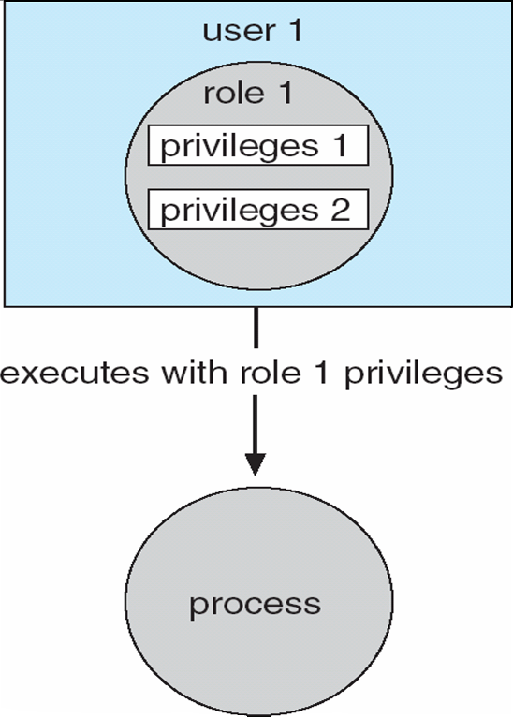

**14.7 Revocation of Access Rights 640**

**In a dynamic protection syseem, we sometimes need to revoke access rights to objects shared by different users**

* Various options to remove the access right of a domain to an object
  + **Immediate vs. delayed ( when)**
  + **Selective vs. general (does it affect all users or specify groups)**
  + **Partial vs. total (can subset of rights associated with an object be revoked, or all )**
  + **Temporary vs. permanent**
* **Access List** – Delete access rights from access list
  + **Simple** – search access list and remove entry
  + **Immediate**, **general** or **selective**, **total** or **partial**, **permanent** or **temporary**
* **Capability List** – Scheme required to locate capability in the system before capability can be revoked
  + **Reacquisition** – periodic delete, with require and denial if revoked
  + **Back-pointers** – set of pointers from each object to all capabilities of that object (Multics)
  + **Indirection** – capability points to global table entry which points to object – delete entry from global table, not selective (CAL)
  + **Keys** -641– unique bits associated with capability, generated when capability created
    - Master key associated with object, key matches master key for access
    - Revocation – create new master key
    - Policy decision of who can create and modify keys – object owner or others?

14.8 Capability-Based Systems 641

* Example: Hydra – capability-based protection system that provides considerable flexibility
  + Implements Fixed set of access rights known to and interpreted by the system
    - i.e. read, write, or execute each memory segment
    - User can declare other **auxiliary rights** and register those with protection system
    - Accessing process must hold capability and know name of operation
    - **Rights amplification** allowed by trustworthy procedures for a specific type
  + Interpretation of user-defined rights performed solely by user's program; system provides access protection for use of these rights
  + Operations on objects defined procedurally – procedures are objects accessed indirectly by capabilities
  + Solves the *problem of mutually suspicious subsystems*
  + Includes library of prewritten security routines
* Example: Cambridge CAP System – different approach to capability-based protection. Simplier & superficially less powerful than hydra, on closer examination shows that it can also be used to provide secure protection of user-defined objects. 2 kinds of capabilities (data (ordinary) &software)
  + Simpler but powerful
  + **Data capability** - provides standard read, write, execute of individual storage segments associated with object – implemented in microcode
  + **Software capability- protected buut not interpreted by the CAP microcode**
    - -interpretation left to the subsystem, through its protected procedures
    - Only has access to its own subsystem
    - Programmers must learn principles and techniques of protection

**14.9 Language-Based Protection 644**

* Specification of protection in a programming language allows the high-level description of policies for the allocation and use of resources
* Language implementation can provide software for protection enforcement when automatic hardware-supported checking is unavailable
* Interpret protection specifications to generate calls on whatever protection system is provided by the hardware and the operating system

**14.9.1 Compiler-based enforcement 644**

1. Protection needs are simply declared, rather than programmed as a

sequence of calls on procedures of an operating system.

**2.** Protection requirements can be stated independently of the facilities

provided by a particular operating system.

**3.** The means for enforcement need not be provided by the designer of a

subsystem.

**4.** A declarative notation is natural because access privileges are closely

related to the linguistic concept of data type.

What, then, are the relative merits of enforcement based solely on a kernel,

as opposed to enforcement provided largely by a compiler?

Security

Flexibility

Efficiency

In summary, the specification of protection in a programming language

allows the high-level description of policies for the allocation and use of

resources. A language implementation can provide software for protection

enforcement when automatic hardware-supported checking is unavailable. In

addition, it can interpret protection specifications to generate calls on whatever

protection system is provided by the hardware and the operating system.

**14.9.2 Protection in Java 647**

* Protection is handled by the Java Virtual Machine (JVM)
* A **class** is assigned a protection domain when it is loaded by the JVM
* The protection domain indicates what operations the class can (and cannot) perform
* If a library **method** is invoked that performs a privileged operation, the stack is **inspected** to ensure the operation can be performed by the library
* Generally, Java’s load-time and run-time checks enforce **type safety**
* Classes effectively **encapsulate** and protect data and methods from other classes

Stack Inspection

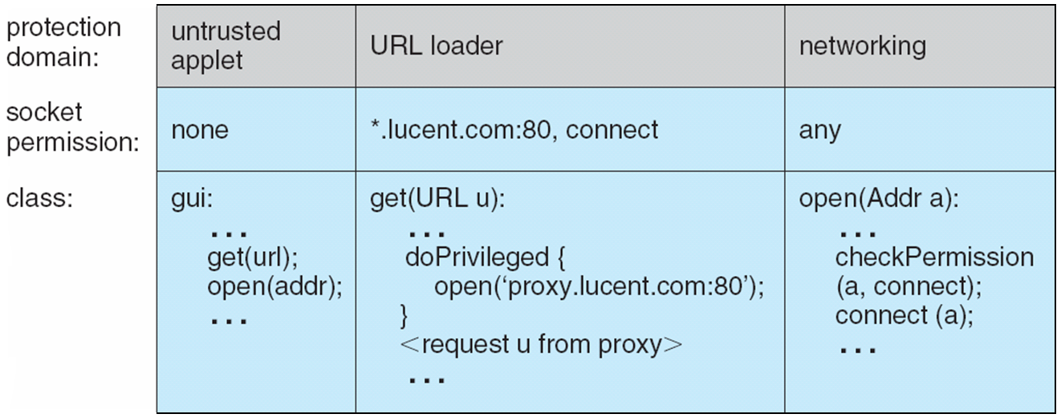

14.10 Summary

Computer systems contain many objects, and they need to be protected from

misuse. Objects may be hardware (such as memory, CPU time, and I/O devices)

or software (such as files, programs, and semaphores). An access right is

permission to perform an operation on an object. A domain is a set of access

rights. Processes execute in domains and may use any of the access rights in

the domain to access and manipulate objects. During its lifetime, a process may

be either bound to a protection domain or allowed to switch from one domain

to another.

The access matrix is a general model of protection that provides a

mechanism for protection without imposing a particular protection policy on

the system or its users. The separation of policy and mechanism is an important

design property.

The access matrix is sparse. It is normally implemented either as access lists

associated with each object or as capability lists associated with each domain.

We can include dynamic protection in the access-matrix model by considering

domains and the access matrix itself as objects. Revocation of access rights in a

dynamic protection model is typically easier to implement with an access-list

scheme than with a capability list.

Real systems are much more limited than the general model and tend to

provide protection only for files. UNIX is representative, providing read, write,

and execution protection separately for the owner, group, and general public

for each file. MULTICS uses a ring structure in addition to file access. Hydra, the

Cambridge CAPsystem, and Machare capability systems that extend protection

to user-defined software objects. Solaris 10 implements the principle of least

privilege via role-based access control, a form of the access matrix.

Language-based protection provides finer-grained arbitration of requests

and privileges than the operating system is able to provide. For example, a

single Java JVM can run several threads, each in a different protection class. It

enforces the resource requests through sophisticated stack inspection and via

the type safety of the language.

\*\*\*\*\*Chapter 15: Security\*\*\*

The Security Problem

* System **secure** if resources used and accessed as intended under all circumstances
  + Unachievable
* **Intruders** (**crackers**) attempt to breach security
* **Threat** is potential security violation
* **Attack** is attempt to breach security
* Attack can be accidental or malicious
* Easier to protect against accidental than malicious misuse

Security Violation Categories

* **Breach of confidentiality**
  + Unauthorized reading of data
* **Breach of integrity**
  + Unauthorized modification of data
* **Breach of availability**
  + Unauthorized destruction of data
* **Theft of service**
  + Unauthorized use of resources
* **Denial of service (DOS)**
  + Prevention of legitimate use

Security Violation Methods

* **Masquerading** (breach **authentication**)
  + Pretending to be an authorized user to escalate privileges
* **Replay attack**
  + As is or with **message modification**
* **Man-in-the-middle attack**
  + Intruder sits in data flow, masquerading as sender to receiver and vice versa
* **Session hijacking**
  + Intercept an already-established session to bypass authentication

Standard Security Attacks

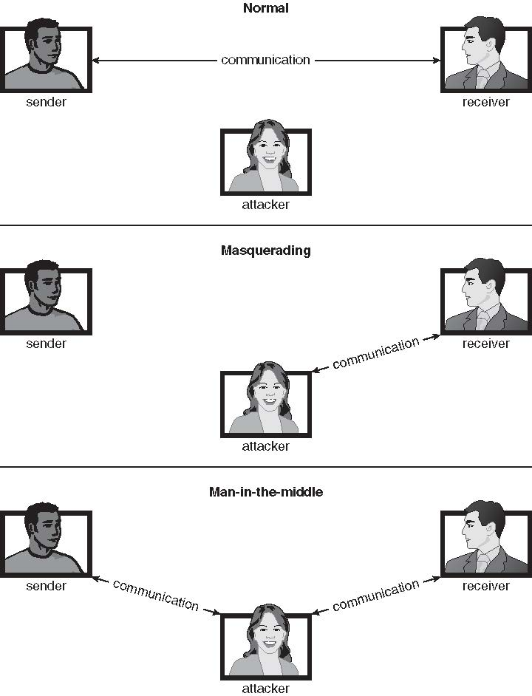

Security Measure Levels

* Impossible to have absolute security, but make cost to perpetrator sufficiently high to deter most intruders
* Security must occur at four levels to be effective:
  + **Physical**
    - Data centers, servers, connected terminals
  + **Human**
    - Avoid **social engineering**, **phishing**, **dumpster diving**
  + **Operating System**
    - Protection mechanisms, debugging
  + **Network**
    - Intercepted communications, interruption, DOS
* Security is as weak as the weakest link in the chain
* But can too much security be a problem?

Program Threats

* Many variations, many names
* **Trojan Horse**
  + Code segment that misuses its environment
  + Exploits mechanisms for allowing programs written by users to be executed by other users
  + **Spyware**, **pop-up browser windows**, **covert channels**
  + Up to 80% of spam delivered by spyware-infected systems
* **Trap Door**
  + Specific user identifier or password that circumvents normal security procedures
  + Could be included in a compiler
  + How to detect them?
* **Logic Bomb**
  + Program that initiates a security incident under certain circumstances
* **Stack** and **Buffer Overflow**
  + Exploits a bug in a program (overflow either the stack or memory buffers)
  + Failure to check bounds on inputs, arguments
  + Write past arguments on the stack into the return address on stack
  + When routine returns from call, returns to hacked address
    - Pointed to code loaded onto stack that executes malicious code
  + Unauthorized user or privilege escalation
* **Viruses**
  + Code fragment embedded in legitimate program
  + Self-replicating, designed to infect other computers
  + Very specific to CPU architecture, operating system, applications
  + Usually borne via email or as a macro
  + Visual Basic Macro to reformat hard drive

Sub AutoOpen()

Dim oFS

Set oFS = CreateObject(’’Scripting.FileSystemObject’’)

vs = Shell(’’c:command.com /k format c:’’,vbHide)

End Sub

* **Virus dropper** inserts virus onto the system
* Many categories of viruses, literally many thousands of viruses
  + File / parasitic
  + Boot / memory
  + Macro
  + Source code
  + Polymorphic to avoid having a **virus signature**
  + Encrypted
  + Stealth
  + Tunneling
  + Multipartite
  + Armored

C program with Buffer-overflow Condition

#include *<*stdio.h*>*

#define BUFFER SIZE 256

int main(int argc, char \*argv[])

{

char buffer[BUFFER SIZE];

if (argc < 2)

return -1;

else {

strcpy(buffer,argv[1]);

return 0;

}

}

Layout of Typical Stack Frame

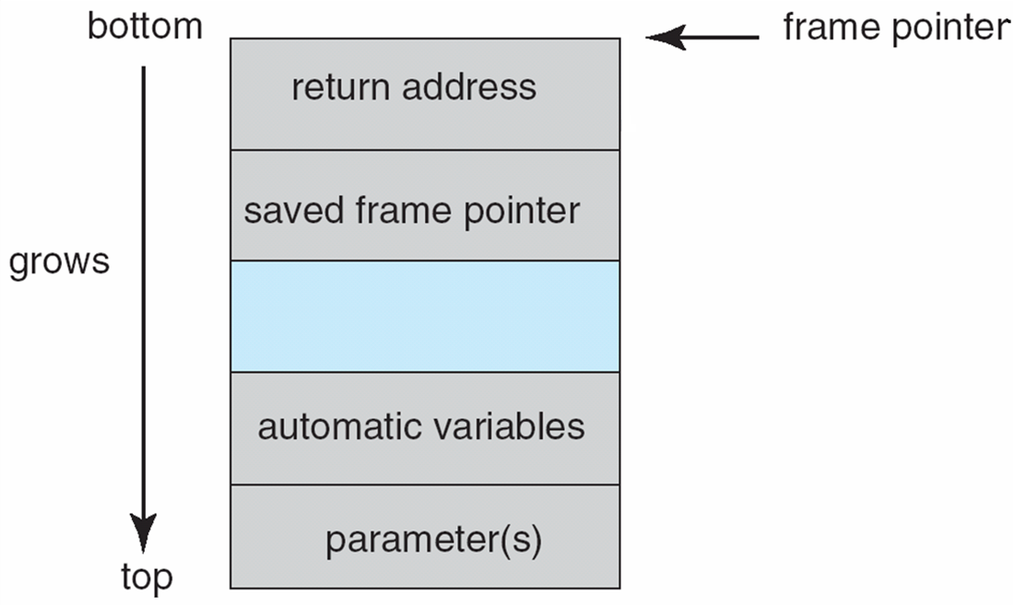

Modified Shell Code

#include <stdio.h>

int main(int argc, char \*argv[])

{

execvp(‘‘\bin\sh’’,‘‘\bin \sh’’, NULL);

return 0;

}

Hypothetical Stack Frame

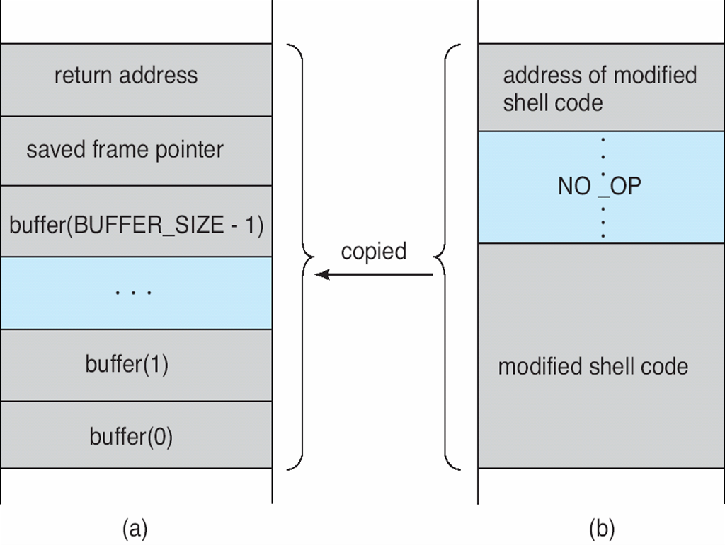

Before attack After attack

Great Programming Required?

* For the first step of determining the bug, and second step of writing exploit code, yes
* **Script kiddies** can run pre-written exploit code to attack a given system
* Attack code can get a shell with the processes’ owner’s permissions
  + Or open a network port, delete files, download a program, etc
* Depending on bug, attack can be executed across a network using allowed connections, bypassing firewalls
* Buffer overflow can be disabled by disabling stack execution or adding bit to page table to indicate “non-executable” state
  + Available in SPARC and x86
  + But still have security exploits

A Boot-sector Computer Virus

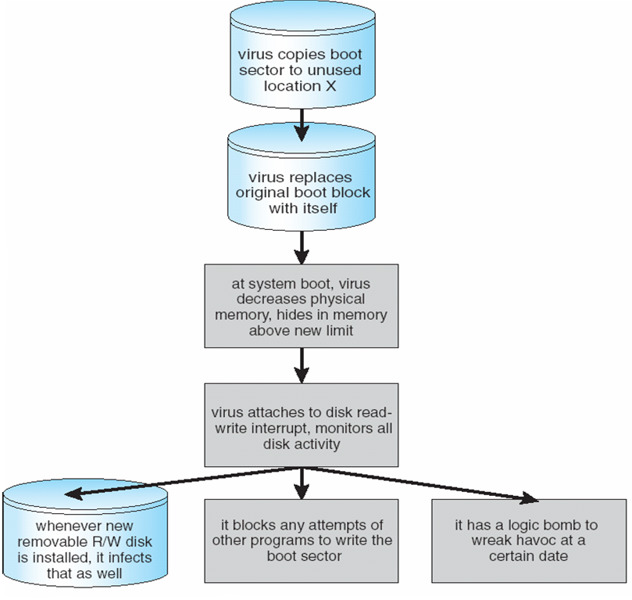

The Threat Continues

* Attacks still common, still occurring
* Attacks moved over time from science experiments to tools of organized crime
  + Targeting specific companies
  + Creating botnets to use as tool for spam and DDOS delivery
  + **Keystroke logger** to grab passwords, credit card numbers
* Why is Windows the target for most attacks?
  + Most common
  + Everyone is an administrator
    - Licensing required?
  + **Monoculture** considered harmful

System and Network Threats

* Some systems “open” rather than **secure by default**
  + Reduce **attack surface**
  + But harder to use, more knowledge needed to administer
* Network threats harder to detect, prevent
  + Protection systems weaker
  + More difficult to have a shared secret on which to base access
  + No physical limits once system attached to internet
    - Or on network with system attached to internet
  + Even determining location of connecting system difficult
    - IP address is only knowledge
* **Worms** – use **spawn** mechanism; standalone program
* Internet worm
  + Exploited UNIX networking features (remote access) and bugs in *finger* and *sendmail* programs
  + Exploited trust-relationship mechanism used by *rsh* to access friendly systems without use of password
  + **Grappling hook** program uploaded main worm program
    - 99 lines of C code
  + Hooked system then uploaded main code, tried to attack connected systems
  + Also tried to break into other users accounts on local system via password guessing
  + If target system already infected, abort, except for every 7th time
* **Port scanning**
  + Automated attempt to connect to a range of ports on one or a range of IP addresses
  + Detection of answering service protocol
  + Detection of OS and version running on system
  + nmap scans all ports in a given IP range for a response
  + nessus has a database of protocols and bugs (and exploits) to apply against a system
  + Frequently launched from **zombie systems**
    - To decrease trace-ability
* **Denial of Service**
  + Overload the targeted computer preventing it from doing any useful work
  + **Distributed denial-of-service** (**DDOS**) come from multiple sites at once
  + Consider the start of the IP-connection handshake (SYN)
    - How many started-connections can the OS handle?
  + Consider traffic to a web site
    - How can you tell the difference between being a target and being really popular?
  + Accidental – CS students writing bad fork() code
  + Purposeful – extortion, punishment

The Morris Internet Worm

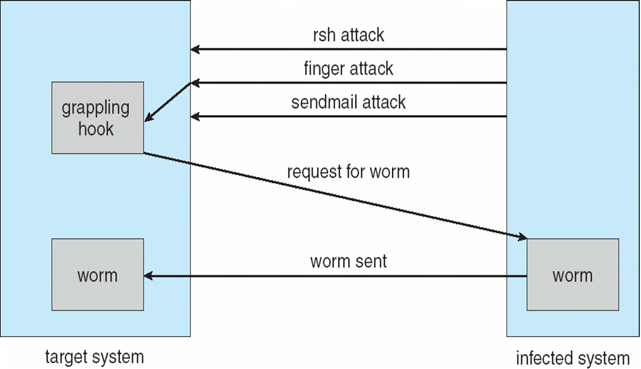

Sobig.F Worm

* More modern example
* Disguised as a photo uploaded to adult newsgroup via account created with stolen credit card
* Targeted Windows systems
* Had own SMTP engine to mail itself as attachment to everyone in infect system’s address book
* Disguised with innocuous subject lines, looking like it came from someone known
* Attachment was executable program that created **WINPPR23.EXE** in default Windows system directory  
  Plus the Windows Registry

**[HKCU\SOFTWARE\Microsoft\Windows\CurrentVersion\Run]   
   "TrayX" = %windir%\winppr32.exe /sinc  
[HKLM\SOFTWARE\Microsoft\Windows\CurrentVersion\Run]   
   "TrayX" = %windir%\winppr32.exe /sinc**

Cryptography as a security Tool

* Broadest security tool available
  + Internal to a given computer, source and destination of messages can be known and protected
    - OS creates, manages, protects process IDs, communication ports
  + Source and destination of messages on network cannot be trusted without cryptography
    - Local network – IP address?
      * Consider unauthorized host added
    - WAN / Internet – how to establish authenticity
      * Not via IP address

Cryptography

* Means to constrain potential senders (*sources*) and / or receivers (*destinations*) of *messages*
  + Based on secrets (**keys**)
  + Enables
    - Confirmation of source
    - Receipt only by certain destination
    - Trust relationship between sender and receiver
* Note symmetric cryptography based on transformations, asymmetric based on mathematical functions
  + Asymmetric much more compute intensive
  + Typically not used for bulk data encryption

Encryption

* Constrains the set of possible receivers of a message
* **Encryption** algorithm consists of
  + Set *K* of keys
  + Set *M* of Messages
  + Set *C* of ciphertexts (encrypted messages)
  + A function *E* : *K* → (*M*→*C*). That is, for each *k* ∈ *K*, *Ek* is a function for generating ciphertexts from messages
    - Both *E* and *E*k for any *k* should be efficiently computable functions
  + A function *D* : *K* → (*C* → *M*). That is, for each *k ∈* *K*, *D*k is a function for generating messages from ciphertexts
    - Both *D* and *D*k for any *k* should be efficiently computable functions
* An encryption algorithm must provide this essential property: Given a ciphertext c ∈ C, a computer can compute m such that Ek(m) = c only if it possesses *k*
  + Thus, a computer holding *k* can decrypt ciphertexts to the plaintexts used to produce them, but a computer not holding *k* cannot decrypt ciphertexts
  + Since ciphertexts are generally exposed (for example, sent on the network), it is important that it be infeasible to derive *k* from the ciphertexts

Symmetric Encryption

* Same key used to encrypt and decrypt
  + Therefore *k* must be kept secret
* DES was most commonly used symmetric block-encryption algorithm (created by US Govt)
  + Encrypts a block of data at a time
  + Keys too short so now considered insecure
* Triple-DES considered more secure
  + Algorithm used 3 times using 2 or 3 keys
  + For example
* 2001 NIST adopted new block cipher - Advanced Encryption Standard (**AES**)
  + Keys of 128, 192, or 256 bits, works on 128 bit blocks
* RC4 is most common symmetric stream cipher, but known to have vulnerabilities
  + Encrypts/decrypts a stream of bytes (i.e., wireless transmission)
  + Key is a input to pseudo-random-bit generator
    - Generates an infinite **keystream**

Secure Communication over Insecure Medium

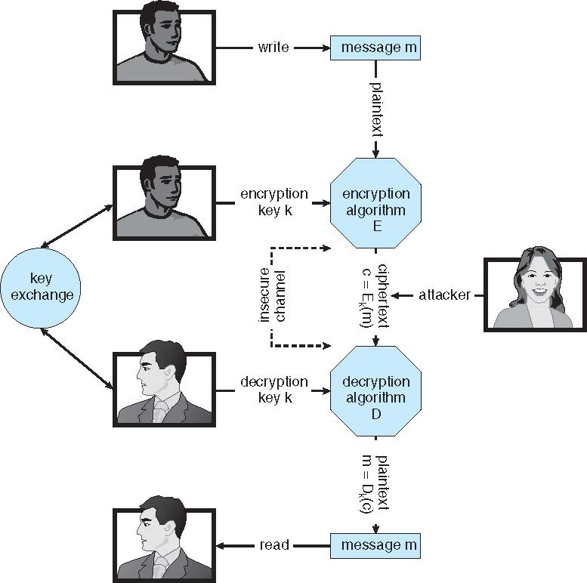

Asymmetric Encryption

* **Public-key encryption** based on each user having two keys:
  + **public key** – published key used to encrypt data
  + **private key** – key known only to individual user used to decrypt data
* Must be an encryption scheme that can be made public without making it easy to figure out the decryption scheme
  + Most common is **RSA** block cipher
  + Efficient algorithm for testing whether or not a number is prime
  + No efficient algorithm is know for finding the prime factors of a number
* Formally, it is computationally infeasible to derive *kd,N* from *ke,N*, and so *ke*  need not be kept secret and can be widely disseminated
  + *ke* is the **public key**
  + *kd* is the **private key**
  + *N* is the product of two large, randomly chosen prime numbers *p* and *q* (for example, *p* and *q* are 512 bits each)
  + Encryption algorithm is *Eke,N*(*m*) = *mke* mod *N*, where *ke* satisfies *kekd* mod (*p*−1)(*q* −1) = 1
  + The decryption algorithm is then *Dkd,N*(*c*) = *ckd* mod *N*

Asymmetric Encryption Example

* For example. make *p* = 7and *q* = 13
* We then calculate *N* = 7∗13 = 91 and (*p*−1)(*q*−1) = 72
* We next select *ke* relatively prime to 72 and*<* 72, yielding 5
* Finally, we calculate *kd* such that *kekd* mod 72 = 1, yielding 29
* We how have our keys
  + Public key, *ke,N* = 5*,* 91
  + Private key, *kd,N* = 29*,* 91
* Encrypting the message 69 with the public key results in the cyphertext 62
* Cyphertext can be decoded with the private key
  + Public key can be distributed in cleartext to anyone who wants to communicate with holder of public key

Encryption using RSA Asymmetric Cryptography

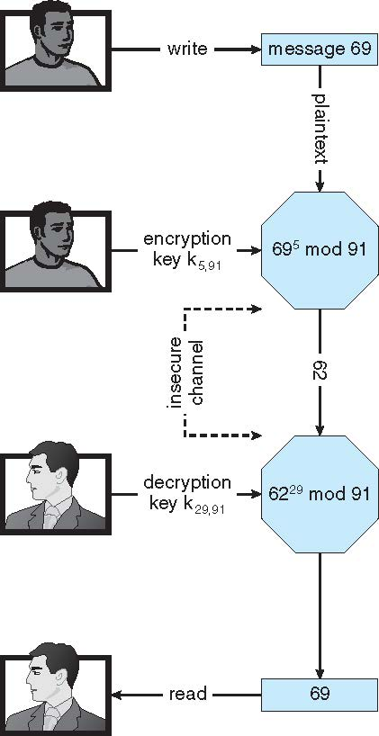

* Note symmetric cryptography based on transformations, asymmetric based on mathematical functions
  + Asymmetric much more compute intensive
  + Typically not used for bulk data encryption

Authentication

* Constraining set of potential senders of a message
  + Complementary to encryption
  + Also can prove message unmodified
* Algorithm components
  + A set *K* of keys
  + A set *M* of messages
  + A set *A* of authenticators
  + A function *S* : *K* → (*M*→ *A*)
    - That is, for each *k* ∈ *K*, *S*k is a function for generating authenticators from messages
    - Both *S* and *S*k for any *k* should be efficiently computable functions
  + A function *V* : *K* → (*M* × *A*→ {true, false}). That is, for each *k* ∈ *K*, *V*k is a function for verifying authenticators on messages
    - Both *V* and *V*k for any *k* should be efficiently computable functions
* For a message *m*, a computer can generate an authenticator *a* ∈ *A* such that *V*k(*m, a*) = true only if it possesses *k*
* Thus, computer holding *k* can generate authenticators on messages so that any other computer possessing *k* can verify them
* Computer not holding *k* cannot generate authenticators on messages that can be verified using *Vk*
* Since authenticators are generally exposed (for example, they are sent on the network with the messages themselves), it must not be feasible to derive *k* from the authenticators
* Practically, if Vk(*m,a)* = **true** then we know *m* has not been modified and that send of message has *k*
  + If we share *k* with only one entity, know where the message originated

Authentication – Hash Functions

* Basis of authentication
* Creates small, fixed-size block of data **message digest** (**hash value)** from *m*
* Hash Function *H* must be collision resistant on *m*
  + Must be infeasible to find an *m’* ≠ *m* such that *H*(*m*) = *H*(*m’*)
* If *H*(*m*) = *H*(*m’*), then *m* = *m*’
  + The message has not been modified
* Common message-digest functions include **MD5**, which produces a 128-bit hash, and **SHA-1**, which outputs a 160-bit hash
* Not useful as authenticators
  + For example *H(m*) can be sent with a message
    - But if *H* is known someone could modify *m* to *m’* and recompute *H(m’)* and modification not detected
    - So must authenticate *H(m)*

Authentication – MAC

* Symmetric encryption used in **message-authentication code** (**MAC**) authentication algorithm
* Cryptographic checksum generated from message using secret key
  + Can securely authenticate short values
* If used to authenticate *H(m)* for an *H* that is collision resistant, then obtain a way to securely authenticate long message by hashing them first
* Note that *k* is needed to compute both *Sk* and *Vk*, so anyone able to compute one can compute the other

Authentication – Digital Signature

* Based on asymmetric keys and digital signature algorithm
* Authenticators produced are **digital signatures**
* Very useful – ***anyone*** can verify authenticity of a message
* In a digital-signature algorithm, computationally infeasible to derive *ks*  from *kv*
  + *V* is a one-way function
  + Thus, *kv* is the public key and *ks* is the private key
* Consider the RSA digital-signature algorithm
  + Similar to the RSA encryption algorithm, but the key use is reversed
  + Digital signature of message *Sks* (*m*) = *H*(*m*)*ks* mod *N*
  + The key *ks* again is a pair (*d, N*), where *N* is the product of two large, randomly chosen prime numbers *p* and *q*
  + Verification algorithm is *Vkv*(*m, a*) (*akv* mod *N* = *H*(*m*))
    - Where *kv* satisfies *kvks* mod (*p* − 1)(*q* − 1) = 1
* Why authentication if a subset of encryption?
  + Fewer computations (except for RSA digital signatures)
  + Authenticator usually shorter than message
  + Sometimes want authentication but not confidentiality
    - Signed patches et al
  + Can be basis for **non-repudiation**

Key Distribution

* Delivery of symmetric key is huge challenge
  + Sometimes done **out-of-band**
* Asymmetric keys can proliferate – stored on **key ring**
  + Even asymmetric key distribution needs care – man-in-the-middle attack

Digital Certificates

* Proof of who or what owns a public key
* Public key digitally signed a trusted party
* Trusted party receives proof of identification from entity and certifies that public key belongs to entity
* **Certificate** **authority** are trusted party – their public keys included with web browser distributions
  + They vouch for other authorities via digitally signing their keys, and so on

Mani-in-the-middle Attack on Asymmetric Cryptography

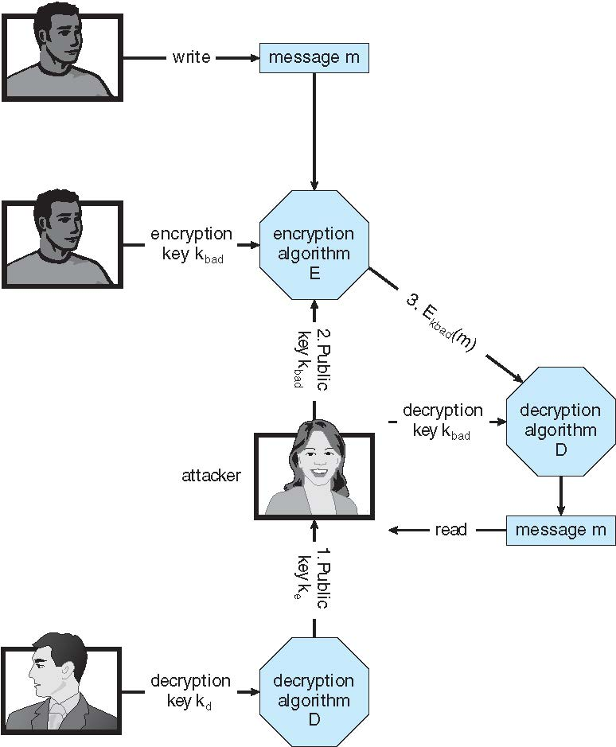

Implementation of Cryptography

* Can be done at various **layers** of ISO Reference Model
  + SSL at the Transport layer
  + Network layer is typically **IPSec**
    - **IKE** for key exchange
    - Basis of **Virtual Private Networks (VPNs)**
    - Why not just at lowest level?
  + Sometimes need more knowledge than available at low levels
    - i.e. User authentication
    - i.e. e-mail delivery

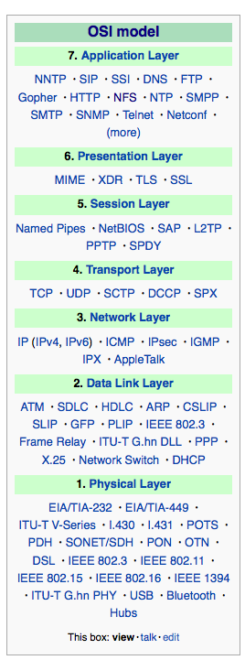

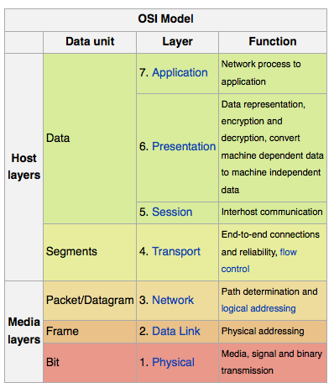 Source: http://en.wikipedia.org/wiki/OSI\_model

Encryption Example SSL

* Insertion of cryptography at one layer of the ISO network model (the transport layer)
* SSL – Secure Socket Layer (also called TLS)
* Cryptographic protocol that limits two computers to only exchange messages with each other
  + Very complicated, with many variations
* Used between web servers and browsers for secure communication (credit card numbers)
* The server is verified with a **certificate** assuring client is talking to correct server
* Asymmetric cryptography used to establish a secure **session key** (symmetric encryption) for bulk of communication during session
* Communication between each computer then uses symmetric key cryptography
* More details in textbook

User Authentication

* Crucial to identify user correctly, as protection systems depend on user ID
* User identity most often established through **passwords**, can be considered a special case of either keys or capabilities
* Passwords must be kept secret
  + Frequent change of passwords
  + History to avoid repeats
  + Use of “non-guessable” passwords
  + Log all invalid access attempts (but not the passwords themselves)
  + Unauthorized transfer
* Passwords may also either be encrypted or allowed to be used only once
  + Does encrypting passwords solve the exposure problem?
    - Might solve **sniffing**
    - Consider **shoulder surfing**
    - Consider Trojan horse keystroke logger
    - How are passwords stored at authenticating site?

Passwords

* Encrypt to avoid having to keep secret
  + But keep secret anyway (i.e. Unix uses superuser-only readably file /etc/shadow)
  + Use algorithm easy to compute but difficult to invert
  + Only encrypted password stored, never decrypted
  + Add “salt” to avoid the same password being encrypted to the same value
* One-time passwords
  + Use a function based on a seed to compute a password, both user and computer
  + Hardware device / calculator / key fob to generate the password
    - Changes very frequently
* Biometrics
  + Some physical attribute (fingerprint, hand scan)
* Multi-factor authentication
  + Need two or more factors for authentication
    - i.e. USB “dongle”, biometric measure, and password

Implementing Security Defenses

* **Defense in depth** is most common security theory – multiple layers of security
* **Security policy** describes what is being secured
* Vulnerability assessment compares real state of system / network compared to security policy
* Intrusion detection endeavors to detect attempted or successful intrusions
  + **Signature-based** detection spots known bad patterns
  + **Anomaly detection** spots differences from normal behavior
    - Can detect **zero-day** attacks
  + **False-positives** and **false-negatives** a problem
* Virus protection
  + Searching all programs or programs at execution for known virus patterns
  + Or run in **sandbox** so can’t damage system
* Auditing, accounting, and logging of all or specific system or network activities
* Practice **safe computing** – avoid sources of infection, download from only “good” sites, etc

Firewalling to Protect Systems and Networks

* A network **firewall** is placed between trusted and untrusted hosts
  + The firewall limits network access between these two **security domains**
* Can be tunneled or spoofed
  + Tunneling allows disallowed protocol to travel within allowed protocol (i.e., telnet inside of HTTP)
  + Firewall rules typically based on host name or IP address which can be spoofed
* **Personal firewall** is software layer on given host
  + Can monitor / limit traffic to and from the host
* **Application proxy firewall** understands application protocol and can control them (i.e., SMTP)
* **System-call firewall** monitors all important system calls and apply rules to them (i.e., this program can execute that system call)

Network Security Through Domain Separation Via Firewall

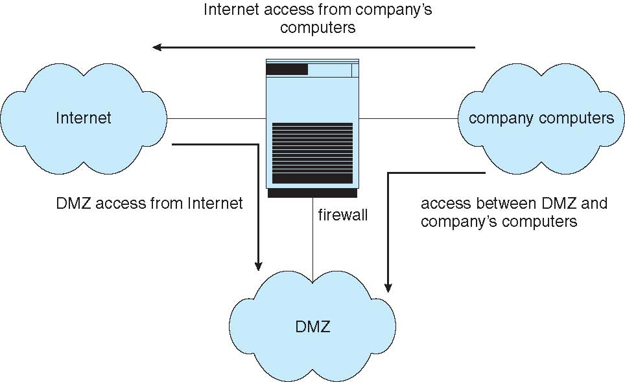

Computer Security Classifications

* U.S. Department of Defense outlines four divisions of computer security: **A**, **B**, **C**, and **D**
* **D** – Minimal security
* **C** – Provides discretionary protection through auditing
  + Divided into **C1** and **C2**
    - **C1** identifies cooperating users with the same level of protection
    - **C2** allows user-level access control
* **B** – All the properties of **C**, however each object may have unique sensitivity labels
  + Divided into **B1**, **B2**, and **B3**
* **A** – Uses formal design and verification techniques to ensure security

Example Windows 7

* Security is based on **user accounts**
  + Each user has unique security ID
  + Login to ID creates **security access token**
    - Includes security ID for user, for user’s groups, and special privileges
    - Every process gets copy of token
    - System checks token to determine if access allowed or denied
* Uses a **subject** model to ensure access security
  + A subject tracks and manages permissions for each program that a user runs
* Each object in Windows has a security attribute defined by a security descriptor
  + For example, a file has a security descriptor that indicates the access permissions for all users
* Win added mandatory integrity controls – assigns **integrity label** to each securable object and subject
  + Subject must have access requested in discretionary access-control list to gain access to object
* Security attributes described by security descriptor
  + Owner ID, group security ID, discretionary access-control list, system access-control list